**W2_Lab**

Bruno Simione Beltrame

N01220860

**History:**



**Prints/Screenshots:**

Lab Goals

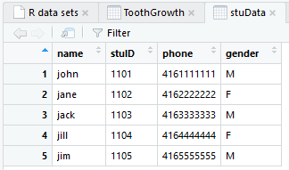

Exercises 1-7

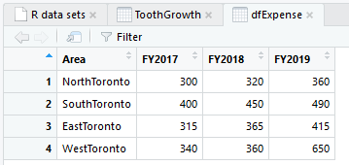

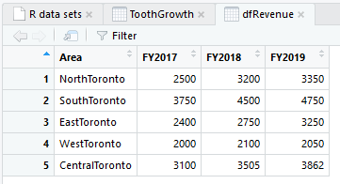

Exercise 8

> barplot(dfRevenue$FY2018, main = "2018 Revenue", xlab = "Area", ylab = "Revenue", names.arg = dfRevenue$Area, col = rainbow(5))

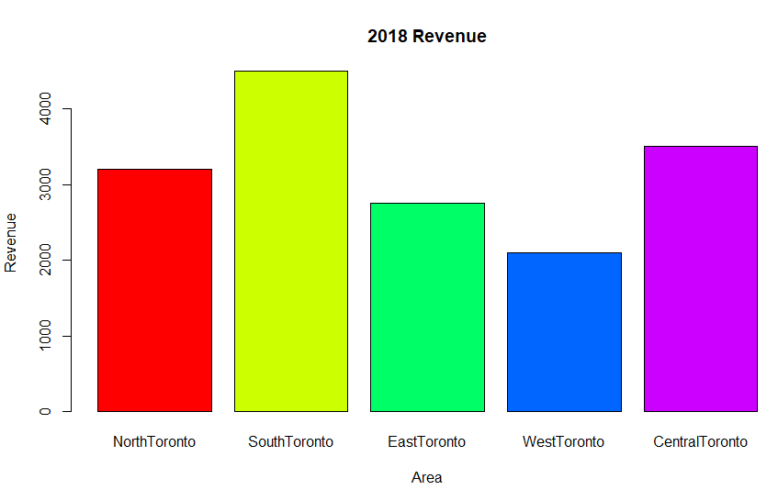

Exercise 9

> pct <- round(dfRevenue$FY2018/sum(dfRevenue$FY2018)*100, 1)

> lbls <- paste(dfRevenue$FY2018, pct, sep = " ")

> lbls <- paste(lbls, "%", sep = "")

> pie(dfRevenue$FY2018, labels = lbls, col = rainbow(length(dfRevenue$FY2018)), main = "2018 Revenue")

> legend("topright", dfRevenue$Area, cex = 1, fill = rainbow(length(dfRevenue$Area)))

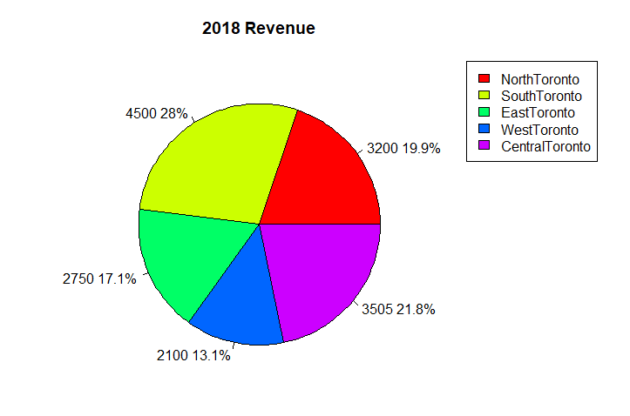

Exercise 10

> plot(ToothGrowth$dose, ToothGrowth$len, xlab = "dose", ylab = "len")

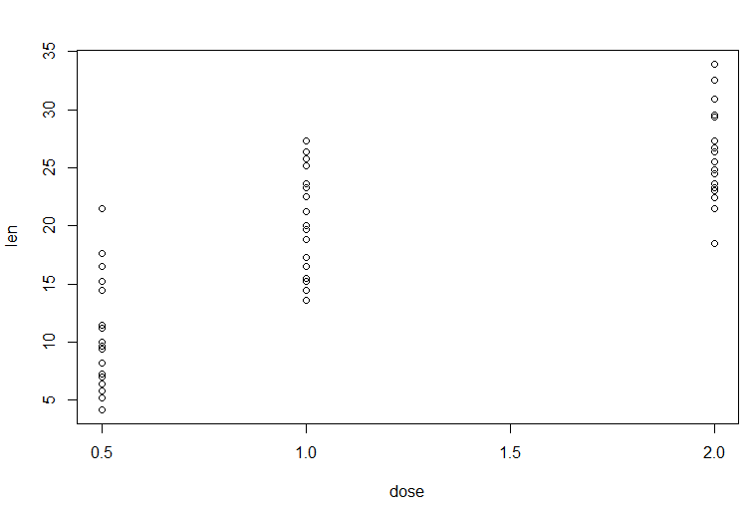

Exercise 11

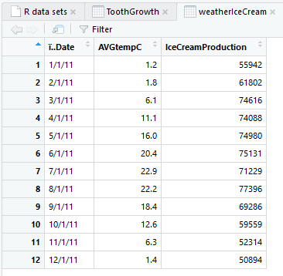

Exercise 12

