**W4Lab – Bruno Simione Beltrame**

**Part A**

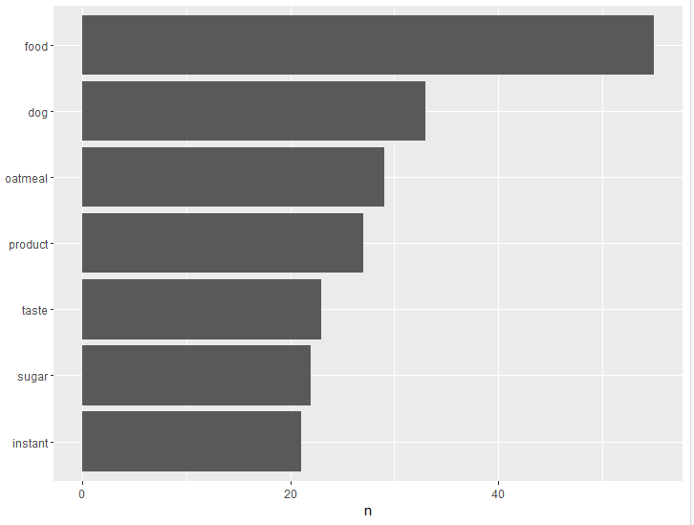

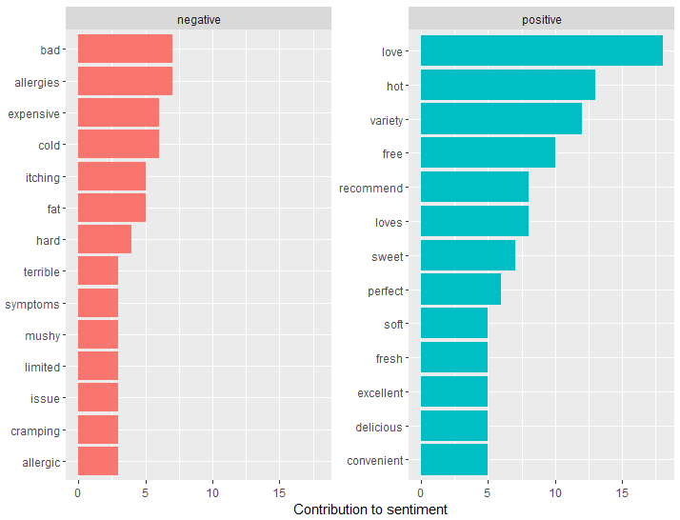

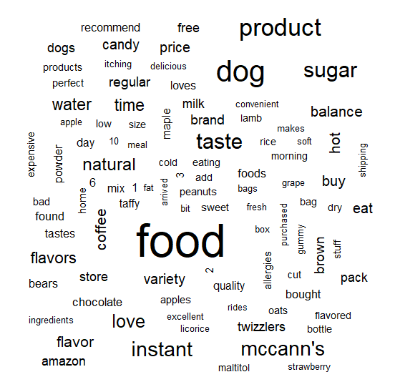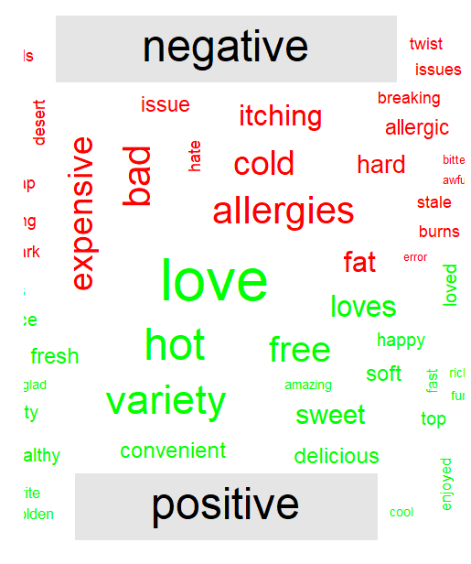

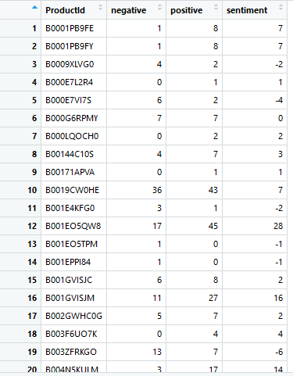

**Challenge Questions**

**1 – Top 10**

> combinedReview_top10 <- combinedReview_sentiment[order(combinedReview_sentiment$sentiment, decreasing = TRUE), ]

> View(combinedReview_top10[c(1:10), c(1,4)])

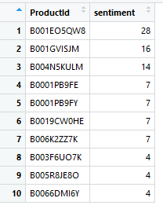

**2 – Worst 10**

> combinedReview_worst10 <- combinedReview_sentiment[order(combinedReview_sentiment$sentiment), ]

> View(combinedReview_worst10[c(1:10), c(1,4)])

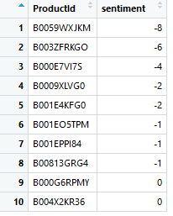

**3 – Big Review**

> reviewsAll <- reviews[, c(2,10)]

> View(reviewsAll)

> combinedReviewAll <- reviewsAll %>% group_by(ProductId) %>% summarise(Text = paste(Text, collapse = " "))

> combinedReviewAll$ProductId <- as.factor(combinedReviewAll$ProductId)

> combinedReviewAll2 <- combinedReviewAll %>% unnest_tokens(word, Text)

> View(combinedReviewAll2)

> combinedReviewAll3 <- combinedReviewAll2 %>% anti_join(stop_words, by = "word")

> combinedReviewAll3 <- filter(combinedReviewAll3, word!="br")

> combinedReviewAll3 %>% count(word, sort = TRUE) %>% filter(n>20) %>% mutate(word = reorder(word,n)) %>% ggplot(aes(word, n)) + geom_col() + xlab(NULL) + coord_flip()

N >20 🡪 Impossible to read

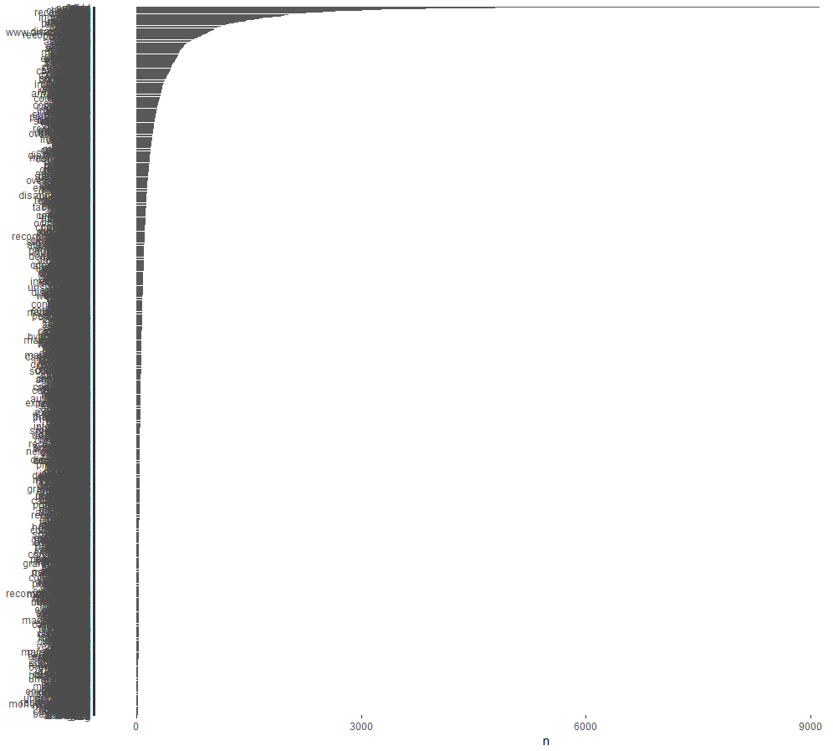

> combinedReviewAll3 %>% count(word, sort = TRUE) %>% filter(n>4000) %>% mutate(word = reorder(word,n)) %>% ggplot(aes(word, n)) + geom_col() + xlab(NULL) + coord_flip()

N > 4000

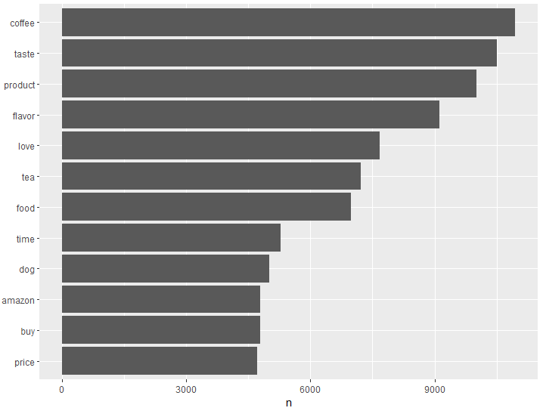

> bing_words_counts_all <- combinedReviewAll3 %>% inner_join(get_sentiments("bing")) %>% count(word, sentiment, sort = TRUE) %>% ungroup()

Joining, by = "word"

> bing_words_counts_all %>% group_by(sentiment) %>% top_n(10) %>% ungroup() %>% mutate(word = reorder(word, n)) %>% ggplot(aes(word, n, fill = sentiment)) + geom_col(show.legend = FALSE) + facet_wrap(~sentiment, scales = "free_y") + labs(y = "Contribution to sentiment", x = NULL) + coord_flip()

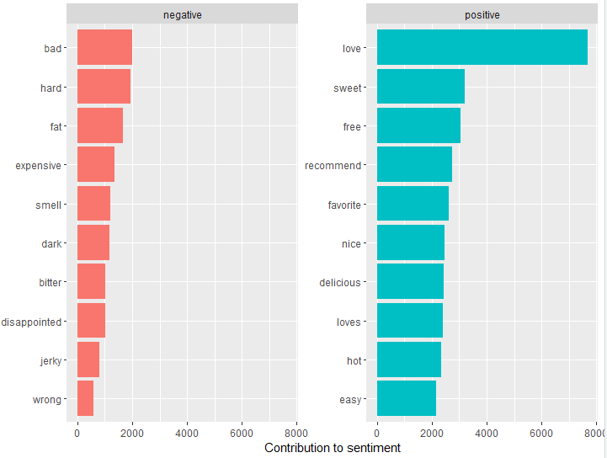

> combinedReviewAll3 %>% count(word, sort = TRUE) %>% with(wordcloud(word, n, max.words = 100))

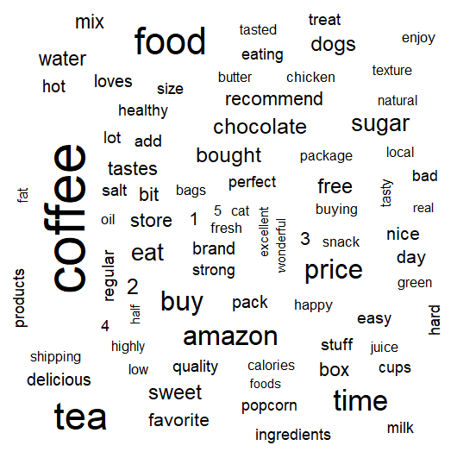

> combinedReviewAll3 %>% inner_join(get_sentiments("bing")) %>% count(word, sentiment, sort = TRUE) %>% acast(word ~ sentiment, value.var = "n", fill = 0) %>% comparison.cloud(colors = c("red", "green"), max.words = 100)

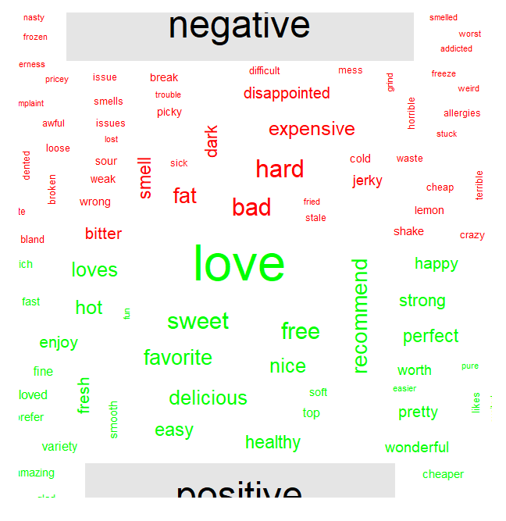

> combinedReviewAll_sentiment <- combinedReviewAll3 %>% inner_join(get_sentiments("bing")) %>% count(ProductId, sentiment) %>% spread(sentiment, n, fill = 0) %>% mutate(sentiment = positive - negative)

Joining, by = "word"

> View(combinedReviewAll_sentiment)

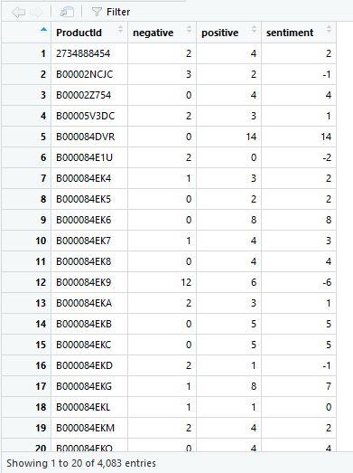

**Sorted:**

**Worst**

> combinedReviewAll_sentiment_sorted <- combinedReviewAll_sentiment[order(combinedReviewAll_sentiment$sentiment),]

> View(combinedReviewAll_sentiment_sorted[,c(1,4)])

**Top**

> combinedReviewAll_top10 <- combinedReviewAll_sentiment[order(combinedReviewAll_sentiment$sentiment, decreasing = TRUE), ]

> View(combinedReviewAll_top10[, c(1,4)])

