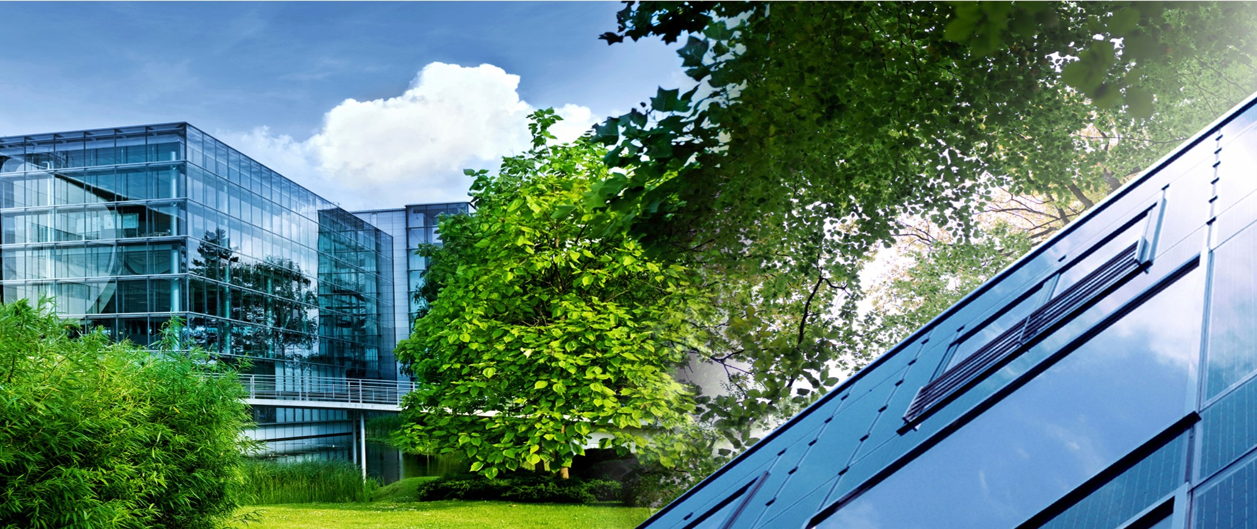



Key = Scope

Measurement and Verification Plan

Reference No.: CCHG/MBH/22/02

Key = Current date

Sustaining your growth

**Table of Contents**

1 Project Overview 4

1.1 Project Details 4

1.2 Project Description 4

1.3 Facility Description 4

1.4 Baseline Characteristics 5

2 M&V Option and Justification 7

2.1 Measurement Option and Boundary 7

2.2 Justification 7

2.3 Estimated Savings 8

3 Baseline Adjustments 9

3.1 Routine Adjustment 9

3.1.1 Independent Variable 9

3.1.2 Regression Model 9

3.1.3 Savings Uncertainty 10

3.2 Non-Routine Adjustments 11

3.3 Description of the Baseline Adjustment Methodology 12

4 Performance Period and Reporting 13

4.1 Performance Period Activities 13

4.2 Reporting Period 13

4.3 Responsibilities 13

4.4 Format of M&V Report 14

4.5 Quality Assurance 15

5 Appendix I 16

5.1 Baseline Characteristics Graphs 16

5.2 Equipment Inventory List 17

5.2.1 Chillers 17

5.2.2 Primary Chilled Water Pump – PCHWP 18

5.2.3 Primary Hot Water Pump – PHWP 18

5.2.4 Secondary Chilled Water Pump – SCHWP 19

5.2.5 Secondary Hot Water Pump – SHWP 20

5.2.6 Cogen Pumps 21

5.2.7 Domestic Pumps 22

5.2.8 Vacuum Pumps 22

5.2.9 Boiler 22

5.2.10 ir Handling Unit – AHU 23

5.2.11 Aspirators 24

5.2.12 Fan Coil Unit- FCU 25

5.2.13 Elevators 26

5.2.14 Medical Equipment 26



# Project Overview

## Project Details

Table 1 Main summary

|  |  |
| --- | --- |
| Entity name | Test |
| Project address | Dubai Mall |
| M&V option | Option C - Chilled Water, Water |
| Number of buildings in scope | 3 |
| Number of floors | 7 |
| Electricity tariff (TL/kWh) | 0.303 AED/MWh |
| Built-up area (sqm) | 18,787 |
| Construction area (sqm) | 78,878 |
| Operating year | 2,003 |

Table 2 Baseline and savings summary

|  |  |  |  |
| --- | --- | --- | --- |
| Total Baseline and Savings Summary | | | |
| Utility | **Annual Baseline** | **Annual Guaranteed Savings** | |
| Chilled Water | 11,667,760 MWh | 200,000 MWh | 1.714% |
| Water | 11,667,760 MWh | 200,000 MWh | 1.714% |
| Total cost | 7,070,662 AED | 121,200 AED | 1.714% |

## Project Description

Medicana International is a multi-specialty hospital located in Beylikduzu, Istanbul. It consists of two linked departments, including in-patient floors and out-patient floors. The hospital was built with the capacity and technical features to allow for delivering service to patients coming from Istanbul, Thrace Region and Europe.

The hospital was constructed in 2006. The total built-up area of the facility is 23,275 m² with 115 beds.

## Facility Description

Medicana Beylikdüzü Hospital consists of 12 floors and has a capacity of 23,275 m2 with 8 operating rooms, 26 observation beds, 9 general intensive care units, 10 newborn intensive care units, and 5 coronary intensive care units. The hospital employs more than 860 staff with specialist physicians, nurses, midwives, emergency medical technicians, laboratory technicians, support service personnel, administrative officers and security personnel. The table below summarizes the major equipment in the facility:

Table 3 Buildings summary

|  |  |  |
| --- | --- | --- |
| Building Name | Heating/Cooling Source | Building Occupancy |
| Medicana Beylikdüzü Hospital | 1 natural gas-fired hot water boilers (Duty)  1 natural gas-fired hot water boilers (Standby)  1 GE Jenbacher JMS 316 GS-N. L branded cogeneration system  3 air-cooled McQuay-branded Chillers | 24 hrs/day – 7 days |

Medicana Beylikdüzü Hospital

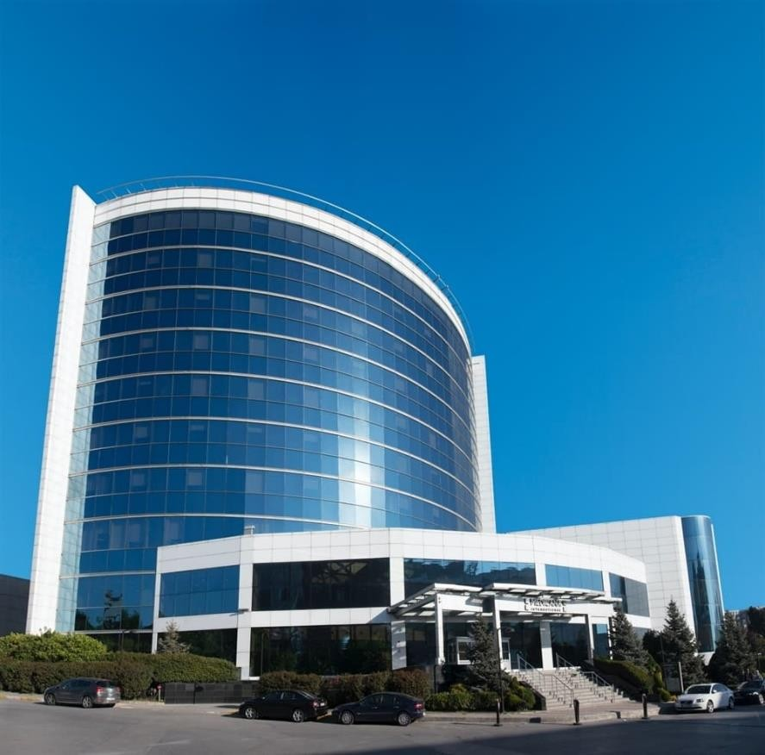

## Baseline Characteristics

At present, data is collected through meter readings provided by the client as detailed below. It is verified that the monthly data starts exactly from the first day of the month and ends exactly on the last day of the month through a set of samples of daily readings. The billing period is specified in the table below.

Table 4 Utilities start and end dates

|  |  |  |
| --- | --- | --- |
| Utility | From | To |
| Chilled Water | 2019-03-02 | 2019-11-23 |
| Water | 2019-03-02 | 2019-11-23 |

Table 5 Client and meters

|  |  |  |
| --- | --- | --- |
| Utility | Client No | Meter No. |
| Electricity | 5330234 | 10789 |
| Electricity Co-Gen | N/A | N/A |

Key = Below are the tables corresponding to the baseline for all the utilities.

Table : Baseline for Chilled Water

|  |  |  |  |
| --- | --- | --- | --- |
| No | From | To | Chilled Water (MWh) |
| 1 | 2019-03-02 | 2019-03-09 | 138,213 |
| 2 | 2019-03-09 | 2019-03-16 | 159,043 |
| 3 | 2019-03-16 | 2019-03-23 | 246,170 |
| 4 | 2019-03-23 | 2019-03-30 | 185,202 |
| 5 | 2019-03-30 | 2019-04-06 | 240,263 |
| 6 | 2019-04-06 | 2019-04-13 | 255,935 |
| 7 | 2019-04-13 | 2019-04-20 | 230,743 |
| 8 | 2019-04-20 | 2019-04-27 | 246,363 |
| 9 | 2019-04-27 | 2019-05-04 | 241,668 |
| 10 | 2019-05-04 | 2019-05-11 | 276,906 |
| 11 | 2019-05-11 | 2019-05-18 | 271,025 |
| 12 | 2019-05-18 | 2019-05-25 | 282,490 |
| 13 | 2019-05-25 | 2019-06-01 | 312,897 |
| 14 | 2019-06-01 | 2019-06-08 | 371,965 |
| 15 | 2019-06-08 | 2019-06-15 | 385,280 |
| 16 | 2019-06-15 | 2019-06-22 | 364,573 |
| 17 | 2019-06-22 | 2019-06-29 | 453,834 |
| 18 | 2019-06-29 | 2019-07-06 | 373,281 |
| 19 | 2019-07-06 | 2019-07-13 | 395,698 |
| 20 | 2019-07-13 | 2019-07-20 | 418,956 |
| 21 | 2019-07-20 | 2019-07-27 | 417,150 |
| 22 | 2019-07-27 | 2019-08-03 | 412,045 |
| 23 | 2019-08-03 | 2019-08-10 | 443,611 |
| 24 | 2019-08-10 | 2019-08-17 | 444,567 |
| 25 | 2019-08-17 | 2019-08-24 | 377,055 |
| 26 | 2019-08-24 | 2019-08-31 | 330,222 |
| 27 | 2019-08-31 | 2019-09-07 | 316,987 |
| 28 | 2019-09-07 | 2019-09-14 | 323,994 |
| 29 | 2019-09-14 | 2019-09-21 | 333,670 |
| 30 | 2019-09-21 | 2019-09-28 | 357,402 |
| 31 | 2019-09-28 | 2019-10-05 | 364,833 |
| 32 | 2019-10-05 | 2019-10-12 | 305,774 |
| 33 | 2019-10-12 | 2019-10-19 | 287,946 |
| 34 | 2019-10-19 | 2019-10-26 | 291,194 |
| 35 | 2019-10-26 | 2019-11-02 | 243,333 |
| 36 | 2019-11-02 | 2019-11-09 | 243,789 |
| 37 | 2019-11-09 | 2019-11-16 | 231,409 |
| 38 | 2019-11-16 | 2019-11-23 | 92,274 |

Table : Baseline for Water

|  |  |  |  |
| --- | --- | --- | --- |
| No | From | To | Water (MWh) |
| 1 | 2019-03-02 | 2019-03-09 | 138,213 |
| 2 | 2019-03-09 | 2019-03-16 | 159,043 |
| 3 | 2019-03-16 | 2019-03-23 | 246,170 |
| 4 | 2019-03-23 | 2019-03-30 | 185,202 |
| 5 | 2019-03-30 | 2019-04-06 | 240,263 |
| 6 | 2019-04-06 | 2019-04-13 | 255,935 |
| 7 | 2019-04-13 | 2019-04-20 | 230,743 |
| 8 | 2019-04-20 | 2019-04-27 | 246,363 |
| 9 | 2019-04-27 | 2019-05-04 | 241,668 |
| 10 | 2019-05-04 | 2019-05-11 | 276,906 |
| 11 | 2019-05-11 | 2019-05-18 | 271,025 |
| 12 | 2019-05-18 | 2019-05-25 | 282,490 |
| 13 | 2019-05-25 | 2019-06-01 | 312,897 |
| 14 | 2019-06-01 | 2019-06-08 | 371,965 |
| 15 | 2019-06-08 | 2019-06-15 | 385,280 |
| 16 | 2019-06-15 | 2019-06-22 | 364,573 |
| 17 | 2019-06-22 | 2019-06-29 | 453,834 |
| 18 | 2019-06-29 | 2019-07-06 | 373,281 |
| 19 | 2019-07-06 | 2019-07-13 | 395,698 |
| 20 | 2019-07-13 | 2019-07-20 | 418,956 |
| 21 | 2019-07-20 | 2019-07-27 | 417,150 |
| 22 | 2019-07-27 | 2019-08-03 | 412,045 |
| 23 | 2019-08-03 | 2019-08-10 | 443,611 |
| 24 | 2019-08-10 | 2019-08-17 | 444,567 |
| 25 | 2019-08-17 | 2019-08-24 | 377,055 |
| 26 | 2019-08-24 | 2019-08-31 | 330,222 |
| 27 | 2019-08-31 | 2019-09-07 | 316,987 |
| 28 | 2019-09-07 | 2019-09-14 | 323,994 |
| 29 | 2019-09-14 | 2019-09-21 | 333,670 |
| 30 | 2019-09-21 | 2019-09-28 | 357,402 |
| 31 | 2019-09-28 | 2019-10-05 | 364,833 |
| 32 | 2019-10-05 | 2019-10-12 | 305,774 |
| 33 | 2019-10-12 | 2019-10-19 | 287,946 |
| 34 | 2019-10-19 | 2019-10-26 | 291,194 |
| 35 | 2019-10-26 | 2019-11-02 | 243,333 |
| 36 | 2019-11-02 | 2019-11-09 | 243,789 |
| 37 | 2019-11-09 | 2019-11-16 | 231,409 |
| 38 | 2019-11-16 | 2019-11-23 | 92,274 |

+



# M&V Option and Justification

## Measurement Option and Boundary

This Measurement and Verification (M&V) plan describes how energy savings will be quantified. The M&V plan presented here adheres to the specifications set forth in the International Performance Measurement and Verification Protocol (IPMVP) Core Concepts. M&V involves the process of using measurements to reliably quantify actual energy savings from an energy savings project within a facility, a process, a building, or a building subsystem. M&V may be used to verify that an energy efficiency project is achieving its intended savings. M&V describes how savings are determined from measurements of energy use before and after implementation of an energy or water savings project, with appropriate adjustments made for changes in conditions. Such adjustments may be routine and expected, while others are non-routine and due to factors unrelated to the project.

This M&V plan describes how baseline energy use is documented, how it varies, and what factors are its primary drivers. The M&V plan also describes how adjustments to baseline energy use are made for unexpected events, such as added equipment or loads, or other unforeseen events that materially affect energy use and savings. The M&V plan is required to document and describe the approach to quantifying savings, the key measurements required and computation methods, the timing of these activities, roles and responsibilities of involved parties, and the quality assurance requirements associated with the process.

For this project, **Option C** was selected as the preferred approach for electricity consumption. Electricity consumption will be taken from the meters on site. The Option C approach taken is consistent with guidance outlined in the IPMVP Core Concepts (IPMVP, 2022).

## Justification

Option C was selected as the preferred approach for the ECMs for the following reasons:

* The estimated savings is >10%.
* There is a correlation with the facility’s utility consumption and weather.
* Multiple ECMs interact and savings retrofit isolation using Options A/B is complex. Option C will capture the interactions and report the aggregate savings.
* The facility has a history of its schedule which is expected to continue for the foreseeable future. This reduces or eliminates the need for multiple baseline adjustments due to changes in static factors during the performance period.
* The cost of evaluating utility meters is low relative to the value of the reported savings.
* Includes interactive effects amongst ECMs, and between ECMs and the rest of the facility.

Option B was not selected as the preferred approach for the ECMs for the following reasons:

* According to the end user energy breakdown from the Technical Report, the large majority belongs to the HVAC related loads. Therefore, isolating the measurement boundary to properly capture the ECM savings will consider most of the facility within scope. It is better to use the utility meters to capture the facility’s energy consumption instead of installing multiple energy meters for each measurement boundary which will increase the costs.

Option A was not selected as the preferred approach for the ECMs for the following reasons:

* The proposed ECMs will introduce an M&V methodology utilizing multiple estimated values which can be avoided by pursuing an Option C.

## Estimated Savings

The following ECMs are proposed for this facility. Estimated savings are based on spot and trend measurements, estimated operating parameters, engineering calculations, and/or hourly building simulation models. Interactions between ECMs have been included in the total savings.

Table 6 ECM

|  |  |  |  |  |
| --- | --- | --- | --- | --- |
| ECM no. | ECM description | Electrical Savings kWh/Year | Cost Savings TL/Year | BOQ |
| 1 | Replacing existing chillers with new efficient chillers | 721,289 | 2,485,520 | 2 |
| 2 | Replacement of existing IE2 motors in AHUs with energy efficient IE3 rated Motor. | 120,241 | 414,343 | 26 |
| 3 | Installation of VFDs on AHU & aspirator motors | 165,766 | 571,221 | 20 |
| 4 | Replacing existing hot water secondary pumps with energy efficient pumps | 20,678 | 71,255 | 14 |
| 5 | Installation of VFDs on hot water secondary pumps | 16,737 | 57,674 | 5 |
| 6 | Replacing existing chilled water secondary pumps with energy efficient pumps | 51,519 | 177,530 | 15 |
| 7 | Installation of VFDs on chilled water secondary pumps | 51,315 | 176,827 | 5 |
| 8 | Replacement of existing air compressors with new VFD compressors | 7,583 | 26,132 | 1 |
| 9 | Modification AHU ducts (convert 100% FAHU to mixed type AHU/ recirculating) | 113,811 | 392,188 | 4 |
| 10 | Replace the faulty isolation valves (NRV) with new isolation valves (NRV) in secondary side of hot water and chilled water circuit | 49,390 | 170,197 | 10 |
| 11 | BMS optimization | 63,312 | 218,170 | 1 Lot |
| 12 | Replacement of old on-off valve with new 2-way motorized valve for AHUs and FAHUs | 166,869 | 575,020 | 52 |
| 13 | Replacement of existing IE2 motors in aspirators with energy efficient IE3 rated motor | 69,773 | 240,434 | 26 |
| Total | | **1,618,284** | **5,576,512** |  |



# Baseline Adjustments

## Routine Adjustment

### Independent Variables

There are a total of 19 psychometric variables that have been computed from weather data coming from the nearest airport, as well as other variables such as custom ones, CDDs or HDDs. The maximum, minimum, standard deviations and sum - where possible - of the variables have also been included.

These +50 variables have been evaluated to find those which hold a strong correlation with the normalized baseline. A multiregression analysis has been conducted in this step to find the best variables and remove outliers which improve the models. A summary of the resulting variables can be found in the table below;

Table 7 Regression summary

|  |  |  |
| --- | --- | --- |
| Utility | Variables | Number of points |
| Chilled Water | min_pres, max_humratio, std_humratio | 50 |
| Water | max_temp, min_pres, std_ppwvap, min_enthma | 51 |

The data for those variables is listed below along with the hourly-normalized baseline.

Table : Variables data for Chilled Water

|  |  |  |  |  |  |  |
| --- | --- | --- | --- | --- | --- | --- |
| No | From | To | Chilled Water (MWh) | min_pres | max_humratio | std_humratio |
| 1 | 2019-01-05 | 2019-01-12 | 1,143 | 1,015 | 0.013 | 0.001 |
| 2 | 2019-01-12 | 2019-01-19 | 1,082 | 1,012 | 0.013 | 0.001 |
| 3 | 2019-01-19 | 2019-01-26 | 927.8 | 1,015 | 0.011 | 0.001 |
| 4 | 2019-01-26 | 2019-02-02 | 1,053 | 1,015 | 0.013 | 0.002 |
| 5 | 2019-02-02 | 2019-02-09 | 1,092 | 1,014 | 0.013 | 0.003 |
| 6 | 2019-02-09 | 2019-02-16 | 1,013 | 1,010 | 0.012 | 0.001 |
| 7 | 2019-02-16 | 2019-02-23 | 941.3 | 1,008 | 0.013 | 0.002 |
| 8 | 2019-02-23 | 2019-03-02 | 890.4 | 998.9 | 0.014 | 0.002 |
| 9 | 2019-03-02 | 2019-03-09 | 822.7 | 1,008 | 0.012 | 0.002 |
| 10 | 2019-03-09 | 2019-03-16 | 946.7 | 1,013 | 0.013 | 0.002 |
| 11 | 2019-03-16 | 2019-03-23 | 1,465 | 1,006 | 0.016 | 0.002 |
| 12 | 2019-03-23 | 2019-03-30 | 1,102 | 1,007 | 0.015 | 0.003 |
| 13 | 2019-03-30 | 2019-04-06 | 1,430 | 1,007 | 0.014 | 0.002 |
| 14 | 2019-04-06 | 2019-04-13 | 1,523 | 1,005 | 0.016 | 0.003 |
| 15 | 2019-04-13 | 2019-04-20 | 1,373 | 1,006 | 0.015 | 0.003 |
| 16 | 2019-04-20 | 2019-04-27 | 1,466 | 1,003 | 0.018 | 0.002 |
| 17 | 2019-04-27 | 2019-05-04 | 1,438 | 1,005 | 0.019 | 0.002 |
| 18 | 2019-05-04 | 2019-05-11 | 1,648 | 1,003 | 0.019 | 0.003 |
| 19 | 2019-05-11 | 2019-05-18 | 1,613 | 1,003 | 0.017 | 0.002 |
| 20 | 2019-05-18 | 2019-05-25 | 1,681 | 1,004 | 0.02 | 0.003 |
| 21 | 2019-05-25 | 2019-06-01 | 1,862 | 1,001 | 0.018 | 0.003 |
| 22 | 2019-06-08 | 2019-06-15 | 2,293 | 996.0 | 0.024 | 0.004 |
| 23 | 2019-06-15 | 2019-06-22 | 2,170 | 993.9 | 0.026 | 0.004 |
| 24 | 2019-06-22 | 2019-06-29 | 2,701 | 995.0 | 0.026 | 0.003 |
| 25 | 2019-06-29 | 2019-07-06 | 2,221 | 992.0 | 0.026 | 0.005 |
| 26 | 2019-07-06 | 2019-07-13 | 2,355 | 991.0 | 0.028 | 0.005 |
| 27 | 2019-07-13 | 2019-07-20 | 2,493 | 993.9 | 0.027 | 0.003 |
| 28 | 2019-07-20 | 2019-07-27 | 2,483 | 994.0 | 0.026 | 0.002 |
| 29 | 2019-07-27 | 2019-08-03 | 2,452 | 993.0 | 0.026 | 0.003 |
| 30 | 2019-08-03 | 2019-08-10 | 2,640 | 990.0 | 0.029 | 0.005 |
| 31 | 2019-08-10 | 2019-08-17 | 2,646 | 992.0 | 0.028 | 0.004 |
| 32 | 2019-08-17 | 2019-08-24 | 2,244 | 996.0 | 0.026 | 0.003 |
| 33 | 2019-08-24 | 2019-08-31 | 1,965 | 998.0 | 0.028 | 0.005 |
| 34 | 2019-08-31 | 2019-09-07 | 1,886 | 996.5 | 0.025 | 0.004 |
| 35 | 2019-09-07 | 2019-09-14 | 1,928 | 996.9 | 0.028 | 0.003 |
| 36 | 2019-09-14 | 2019-09-21 | 1,986 | 1,002 | 0.026 | 0.004 |
| 37 | 2019-09-21 | 2019-09-28 | 2,127 | 1,002 | 0.024 | 0.004 |
| 38 | 2019-09-28 | 2019-10-05 | 2,171 | 1,005 | 0.025 | 0.004 |
| 39 | 2019-10-05 | 2019-10-12 | 1,820 | 1,005 | 0.023 | 0.003 |
| 40 | 2019-10-12 | 2019-10-19 | 1,714 | 1,007 | 0.023 | 0.004 |
| 41 | 2019-10-19 | 2019-10-26 | 1,733 | 1,008 | 0.021 | 0.003 |
| 42 | 2019-10-26 | 2019-11-02 | 1,448 | 1,007 | 0.019 | 0.003 |
| 43 | 2019-11-02 | 2019-11-09 | 1,451 | 1,009 | 0.017 | 0.002 |
| 44 | 2019-11-09 | 2019-11-16 | 1,377 | 1,012 | 0.015 | 0.003 |
| 45 | 2019-11-23 | 2019-11-30 | 768.9 | 1,015 | 0.013 | 0.001 |
| 46 | 2019-11-30 | 2019-12-07 | 974.7 | 1,013 | 0.014 | 0.001 |
| 47 | 2019-12-07 | 2019-12-14 | 989.4 | 1,011 | 0.016 | 0.002 |
| 48 | 2019-12-14 | 2019-12-21 | 998.7 | 1,014 | 0.015 | 0.002 |
| 49 | 2019-12-21 | 2019-12-28 | 904.1 | 1,014 | 0.01 | 0.001 |
| 50 | 2019-12-28 | 2019-12-31 | 847.2 | 1,014 | 0.014 | 0.002 |

Table : Variables data for Water

|  |  |  |  |  |  |  |  |
| --- | --- | --- | --- | --- | --- | --- | --- |
| No | From | To | Water (MWh) | max_temp | min_pres | std_ppwvap | min_enthma |
| 1 | 2019-01-05 | 2019-01-12 | 1,143 | 29.0 | 1,015 | 202.4 | 38,834 |
| 2 | 2019-01-12 | 2019-01-19 | 1,082 | 28.0 | 1,012 | 231.7 | 38,970 |
| 3 | 2019-01-19 | 2019-01-26 | 927.8 | 27.0 | 1,015 | 220.8 | 31,867 |
| 4 | 2019-01-26 | 2019-02-02 | 1,053 | 30.2 | 1,015 | 392.3 | 33,168 |
| 5 | 2019-02-02 | 2019-02-09 | 1,092 | 28.5 | 1,014 | 412.6 | 26,735 |
| 6 | 2019-02-09 | 2019-02-16 | 1,013 | 28.0 | 1,010 | 235.3 | 33,725 |
| 7 | 2019-02-16 | 2019-02-23 | 941.3 | 31.2 | 1,008 | 256.9 | 34,255 |
| 8 | 2019-02-23 | 2019-03-02 | 890.4 | 31.5 | 998.9 | 266.9 | 35,095 |
| 9 | 2019-03-02 | 2019-03-09 | 822.7 | 26.8 | 1,008 | 242.1 | 32,978 |
| 10 | 2019-03-09 | 2019-03-16 | 946.7 | 30.0 | 1,013 | 261.3 | 34,901 |
| 11 | 2019-03-16 | 2019-03-23 | 1,465 | 30.1 | 1,006 | 340.7 | 37,267 |
| 12 | 2019-03-23 | 2019-03-30 | 1,102 | 36.0 | 1,007 | 412.1 | 39,175 |
| 13 | 2019-03-30 | 2019-04-06 | 1,430 | 38.8 | 1,007 | 284.6 | 37,960 |
| 14 | 2019-04-06 | 2019-04-13 | 1,523 | 39.0 | 1,005 | 471.9 | 42,032 |
| 15 | 2019-04-13 | 2019-04-20 | 1,373 | 38.0 | 1,006 | 489.6 | 37,817 |
| 16 | 2019-04-20 | 2019-04-27 | 1,466 | 40.0 | 1,003 | 349.2 | 43,219 |
| 17 | 2019-04-27 | 2019-05-04 | 1,438 | 35.5 | 1,005 | 342.2 | 49,620 |
| 18 | 2019-05-04 | 2019-05-11 | 1,648 | 39.5 | 1,003 | 423.2 | 50,281 |
| 19 | 2019-05-11 | 2019-05-18 | 1,613 | 39.0 | 1,003 | 356.3 | 49,435 |
| 20 | 2019-05-18 | 2019-05-25 | 1,681 | 39.0 | 1,004 | 394.3 | 55,272 |
| 21 | 2019-05-25 | 2019-06-01 | 1,862 | 43.0 | 1,001 | 439.8 | 51,738 |
| 22 | 2019-06-01 | 2019-06-08 | 2,214 | 45.1 | 1,000 | 431.9 | 51,333 |
| 23 | 2019-06-08 | 2019-06-15 | 2,293 | 45.0 | 996.0 | 649.8 | 55,963 |
| 24 | 2019-06-15 | 2019-06-22 | 2,170 | 43.0 | 993.9 | 598.9 | 59,860 |
| 25 | 2019-06-22 | 2019-06-29 | 2,701 | 42.8 | 995.0 | 522.1 | 62,730 |
| 26 | 2019-06-29 | 2019-07-06 | 2,221 | 44.0 | 992.0 | 729.8 | 54,034 |
| 27 | 2019-07-06 | 2019-07-13 | 2,355 | 42.2 | 991.0 | 689.5 | 60,406 |
| 28 | 2019-07-13 | 2019-07-20 | 2,493 | 42.0 | 993.9 | 513.3 | 64,100 |
| 29 | 2019-07-20 | 2019-07-27 | 2,483 | 43.0 | 994.0 | 351.0 | 73,147 |
| 30 | 2019-07-27 | 2019-08-03 | 2,452 | 43.5 | 993.0 | 502.5 | 66,426 |
| 31 | 2019-08-03 | 2019-08-10 | 2,640 | 46.0 | 990.0 | 727.0 | 61,443 |
| 32 | 2019-08-10 | 2019-08-17 | 2,646 | 46.0 | 992.0 | 640.2 | 64,363 |
| 33 | 2019-08-17 | 2019-08-24 | 2,244 | 43.8 | 996.0 | 501.4 | 56,866 |
| 34 | 2019-08-24 | 2019-08-31 | 1,965 | 45.0 | 998.0 | 816.5 | 53,085 |
| 35 | 2019-08-31 | 2019-09-07 | 1,886 | 44.0 | 996.5 | 573.8 | 60,951 |
| 36 | 2019-09-07 | 2019-09-14 | 1,928 | 44.0 | 996.9 | 526.2 | 66,543 |
| 37 | 2019-09-14 | 2019-09-21 | 1,986 | 43.1 | 1,002 | 673.3 | 58,115 |
| 38 | 2019-09-21 | 2019-09-28 | 2,127 | 42.0 | 1,002 | 539.9 | 67,715 |
| 39 | 2019-09-28 | 2019-10-05 | 2,171 | 40.3 | 1,005 | 569.3 | 59,854 |
| 40 | 2019-10-05 | 2019-10-12 | 1,820 | 38.0 | 1,005 | 452.4 | 58,338 |
| 41 | 2019-10-12 | 2019-10-19 | 1,714 | 40.0 | 1,007 | 547.0 | 56,888 |
| 42 | 2019-10-19 | 2019-10-26 | 1,733 | 38.0 | 1,008 | 482.6 | 54,039 |
| 43 | 2019-10-26 | 2019-11-02 | 1,448 | 38.0 | 1,007 | 527.2 | 43,897 |
| 44 | 2019-11-02 | 2019-11-09 | 1,451 | 34.0 | 1,009 | 326.5 | 46,547 |
| 45 | 2019-11-09 | 2019-11-16 | 1,377 | 32.3 | 1,012 | 427.8 | 35,916 |
| 46 | 2019-11-23 | 2019-11-30 | 768.9 | 29.0 | 1,015 | 178.7 | 37,721 |
| 47 | 2019-11-30 | 2019-12-07 | 974.7 | 29.1 | 1,013 | 194.1 | 44,312 |
| 48 | 2019-12-07 | 2019-12-14 | 989.4 | 29.4 | 1,011 | 303.9 | 41,896 |
| 49 | 2019-12-14 | 2019-12-21 | 998.7 | 30.0 | 1,014 | 374.1 | 35,963 |
| 50 | 2019-12-21 | 2019-12-28 | 904.1 | 27.0 | 1,014 | 199.7 | 30,524 |
| 51 | 2019-12-28 | 2019-12-31 | 847.2 | 26.0 | 1,014 | 240.4 | 39,057 |

### Regression Model

A total of (423) regressions based on multiple combinations of variables have been computed to find the best performing models. Outliers have been removed to improve the accuracy of these models.

Cross validation has been used to evaluate how well each model generalizes and predicts unseen data, which gives insight into the risk and uncertainty of the model.

The criteria used to choose the *best* model are the IPMVP compliancy criteria, how well it generalizes to unseen data, the simplicity of the model and its physical meaning.

The regression equation of the different models are:

For Chilled Water

For Water

The scatter plots below show the predictions as a function of the baseline for each utility.

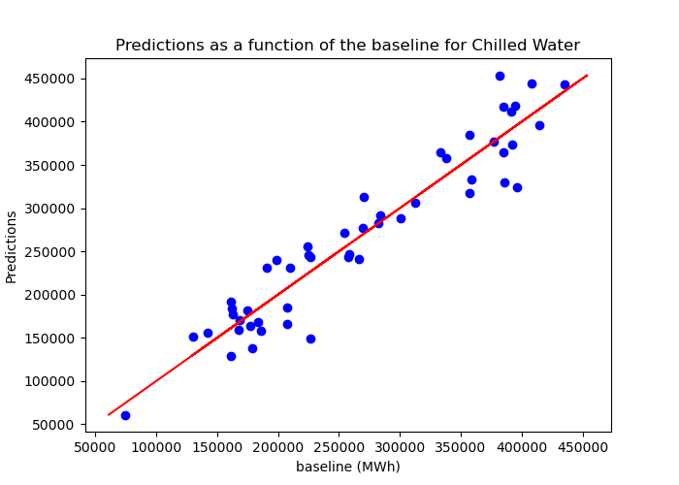

Figure : Predictions as a function of the baseline for Chilled Water

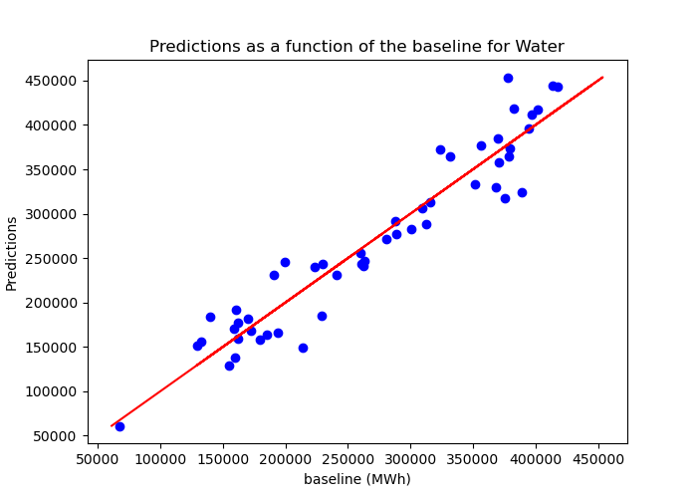

Figure : Predictions as a function of the baseline for Water

IPMVP defines the below statistical indicators associated with a valid regression model. Below are the results of the regression model for the selected variables.

Table : IPMVP criteria for Chilled Water

|  |  |  |  |
| --- | --- | --- | --- |
| Chilled Water | value | IPMVP Recommendations | IPMVP Adherence |
| R2 | 0.898 | > 0.75 | yes |
| CV RMSE | 0.118 | < 0.2 | yes |
| t-stat, intercept | 2.677 | ABS (t) > 2 | yes |
| t-stat, min_pres | -2.7 | ABS (t) > 2 | yes |
| t-stat, max_humratio | 5.654 | ABS (t) > 2 | yes |
| t-stat, std_humratio | -0.182 | ABS (t) > 2 | no |

Table : IPMVP criteria for Water

|  |  |  |  |
| --- | --- | --- | --- |
| Water | value | IPMVP Recommendations | IPMVP Adherence |
| R2 | 0.908 | > 0.75 | yes |
| CV RMSE | 0.113 | < 0.2 | yes |
| t-stat, intercept | 2.516 | ABS (t) > 2 | yes |
| t-stat, max_temp | 1.788 | ABS (t) > 2 | no |
| t-stat, min_pres | -2.646 | ABS (t) > 2 | yes |
| t-stat, std_ppwvap | 1.722 | ABS (t) > 2 | no |
| t-stat, min_enthma | 4.695 | ABS (t) > 2 | yes |

### Savings Uncertainty

The IPMVP defines acceptable accuracy of the expected savings as being twice the standard error of the baseline model. The regression model defines the baseline consumption based on the current variables. The standard error (SE) of the regression model is shown in the table below. The annual standard error is then the standard error for each of the number of samples summed in quadrature.

The resulting uncertainty of the savings estimate is:

Table 8 Savings and uncertainty

|  |  |  |  |  |  |
| --- | --- | --- | --- | --- | --- |
| Building | Utility | Standard Error (SE) | SETotal | Savings kWh/year | Uncertainty%  68% confidence |
| Test | Chilled Water | 189.7 | 1,341 | 200,000 | 0.671% |
| Test | Water | 182.5 | 1,303 | 200,000 | 0.652% |

This result demonstrates that the uncertainty in the savings is significantly less than twice the standard error and therefore meets the IPMVP criterion.

To determine the confidence interval at a 90% confidence level, the previous result is multiplied by the corresponding Z statistic (two tailed).

Table 9 Precision and confidence intervals at 90% confidence level

|  |  |  |  |
| --- | --- | --- | --- |
| Energy | Expected accuracy on the expected savings | Confidence interval on the savings (kWh) | Z statistic |

|  |  |  |  |  |  |  |
| --- | --- | --- | --- | --- | --- | --- |
|  | Utility | Relative Precision | Absolute Precision | Lower | Upper |  |
| Test | Chilled Water | 1.126 | 2,251 | 197,748 | 202,251 | 1.679 |
| Test | Water | 1.094 | 2,187 | 197,812 | 202,187 | 1.679 |

## Non-Routine Adjustments

Non-routine adjustments will be used when there are significant changes in the static factors listed below. The information in the table below was obtained from the operations team on site during the energy audit:

Table 10 Data on buildings

|  |  |
| --- | --- |
| Static factors | Source of Data |
| Built-up area (sqm) | 23,275 m2 |
| Construction area (sqm) | 4,961 m2 |
| Equipment inventory list | Refer to the Appendix 3.2 and the Technical Report for more details |
| Insulation | Based on the Level 1 Audit Report, there is no thermal insulation in the building. |
| Building utilization schedule* | 24 hrs/ day – 7 days/week |
| Hrs of operation of HVAC and lighting systems* | 24 hrs/ day – 7 days/week |
| Temperature set points* | The average measured space temperature varies between 22-24o C for most areas in the hospital. While for the critical areas like labs, sterilization rooms, etc. the setpoint is 10 to 13 o C |
| Occupancy rate** | N/A |
| Medical equipment* | Qty. of MRIs, X-ray units, ultrasound, EKG machines, spotlights, powered tables, patient monitors, etc. |
| No. of beds | 115 |

* Refer to the Technical Report for more details

** The occupancy data was not provided. It is important that this data is provided so it is documented

The non‐routine changes may change ECM utility savings and should be documented and adjusted such as space allocation changes, standard operating hours, conditioning of previously unconditioned spaces, purchase of new equipment and billing adjustments. In such case, a communication plan will be individually tailored according to the type and location of the changes that occurred and the impacted ECMs.

In case of additional loads, targeted metering if deemed viable will be done to quantify the added kW and kWh that will then be used in the non-routine adjustment.

In case of removing loads, a proper communication shall be done before its removal in order to undertake a targeted measurement which will quantify the kW/kWh to be removed from non-routine adjustment calculation.

In case of equipment upgrade, measurements will be done before and after the upgrade to quantify the difference in kW/kWh to be used in the non-routine adjustment calculation.

In any other case, proper communication shall be done, and the best engineering practices calculation used to calculate/quantify the changes of kW/kWh.

## Description of the Baseline Adjustment Methodology

Savings are defined as the avoided energy use, which can be calculated as the adjusted baseline less the current consumption. In this case, the adjusted baseline is calculated from a baseline model that correlates the energy use to local weather conditions.

# Performance Period and Reporting

## Performance Period Activities

Although the primary measurement & verification will be through the evaluation of the building level meters, ESCO will conduct the following on-site activities to verify and maintain performance:

* Conduct inspections to verify that all equipment, software, and control sequences are functional, up to date, and fully operational.
* Ensure that systems and sequences have not been bypassed or overridden.
* Verify that performance levels (e.g., lighting, temperature, ventilation, etc.) are within acceptable limits. The acceptable limits include the current standing building standards in the facilities as well as the accepted scope of the ECMs (temperature set-points etc.)
* Ensure that operations & maintenance activities are being conducted as per the manufacturer’s and ESCO’s recommendations.
* Confirm that no significant changes relating to defined static factors including any addition of electric load, change in operation, manual operation of equipment have occurred. If so, document what changes have occurred, when, and propose a non-routine baseline adjustment for review and acceptance*.*

## Reporting Period

The reporting period starts after the whole project implementation and commissioning period and after the date of substantial completion and is 60 months in duration. An annual performance report will be submitted on annual basis (after each 12-month period).

## Responsibilities

The table below summarizes the responsibilities of both parties on a regular basis to ensure the timely delivery of M&V reports.

Table 11 Responsibilities of each party

|  |  |  |
| --- | --- | --- |
| Party in Charge | Data | Frequency |
| ESCO | Electric Consumption (specific meter account numbers listed in the Baseline Period Energy) | Quarter Hourly (through Hubgrade) |
| Client | Provide the Utility Bills | Monthly |
| Client/ESCO | Changes in:   * Built-up area * Area utilization * Occupancy/Footfall (if applicable) * Operating schedules * Addition/removal of equipment * Changes in equipment schedules * Equipment addition/removal/shutdown in the building * Large Medical Equipment * No of beds | When changes occur |
|
|
|
|
|
|
|
| ESCO | On-site inspection of the facility | With scheduled maintenance tasks |
| ESCO | Cooling Degree Days – collected from degreedays.net | Recorded hourly, daily, weekly, and monthly |
| ESCO | M&V Report is shared 3 weeks after receiving the last electricity invoice and all required information and static factors to fully calculate non-routine adjustments | Annually |

## Format of M&V Report

M&V reports will be developed annually, presenting the results of the analysis, and descriptions of any adjustments applied to the baseline period. The report format will adhere to the IPMVP Core Concepts-2014, Section 8.0.

At a minimum, the report will include the following sections:

* Project background
* A brief description of the ECMs and the chosen Option
* Reporting period of the report
* A summary with the following:
  + Date/time of any recorded measurements
  + Data of energy consumption
  + Data for independent variables and static factors
  + Detailed description of:
    - any inspection activities
    - savings calculations and the followed methodology
    - data analysis and the followed methodology
    - list of any assumptions
    - any baseline adjustments
    - utility costs used in the calculations
  + Provide a clear presentation of the verified savings, cost savings, and comparison to the guaranteed proposed saving.

## Quality Assurance

The following procedure will be used to ensure the quality of the energy savings calculations and all other related activities in preparing the reports.

Only professionals with Certified Measurement and Verification Professional (CMVP) certification may calculate the savings and adjustments. Moreover, all savings calculations will be based on fundamental engineering principles and performed to the best of the knowledge of the professionals involved. Each calculation will be verified by another person who knows the project and has the required skills.

All savings calculations will be based on the energy and water data (electricity, etc.) from the copies of the bills from the meters.

Each calculation will be verified by the qualified person in charge of doing so.

Independent Variables: All meteorological data will come from the same source, more specifically, from the weather station located nearest to the project site, at Istanbul / Ataturk, TR (28.81E,40.98N).

Static factor: Information related to project static factor changes will be sent by the project’s internal supervisor (client) to be analyzed by the CMVP-accredited professional to determine the direct and indirect impacts on projected savings. This professional will then be able to make the necessary adjustments for the reference year to determine the real savings of the measures implemented.

# Appendix I

## Baseline Characteristics Graphs

Below are the baseline characteristics graphs for each utility and each variable.

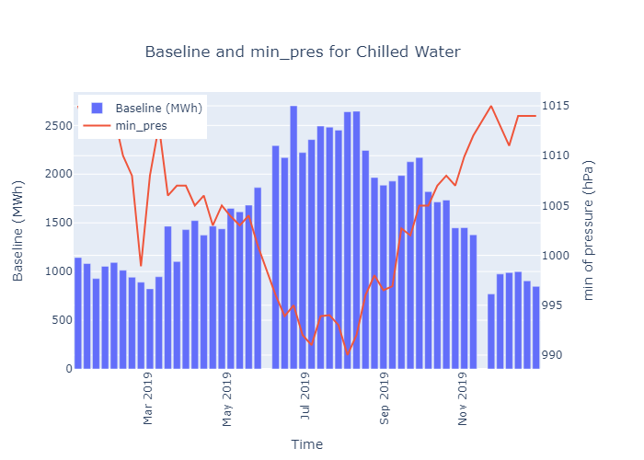

Figure : Baseline and min_pres for Chilled Water

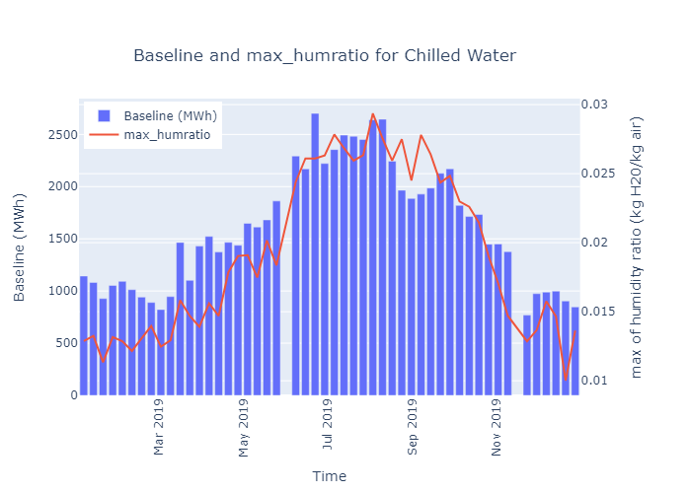

Figure : Baseline and max_humratio for Chilled Water

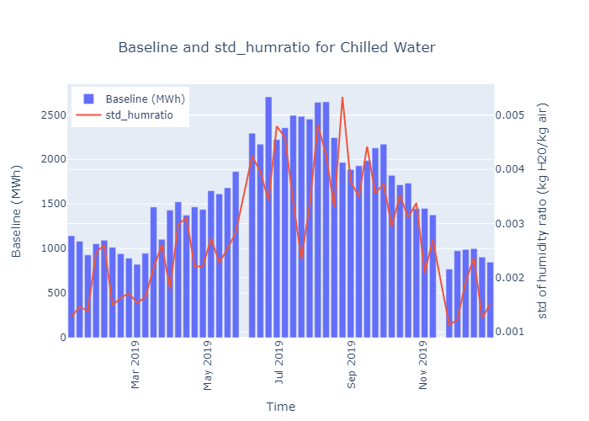

Figure : Baseline and std_humratio for Chilled Water

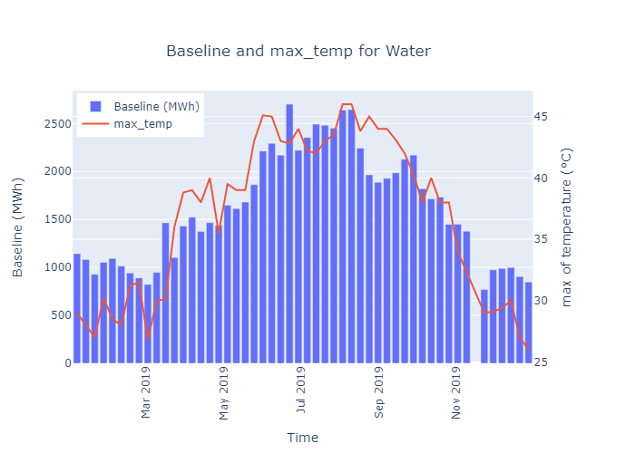

Figure : Baseline and max_temp for Water

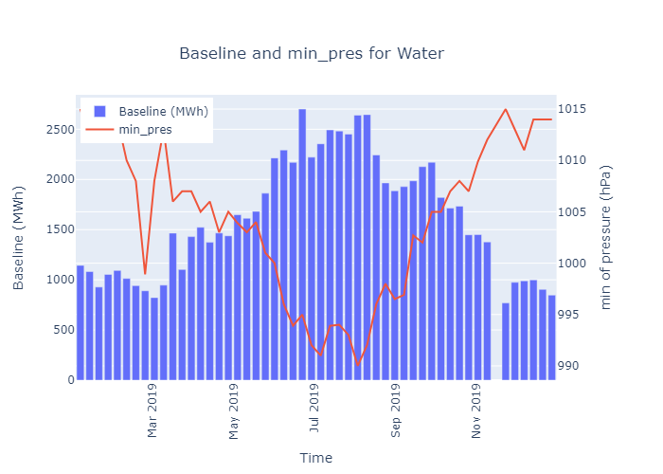

Figure : Baseline and min_pres for Water

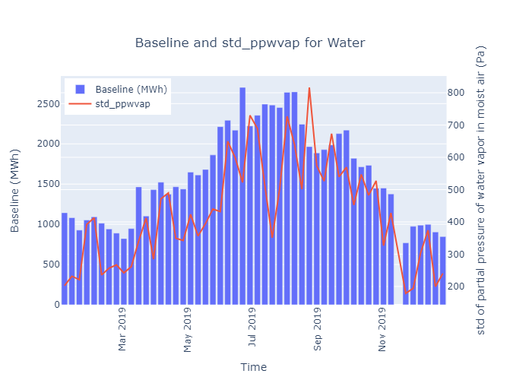

Figure : Baseline and std_ppwvap for Water

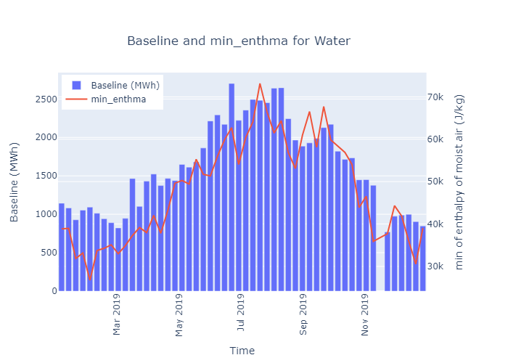

Figure : Baseline and min_enthma for Water

## Equipment Inventory List



Enova Facilities Management Services LLC

PO Box 22707Dubai, United Arab Emirates off. +971 (0)4203 8111 – fax: +971 (0)4203 8112

www.Enova-me.com

Accredited ESCO; ISO 9001, ISO 14001, ISO 50001, OHSAS 18001 Certified