Product Name |  | Product Image |  | Key Flavor Words |  | Flavor Strength |  | Target Users |  | Price (CNY) |  | Capacity (ml)
悦刻 RELX
Manyuan Yinyin |  | 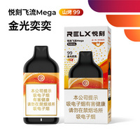 |  | Tobacco base note, cocoa milk aroma, nut & wine aroma |  | Moderate |  | Tobacco lovers, fans of compound milk/nut aroma |  | 139 |  | 9.6
Jinguang Yiyi |  | 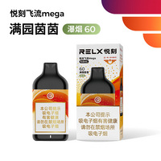 |  | Tobacco base note, pineapple fruit aroma, soft aftertaste |  | Moderate |  | Fans of fruity tobacco, users needing smooth aftertaste |  | 139 |  | 9.6
Feima Huanyou |  | 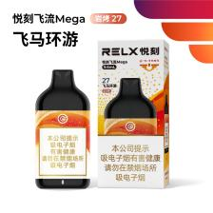 |  | Tobacco base note, woody agarwood, mild & warm aftertaste |  | Moderate |  | Chinese tobacco lovers, fans of calm & steady aroma |  | 139 |  | 9.6
Voopoo
Shanwu Qiu |  | 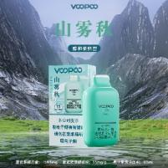 |  | Floral & fruity, elegant tobacco, mixed herbal |  | Moderate |  | Herbal aroma lovers, users needing throat hit |  | 129 |  | 9.6
铂岚 POOLAN
Jingting Shan |  | 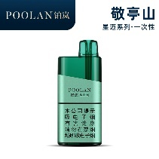 |  | Fresh tobacco aroma, dragon wood aroma, fine smoke |  | Light |  | Fresh tobacco lovers, fans of Chinese-style flavors |  | 139 |  | 10.5
Nian Guan Shan |  | 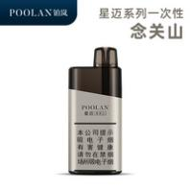 |  | Fresh champagne aroma, soft taste, clean aftertaste |  | Light |  | Light-taste users, beginners, champagne aroma lovers |  | 139 |  | 10.5
迷睿
Xia Mu |  | 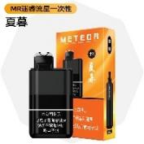 |  | Original tobacco aroma, fresh berry fruit, elegant tobacco rhyme |  | Light |  | Berry aroma lovers, users needing elegant tobacco taste |  | 129 |  | 10
Jin Lü |  | 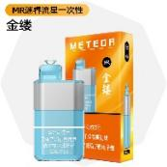 |  | Rose & jasmine, floral sweet aroma, tobacco aftertaste |  | Light |  | Floral aroma lovers, users needing light sweet tobacco |  | 129 |  | 10
Jian Shan |  | 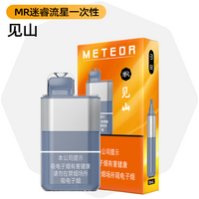 |  | Fresh natural aroma, soft taste, delicate layers |  | Light |  | Light-taste users, Chinese-style flavor lovers, fans of light mixed aroma |  | 129 |  | 10
Bai An |  | 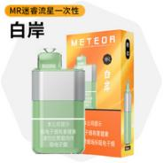 |  | Citrus sweet aroma, roasted oolong, fresh cooling, herbal aftertaste |  | Light |  | Cooling aroma lovers, beginners, citrus fruit tea lovers |  | 129 |  | 10
美深威
Jiang Kao 53 |  | 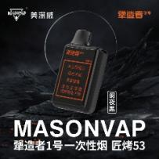 |  | Original tobacco aroma, caramel coffee, large vapor, smooth |  | Moderate to strong |  | Caramel coffee lovers, large vapor users, experienced smokers |  | 109 |  | 9.3
Craftsman No.5-01  New |  | 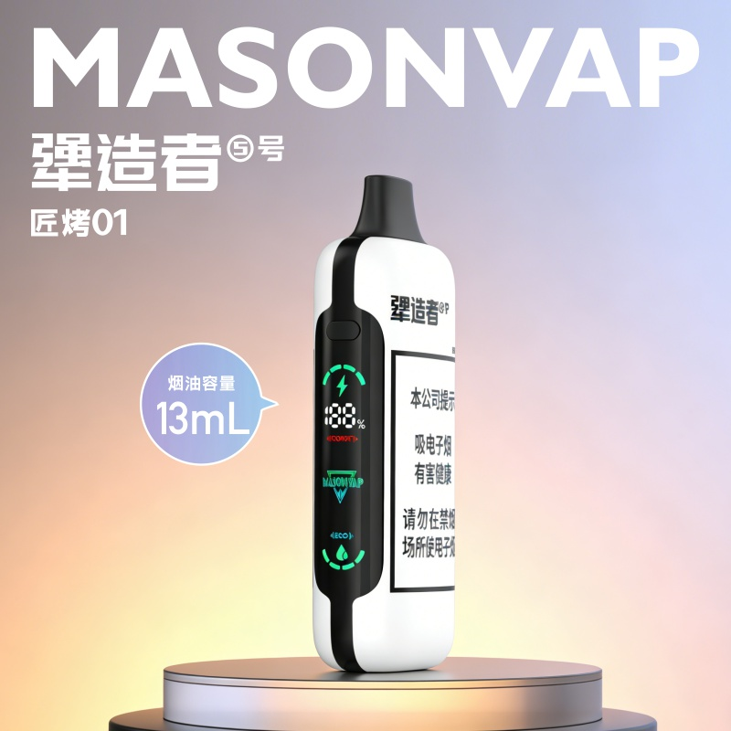 |  | Fresh & mellow sweetness, sweet bean aroma, nutty coffee, baked cake aftertaste |  | Light |  | Users who prefer fresh floral & bean notes, rich layered aftertaste, and mild non-irritating experience |  | 149 |  | 13
Craftsman No.5-02  New |  | 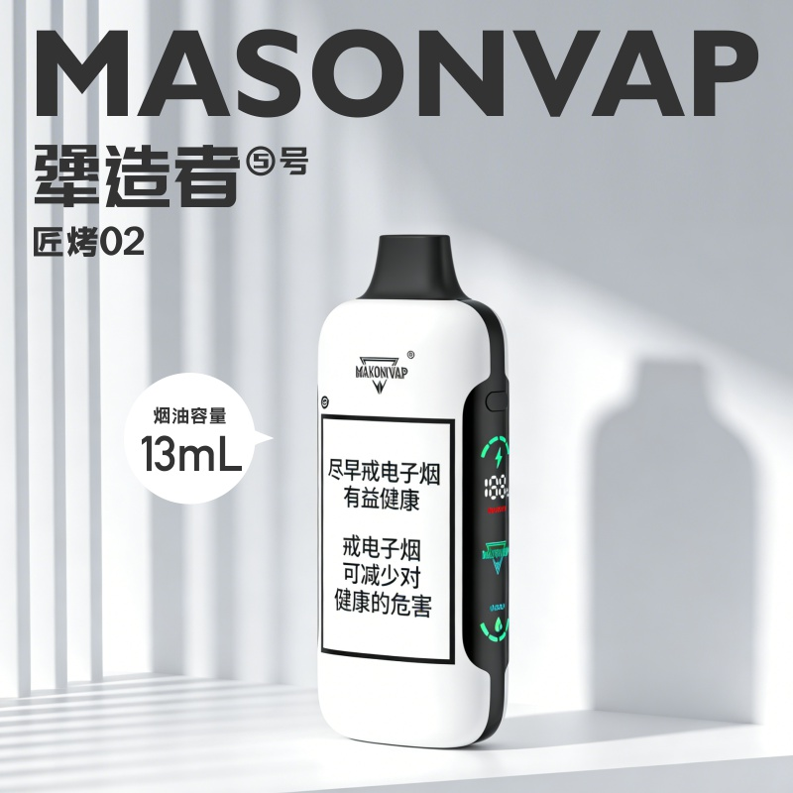 |  | Rich tobacco sweetness, subtle astringent aftertaste, light coffee & cocoa, raw chocolate finish |  | Moderate |  | Users who favor rich tobacco sweetness, subtle astringent aftertaste, cocoa & coffee hints, and full-bodied sweet taste |  | 149 |  | 13
HQD
Frost Moon | 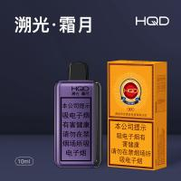 |  | Blueberry fruit aroma, mixed roasted tobacco scent, mild & smooth aftertaste |  | Moderate |  | For enthusiasts of blueberry fruit-flavored roasted tobacco, those seeking steady taste and experienced vapers |  | 129 |  | 10

