Product Name | Product Image | Key Flavor Words | Flavor Strength | Target Users | Price (CNY) | Per Pod Capacity (ml)
Phantom Pro Series (Works with Pro Device, 3-level adjustment)
Lantian Nuan Yang | 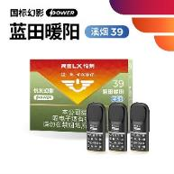 | Elegant tobacco aroma | Light | Elegant tobacco rhyme lovers | 129 | 1.9
Senlin Fuxing | 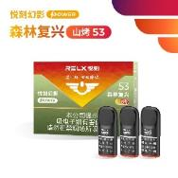 | Herbal & plant aroma | Moderate | Moderate tobacco rhyme / balanced taste users | 129 | 1.9
Chuanjia Bao Zang |  | Clear tobacco aroma | Light | Elegant tobacco rhyme lovers | 129 | 1.9
Hongyun Gun Gun | 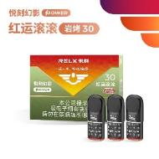 | Caramel sweet licorice aroma | Moderate to strong | Caramel tobacco lovers | 129 | 1.9
Sunrise Over the Sea (New Arrival) |  | Refreshing sea salt tobacco with a light sweet finish | Light | Lovers of light sweet tobacco; fans of the "Stream Smoke" line | 129 | 1.9
Phantom Infinity Series (Rich flavors for you)
Jinfeng Xixi (New) |  | Rock sugar chrysanthemum tea | Light | Tea taste / light taste lovers | 119 | 1.9
Lü Shan Ying Ying |  | Light bean tobacco aroma | Moderate | Foreign cigarette flavor lovers | 119 | 1.9
Lanting Zhu Xue | 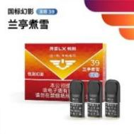 | Licorice sweet tobacco aroma | Light | Elegant tobacco rhyme / light sweet lovers | 119 | 1.9
Zhu Zhang Sheng Ma |  | Herbal flower tea tobacco | Light | Moderate tobacco rhyme / balanced taste users | 119 | 1.9
Rao Zhi Qing Wu |  | Elegant tobacco aroma | Light | Elegant tobacco rhyme lovers | 119 | 1.9
Haohai Chao Sheng | 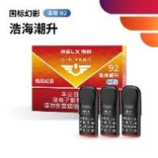 | Fresh sweet tobacco aroma | Light | Elegant tobacco rhyme / fresh sweet lovers | 119 | 1.9
Liu An Hua Ming |  | Red date honey tobacco | Moderate | Moderate tobacco rhyme / balanced taste users | 119 | 1.9
Qun Yu Shan Jian | 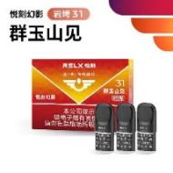 | Caramel sweet wood licorice aroma | Moderate to strong | Experienced caramel tobacco lovers | 119 | 1.9
Qingyu Series (Best value)
Wang Jiang You Jing |  | Herbal longan sweet aroma | Moderate | Moderate tobacco rhyme / balanced taste users | 99 | 1.9
Xuri Lingyun |  | Fresh melon sweet aroma | Light | Chinese-style light tobacco / fresh taste lovers | 99 | 1.9
Senlin Fuxing |  | Moss bean sweet tobacco | Moderate | Full smoke / strong hit users | 99 | 1.9
Dian Dian Ling Xi |  | Light tobacco aroma | Light | Elegant tobacco rhyme lovers | 99 | 1.9
Chen Guang Ru Lin | 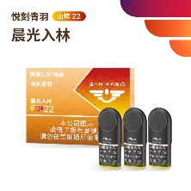 | Wine tobacco aroma | Moderate | Moderate tobacco rhyme / balanced taste users | 99 | 1.9
Jia Ren Jia Qi | 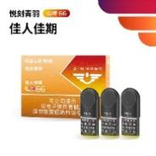 | Light sweet herbal tobacco | Light | Moderate tobacco rhyme / light sweet lovers | 99 | 1.9
Nuan Xi Chuan Lin (Top Rated) |  | Herbal fruit sweet aftertaste | Moderate | Mixed aroma / moderate tobacco rhyme users | 99 | 1.9
Rou Qing Niu Zai | 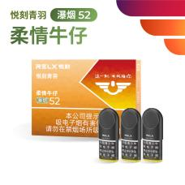 | Exotic tobacco aroma | Moderate | Foreign cigarette flavor lovers | 99 | 1.9
Zeus Series (Premium, strong)
Lü Shan Ying Ying | 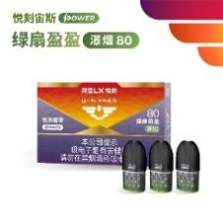 | Light bean tobacco aroma | Moderate | Foreign cigarette flavor / premium users | 169 | 2.85
Fu Liu Feng | 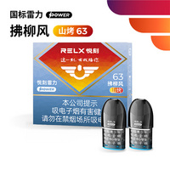 | Chinese tobacco, elegant woody, light sweet | Moderate | Chinese tobacco lovers, fans of soft herbal aroma | 99 | 3
Guang Sha Jian | 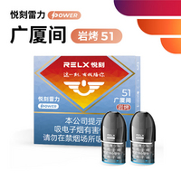 | Mellow tobacco, rich layers, fine smoke | Moderate | Experienced tobacco users, users pursuing strong satisfaction | 99 | 3
Daqian Series (Large capacity, best value)
Chun Ming | 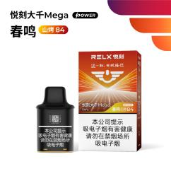 | Cooling soft tobacco | Light | Beginners / light substitution users | 129 | 10
Bai Fen | 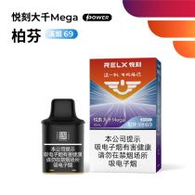 | Cream plum aroma | Light | Chinese-style light tobacco / fresh taste lovers | 129 | 10
Zhi Xia | 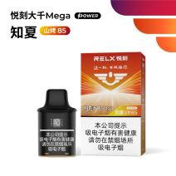 | Mellow cigar, citrus floral note | Light | Summer fresh taste lovers | 129 | 10
Gentle Mist | 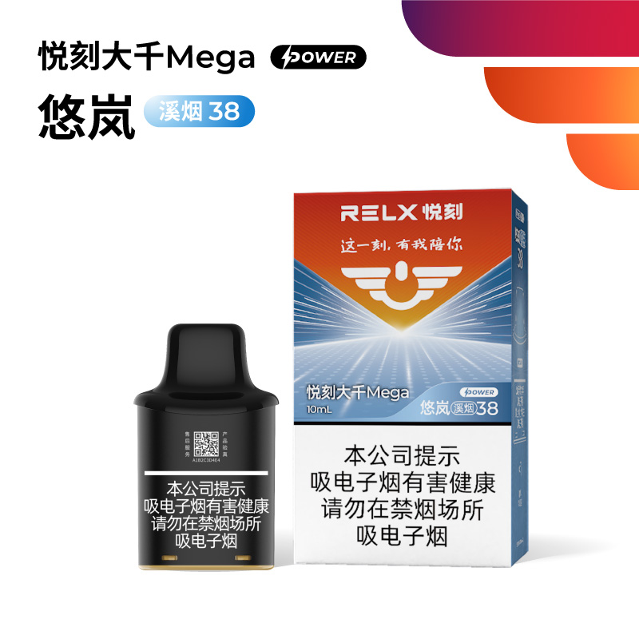 | Elegant hay sweetness with a smooth, lingering finish | Light | Fans of light Chinese tobacco; daily long-term users | 129 | 10
Ganze | 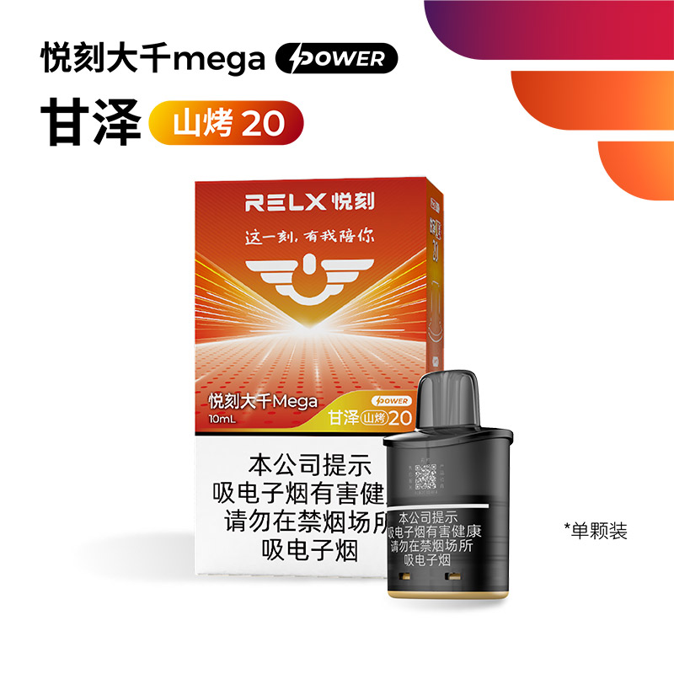 | Aniseed-sweet top note, rich woody heart, warm toasted tobacco finish | Medium-strong | Traditional smokers, adult users, those who prefer rich woody tones | 129 | 10
Sui He | 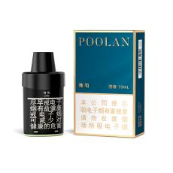 | Honey lychee tea | Light | Fruit tea / fresh floral lovers | 109 | 10
Tai Xiao | 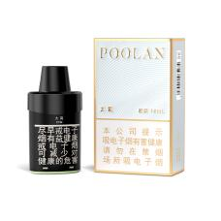 | Fresh oolong | Light | Tea / oolong lovers | 109 | 10
Selected Compatible (For RELX Device)
Cui Chuan Cang | 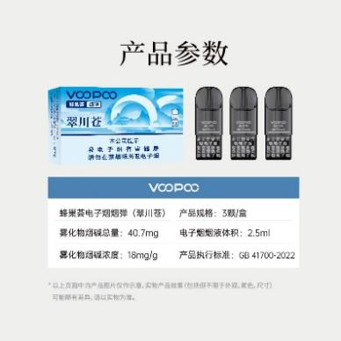 | Elegant fruity sweet tobacco | Light | Sweet / fruity tobacco lovers | 99 | 2.5
Yun Ling Song Feng | 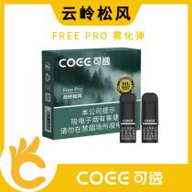 | Pine needle herbal, elegant tobacco base, clean aftertaste | Moderate | Chinese-style flavor lovers, light substitution users, beginners | 99 | 3
Bi Hai Cheng Kong | 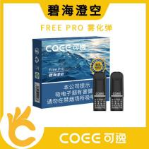 | Sea salt fresh cooling, light fruit, smooth taste | Light | Cooling aroma lovers, beginners, summer fresh users | 99 | 3
Jin Si Lu (3pcs) | 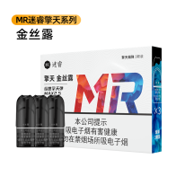 | Caramel tobacco | Moderate | Chinese tobacco lovers | 119 | 2.5
Cold Moon  （3pcs） | 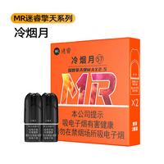 | Herbal fresh aroma | Moderate | For lovers of traditional Chinese tobacco flavor | 119 | 2.5
Lanting Ya Ji | 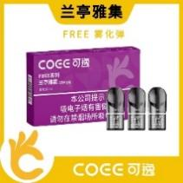 | Honey violet aroma | Light | Beginners / light aroma lovers | 99 | 1.9

