Phantom (5th Gen)
Price: 328 CNY
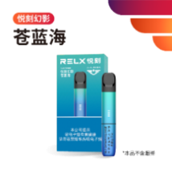  蓝绿渐变 | 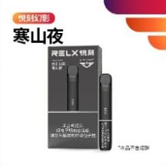  墨黑色 |   嫩绿色 | 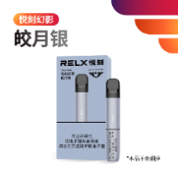  银色 | 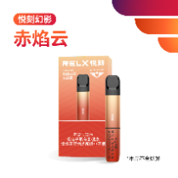  红色 | 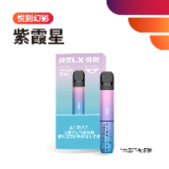  蓝紫渐变（爆款）
Features:
- Soft & delicate taste
- 380mAh battery
- Support fast charging
- fully charged in ~45 mins

Phantom Pro (6th Gen)
Price: 428 CNY
Features:
- 440mAh battery
- Fast charging in 25 mins
- 3-level adjustable power
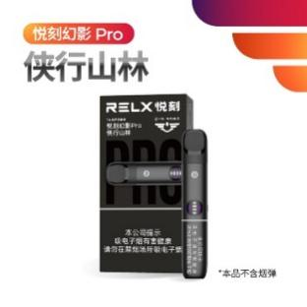  黑色 | 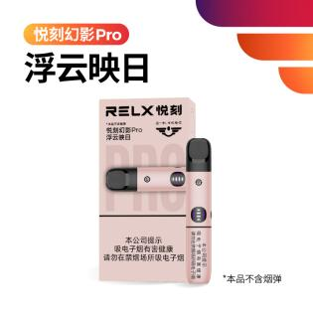  粉色 | 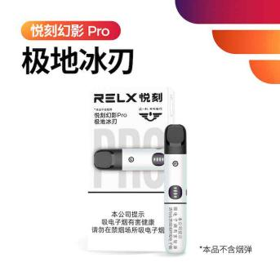  白色 | 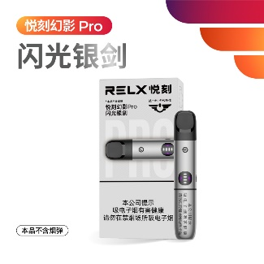  银色（镜面银色）

POOLAN Yuying S (RELX 6th Gen Alternative)
Price: 368 CNY
- Real-time battery display
- level power adjustment
- Precise puff count
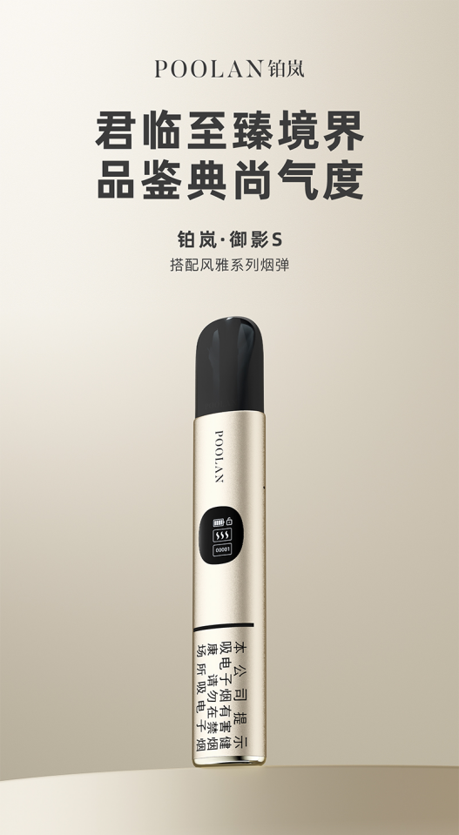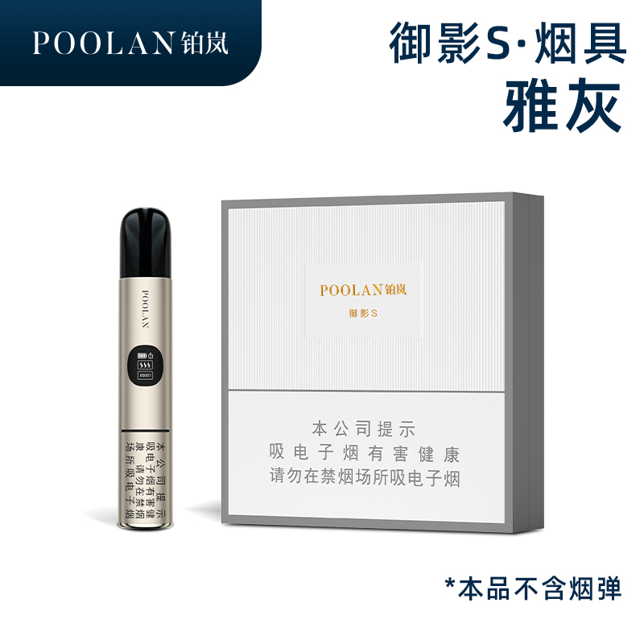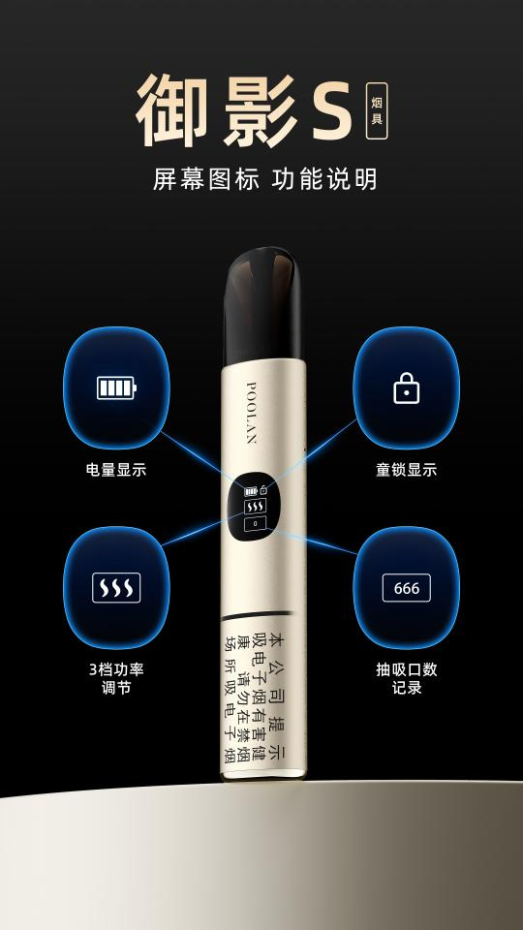

Zeus  Price: 888 CNY  (Works with non-Zeus pods via adapter) | Daqian  Price: 258 CNY  (Works with non-Daqian pods via adapter)
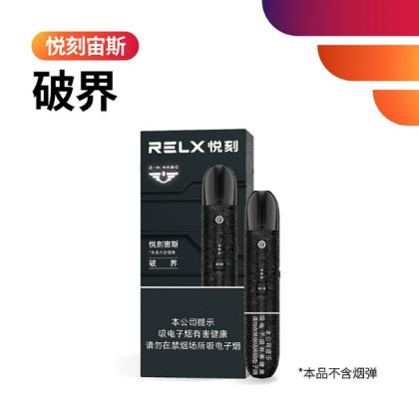 | 
Features:  - Mechanical adjustable power & air resistance;  - 800mAh large battery;  - support fast charging; 80% charged in 25 mins | Features:  - 800mAh large battery;  - strong power;  - fine vapor

Qingyu
Price: 218 CNY
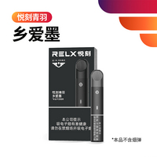  黑色 | 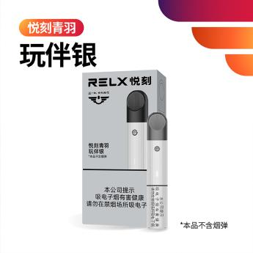  00*银色
Features:
- Entry choice
- Type-C charging
- 350mAh battery
- fully charged in ~50 mins

