**GDD**

Title:

Live From Atlia – the Game About Political Debate

Overview of Game Concept:

A digital card game based around a political campaign.

Theme:

Wacky, over the top science fiction with some dry humour sprinkled in.

Research

In preparation we looked at other card games like Magic the Gathering which helped inform some of the mechanical changes we made to our own game, we also looked at games like Hearthstone in order to inform us how to implement a card game digitally. We also looked at other games such Nova Cry and Might and Magic: Duel of Champions however nothing we saw was at all similar to the game we were going to make. As a result we think ours would be a success due to bringing something new and interesting to an already established genre.

Genre

2D card game

Market:

Out market would be people who have been playing card games for a while that are looking for something new in the genre. Also people who are fans of games of strategy but dislike having to constantly pay for new cards in order to stay competitive.

Narrative:

The narrative of the game is based around two aliens attempting to become president of the galaxy, and all the chicanery that inevitably ensures.

Graphics

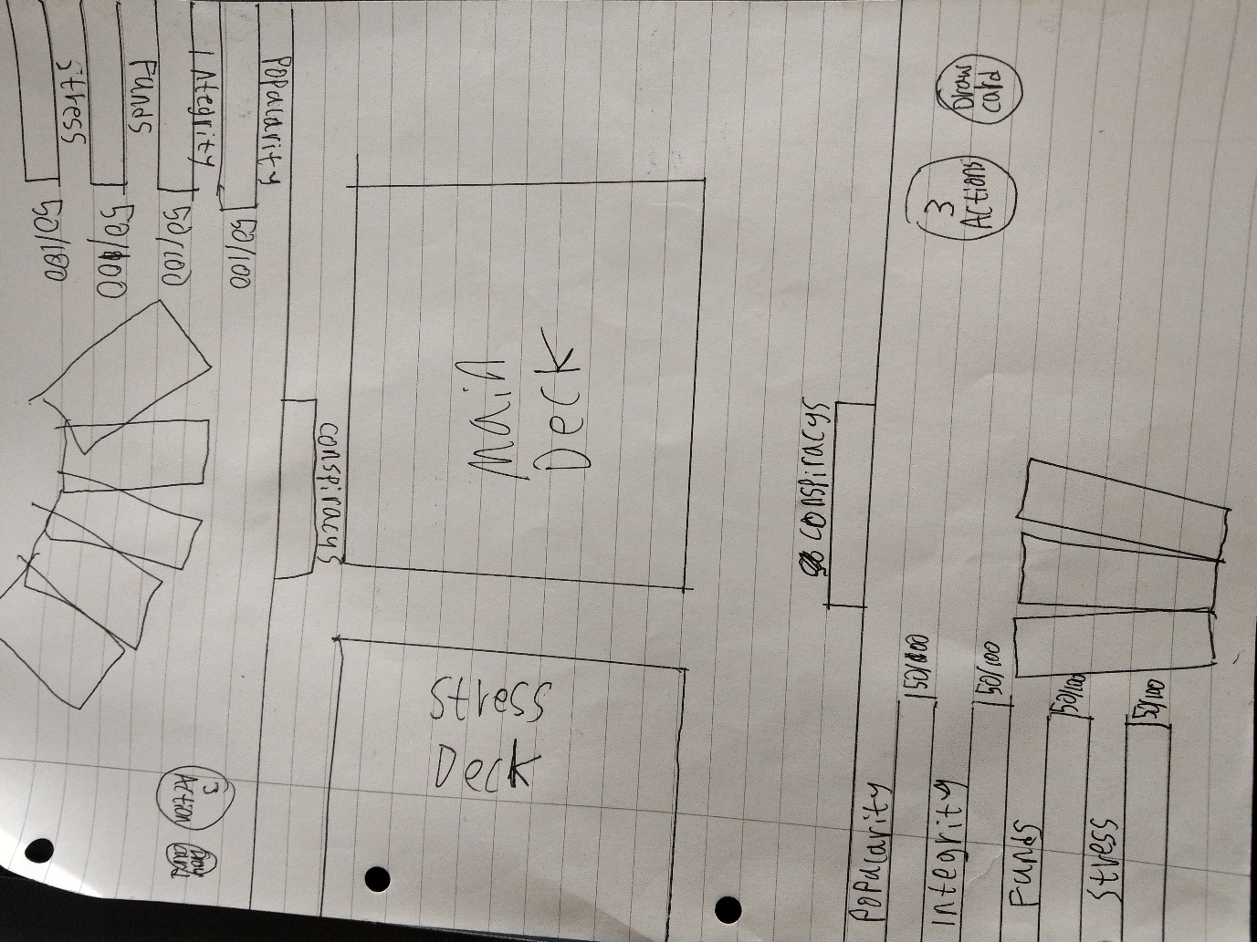

(UI prototype)