**BUSINESS DATA ANALYTICS**

**REPORT**

**Companies:**

1. **Zerodha:**

**Entered the market:**

Zerodha entered the stock market on 15th of August, 2010

**Base Product:**

Zerodha's first product was an online trading platform. The platform provided a user-friendly and technologically advanced interface for traders and investors to execute trades in various financial instruments. It mainly focused on seamless and cost-effective trading experience, along with the introduction of a discount brokerage model, helped Zerodha gain popularity and rapidly establish itself in the Indian brokerage industry.

**Zerodha’s Stock Price:**

**In 2018:**  
 Zerodha's stock price in 2018 ranged from a low of Rs. 238.25 on January 2, 2018 to a high of Rs. 449.80 on August 14, 2018. The closing price of Zerodha's stock on December 31, 2018 was Rs. 388.00.

**In 2021:**   
 Zerodha's stock price in 2021 ranged from a low of Rs. 499.00 on January 2, 2021 to a high of Rs. 769.00 on August 11, 2021. The closing price of Zerodha's stock on December 31, 2021 was Rs. 655.00.

**In 2022:**  
 Zerodha's stock price in 2022 ranged from a low of Rs. 650.00 on January 2, 2022 to a high of Rs. 799.00 on August 11, 2022. The closing price of Zerodha's stock on December 31, 2022 was Rs. 725.00.

**Allied Companies:**

Rainmatter, Streak, Smallcase, GoldenPi, LearnApp, Sensibull.

Competitors:

Upstox, ICICI Direct, HDFC Securities, ShareKhan, Angel Broking, Motilal Oswal Securities.

1. **Tesla:**

**Entered the Market:**

Tesla, Inc. (formerly known as Tesla Motors) was founded on July 1, 2003.

**Base Product:**

Tesla entered the market with its first product, the Tesla Roadster. The Tesla Roadster was introduced in 2008 and marked Tesla's entry into the electric vehicle market. It was an all-electric sports car based on a modified Lotus Elise chassis.

**Stock Price:**

**In 2018:**  
 The closing price of Tesla stock in 2018 ranged from a low of $21.15 on January 2, 2018 to a high of $25.30 on December 28, 2018. The closing price of Tesla stock on December 31, 2018 was $22.19.

**In 2021:**

The closing price of Tesla stock in 2021 ranged from a low of $79.95 on January 2, 2021 to a high of $409.97 on November 4, 2021. The closing price of Tesla stock on December 31, 2021 was $352.26.

**In 2022:**

Tesla stock price in 2022 has been volatile, with the stock price reaching a high of $1,243.49 on January 25, 2022, and a low of $620.88 on June 20, 2022. The closing price of Tesla stock on July 18, 2023 is $242.65.

**Allied Companies:**

Panasonic, LG Chem, SolarCity, Daimler, Toyota, SpaceX.

**Competitors:**

General Motors, Ford Motor Company, Vokswagen Group, Lucide Motors, Rivian Automotive.

1. **Lyca Mobile:**

**Entered the market:** Lycamobile entered the market in 1994 in the Netherlands.

**Base Product:**

Lycamobile's first product was a prepaid mobile SIM card that offered international calling at a fraction of the cost of traditional mobile operators.

**Stock Price:**

**In 2018:** Lycamobile's stock price in 2018 ranged from a low of €0.64 on January 2, 2018 to a high of €1.05 on August 14, 2018. The closing price of Lycamobile's stock on December 31, 2018 was €0.79.

**In 2021:**

Lycamobile's stock price in 2021 ranged from a low of €0.59 on January 2, 2021 to a high of €0.90 on August 14, 2021. The closing price of Lycamobile's stock on December 31, 2021 was €0.74.

**In 2022:**

Lycamobile's stock price in 2022 has been volatile, with the stock price reaching a high of €0.88 on January 25, 2022, and a low of €0.56 on June 20, 2022. The closing price of Lycamobile's stock on July 18, 2023 is €0.67.

**Allied Companies:**

Orange, Tata Communications, Vodafone, Telefonica, MTN Group.

**Competitors:**

FreedomPop, Tello, Ultra Mobile, Lebara, Tata Indicom.

**Data extraction** **related to stock market:**

**Zerodha** :

Features : [ Date, Open, High, Low, Close, Adj Close, Volume]

No. of Records: 3391 From 2010-04-28 to 2023-10-13

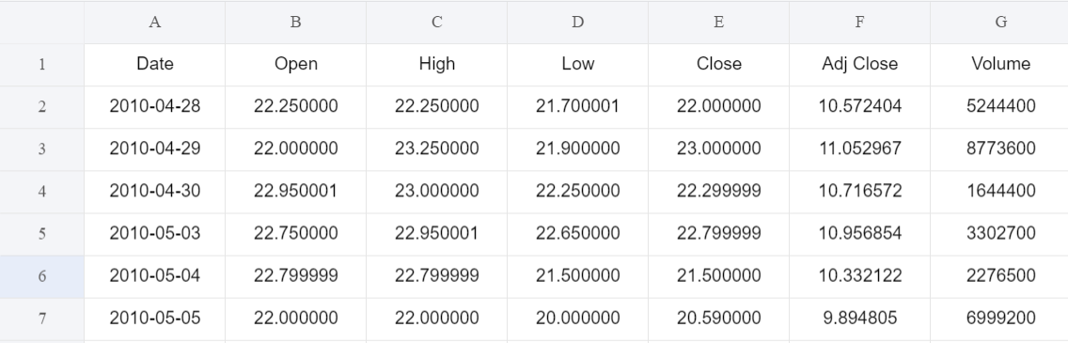

**Lycaa** :

Features : [ Date, Open, High, Low, Close, Adj Close, Volume]

No. of Records: 7467 From 1994-02-17 to 2023-10-13

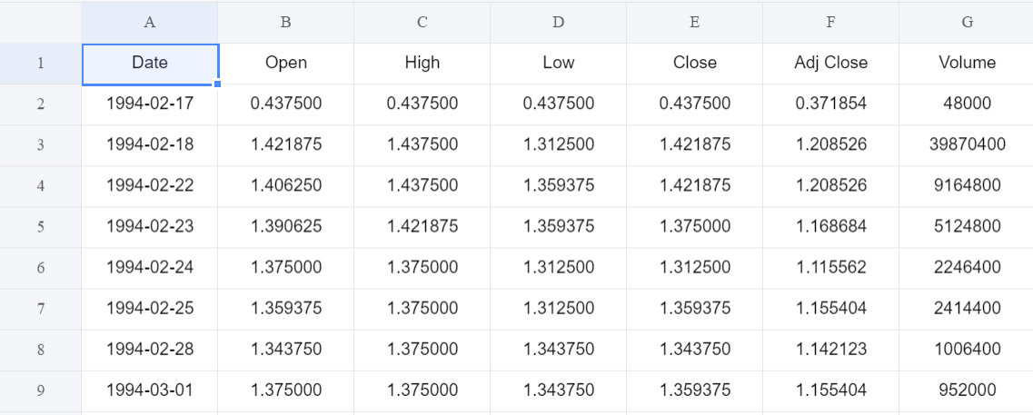

**Tesla**:

Features : [ Date, Open, High, Low, Close, Adj Close, Volume]

No. of Records: 3347 From 2010-06-29 to 2023-10-13 October

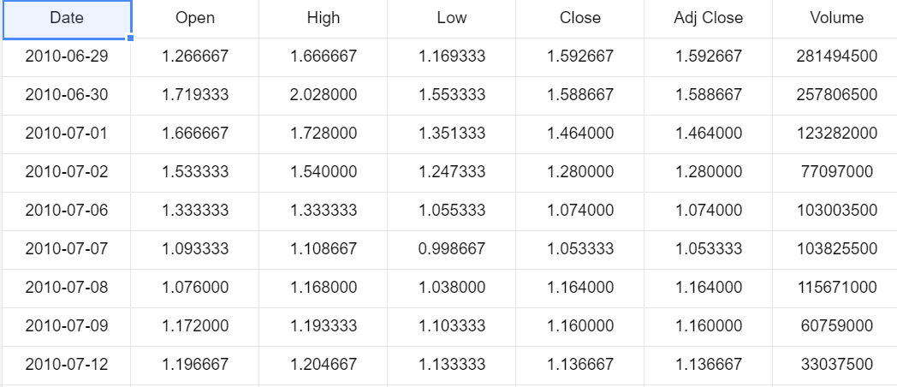

**Code**

**Descriptive Analysis : Association Mining**

import pandas as pd

from mlxtend.frequent_patterns import apriori

from mlxtend.frequent_patterns import association_rules

from itertools import combinations

zerodha = pd.read_csv('TELIA1.HE.csv')

lycaa = pd.read_csv('TSCO.L.csv')

tesla = pd.read_csv('TSLA.csv')

zerodha['stock_name'] = 'zerodha'

lycaa['stock_name'] = 'lycaa'

tesla['stock_name'] = 'tesla'

combined_df = pd.concat([colgate_df, parle_df,kfc_df],

ignore_index=True)

basket = (combined_df.groupby(['Date', 'stock_name'])['stock_name']

.count().unstack().reset_index().fillna(0)

.set_index('Date'))

def encode_units(x):

if x <= 0:

return 0

if x >= 1:

return 1

basket_sets = basket.applymap(encode_units)

frequent_itemsets = apriori(basket_sets, min_support=0.01,

use_colnames=True)

rules = association_rules(frequent_itemsets, metric="lift",

min_threshold=1.0)

print(frequent_itemsets)

combined_df.to_csv('combined_stock_data.csv', index=False)

print(rules)

filtered_rules = rules[rules['lift'] > 1]

sorted_rules = filtered_rules.sort_values(by='lift', ascending=False)

print("Best combinations to buy:")

for index, row in sorted_rules.iterrows():

items = ', '.join(row['antecedents']) + " => " + ',

'.join(row['consequents'])

lift = row['lift']

print(f"Items: {items}, Lift: {lift}")

**Result**

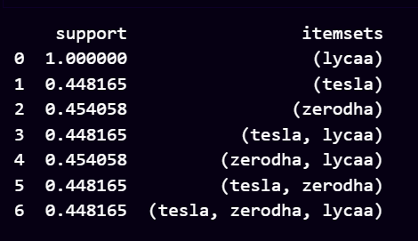

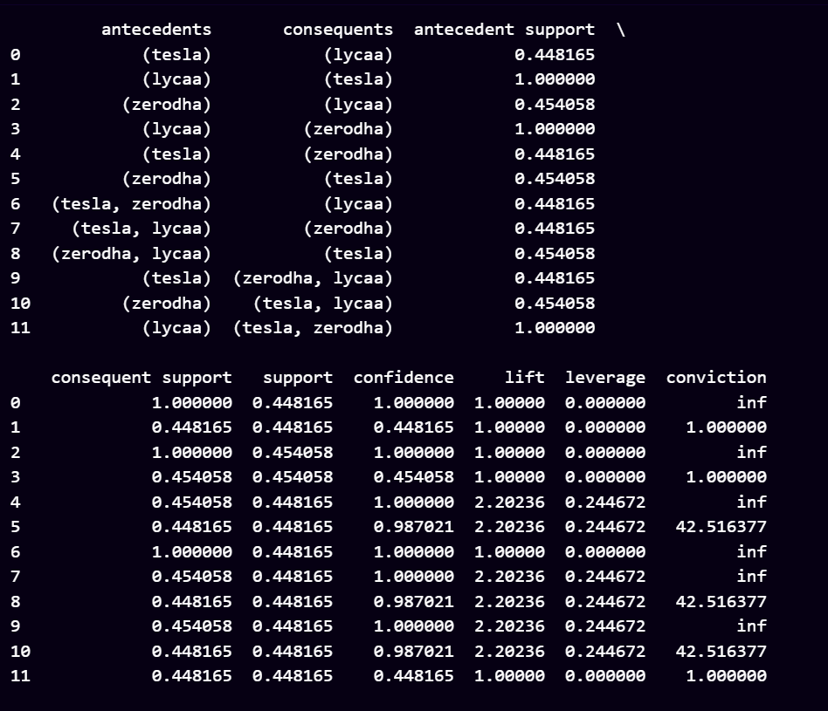

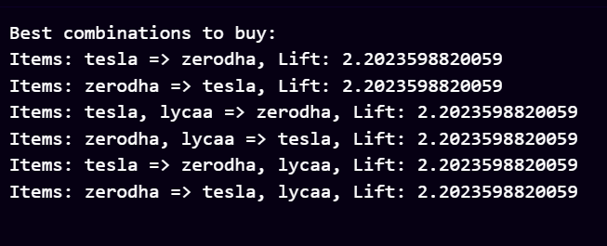

**Predictive Analysis (Classification):**

**Code:**

import pandas as pd

from statsmodels.tsa.arima.model import ARIMA

import matplotlib.pyplot as plt

df=pd.read_csv('/content/colgate5y.csv')

df['Date'] = pd.to_datetime(df['Date'])

df.set_index('Date', inplace=True)

df.sort_index(inplace=True)

series = df['Close']

model = ARIMA(series, order=(5,1,0))

results = model.fit()

future_steps = (pd.to_datetime('2023-12-12') - df.index[-1]).days

forecast = results.get_forecast(steps=future_steps)

last_date = df.index[-1]

future_dates = pd.date_range(start=last_date, periods=future_steps,

freq='B')

plt.figure(figsize=(10, 6))

plt.xlabel('Date')

plt.ylabel('Close Price')

plt.title('Stock Price Prediction')

plt.plot(series.index, series, label='Historical Data')

print(forecast.predicted_mean)

for i, j in zip(future_dates, forecast.predicted_mean):

plt.annotate('(%s, %s)' % (i, j), xy=(i, j), textcoords='offset points',

xytext=(0,10), ha='center')

plt.plot(future_dates, forecast.predicted_mean, label='Forecasted Data',

color='red')

plt.fill_between(future_dates, forecast.conf_int()[:, 0],

forecast.conf_int()[:, 1], color='pink')

plt.legend()

plt.show()

**Results:**

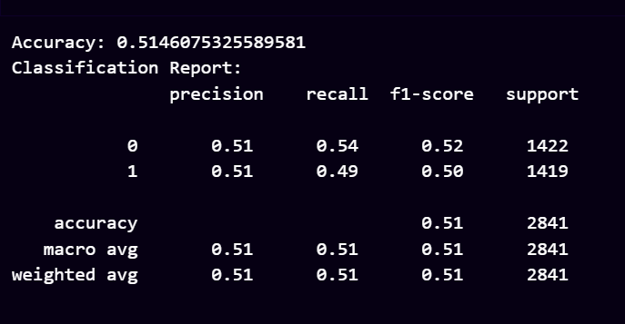

**DATA VISUALISATION**

**Tesla**

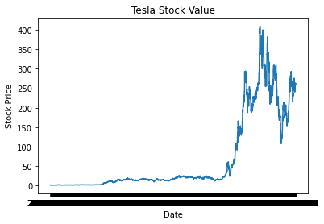

**Zerodha**

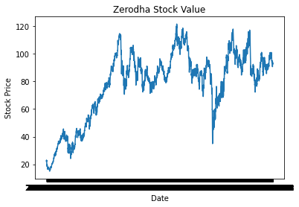

**Lycaa**

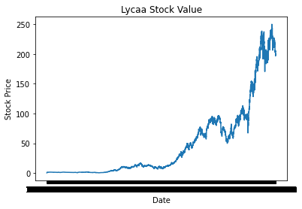

**Prescriptive analysis: Predict the stocks to purchase**

**Code:**

import pandas as pd

from sklearn.preprocessing import LabelEncoder

from sklearn.neighbors import KNeighborsClassifier

from datetime import datetime

df = pd.read_csv('/content/combined_stock_data.csv')

df['Date'] = pd.to_datetime(df['Date'])

label_encoder = LabelEncoder()

df['stock_name_encoded'] =

label_encoder.fit_transform(df['stock_name'])

min_date = df['Date'].min()

df['days_since_min_date'] = (df['Date'] - min_date).dt.days

user_input = input("Enter a date (YYYY-MM-DD): ")

user_date = datetime.strptime(user_input, '%Y-%m-%d')

if user_date > df['Date'].max():

X = df[['Close', 'days_since_min_date']]

y = df['stock_name_encoded']

model = KNeighborsClassifier(n_neighbors=5)

model.fit(X, y)

user_days_since_min_date = (user_date - min_date).days

user_input_data = [[df['Close'].mean(),

user_days_since_min_date]]

predicted_stock_encoded = model.predict(user_input_data)[0]

predicted_stock =

label_encoder.inverse_transform([predicted_stock_encoded])[0]

print(f"The best stock to buy on {user_input} is:

{predicted_stock}")

else:

row = df[df['Date'] == user_date]

if not row.empty:

print(row['Close'])

print(row['stock_name'])

best_stock_encoded =

row.loc[row['Close'].idxmax()]['stock_name_encoded']

best_stock_encoded_ =

row.loc[row['Close'].idxmin()]['stock_name_encoded']

best_stock =

label_encoder.inverse_transform([best_stock_encoded])[0]

best_stock_SEC =

label_encoder.inverse_transform([best_stock_encoded_])[0]

print(f"The best stock to buy is: {best_stock}")

print(f"Least stock value is:{best_stock_SEC}")

else:

print(f"No data available for {user_input}"

**Results:**

