Magneto-Chiral Dichroism

User Manual

2024
LNCMI – CNRS
Instrumentation Team
Summary
Prerequisites and Recommendations 3
Python environments 3
Getting the software code 3
Git GUI Client Setup 3
Git Terminal 4
GUI appearance and usage 5

Prerequisites and Recommendations
For the MchD Python project there is some versioning that needs to be respected due to the dependencies of the used instruments.
Software | Recommended version
Python | 3.8.10 (32bit)
NiDaqMx | 20.1
PyCharm | 2018.3.7
Windows OS | Windows 10 (32 bit)

Please be sure that those versions are respected to be able to install WinSpec and BWTEK with the goal to use Princeton Instruments spectrometers and the GlacierX aswell.

Python environments
No Anaconda version is listed in the previous section because the compatible Anaconda with on Windows 10 (32bit) installs python 3.7 which is not compatible with the software dependencies.
Thus, the conda environment management won't be applied.

Getting the software code
The software code is stored in a server accessible by https://github.com/. You will need an account (and permissions) in order to edit the MChD repository containing the source code.
You will be able clone the repository with an anonymous account, whether by a handy Git GUI Client as GitHub Desktop or by a git terminal.
Note that you may also need to install Git.

Git GUI Client Setup
Download your preferred Git GUI Client (this guide will focus on GitHub Desktop) and set it up. Then chose to clone a repository and the local destination as shown in the following images :

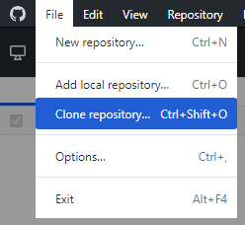
Choose the URL option and then complete the form with the URL that can be found on the server https://github.com/Bruyant/MChD-python.git and your local repository storage. Typically it will look like :
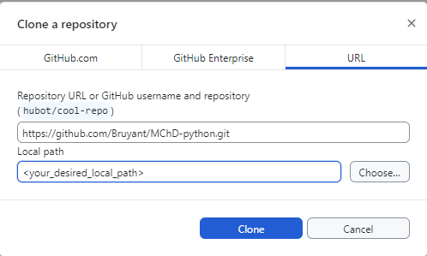

Git Terminal
If you are more familiarized with a developer environment and a terminal, after configuring your Git, just launch the following command:
git clone https://github.com/Bruyant/MChD-python.git

Note that if you have a preference to store the repository somewhere, use the -C command option to give the specific folder.

GUI appearance and usage
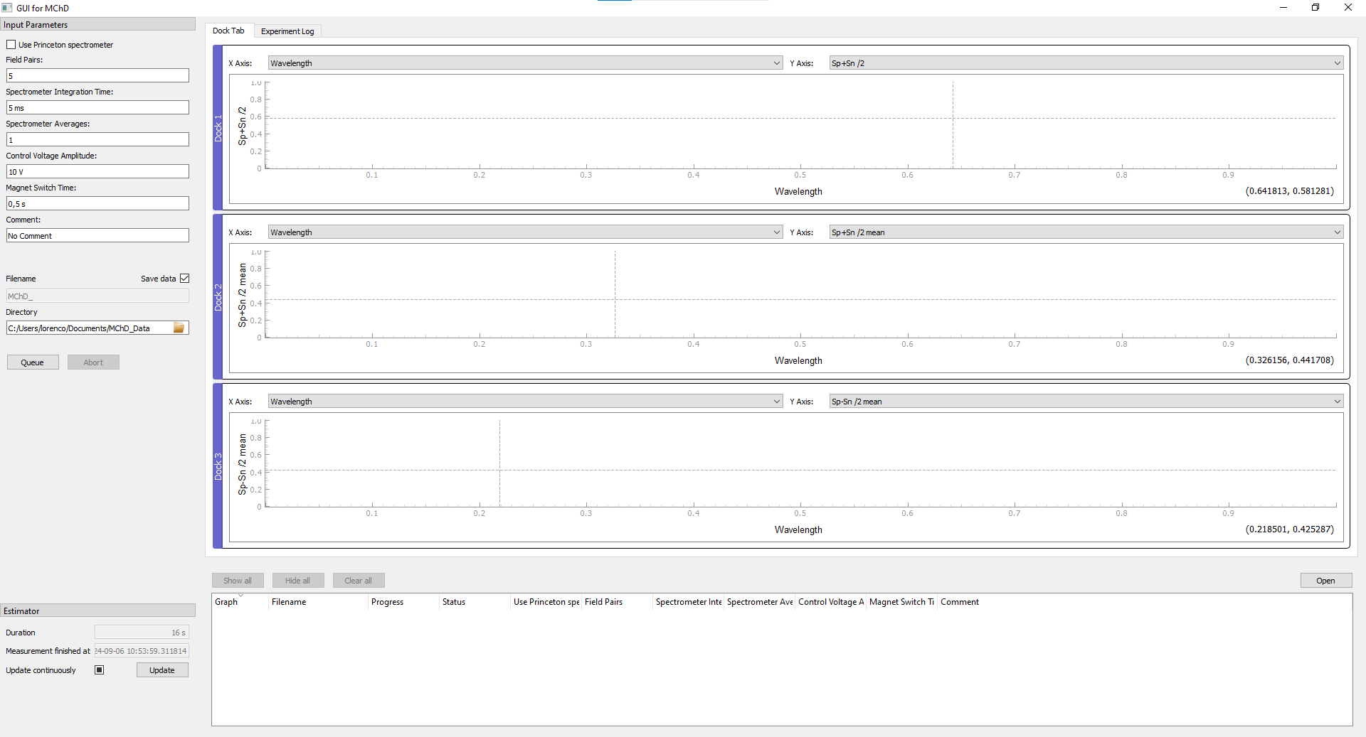
Upon launching the script MchD_Manager.py a GUI will open as follows :
The left panel is dedicated to several inputs of the experiment. Here’s a brief explanation :
- Use Princeton spectrometer : A boolean to chose whether the used spectrometer is the Princeton Instruments or the GlaacierX.
- Field Pairs : the number of magnetic field pairs that will be done during the experiment. 1 pair is then composed by measures on B+ and on B-.
- Spectrometer integration time : indicates how much time the spectrometer is integrating (acquiring, counting) for one single spectrum.
- Spectrometer averages : the number of continuous spectrum acquisitions (respecting the integration time) on one magnetic field polarity. The same value is respected for the opposed polarity.
- Control voltage Amplitude : the output control voltage of the National Instruments USB-6001 to drive the power supply of the coil. Take into account the power supply’s gain to avoid over voltage/current on the coil.
- Magnet Switch time : The estimated time that the coil takes to swap from a B0 to B1. At the start and finish of the experiment this will be from B+ to 0 mT. On the middle of the experiment, this time also refers to pass from B+ to B- (or B- to B+).
- Comment : user input to add a comment about the experiment itself. Can be some testing conditions, sample name… that will appear on the metadata of the file.
- Filename : indicates the prefix of the filename. Not editable.
- Directory : indicates the saving directory of the resulting file. Can be chosen by the user.
There is an estimator section at the bottom of the left panel that informs the user about the estimated duration that the experiment will take based on the input parameters. Its finish date is also refreshed every 2s. Please refer to the PyMeasure documentation for more details about the estimator usage.
The right part of the GUI contains graphics that shows the result of the mean of “Spectrometer averages” spectrums on B+ and B- for the last acquired pair or the mean over the all acquired pairs (if the selected choice contains “mean”). The bottom section indicates the queue and evolution of the current experiment.
Overall, the MChD code has been developed over the PyMeasure architecture. Refer to their documentation for more details about the general usage.

