Bryan Villegas

8/2/17

**Introduction**

The goal of this project was to extent an existing application, which is used to integrate various news, weather, and other apps into one application. The application puts these items on cards that a user can conveniently scroll through. A user would open the application in the morning and see all their favorite news feeds, scores, and weather instead of having to spend time alternating between applications to look for these things. Our target audience will be people of all ages that read news and the weather.

**Related Applications**

This application is very closely related to a well-known application called “Google News”. Google News gives users their information on cards, allowing the user to scroll through a list of different items. Google News shows users news and sports and even local news. As with every application, there are pros and cons. Some of the pros are:

- Shows the user news articles they may enjoy based on their search and website history.

- Shows the user scores for different sporting events.

- Shows local news

However, with every application there are a few downsides. Google News is a great application however many users have complained about a few things. Some of the cons include:

- Most of the features require you to login.

- No Twitter or Facebook, the application does not allow users to access their social media accounts.

- Users can’t customize their favorites or change what their news sources are.

- No weather unless logged in

**Development Timeline**

7/25 – Research

7/26 - 7/28 – Design/ Implementation

7/29 – Testing

**Implemented features**

The API’s that were used were News, Yahoo Weather. The main components used are Card View, Recycler View, AsyncTasks, Material Design, and a imported module called Picasso. When the application is opened, the user receives news articles and at the top, the weather. A few of the new features that were implemented were the images next to each article card and is dynamically loaded from a image link using Picasso. The biggest new feature is the weather feature which uses the Yahoo Weather API to get the weather from your location. It includes the temperature, weather description, and city/state. Next is the categories feature, which allows the user to get articles by categories instead of picking a specific news source. The settings tab on the top right corner allows them to pick from different categories of news, like sports, technology, etc. By default the app shows top news from google. Below are some screenshots to illustrate the app and show before and after extending the app.

Before: After: 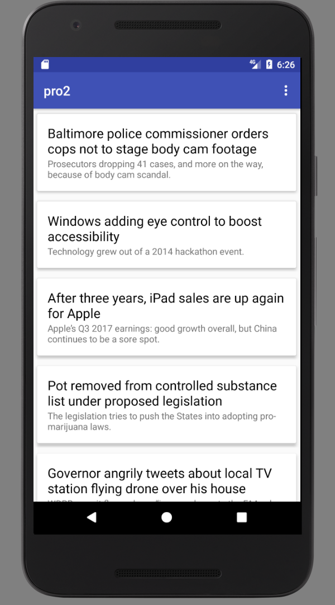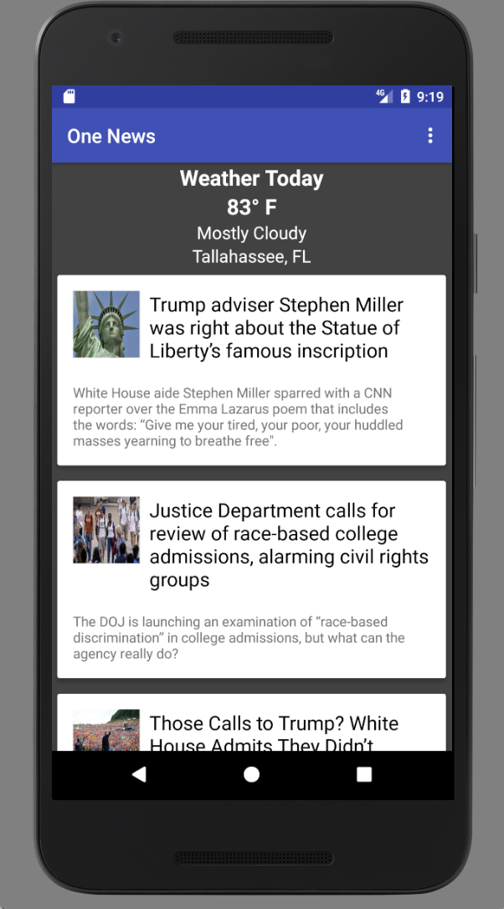

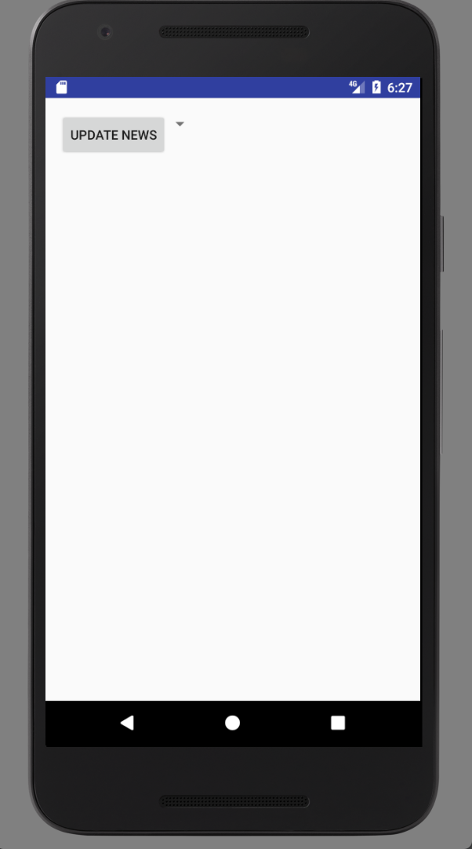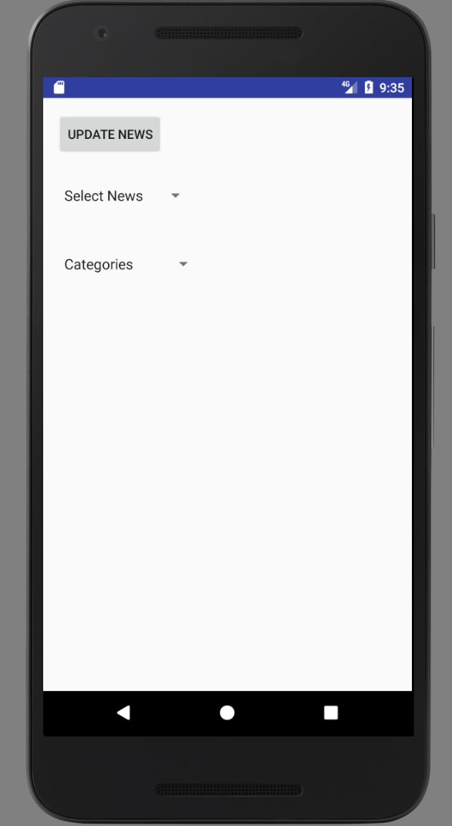

**Future Development**

In the future I would like to add an image for the weather part of the app to reflect the weather. Using picasso I could load images dynamicly to change the image depending on the weather. Also, I would like to add GPS so that you can get the weather from anywhere, currently the app only gets the weather for Tallahassee. Last, I’d also like to integrate social media into the app. For example, if a user likes an article they could share it to their social media.

**Conclusion**

To conclude, the application is a news and weather app that integrates both news and weather into one application for a user. The application, though similar to Google News, includes weather and news articles. When waking up in the morning, one could simply open one application like this one instead of jumping around from application to application. This could help conserve battery and limit the additional resources needed on your phone. This application targets all audiences except maybe children.

References

<https://developer.yahoo.com/weather/>

<https://newsapi.org>

http://square.github.io/picasso/