Bryan Hess PS2 Report

ps2-1.)



ps2-2.)

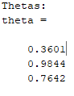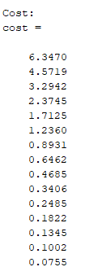

ps2-3.)

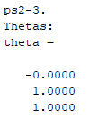

There is a significant difference between the two estimations as there are only 15 iterations. This low number of iterations is not sufficient for the gradient decent algorithm to operate. In order to see similar results between the two, we should increase the number of iterations.

ps2-4-b.)

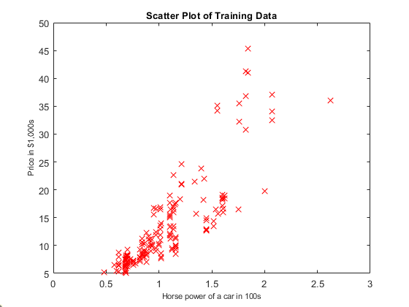

ps2-4-c.)

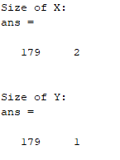

ps2-4-e.)

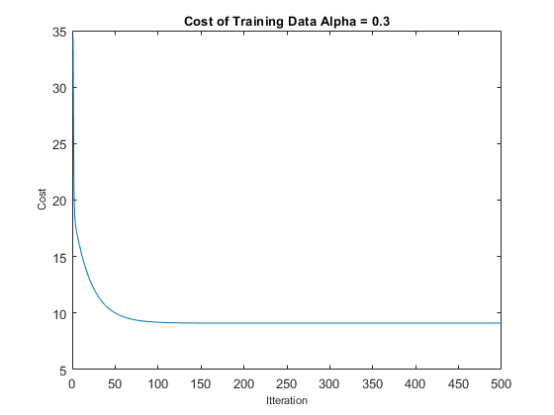

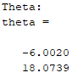

ps2-4-f.)



ps2-4-g.)



The difference in error between the two methods is almost negligible. This means that given proper values of alpha and number of iterations, the gradient decent algorithm is a good means of predicting values when supplied with enough training data.

ps2-4-h-1.)

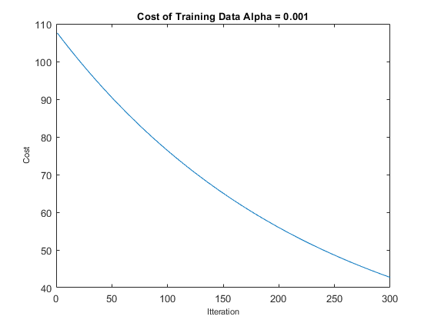

ps2-4-h-2.)

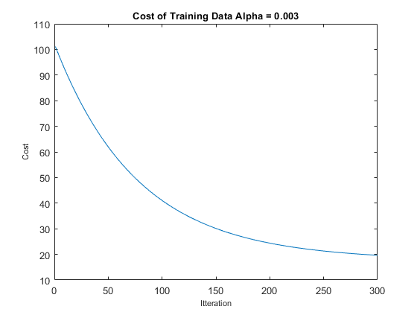

ps2-4-h-3.)

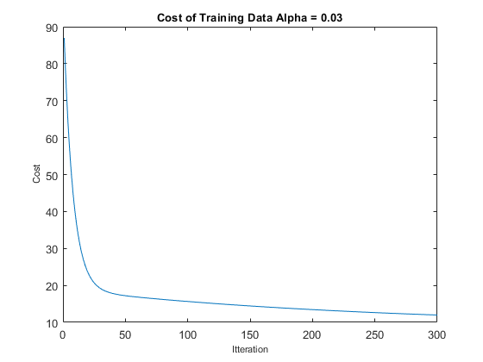

ps2-4-h-4.)

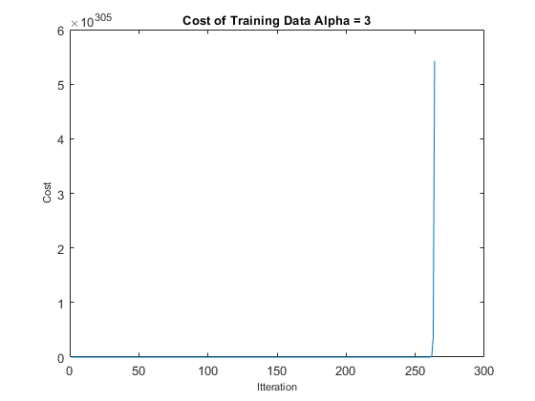

The larger the supplied alpha value, the quicker the cost function is to bottom out. This behavior can be seen in alpha .001 to .03. A too small alpha will take too long to see the proper minimization of cost. The outlier in this is when alpha = 3. This causes the function to skyrocket. A too large of an alpha value will overshoot the convergence point.

ps2-5-a.)

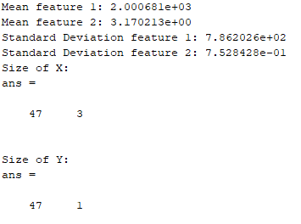

ps2-5-b.)

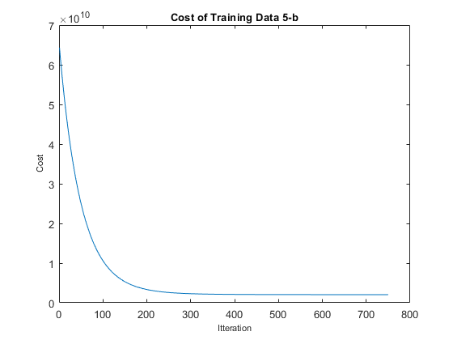

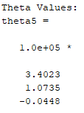

ps2-5-c.)



$238,747.00