ECE 1395 Problem Set 6

Bryan Hess: 4259226

Ps6-1-a.)



These values will slightly change each run depedning how the X_train and X_test values shuffle.

Ps6-1-b.)

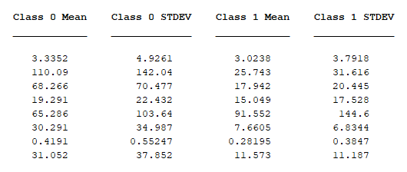

Ps6-1-c.)



Ps6-2-a.)



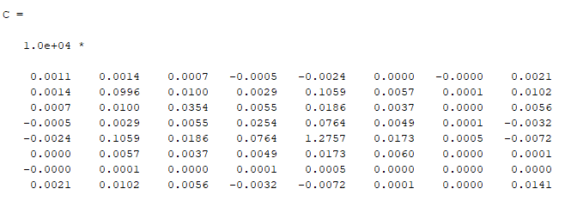

Ps6-2-c.)



In this case the naïve classifier slightly outperfomred the Mahalanobis classifier. This is not always the case as multpile runs will show that one may perform better one run, but poorer the second time. Both methods are sutable, and often give comperable results, rarely deviating more than a few percentages from one another (although I have seen a 14% difference once).