ECE 1395 Problem Set 7

Bryan Hess: 4259226

ps7-1-b.)



ps7-2-b.)

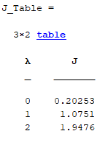

ps7-3.)

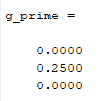

ps7-4.)



ps7-5.)

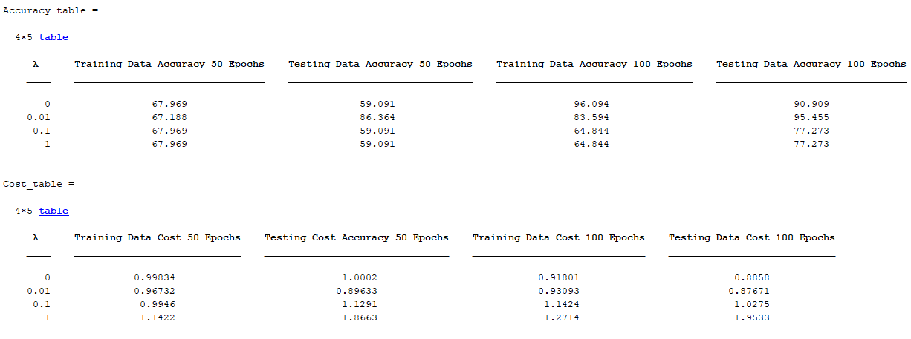

The accuracies are volitile on each run, however the costs stay relatively consistant.