ECE 1395 Problem Set 8

Bryan Hess: 4259226

ps8-1-a.)

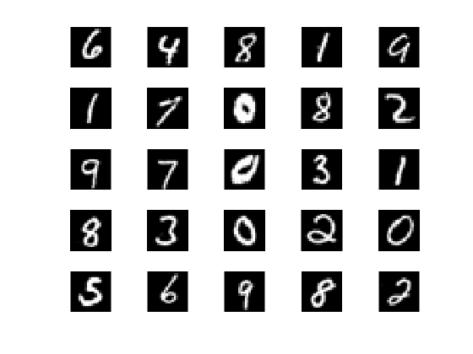

ps8-1-d.)

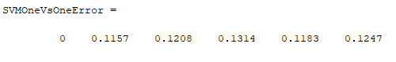

ps8-1-e.)



ps8-1-f.)

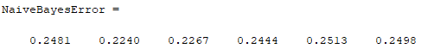

ps8-1-g.)



ps8-1-h.)

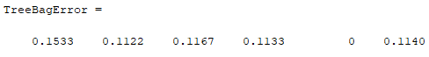

ps8-1-i.)



ps8-1-j.)

The tests performed on each dataset had varying performances for each algorithm depending on the test data. Each run generally had similar performances with slight variations. Majority voting did not yield the lowest error on test data (narrowly beat out by random forrests), however held lower error than most of the other sets. Bagging did help the the classifiers as it gives a wider view of how the classifier performs over a large set of data.