Bryan Turek

-

Experiment #9 – Addressing Modes of the I8086
CPE 311 S-001

Lab Partner: Tyler Durham

-

09/12/2013
Introduction:

The goal of this experiment aims at understanding and expanding the concept of interrupts. We will learn how to use and call Interrupt Service Routines (ISR) within DOS. In the second part, we will detect the switch bouncing problem and provide a software debouncing solution.

Exercise 1:

Experiment: In this exercise, we activated an interrupt simply by using the INT instruction along with the Interrupt Vector number.

Results:

1. INT 0 is a divide-by-zero error. It interrupts when trying to DIV by a divisor of 0.
2. INT 3 is a breakpoint interrupt. Usually follows an exception.

Exercise 2:

Experiment: In this experiment we triggered a divide-by-zero error using the code given to us in the manual. Basically it divides by CL where 0 is the contents of CL.

Results:

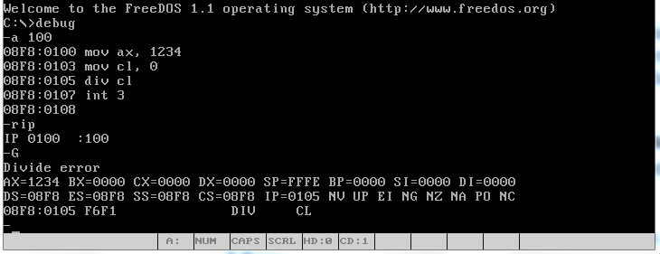

Exercise 3:

Experiment: In this experiment we manually execute INT 0 by directly running its ISR. We first found out the base and offset addresses associated with INT 0 then loaded those addresses in CS and IP. We then executed the ISR using G.

Results:
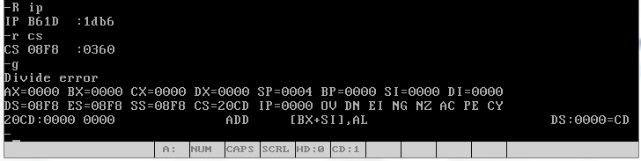
Exercise 4:

Experiment: In this experiment we changed the response of a INT 0 error by re-writing it's ISR. We first assembled the code given to us in the lab report. We then changed the address of INT 0 to be CS:0100. To test the code we ran the following code:

MOV AX, 1234
MOV CL, 0
DIV CL
INT 3

Results: The output of the following code showed “ABCDEFGHI”. “A” = 41 and was incrementally increased until “I”.

Exercise 5:

Results:

1. An ISR can unexpectedly occur even though a programmer did not want it to. Both an ISR and a subroutine can be called directly through a program.
2. Both can be called from a program, however an ISR can also be invoked from a signal from the hardware.
3. A hardware interrupt is an interrupt called from the hardware level. It stops the normal execution to handle the service the interrupt.
One example of a hardware interrupt would be in the case a printer wants to print a job that was sent to it.
4. The hardware will send a INT 2 signal to the CPU that grabs the address of the interrupt for that piece of hardware.

Exercise 6:

Experiment: In this experiment we set up a circuit that contained a pushbutton connected to an input port on the 8086.

Results: While pressing the button we noticed the value in the resistor went from 5V to 0V indicating the pushbutton was setup correctly.

Exercise 7:

Experiment: In this experiment we were asked to read in the values from the pushbutton. While reading in the values we were asked to detect a “bouncing” effect from the pushbutton.

Results: We successfully read in the values from the pushbutton and noticed an unusual sequence of values.

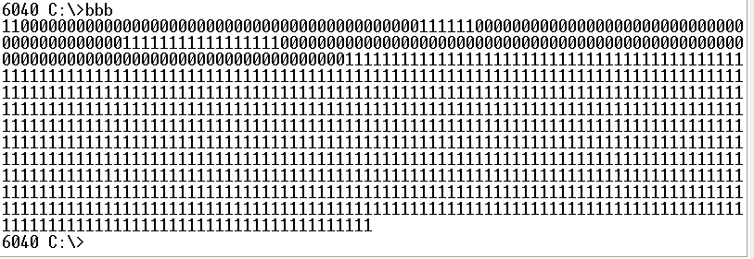
CODE:

Assume cs:code, ds:data, ss:stack

data segment
; All variables defined within the data segment
message db "Lab 5 Exercise 1$"
input db 1000 dup(?)
var db "w"
storage db 17 DUP(" ")
data ends

stack segment
;Stack size and the top of the stack defined in the stack segment
dw 100 dup(?)
stacktop:
stack ends

code segment
begin:
mov ax, data
mov ds,ax
mov ax, stack
mov ss,ax
mov bx,0
mov sp, offset stacktop

MOV DX,143H
MOV AL, 02H
OUT DX,AL

;This sets the control register to direction mode

MOV DX, 140H
MOV AL, 00H
OUT DX, AL

;this tells the control register
;that all of the pins in port b are outputs

MOV DX, 143H
MOV AL, 03H
OUT DX, AL

mov DX, 140H
;this sets the control register to operation mode
initial1:
in AL, DX
AND AL, 00000001b
cmp AL, 00000000b
jne initial1

initial2:
in AL, DX
and AL, 00000001b
cmp AL, 00000001b
jne initial2

mov SI, offset input
mov CX, 1000
store:
in AL, DX
and AL, 00000001b
mov [SI], AL
inc SI
loop store

mov SI, offset input
mov CX, 1000
mov AH, 2
print:
mov DL, [SI]
add DL, 30h
int 21h
inc SI
loop print

mov ah, 4ch
int 21h
code ends
end begin

Exercise 8:

Experiment: In this experiment the goal was to implement a software solution to solve the problem of contact bouncing. To do this involved writing a delay before reading in the values from the switch. The delay should provide enough time to miss the bouncing effect of the pushbutton.

Results: By using a delay loop where were able to successfully remove the bouncing effect from the input values. The disadvantages to this solution is that if the delay is too long then not every push of the button may be registered, and if the delay is too short, then the bouncing may still occur. The advantage is that it removes the effect without any more hardware.

CODE:

Assume cs:code, ds:data, ss:stack

data segment
; All variables defined within the data segment
message db "Lab 5 Exercise 1$"
input db 1000 dup(?)
var db "w"
storage db 17 DUP(" ")
data ends

stack segment
;Stack size and the top of the stack defined in the stack segment
dw 100 dup(?)
stacktop:
stack ends

code segment
begin:
mov ax, data
mov ds,ax
mov ax, stack
mov ss,ax
mov bx,0
mov sp, offset stacktop

MOV DX,143H
MOV AL, 02H
OUT DX,AL

;This sets the control register to direction mode

MOV DX, 140H
MOV AL, 00H
OUT DX, AL

;this tells the control register
;that all of the pins in port b are outputs

MOV DX, 143H
MOV AL, 03H
OUT DX, AL

mov DX, 140H
;this sets the control register to operation mode
initial1:
in AL, DX
AND AL, 00000001b
cmp AL, 00000000b
jne initial1

initial2:
in AL, DX
and AL, 00000001b
cmp AL, 00000001b
jne initial2

mov CX 5000
delay:
nop
loop delay

mov SI, offset input
mov CX, 1000
store:
in AL, DX
and AL, 00000001b
mov [SI], AL
inc SI
loop store

mov SI, offset input
mov CX, 1000
mov AH, 2
print:
mov DL, [SI]
add DL, 30h
int 21h
inc SI
loop print

mov ah, 4ch
int 21h
code ends
end begin

Exercise 9:

Experiment: In this experiment we look for a hardware solution to the debouncing problem.

Results: To solve the bouncing problem we found that a gate switch can remove the bouncing. To do this you need to wire a NAND flip-flop. The flip-flop only accepts input when the switch is on set. It will not take another input until the switch is reset, thus ignoring the bouncing problem.

Conclusion:

This lab helped us understand more clearly the effect of interrupts within the computer architecture. It also allowed us to better understand how switches and inputs can affect the computer. This lab definitely helped me realize how keyboards can interface with the computer to allow us to interact with it.

