Bryan Turek

-

Experiment #3 – Introduction to DEBUG
CPE 311 S-001

Lab Partner: Tyler Durham

-

09/8/2013
Introduction:

This lab is designed to introduce students to several pieces of hardware used to test equipment. These pieces of hardware include; Oscilloscopes, Toggle switches, and the Single Board Computer (SBC).

Exercise 1:

Experiment: An oscilloscope is used to graph signal voltages, this also allows one to debug circuits.
The purpose of this experiment was to familiarize us with the oscilloscope and learn how to gain measurements from it.

Results: Using a function generator, we generated 3 different signals to debug and gain measurement readings from. These signals were as follows:
120Hz Sinusoidal wave, 400kHz Square wave, and a 80kHz Triangular wave.

Wave: Period Match FG? P-to-P
1 (120Hz Sin wave): 8.8ms yes 5.56V
2 (400kHz Square wave): 2.44µs yes 5.96V
3 (80kHz Triangle wave): 13.20µs yes 5.48V

Exercise 2:

Experiment: In this exercise we learned how to build a toggle switch and observe the output of the switch.

Results: To properly setup a toggle switch, you set the oscilloscope into a trigger function mode.
If you set the trigger level to 5V nothing will show until you set the input signal to no less than 5V.

1. The response shown on the scope looks like two heart beats far away.

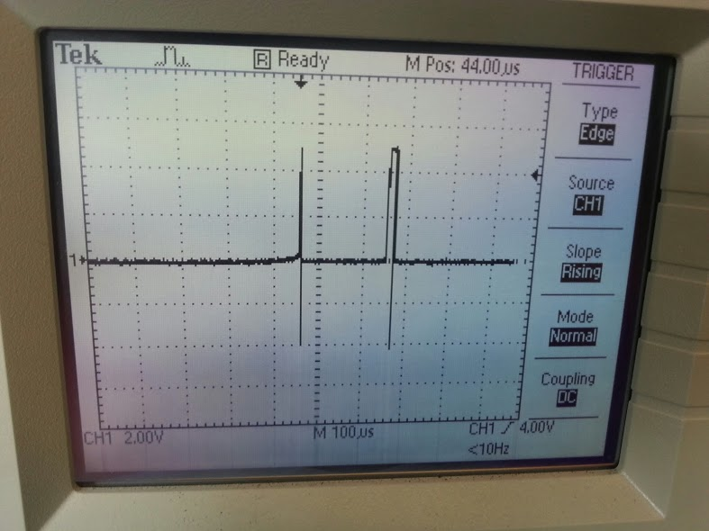
2. The difference between this signal and the Square wave in exercise one is that this one does not continue forever.
3. The lapse of switching the toggle switch accounts for the distortion seen when doing so.

Exercise 3:

Experiment: This experiment is here to teach us about the Single Board Computer or the SBC.

Results: Questions answered about the SBC.

1. ALi M6117 386SX is the CPU.
2. The 6040 has 8 analog inputs and 8 analog outputs. It comes with a 12-bit converter. It allows for up to 100,000 times a second, so 50,000 will work.
3. There are 24 digital I/O lines on the 6040. They are grouped to 3 lines each.
4. The hardware reset is on the 6040 and is located in the watchdog timer.
5. The typical watchdog timer is 1.6 seconds.

Conclusion:

In this lab we learned the importance of becoming familiar with different hardware and its capabilities. After this lab we became familiar with Oscilloscopes, Toggle switches and the 6040 SBC Board.

