PART 1:

1. A doubly-linked list would be used in linking free memory control blocks by linking all the control blocks together and traversing through it to find the best size and whether or not the block is allocated or free. A doubly-linked list would also be easy to sort and therefore find useful blocks faster and more efficiently.

2. The ordering in which a pointer to the previous FMCB would be useful in both the decreasing size and the boundary tag method.

3. The difference between external fragmentation and internal fragmentation is external ocurs when several blocks are free but not contiguous. They cannot be used to fulfill a request for a process. Internal is when a block is not entirely used.

4. Fixed partitions are a static method in which it divides the available space into fixed sizes. They are used in real-time systems. Variable regions is a dynamic method that allocates the size when it is started by the OS. They have control blocks which are dynamically created, and can have concurrent processes.

5. One disadvantage of allocating AMCB's in the storage block is that it takes up memory of the process and will then need more space to be allocated in the storage block. The advantage to this method is that solves allocating the control blocks due to the space available in each storage block.

PART 2:

1. First-fit:

This method will allocate the first block of memory that has equal to or greater than the required amount for the process.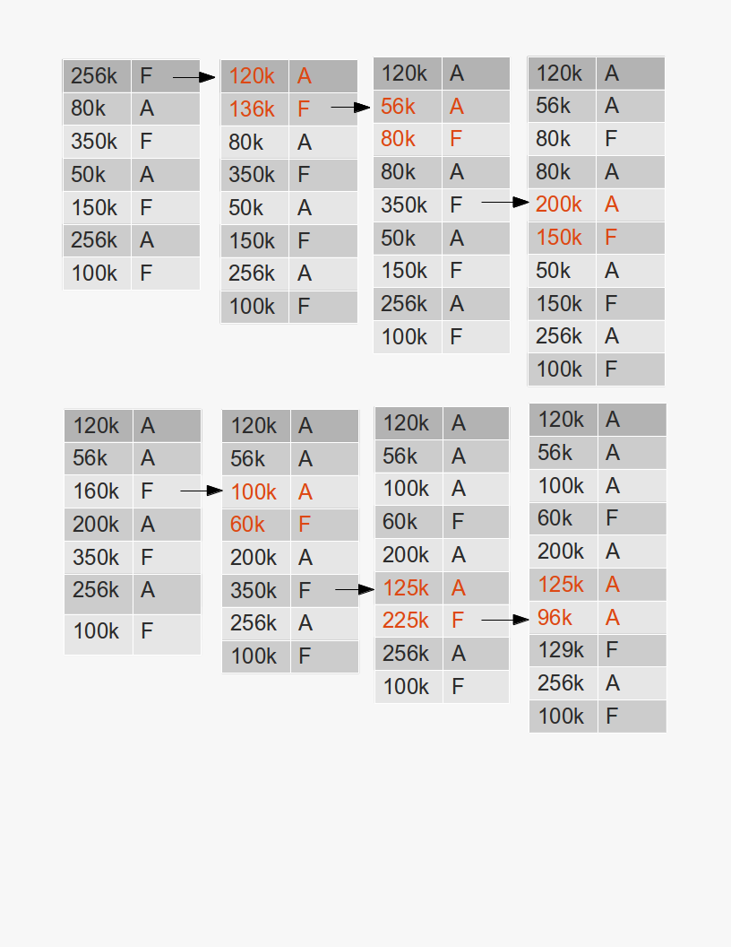

2. Next-fit:

Similar to first-fit it uses the first unallocated block however starts from the previously allocated block.

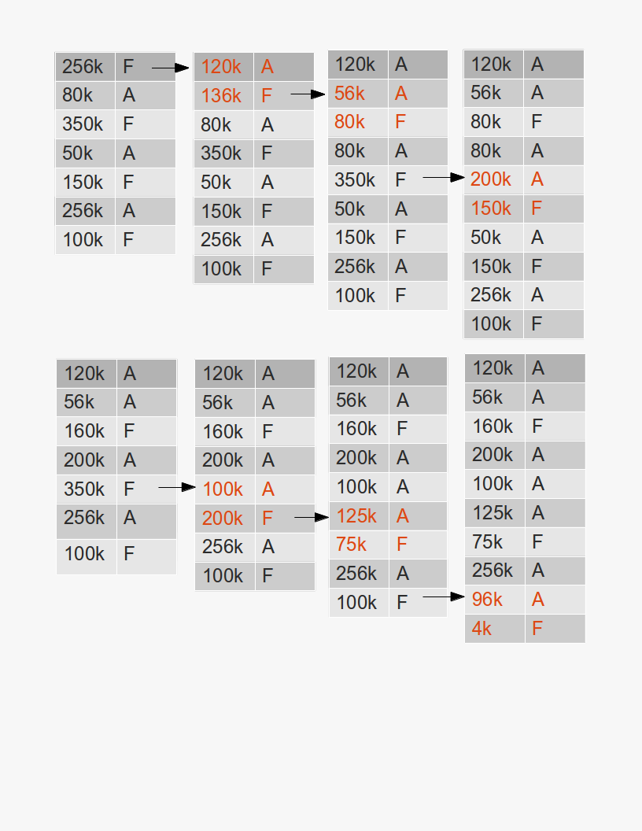

3. Best-fit

This style of allocating memory will find the memory block in which the difference between it's current space and the requesting process is smallest.

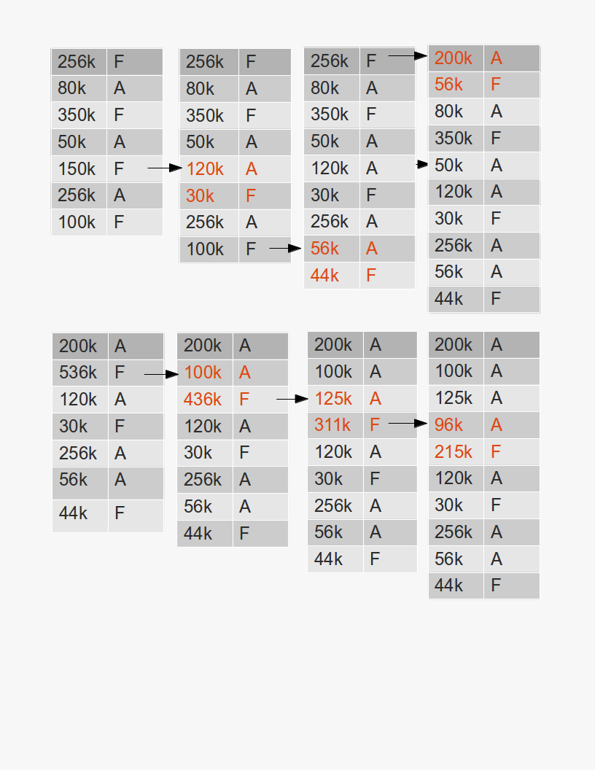

4. Worst-fit

This style of allocating memory will find the memory block in which the difference between it's current space and the requesting process is greatest.

