RR-Project-1

# Reproducible Research --- Project 1

## Analysis with NA ingnored

* Setup figure diretory

knitr::opts_chunk$set(fig.path="figures/")

* Load data

data <- read.csv(file="activity.csv", header = TRUE)

* Calculate total steps of each day

step_by_day <- with(data, tapply(steps, date, sum))

* Create a Histgram

orig_hist <- hist(step_by_day, main = "Original Data")

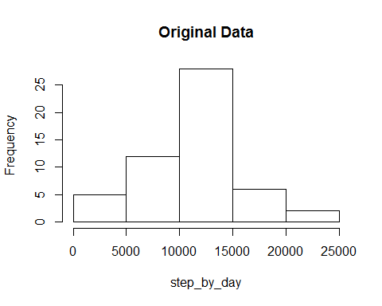

## for comparison with new data set below  
 orig_hist$count

## [1] 5 12 28 6 2

* Calculate mean and median, ignoring NAs

mean(step_by_day, na.rm = TRUE)

## [1] 10766.19

median(step_by_day, na.rm = TRUE)

## [1] 10765

* Calculate mean by interval

mean_by_interval <- with(data, tapply(steps, interval, mean, na.rm = TRUE))

* Create a time series plot of mean steps averaged across all days

t_series <- subset(data, date == "2012-10-01")$interval  
 plot(t_series, mean_by_interval, type = "l", xlab="Interval", ylab = "Mean Steps", main = "Original Data")

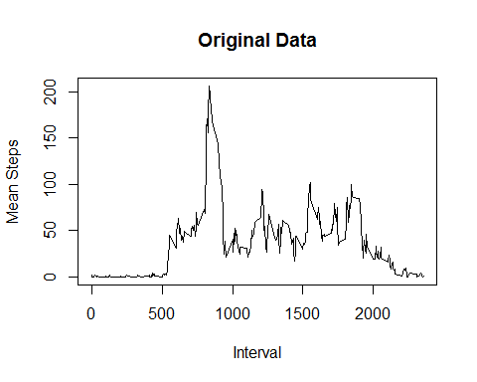

* find the maximum

max(mean_by_interval)

## [1] 206.1698

which(mean_by_interval == max(mean_by_interval))

## 835   
## 104

## Imputing missing values: replacing NAs with the mean of the interval

* Calculate and report the total number of missing values in the dataset (i.e. the total number of rows with NAs)

sum(is.na(data$step))

## [1] 2304

**Discusion:** 2304 out of 17568 observations missing, about 13%

* use Mean of the interval to replace NA

num_of_dates <- nrow(step_by_day)  
 num_0f_interval <- nrow(mean_by_interval)  
   
   
 new_data <- data.frame (steps = numeric(), date = factor(), interval = integer() )   
 d1 <- as.Date("2012-10-01")  
 for (i in 1:num_of_dates) {  
 d <- as.Date(d1 + i - 1)  
 tmp_data <- subset(data, date == as.character(d))  
   
   
 for (j in 1:num_0f_interval) {  
 steps <- tmp_data[j,1]  
 if (is.na(steps)) {  
 steps <- mean_by_interval[j]  
 }  
   
   
 if(!exists("new_data")) {  
 new_data <- c(steps, d, t_series[j])  
 }  
 else {  
 tmp_row <- c(steps, d, t_series[j])  
 new_data <- rbind(new_data, tmp_row)  
 }  
 }   
   
 }  
   
 colnames(new_data) <- c("steps","date","interval")  
 new_data$date <- as.Date(new_data$date, origin ="1970-01-01")

## Statistics with new data set (NAs replaced by mean of the interval)

* Calculate total steps of each day and Plot a histgram

step_by_day_2 <- with(new_data, tapply(steps, date, sum))  
   
 new_hist <- hist(step_by_day_2, main = "Modified Data")

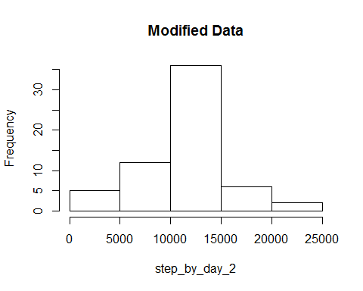

## for comparison with original data set  
 new_hist$count

## [1] 5 12 36 6 2

* Calculate mean and median,

mean(step_by_day_2, na.rm = TRUE)

## [1] 10766.19

median(step_by_day_2, na.rm = TRUE)

## [1] 10766.19

**Discussion:** After imputing NAs, median and mean steps did not change with any significance, most likely due to the fact that NAs were replaced by mean of the interval. However, the peak of the histagram with steps between 10000 and 15000, increased significantly, while other bins have significant change. This deserves further investigation.

* Add a new column, wday, two level factor, weekday or weekend

weekday <- c("Monday", "Tuesday", "Wednesday", "Thursday", "Friday")  
 wday_vector <- factor((weekdays(as.Date(new_data$date)) %in% weekday), levels=c(TRUE, FALSE), labels=c("weekday", "weekend"))  
 new_data$wday <- wday_vector

* Calculate mean by interal for weekday and weekend
* Make a panel plot of mean steps ~ interval for weekday and weekend

mean_by_interval_wday <- with(new_data, tapply(steps, list(wday, interval), mean))  
  
 par(mfrow = c(1,2), mar = c(5, 5, 4, 2))  
 plot(t_series, mean_by_interval_wday["weekday",], type ="l", ylim = c(0, 240), xlab = "Interval", ylab = "Mean Steps", main = "Weekday")  
 plot(t_series, mean_by_interval_wday["weekend",], type ="l", ylim = c(0, 240), xlab = "Interval", ylab = "Mean Steps", main = "Weekend")

