**Final Project Algorithm and Programming Report**



**Lecturer:**

**Jude Joseph Lamug Martinez, MCS**

**Report by:**

**Bryan Sujoso - 2602179151**

**Binus School of Computer Science Undergraduate Program Universitas Bina Nusantara**

**Jakarta**

**2023**

1. Brief Description

For my final project I made a top down bullet hell game mainly inspired by “Touhou Project”. It is made in pygame with modules and sprites that are taken online along with the music. The game itself contains 3 difficulties in which the player will fight a singular slime and dodge its projectile. Starting the game, a random background will be created and the user is prompted with a main screen in which 3 buttons which are of varying difficulty and when clicked will start the battle. The player also has directional idle animation and can move with “WASD” with directional movement animation along with the boss having 3 animations for different attacks and phases. The boss also has varying attack patterns done at random with the player having a singular shot with left click and a burst shot with the right click and a dash with the space bar. Upon death or a win the player will be given a score and an option to leave or go back to the main menu in which a new random background will be created and all the stats and lingering bullets will be cleared.

1. Use Case Diagram

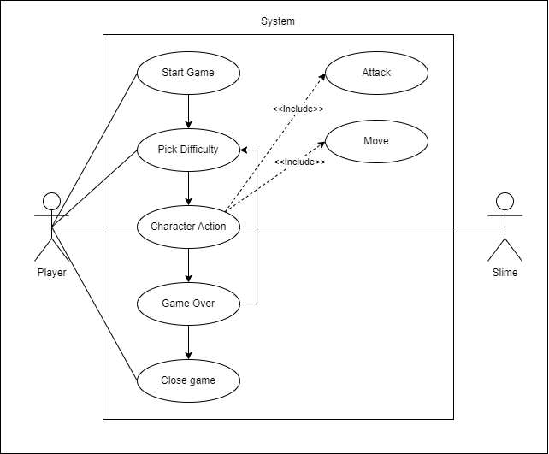

1. Activity Diagram

Sir please i cant its too much

1. Class Diagram

Sir please i cant its too much

1. Modules
2. Pygame Module

The Pygame Module is the main module used to create the game in python and within it I also used a sub module Pygame Mixer which allows the use of playing music and Pygame Font which allows me to write text in the window itself.

1. Random Module

The Random Module is mainly used for generating the background and the swapping of boss phases.

1. Sys Module

The Sys Module is used only to end the python operation after pygame is done exiting.

1. Math Module

The Math Module is used in the aiming system for both players and enemies by calculating the angle between the target and the shooter. (Player to Cursor or Boss to Player).

1. Essential Algorithms
2. Pygame While Loop

This is the main algorithm used to refresh the screen and keep the game and stats updating constantly. The background would first be updated, the player movement and boss movement would be checked along with the collision and the stats would then be updated after which the other ui would be updated such as the health, player sprite, bullet location, boss sprite and the boss bullet location.

1. Background Generation

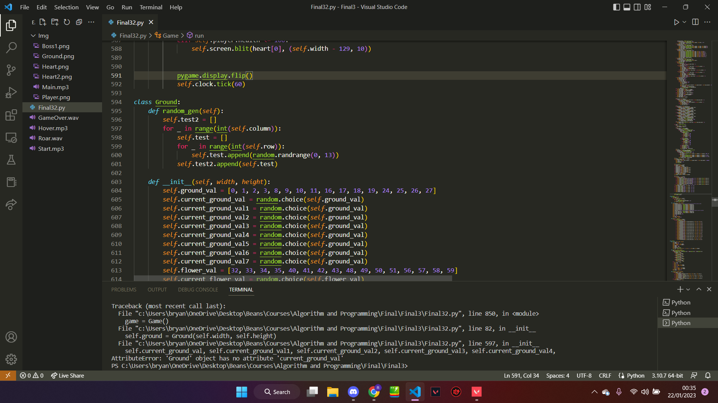

This Algorithm divides the screen width and height with the image giving rows and columns with the length of the image, with this it would create a list in which tile locations are specified with random values from 0 to 12 and these 12 number would then be given another random value from the sprite sheet generalising 0 to 7 being just a normal grass, 8 to 10 being grass with a flower and 11 to 12 a grass with stone tiles atop. This random background is then saved and would be used for the display of the game until the player returns to the main menu in which it generates another background.

1. Animation Sprite Sheet

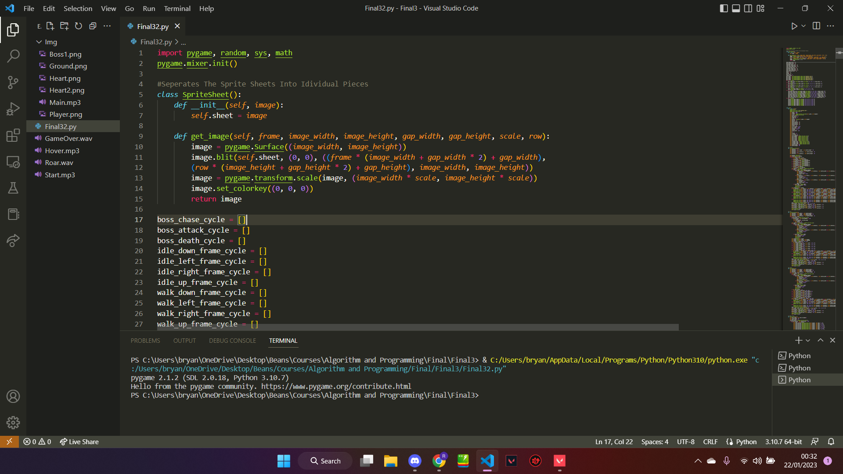

When this algorithm is called, it will receive a frame input along with the specified image details, this allows it to pick specific frames from the sprite sheet and return it as the spritesheet has the same sizes for the image width, height, and gaps in between.

1. Player Movement

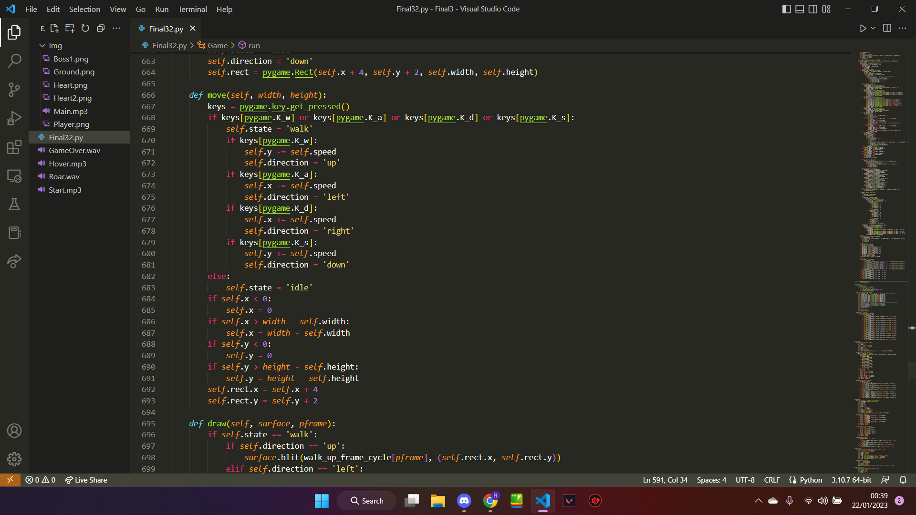

This algorithm takes care of the player movement and keeps the player within bounds, it also assigns the player with a state and a direction which is used in the animation to allow for more accurate directional and lively sprite. It keeps the player inbound by comparing its player coord and the edges of the screen in which it will teleport the player to the nearest inbound coord. The movement is done by adding or subtracting the player location with its speed.

1. Player Dash and Attack

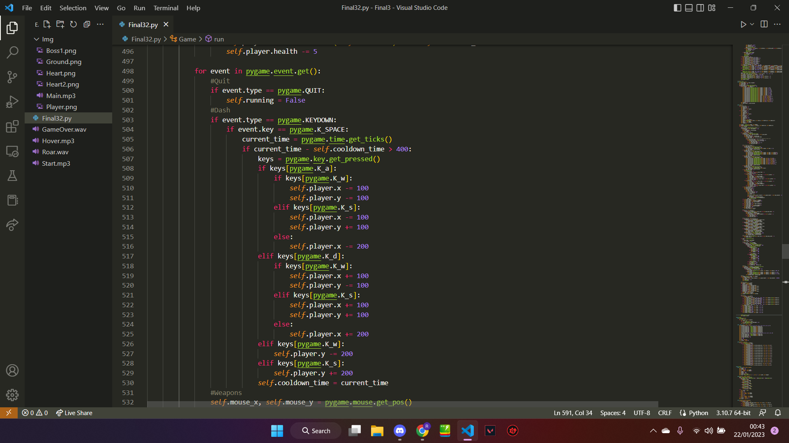

This Algorithm is used as a way to dash and mobilise the player and give a way for the player to attack the boss. When spacebar is pressed, it will teleport the player a set distance based on the current directional keys pressed. It also has a timer system in which the player can only dash every 0.4 seconds

When left click is pressed, it will shoot a singular bullet in which it will take damage value and an offset value. The offset value is useless in left click but in right click, a burst of 3 bullets is shot and the offset value is used to create a shotgun like burst. Both these clicks share a cooldown and so only a single shot can be done every 0.5 seconds.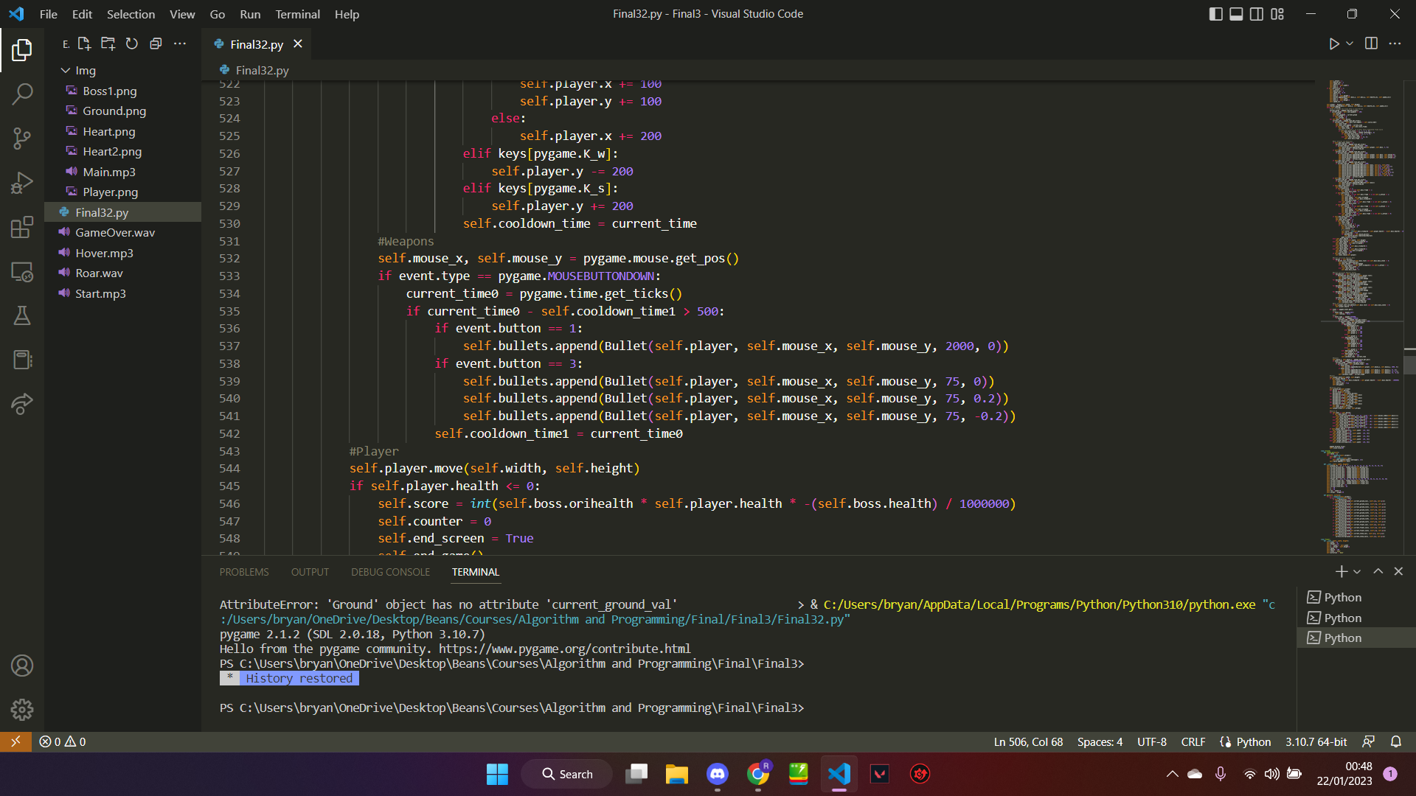

1. Boss Movement

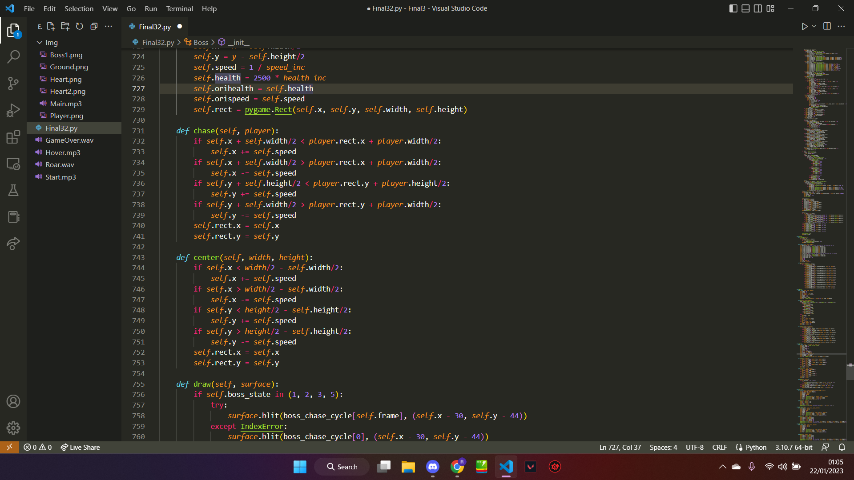

This algorithm allows the movement of the boss, it alternates between 2 movement patterns in which in “chase”, it would chase the player by moving according to the players coord adding and subtracting itself based on the current players x and y, the second mode of movement is when the boss goes to the centre of the screen

1. Screen Shots

^Main Menu ^Victory Screen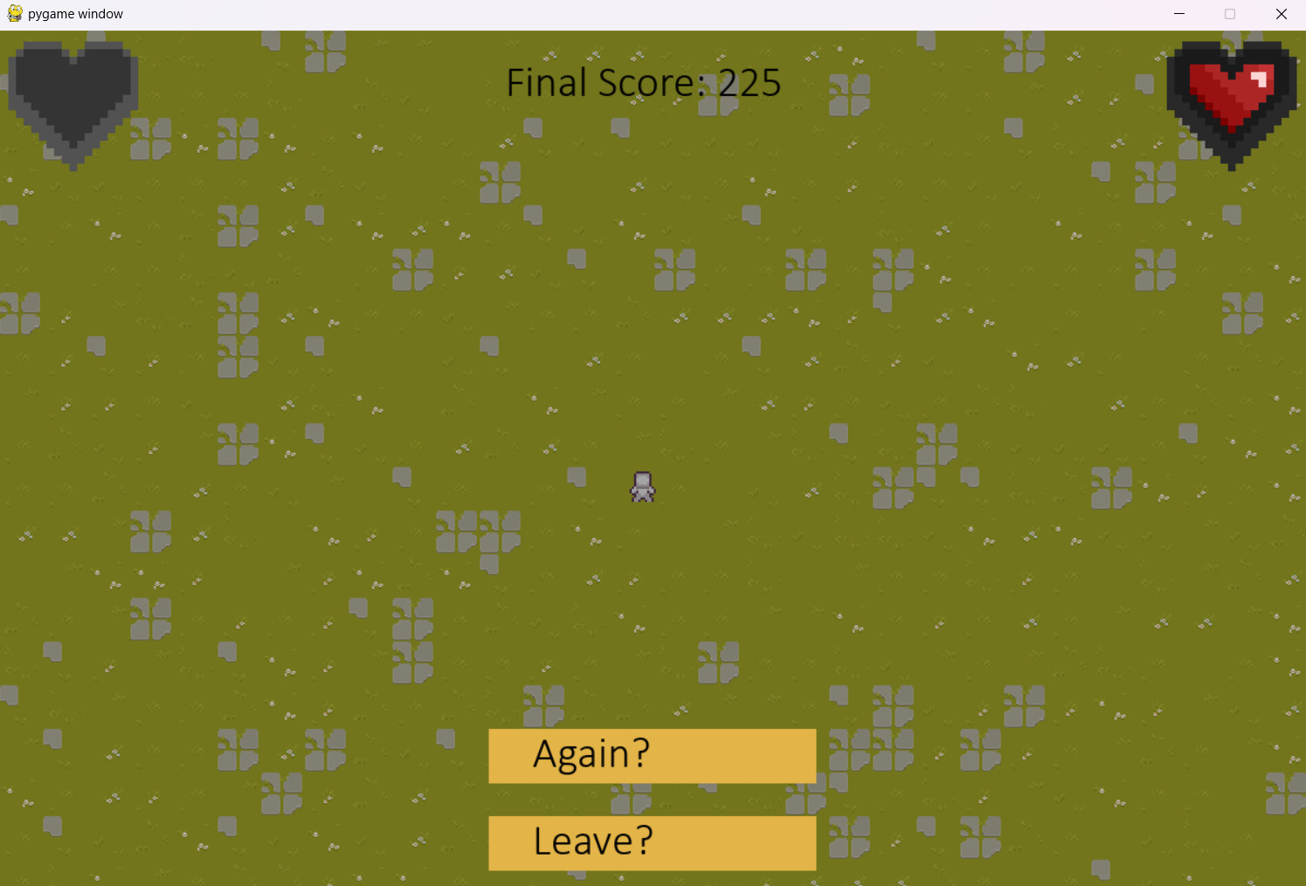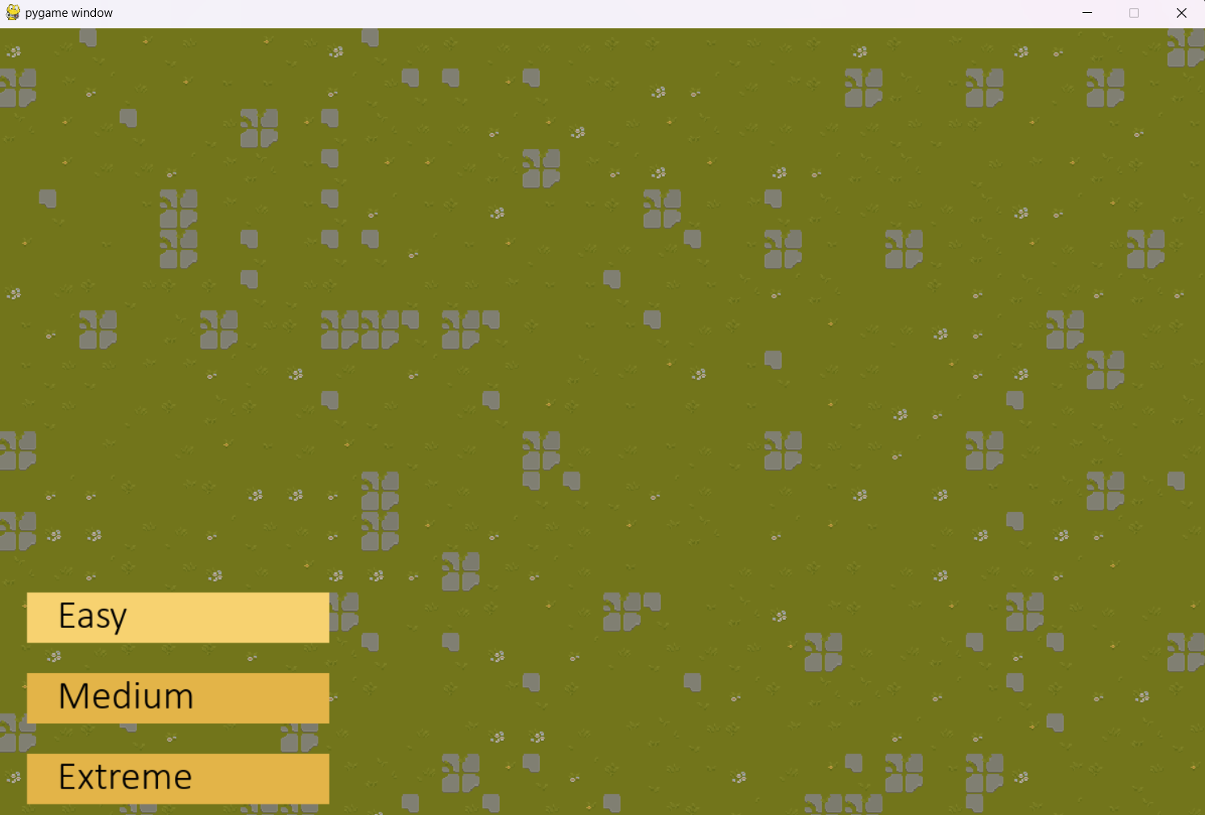

^Defeat Screen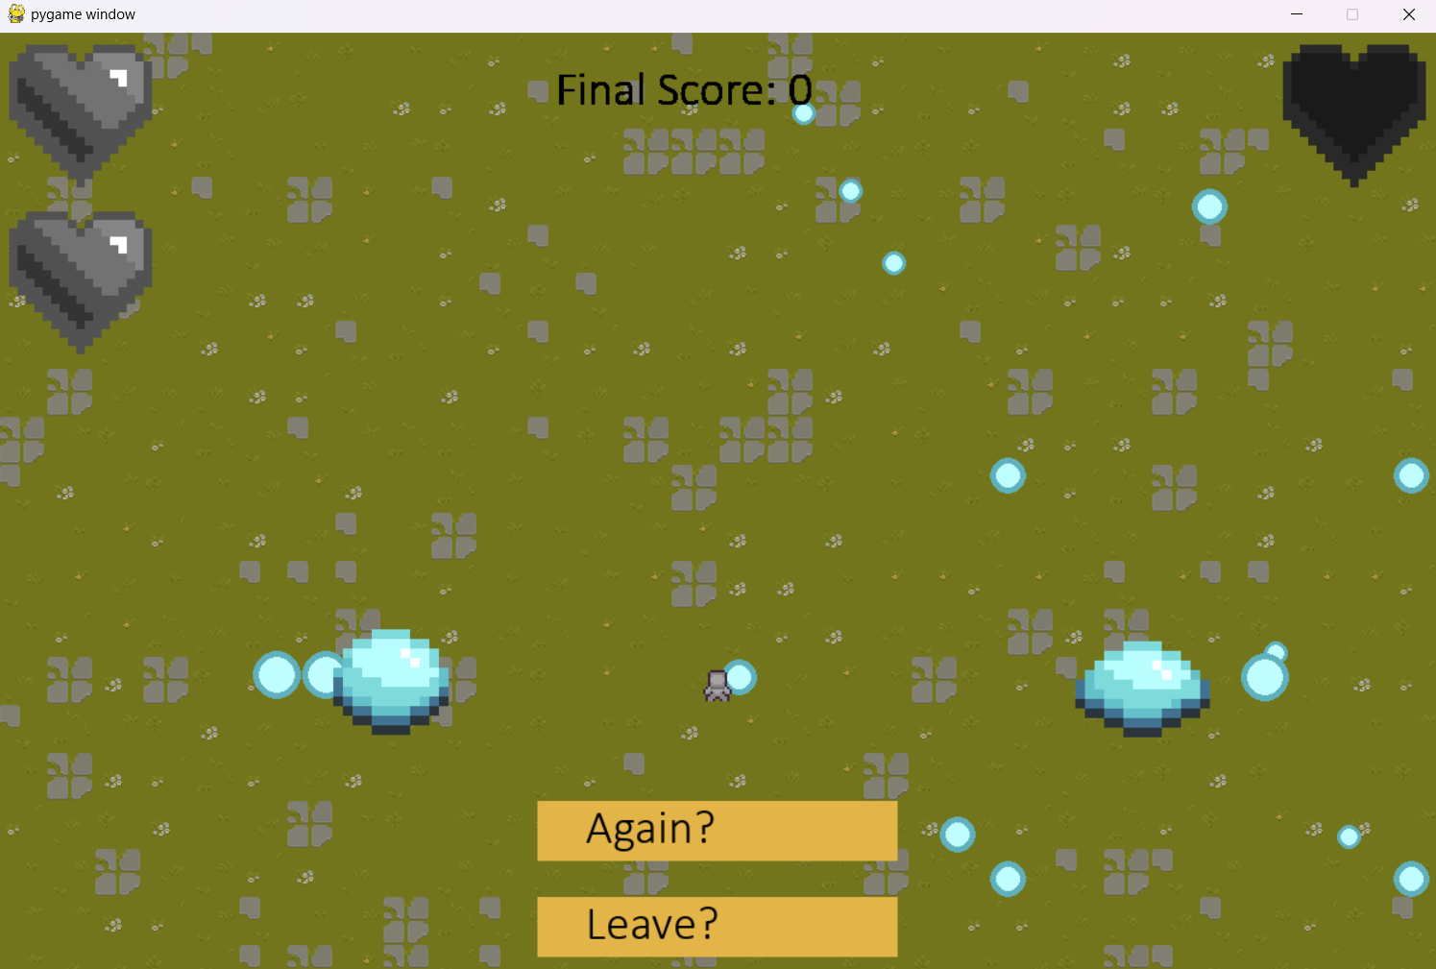

1. Reflections

I realised two things that I'm lacking when “finishing up” the project and that is Time Management and a cleaner work ethic. As it is, the game is somewhat complete but I would definitely like to add so many more features yet due to the jumbled up spaghetti code it takes such a long time implementing one new feature as other things would break.

Keeping a cleaner workspace and a more orderly code with labels would definitely help clear confusion and increase the efficiency of work. Time management and setting goals could also help in improving workflow and keeping yourself on track.

Overall I really enjoyed working on this project and have learnt new things. Although it is not fully completed im still happy with the product and would probably add on to it just as a personal project.

1. Resources

<https://cainos.itch.io/pixel-art-top-down-basic>

<https://snoblin.itch.io/pixel-rpg-free-npc>

<https://deadmadman.itch.io/dungeons-and-chickens-top-down-asset-pack>

<https://fliflifly.itch.io/hearts-and-health-bar?download>

<https://www.youtube.com/watch?v=4WkIAHsNIdY&t>