**Statistical Analyses**

RStudio was used to visualize and analyze the data gathered from online survey. Pearson’s correlation was used for correlation statistics.

**Descriptive Statistics**

Figure 1 is the boxplot displaying overview of the data with x-axis indicating variable and y-axis indicating the score in 7-scale. Note that a “_” prefix means “not”. Some outliers of participants considered that robot was receiving command when eyes were turning and brightening. In terms of respect, some outliers indicated that the robot did not respect while brightening eyes. Some outliers suggested that the robot was not willing to listen while eyes were blinking. Most of the participants had little experience with robot while some outliers had more experience.

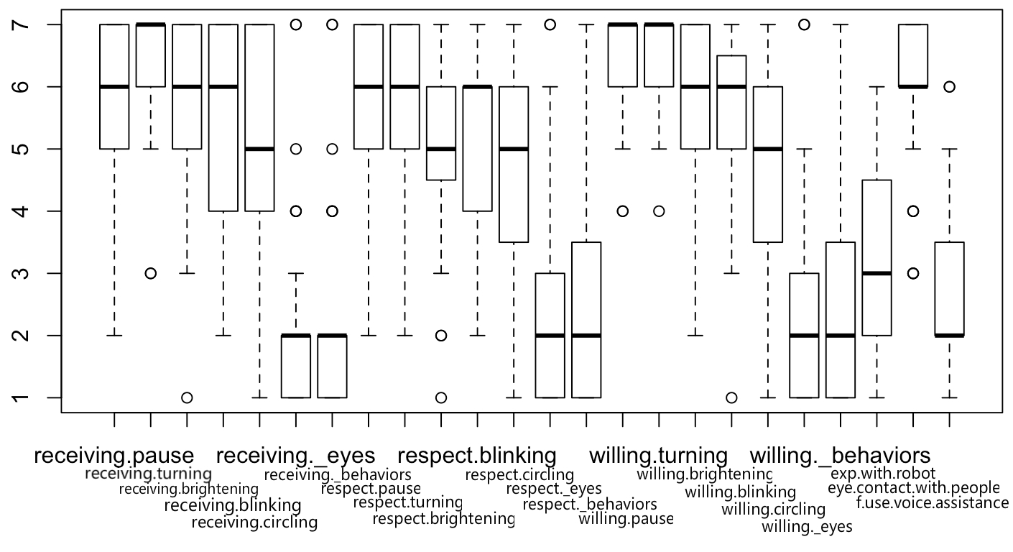

Figure 1

**Correlation Statistics**

We used function cor() and rcorr() in RStudio to explore the correlations. We used **Pearson’s correlation** to calculate the **r-values** and **p-values** for significant tests.

An **alpha** level of **0.05** was used for all statistics tests. **31** participants were recruited in this survey. As a result, we found the following interesting correlations:

1)People’s perception of robot receiving command when turning eyes towards them and people’s perception of robot receiving command when eyes circling were positively correlated, ***r*(29) = .51, *p* < .01 (0.0031)**.

2)People’s perception of robot receiving command when pausing the current actions and people’s perception of robot willing to receive command when eyes brightening were positively correlated, ***r*(29) = .58, *p* < .01 (0.0007)**.

3)People’s perception of robot receiving command when pausing its current actions and experience with robot were positively correlated, **r(29) = .38, *p* = .04**.

**Inferential Statistics**

We conducted a **within-subject** study with 31 participants and **multiple dependents variables** (DV), we would explore how these DV affect the independent variables, therefore **MULTI-WAY, WITHIN-PARTICIPANTS ANOVA** was used for inferential statistics analysis. Original data of “full_data_simplified.csv” was cleaned and organized to “full_data_within_subject.csv” for further study.

A hypothesis of “Owning a pet of cat or dog positively affects human’s perception of whether robot’s receiving command when pausing its current action” was proposed.

A multi-way analysis of variance yielded a main effect on human’s perception of robot receiving command when pausing its current actions for whether he/she owns a pet of cat or dog.

The perception of receiving command when robot pausing its current actions was significantly stronger for owning a cat **F(1, 30) = 35.43, p < .01, (M = 1.13 SD = 0.34)** than owning a dog **F(1, 30) = 1.63, p = 0.20, (M = 1.29 SD = 0.46).** As such, a sub null hypothesis of “Owning a cat does not positively affect human’s perception whether robot’s receiving command when pausing its current action” was rejected. However, another sub null hypothesis with the condition of “owning a dog” was accepted. Overall, the interaction effect was significant, **F(1, 30) = 7.38, p = .01** (0.00808 to be more specific), indicating that owning a pet of cat or dog dramatically affect human’s perceptions of robot’s status of receiving command when robot pausing its current actions, while owning a cat has significantly effects while owning a dog does not.

Whether owning a cat or not and was depicted in figure 2. A **Post-Hoc Comparison** in R was conducted for **pairwise comparison**, the result and the adjusted p-value were shown in Figure 3.

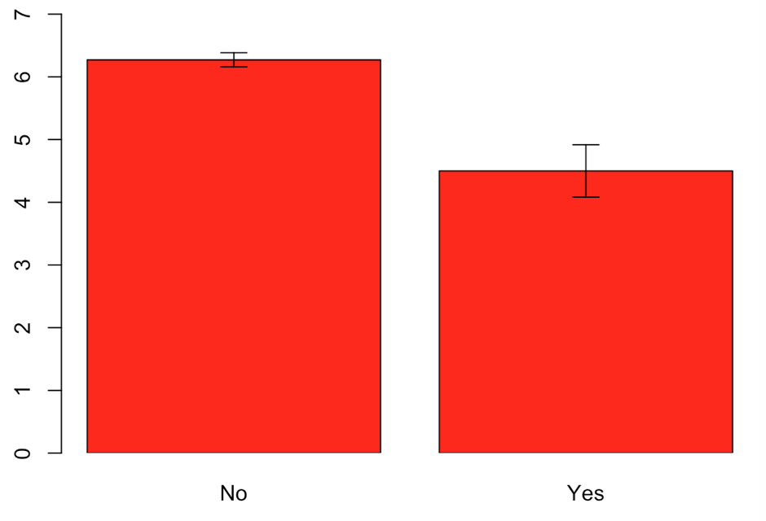 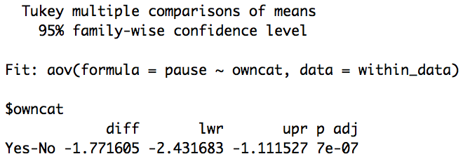

Figure 2 Figure 3

**References**

Kaiser, H. F. (1960). The application of electronic computers to factor analysis. Educational

and Psychological Measurement, 20, 141-51.

Cattell, R. B. (1966). The Scree test for the number of factors. Multivariate Behavioral Research,

1, 245-76.

Cronbach, L. J. (1951). Coefficient alpha and the internal structure of tests. Psychometrika, 16(3), 297-334