**Protocol**

***1. Introduction & Consent***

*<****Log into robot and mute it>***

*<Outside of room>*

Experimenter: Hi, are you <their name>? Great! I’m <your name>, nice to meet you, thank you so much for coming in!

Experimenter: If you could please just have a seat here <wait for them to sit down>. <if needed> would you like for me to take your bag? I can keep an eye on it while you do the study <put bag in lab for safekeeping>

Experimenter: <put consent form in front of them> The first thing I have is a consent form for you to fill out. The two places to pay attention to are one the back here <point> where you need to say yes or no and initial, this is whether or not we can use your anonymized video in scientific publications, and here <point> where there’s a place for you to sign. There are two copies, one for you and one for me, just fill out the one for me. If you have any questions on this please let me know.

<experimenter should leave room or avoid staring at participant while they read, during this time if the person was recruited off the street, message the other experimenter to tell them the person’s name>

***2. Overview***

<after participant has signed>

Experimenter: Great! Today you’ll be working with another person who’s participating in the study from **Goodnight Hall** on campus. First, we’ll ask you to complete a training task, then you’ll be working together to complete the construction of an object. If you finish the object correctly in a time that’s faster than any other team to do the study, you’ll receive an extra dollar. After you build the object, we’ll ask you to fill out a questionnaire.

Do you have any questions on that?

<if yes, answer questions, if no, let participant into room and ask them to sit down, then proceed>

***3. Training***

Experimenter: Ok, so as I said, now you’ll be doing a training task.

*If no mobility, maze website:* You’ll be navigating a maze. Here’s a page with the controls listed on them. You’ll have up to 10 minutes to try to get through the maze. (set to 33x33, set timer to 10 minutes) If you finish before the 10 minutes are up, just open the door so that I know you’re done. Do you have any questions on that?

*If full mobility, driving practice*: You’ll be practicing with driving the videoconferencing system around a room. There are cups set up on the ground that you can try not to run into. Here’s a page with the controls listed on them. You’ll have up to 10 minutes to get familiar with the system. (set timer to 10 minutes) If you finish before the 10 minutes are up, just open the door so that I know you’re done. Do you have any questions on that?

<if no questions> Ok! <start the timer> then I’ll be back in 10 minutes or when you open the door.

***3. Construction task***

<re-enter room and **disconnect robot if used**>

How did you do? <wait for response>

Now you’ll be building an object with another person who’s doing the study in Goodnight Hall on campus. You will have the picture of the final object that you’re building and they will have the parts. You are not allowed to show them the picture of the final object.

If together, you manage to build the object **correctly** in a **faster time** than any of the other teams that have done the study, you will both receive an extra dollar. When I start the timer, you will be free to start, when you both agree that you are finished, open the door and say that you are done.

Do you have any questions on that?

<if yes, answer questions, if no, proceed> Let me just check to see if the other person is ready, I’ll be back in a minute. <leave room and check that stuff is ready with Irene, once things are ready, re-enter room> They’re all set, so let’s get you started.

<**start camera**>

<**connect to robot**>

<once connected> Hi, are you…<check clipboard> Irene? Ok, and you received instructions from your experimenter? Great! Then as soon as I start the timer, you can go ahead and get started, and remember that <look at the participant> you should open the door and say when you’re done because that will be when we record how fast you were. Again, if your team is the fastest to the correct object, you’ll both receive an extra dollar.

<start timer and exit the room and wait for them to signal that they’re done>

<re-enter the room when the door is opened, **turn off camera**>

Experimenter: All right, you’re all set then, we’re going to log off on this end and Irene, your experimenter should come in to instruct you shortly.

<shut off robot>

Ok, now we just have a questionnaire for you to fill out, again, open the door when you get done with that. <give participant questionnaire and pen, then exit room>

***5. Debrief***

<when questionnaire is complete>

Experimenter: All done? Great! Thank you so much for taking the time to help us with the study! I just have one more thing for you to fill out so we can pay you <give payment sheet to participant to fill out> We told you that you would get an extra dollar for building the object correctly in the shortest amount of time to incentivize you, but in reality we’re just going to give you the extra dollar.

What we were looking at today was how differences in the mobility of the video system that you’re using might make it easier or more difficult to complete tasks in different situations. For example, you interacted with a system that <didn’t move/had full mobility>. The reason we’re looking at this is because there are a number of systems like these that are out now that provide different amounts of mobility, but whether or not this mobility is necessary in all contexts and how that mobility is really going to affect your ability to work together hasn’t really been looked at. For this study, we had one of our experimenters acting as the other participant to try to keep things consistent for everyone. Do you have any questions on that? <if yes, answer questions, if no, pay person>. If you think you might be interested in participating in future studies, we have a sheet that you can fill out <offer sheet> but if not it’s no problem. Also, if you have any friends that might be interested in doing the study, feel free to pass the word on, just please don’t tell them what the study was about. If you have no questions, thank you again for coming in, and you’re all set!

**Prep checklist:**

**Training setup:**

Make sure browser is open to <http://maze.uxclip.com/> with window as small as possible and is on the 33x33 maze.

or

Cups are down on the floor in marked locations

Camera:

* camera memory is cleared so there is space to record
* cameras are placed on the tripods in the room
* cameras are plugged in

Robot:

* iPad is placed in robot
* iPad is on
* Skype is running on iPad and is running Double software
* Robot is on and light is solid green
* test log in robot

Room:

* see room setup map
* shade on mirror is completely down
* parts for the task are set up
* black, green, and blue pens are ready for questionnaires
* paperwork ready (consent form, training sheet, questionnaires, experimenter sheet)
* timer on the table set to 10

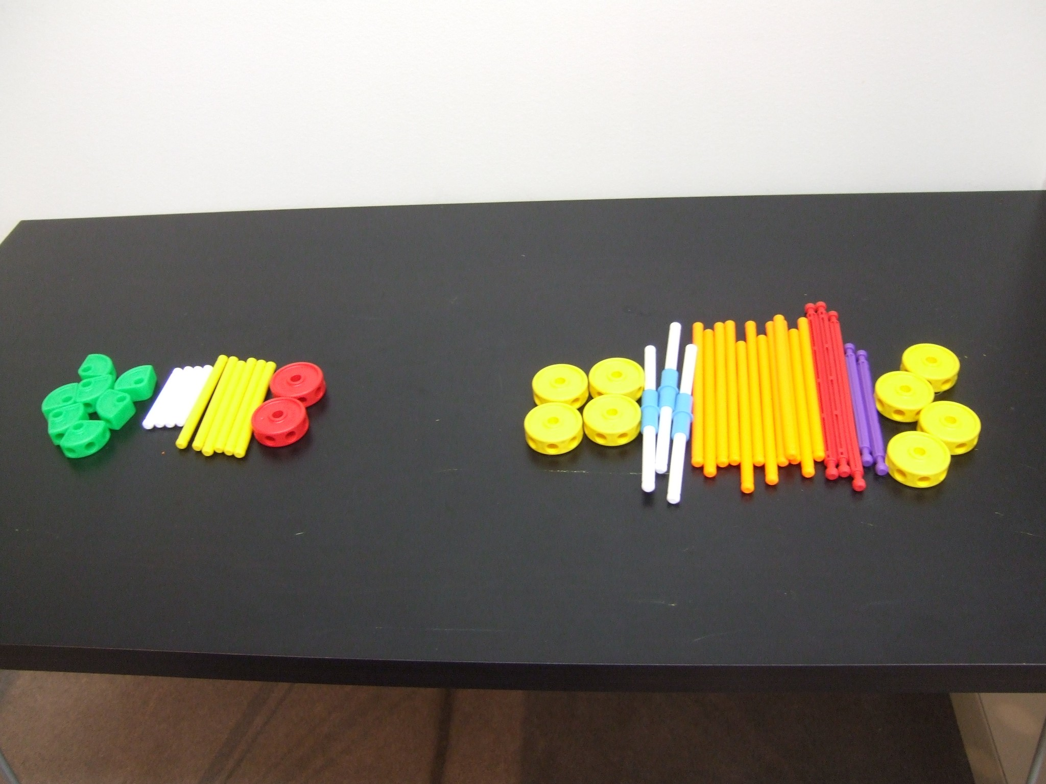

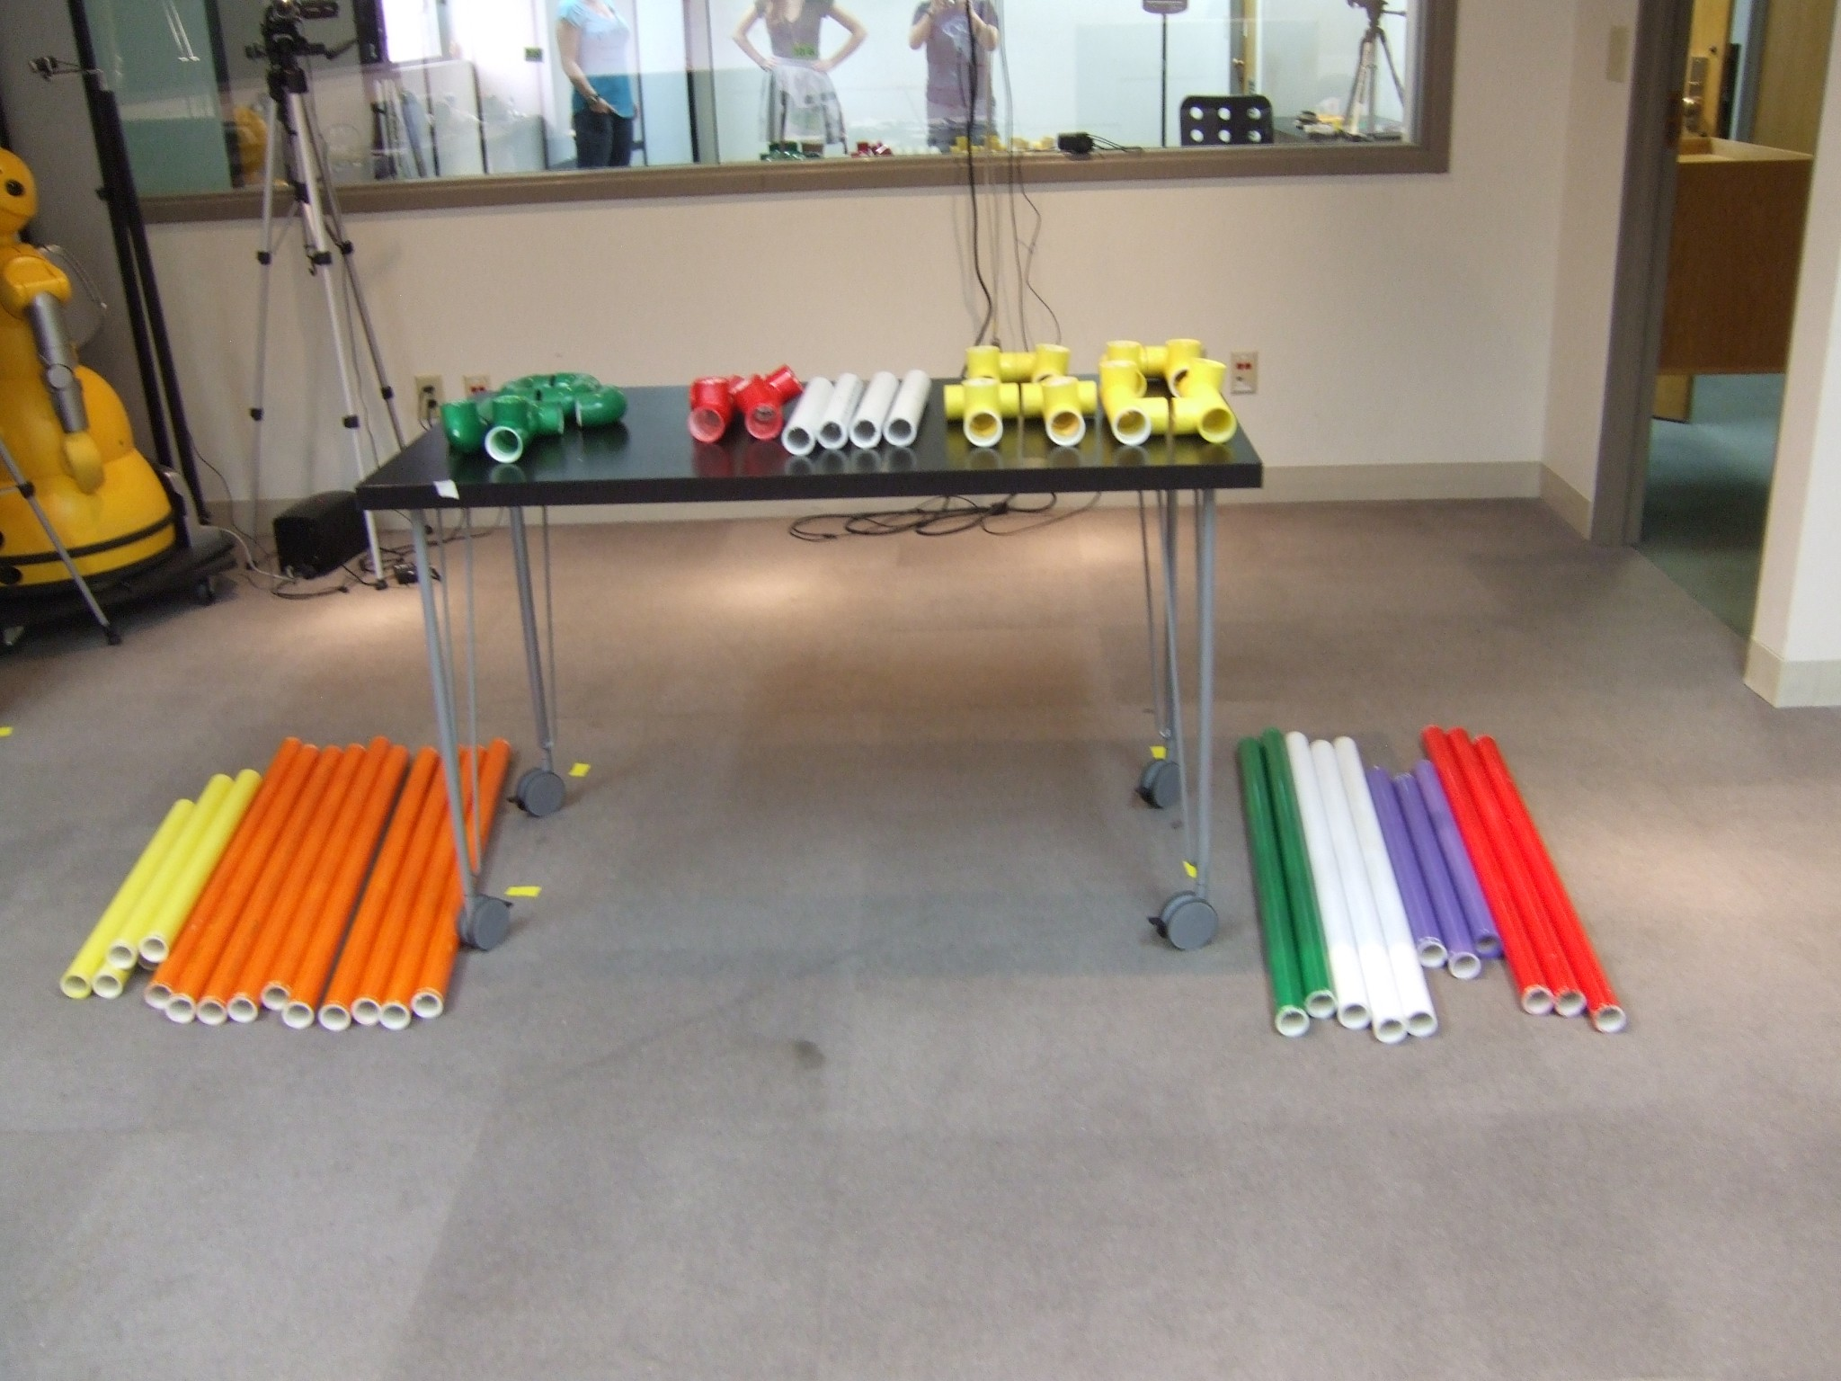

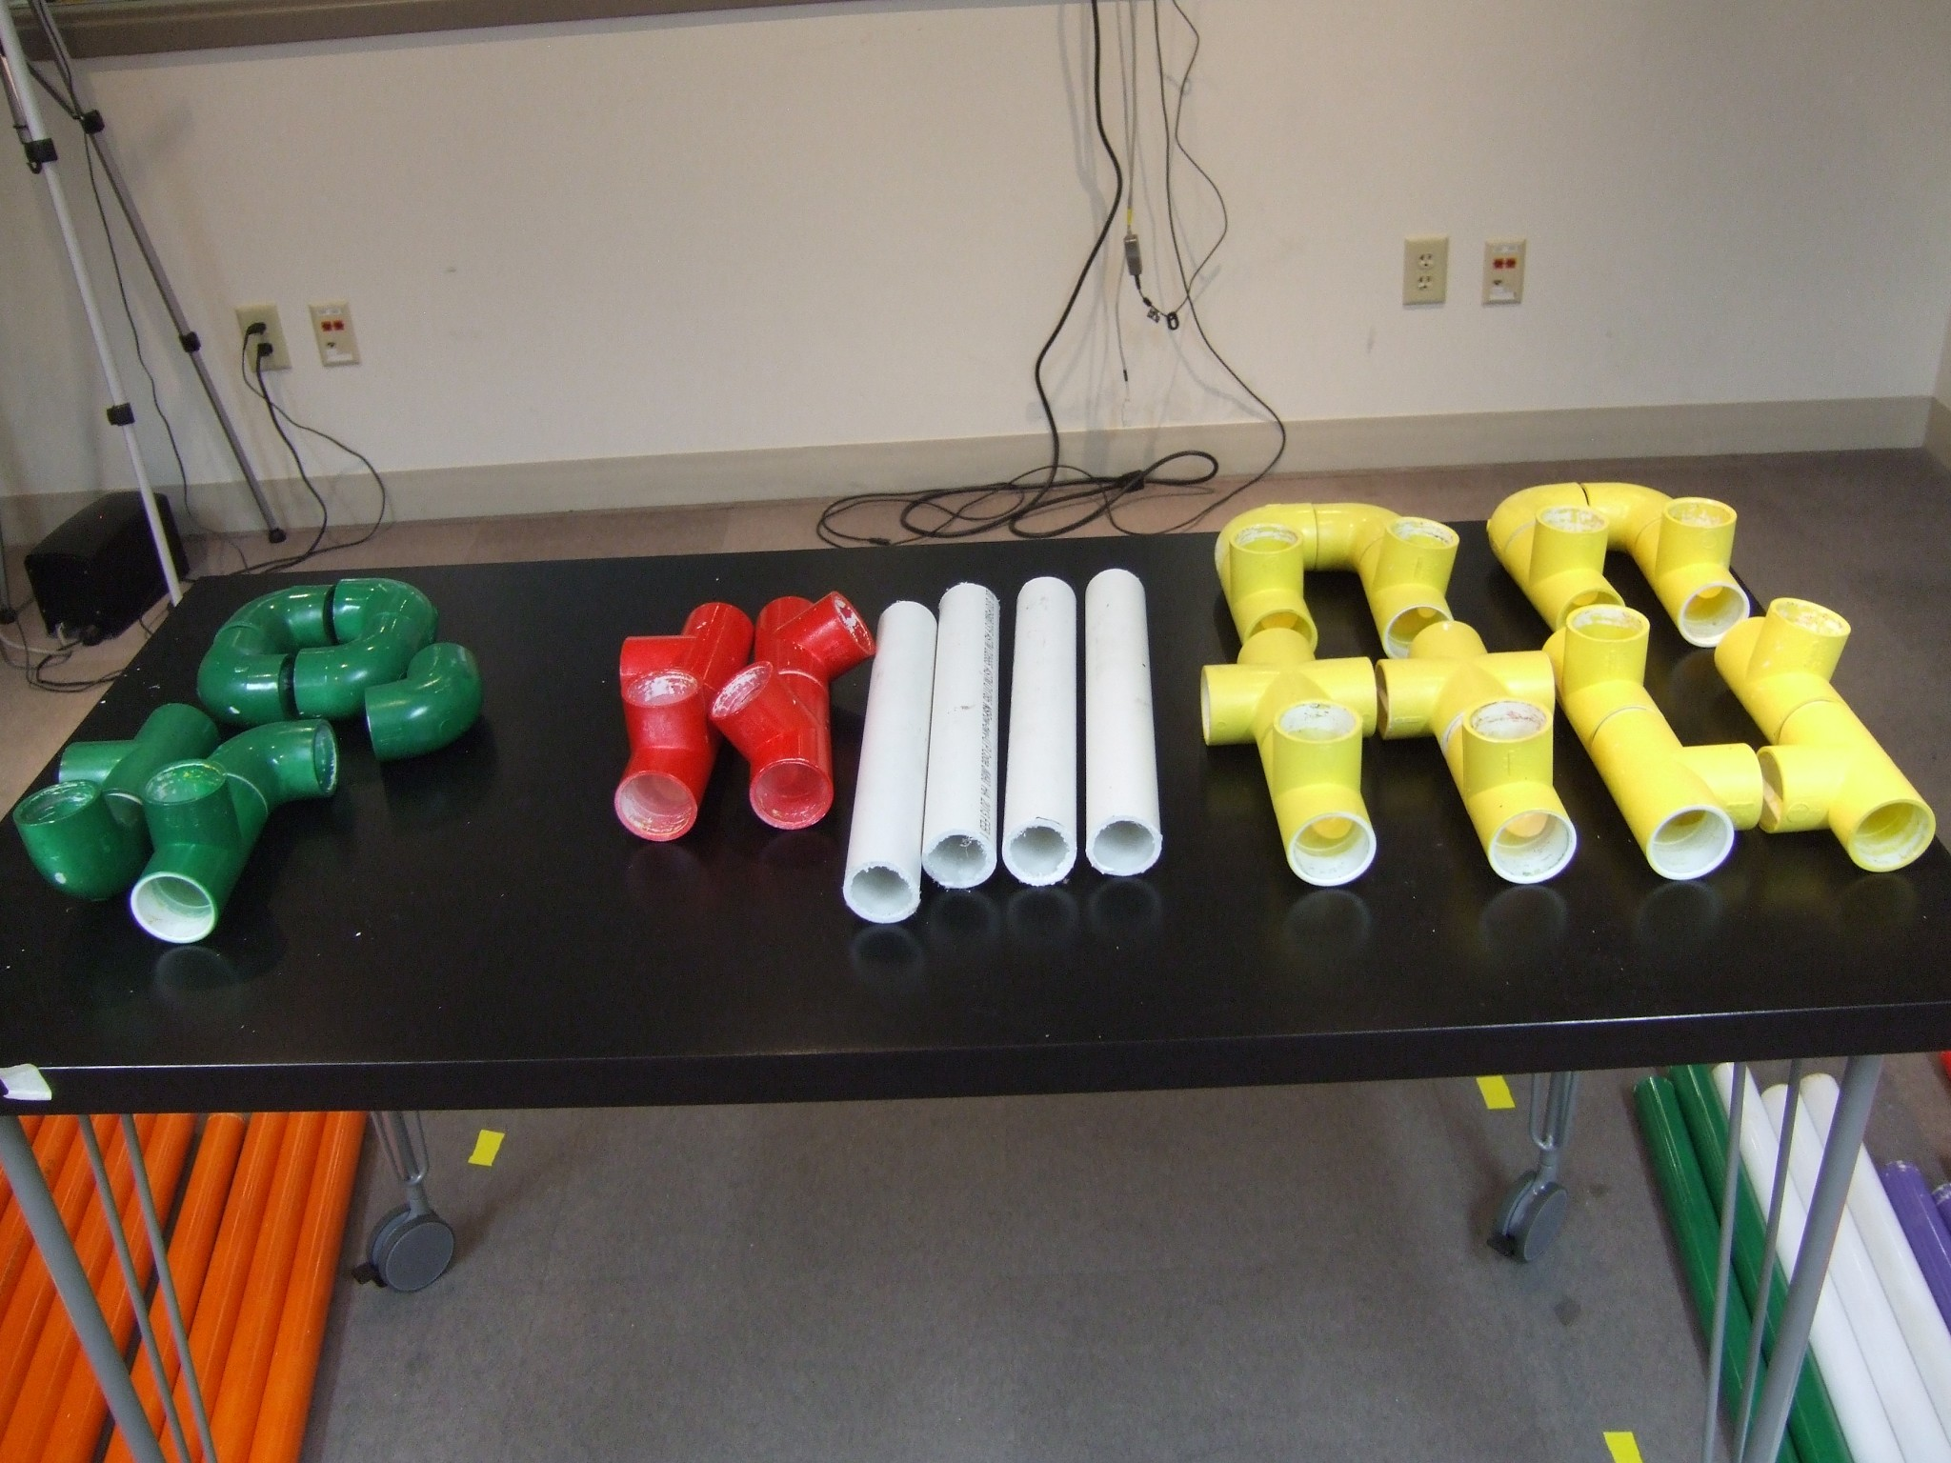

**Clean up checklist:**

* charge ipad
* transfer files from cameras and put memory cards back in cameras
* number questionnaires for the next day with participant id’s
* make sure there is enough money to pay participants for next session
* lock up payment forms and money
* lock up ipad

**For library side:**

* black, green, and blue pens are ready for questionnaires
* paperwork ready (consent form, training sheet, questionnaires, experimenter sheet)
* check that there is enough space for video
* log in robot
* make sure Skype window has been enlarged

**Clean up checklist:**

* transfer videos to lab computer

return filled in paperwork to lab box

**Lab side protocol**

***1. Introduction & Consent***

<**during this time answer the call on the robot and mute the robot so that the library participant can do their training**>

*<Outside of room>*

Experimenter: Hi, are you <their name>? Great! I’m <your name>, nice to meet you, thank you so much for coming in!

Experimenter: If you could please just have a seat here <wait for them to sit down>. <if needed> would you like for me to take your bag? I can keep an eye on it while you do the study <put bag in lab for safekeeping>

Experimenter: <put consent form in front of them> The first thing I have is a consent form for you to fill out. The two places to pay attention to are one the back here <point> where you need to say yes or no and initial, this is whether or not we can use your anonymized video in scientific publications, and here <point> where there’s a place for you to sign. There are two copies, one for you and one for me, just fill out the one for me. If you have any questions on this please let me know.

<experimenter should leave room or avoid staring at participant while they read, during this time if the person was recruited off the street, message the other experimenter to tell them the person’s name, **set up table in room when training is complete, move the camera back, and turn it on**>

***2. Overview***

<after participant has signed, take sheet>

Experimenter: Great! Today you’ll be working with another person who’s participating in the study from Memorial LIbrary. You’ll be working together to complete the construction of two objects. **They** will have the diagram for building the objects and **you** will have the parts. You’ll construct one object at a time and will fill out a questionnaire in between building the objects.

For each object that you build ***correctly,*** in a ***faster time*** than any other teams that have done the study, you will receive an extra dollar.

Do you have any questions on that?

<if yes, answer questions, if no, proceed>

***3. First construction task***

Experimenter: Ok, please give me just a minute to get the room set up. <have participant wait outside while you set up>

<turn on the video camera, set timer to 0 minutes, wait for confirmation from library experimenter that system is unmuted, then continue>

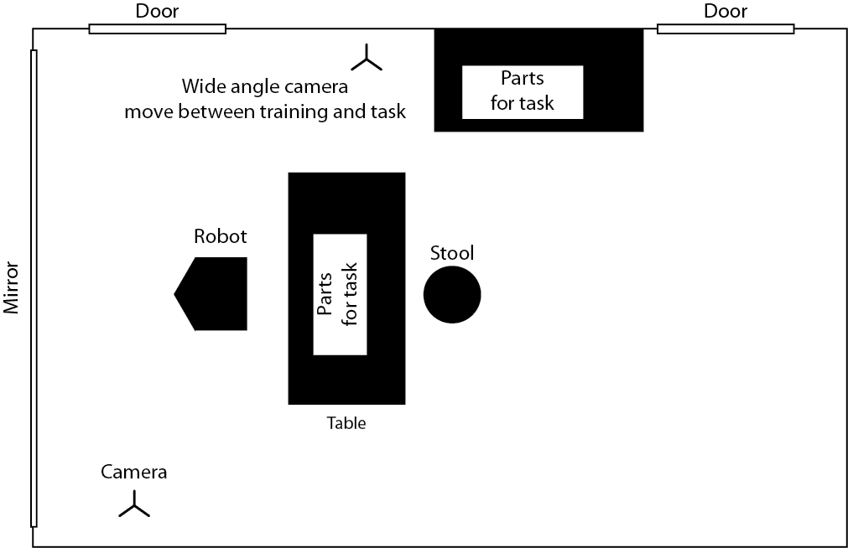

Experimenter: Ok, let’s introduce the two of you. <bring participant into room>

Experimenter: <to remote person> Hi, are you <name of remote person>? Great! This is <name of local person>, <name of local person>, this is <name of remote person>. <name of remote person> do you have the diagram for building the first object? <wait for yes, if no, message library experimenter to provide the sheet>.

Experimenter: All right, so you have the instructions. The orientation that you build the object in doesn’t matter as long as the correct colored pieces are in the correct locations. When you’re done constructing the object, please open the door so that I know that you’ve finished. Do either of you have any questions? <if yes, answer questions, if no, continue>

Experimenter: Ok, then I’ll leave you to it. <start timer and exit the room>

<re-enter the room when the door is opened and **turn off camera**>

Experimenter: All right, <to the remote user> if you could just wait here then you’ll be getting your instructions shortly. <to the local user> If you could please follow me <lead person out of the room and have them sit at the table outside>.

Experimenter: <give participant the first questionnaire> Here’s the first questionnaire for you. Take your time and just let me know when you’re done.

<experimenter should enter room at this point, **turn robot camera off and mute, take a picture** of first object, check construction of the first object and **rate on sheet**, **disassemble object**, and swap tables for second construction project, **reset timer, when disassembling complete turn camera back on and un-mute**>

***4. Second construction task***

Experimenter: Done? Ok, let me just check if <remote person’s name> is done too, give me a minute. <check if they’re done, if not, delay: “he/she’s not done yet, let’s give them a few more minutes”>

<message other experimenter to confirm when they are both done with the questionnaire, when they’re both done, proceed>

Experimenter: <when both are done> All right, we’ll head back in so you can work together to make the second object. <lead participant back into lab room and have them take a seat again, <**turn on camera**>

Experimenter: All right, so <remote person’s name> do you have the diagram for the next object? <wait for yes> Do either of you have any questions? <if yes, answer questions, if no, continue>

Experimenter: Ok, then just open the door again when you’re done <**turn on timer** and exit room>

<once door is open, re-enter, **turn off camera**>

Experimenter: Hi again, <to remote person> please wait here again and <look at local person> if you could follow me? <lead local out of room and have them take a seat at the desk outside of the lab>

Experimenter: Ok, here’s the last questionnaire, just let me know when you get done with that. <give participant second questionnaire>

<while they’re filling out second questionnaire, enter room, **take picture** of second object, check construction of the second object and **rate on sheet**, **disassemble object, reset timer**>

***5. Debrief***

<when questionnaire is complete>

Experimenter: All done? Great! Thank you so much for taking the time to help us with the study! I just have one more thing for you to fill out so we can pay you <give payment sheet to participant to fill out> We told you that you would get an extra dollar for each object that you built correctly in the shortest amount of time to incentivize you, but in reality we’re just going to give you the extra two dollars.

What we were looking at today was how differences in the mobility of the video system that you’re using might make it easier or more difficult to complete tasks in different situations. For example, you interacted with a system that <didn’t move/was able to orient/had full mobility> in two tasks that required varying levels of environmental awareness. The reason we’re looking at this is because there are a number of systems like these that are out now that provide different amounts of mobility, but whether or not this mobility is necessary in all contexts and how that mobility is really going to affect your ability to work together hasn’t really been looked at. Do you have any questions on that? <if yes, answer questions, if no, pay person>. If you think you might be interested in participating in future studies, we have a sheet that you can fill out <offer sheet> but if not it’s no problem. Thank you again for coming in!

**Library side protocol**

***1. Introduction & Consent***

*<****Log into robot and mute it>***

*<Outside of room>*

Experimenter: Hi, are you <their name>? Great! I’m <your name>, nice to meet you, thank you so much for coming in!

Experimenter: If you could please just have a seat here <wait for them to sit down>. <if needed> would you like for me to take your bag? I can keep an eye on it while you do the study <put bag in lab for safekeeping>

Experimenter: <put consent form in front of them> The first thing I have is a consent form for you to fill out. The two places to pay attention to are one the back here <point> where you need to say yes or no and initial, this is whether or not we can use your anonymized video in scientific publications, and here <point> where there’s a place for you to sign. There are two copies, one for you and one for me, just fill out the one for me. If you have any questions on this please let me know.

<experimenter should leave room or avoid staring at participant while they read, during this time if the person was recruited off the street, message the other experimenter to tell them the person’s name>

***2. Overview***

<after participant has signed>

Experimenter: Great! Today you’ll be working with another person who’s participating in the study from the **Computer Science** **building**. First, we’ll give you a few minutes to train on the videoconferencing system that you’ll be using to communicate with the other person. After that, you’ll be working together to complete the construction of two objects.

Do you have any questions on that?

<if yes, answer questions, if no, let participant into room and ask them to sit down, then proceed>

***3. Training***

Experimenter: Ok, so as I said, you’ll be logging in to a videoconferencing system to interact with the other person. You’ll have as much time as you need to get acquainted with the system.

<If on the orientation condition> Experimenter: On this interface these two slide bars or these buttons control the orientation of your camera. You can turn the camera by moving this slider <demonstrate> and tilt the camera using this slider <demonstrate>. The rest of the interface is for diagnostic purposes so just ignore it.

<if on the mobility condition> Experimenter On this interface these two slide bars or these buttons control the orientation of your camera. You can turn the camera by moving this slider <demonstrate> and tilt the camera using this slider <demonstrate>. You can drive the system around by clicking and holding with the left mouse button on this area <demonstrate> then drag the mouse in the direction that you want to go. <demonstrate> This lets you move the robot around in the room.

In order to do the training, there will be 20 words scattered around for you to find. Each word has a number next to it. Please find all of the words in order and write the sentence that they make on this sheet <give participant the training sheet>. Do you have any questions on that? <if yes, answer questions, if no, continue>

When you’re done, just open the door so that I know and we can move on to the next part. <leave the room and close the door>

***3. First construction task***

<re-enter room and **mute skype**>

Please re-position the robot so that it is facing the table in the center of the room.

<**start recording software**>

Now you’ll be building two objects with another person who’s doing the study in the Computer Science building. You will have the diagrams for building the objects and they will have the parts, but you are not allowed to show them the diagrams. You’ll construct one object at a time and will fill out a questionnaire in between building the objects.

For each object that you build ***correctly*** in a ***faster time*** than any of the other teams that have done the study, you will receive an extra dollar.

Do you have any questions on that?

<if yes, answer questions, if no, proceed>

Experimenter: Ok, let’s introduce the two of you. The experimenter on that side will instruct you on this next part. Just open the door again when you get done with this part.

<**unmute Skype**>

<exit the room and wait for them to signal that they’re done>

<re-enter the room when the door is opened, **turn off recording software**>

Experimenter: All right, we’ll just mute the system <mute the system> for now while you fill out the questionnaire. <hand the participant the questionnaire> Just open the door when you get finished so I know you’re done. <exit the room>

***4. Second construction task***

<message other experimenter to confirm when they are both done with the questionnaire, when they’re both done, proceed>

Experimenter: Done? Ok, let me just check if <remote person’s name> is done too, give me a minute. <check if they’re done, if not, delay: “he/she’s not done yet, let’s give them a few more minutes”>

Experimenter: <when both are done> All right, here’s the diagram for the next object <give participant the instruction sheet and **turn on recording software**>. We’ll just un-mute the system again and the experimenter there will give you directions. Again, just open the door when you’re done. <un-mute the system and then leave the room>

<once door is open, re-enter, **turn off recording software**>

Experimenter: Ok, here’s the last questionnaire, <hand over questionnaire and log out the system> just let me know when you get done with that by opening the door.

***5. Debrief***

<when questionnaire is complete>

Experimenter: All done? Great! Thank you so much for taking the time to help us with the study! I just have one more thing for you to fill out so we can pay you <give payment sheet to participant to fill out> We told you that you would get an extra dollar for each object that you built correctly in the shortest amount of time to incentivize you, but in reality we’re just going to give you the extra two dollars.

What we were looking at today was how differences in the mobility of the video system that you’re using might make it easier or more difficult to complete tasks in different situations. For example, you interacted with a system that <didn’t move/was able to orient/had full mobility> in two tasks that required varying levels of environmental awareness. The reason we’re looking at this is because there are a number of systems like these that are out now that provide different amounts of mobility, but whether or not this mobility is necessary in all contexts and how that mobility is really going to affect your ability to work together hasn’t really been looked at. Do you have any questions on that? <if yes, answer questions, if no, pay person>. If you think you might be interested in participating in future studies, we have a sheet that you can fill out <offer sheet> but if not it’s no problem. Thank you again for coming in!