

{{TODAY_LONG}}

Via Fax: {{meds.provider.fax1}}
{{meds.provider.name}}
{{meds.provider.address1line1}}
{{meds.provider.address1city}}, {{meds.provider.address1state}} {{meds.provider.address1zip}}
Telephone: {{meds.provider.work1}}

Re: My Client: {{fullname}}
Date of Birth: {{clientBirthdate}}
Date of Injury: {{incidentDate}}

To Whom It May Concern:

The purpose of this transmittal is to let you know that {{fullname}}’s case was LOST AT TRIAL. {{fullname}}’s bill amount of {{meds.amount}} from {{meds.provider.name}} will not be paid through Higdon Lawyers as there will be no recovery for this case. Attached is a copy of the Judgment from the Court.

If you have any questions, contact Mary Higdon at 713-223-7300.

Very truly yours,

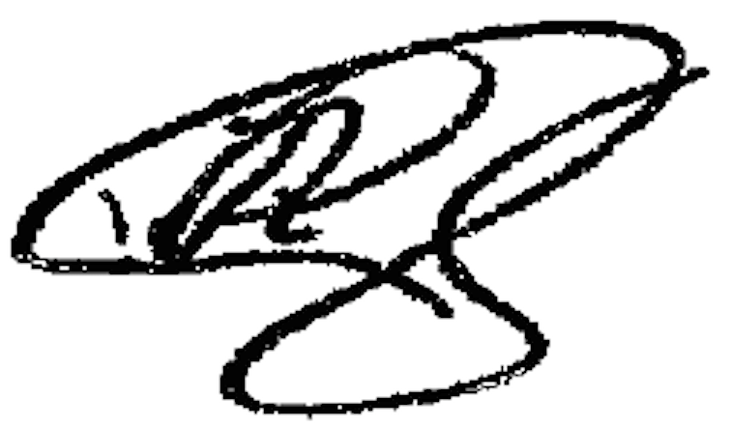

Paul Higdon

