

{{TODAY_LONG}}

Via Fax: {{meds.provider.fax1}}
{{meds.provider.name}}
{{meds.provider.address1line1}}
{{meds.provider.address1city}}, {{meds.provider.address1state}} {{meds.provider.address1zip}}
Telephone: {{meds.provider.work1}}

Re: My Client: {{fullname}}
Social Security: {{ssn}}
Date of Birth: {{clientBirthdate}}
Date of Injury: {{incidentDate}}

To Whom It May Concern:

This law firm represents {{fullname}} regarding the insurance related claims arising from an incident in which {{fullname}} suffered personal injuries. As you know, my client has been suffering badly from their injuries sustained in the accident, which was clearly the fault of the defendant. Unfortunately, the defendant, its liability insurance company and its liability insurance company's lawyers have not accepted responsibility for the defendant's actions. It is my understanding that you are currently treating the client for those injuries. Please be advised that the client is of limited financial means and does not have health insurance to cover your charges for the reasonable and necessary medical treatment that you have provided and will provided.

Consequently, our firm will protect payment, in whole or in part, for reasonable and necessary medical charges and expenses incurred by the client. Once the other party's insurance company has paid on this claim, your charges will be deducted and paid out of the proceeds of the recovery, if any, after attorney’s fees and expenses, made on behalf of the patient. In the event the case cannot be settled and must proceed to trial, you, the treating physician agree to testify without additional charge, to prove up and/or defend your bill from Defendant’s expert or counter-affidavit. Failure to do so renders this agreement void and Patient is permitted to settle its claim without regard to this letter of protection.

Further, this letter of protection is not assignable or transferable. The provider to whom this letter of protection is given agrees the account for which this letter is given cannot be sold, transferred, assigned, discounted or factored until such time as the case is completed. Any sale, transfer, assignment, discount or factoring of the account renders this letter of protection void and Patient is permitted to settle its claim without regard for this letter of protection.

It is understood that the charges for medical treatment are the same that would have been charged if the client were able to pay for the services initially or had other means to cover the charges and did not wait for a judgment to be rendered against the defendant's insurance company.

It is also understood that you have no financial interest in the outcome of the claims asserted by the client against the defendant who is actually responsible for caused the injuries.

Thank you for your anticipated assistance and cooperation in this matter.

Very truly yours,

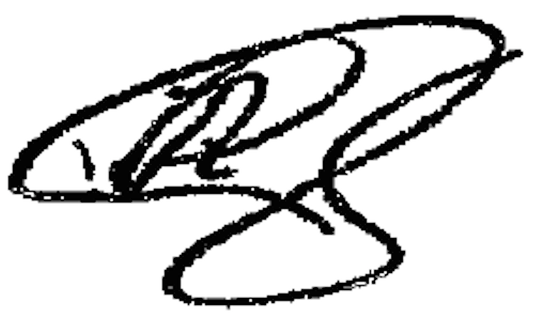

Paul Higdon

