UTA Housing Application

Team 6

The RAs

CSE 3310: Fundamentals of Software Engineering

Iteration 3

12/05/22

Bry: Christopher Gonzalez, Hanumath Ponnaluri, Marshal Marks, Bryan Corona

Table of Contents

Team Project Description **2**

Requirements **4**

Use Case List **5**

High-Level Use Cases **6**

Use Case Diagrams **8**

Requirements to Use Case Traceability Matrix **11**

Increment Matrix **12**

Domain Model **13**

Expanded Use Cases **14**

User Interface Prototypes **22**

Sequence Diagrams **27**

**Design Class Diagram** **33**

Video Link **34**

# Team Project Description

**Summary**

1 The app we have chosen to design/build is a UTA housing hub. The UTA housing portal

2 website is pretty clunky (more so on mobile) and is very plain, so the app we are trying to

3 make will make it easier to apply to on-campus/off-campus housing. The app will let the user

4 make an account to log in and save their information. The user can then look for

5 on-campus and off-campus locations near UTA that will have visuals, information about the

6 areas and living spaces, and 3d models. After finding the right choice/s they can complete

7 applications that will offer things like tours and roommate searching.

**Functions**

8 In order to fill out applications, the app shall let the user create an account that will take in their

9 names, email, and password information. Applications for on-campus housing shall have

10 several things that a user can fill out. Such things include Personal & Contact Details,

11 Chapter 62 Registration, Roommate Matching, Room Preference, Online Agreement/Terms & 12 Conditions, and Signature. A messaging section shall be in the app that will house the emails 13 given by housing that contain application responses, general updates, roommate information, 14 and more.

15 The app shall have a listing of the On-Campus options offered by UTA which shall allow

16 the user to view basic information (cost, number, directions, and a link for more details),

17 view images, and a 3D model of the on-campus option provided by UTA housing of the

18 selected housing option.

19 In order to look at the apartments before applying to them, the user can click on a tab to

20 apply to tour the housing. This is convenient so students can have a look at what they are

21 getting to without having to go through this process separately. They can select a date and

22 time and they will be ready to tour their prospective apartments/housing.

23 The app shall contain a catalog of off-campus housing options. The user shall also be able to

24 sort the lists by general location as well as search by name. When a specific housing option is

25 selected, links shall be provided for the websites, phone numbers, email addresses, and

26 physical addresses for each of the selected housing option. A map view that shows the

27 location relative to UTA.

**Resources**

28 As for the resources we will be using, a database can be used in order to store the information 29 of the users. The UTA housing websites will be used in order to get information about

30 housing as well as Google Maps in order to find the locations of each residence/apartment.

**Team Experience Levels**

*Christopher Gonzalez*: I have no experience with Android development, I had not thought of trying to create an app. As for my experience with java, I learned it in high school but had not really used it since, until 1325. I understand it and have some experience with it, so hopefully, I can pick up quickly on Java for android development.

*Hanumath Ponnaluri*: I am new to android development, but I am decently experienced in Java. My Java is from CSE1325, so I have experience in making a tabletop combat game and simple programs and applications. I hope to learn more about android development through this project.

*Marshal Marks*: I have a lot of experience with Java development, but I am still fairly new to Android development specifically. I hope to learn how to use the Android development environment and apply my Java knowledge to this project.

*Bryan Corona*: I do not have any experience with Android development since I have not tried making an app of some sort. My experience with Java is still pretty much from CSE 1325 but I am trying to learn more about it.

# Requirements

| Req Id | Req Statement | Line |
| --- | --- | --- |
| R1 | The app shall let the user create an account that will take in their name, email, and password information | 8-9 |
| R1.1 | The app shall let the user reset their password | 10-11 |
| R1.2 | The app shall let the user change their account information (name, email, password) | derived |
| R2 | The app shall have applications for on-campus housing that the user can fill out | 9 |
| R2.1 | The app shall include Personal & Contact Details, Chapter 62 Registration, Roommate Matching, Room Preference, etc in the applications | derived |
| R3 | The app shall have a messaging section | 12 |
| R3.1 | The app shall have messages from housing containing application responses, general updates, roommate information, and more | 13-14 |
| R4 | The app shall let the user schedule a tour by taking in credentials including their name, email, and phone number | 19 |
| R4.1 | The app shall let the user change the tour date | derived |
| R5 | The app shall show a listing of the on campus housing options | 15 |
| R5.1 | The app shall have a search function in the listing | derived |
| R6 | The app shall let the user view high low cost, images, number, directions, and 3D model (model provided by uta website) | 16 |
| R7 | The app shall show a listing of the off campus housing options | 23 |
| R7.1 | The app shall let the user sort housing options by region | 23-24 |
| R7.2 | The app shall let the user search for the name of a housing option | 24 |
| R7.3 | The app shall allow the user to select a housing option that will take them to the profile of said housing | 24-25 |
| R8 | The app shall let each housing option have its own profile page | derived |
| R8.1 | The app shall show the apartment name and address | 26 |
| R8.2 | The app shall display a map view of the location of the housing option | 26-27 |
| R8.3 | The app shall provide contact information for the housing option (website, phone number, email address) in the profile page | 25 |
| R9 | The app shall let the admin view student files | derived |
| R10 | The app shall let the admin update housing information | derived |

# 

# Use Case List

| Use Case # | Use Case Name |
| --- | --- |
| UC1 | Login |
| UC1.1 | User Registration |
| UC2 | View on-campus housing |
| UC2.1 | Use search function |
| UC2.2 | View information |
| UC2.3 | View 3d models |
| UC3 | Apply for touring the housing |
| UC4 | Apply to on-campus housing |
| UC5 | View off-campus housing options |
| UC5.1 | Filter by region |
| UC5.2 | Use search function |
| UC6 | View profile for off-campus housing |
| UC7 | Check messaging section |
| UC8 | Reset password |
| UC9 | Change account information |
| UC10 | View Student Applications |
| UC11 | Update Housing Info |

# High-Level Use Cases

* UC1 Login
* TUCBW the user enters their login information and clicks the ‘Login’ button
* TUCEW the user gets signed in
* UC1.1 User Registration
* TUCBW the user entering their information and clicks create account
* TUCEW the user getting sent to the home menu
* UC2 View on-campus housing
* TUCBW the user on app home and clicks on campus housing button
* TUCEW the user clicking or searching a housing option
* UC2.1 Use search function
* TUCBW the user enters the the specific housing option and clicks search button
* TUCEW the user will view an updated on campus housing page meeting the information entered
* UC2.2 View information
* TUCBW the user clicks on a on-campus housing option in on-campus housing page
* TUCEW the user is sent to specified on-campus housing page with information of selected option
* UC2.3 View 3d models
* TUCBW the user clicks on 3D model button for specified on-campus housing page
* TUCEW the user is redirected to internet browser to view provided 3D model of on-campus housing option
* UC3 Apply for touring the housing
* TUCBW the user clicks on the schedule a tour in the home menu
* TUCSW the user gets confirmation of when and where the tour is scheduled for
* UC4 Apply to on-campus housing
* TUCBW the user clicks on ‘apply for on-campus housing’
* TUCEW the user gets a confirmation of the application
* UC5 View off-campus housing options
* TUCBW the user clicks on ‘off-campus housing’ in the home menu
* TUCEW the user closes the app or clicks to another section of the app
* UC5.1 Filter by region
* TUCBW the user clicks the “region” button above the housing list
* TUCEW the user clicks the “region” button again, clicks the back button, or opens a housing profile
* UC5.2 Use search function
* TUCBW the user clicks on the search bar and types the text they want to search
* TUCEW the user clicks the back button or opens a housing profile
* UC6 View profile for off-campus housing
* TUCBW the user selects a specific housing option to view
* TUCEW the user clicks the ‘back’ button to exit that profile page
* UC7 Check Messaging Section
* TUCBW the user clicking on the messaging section in the home menu
* TUCEW the app displaying messages sent by housing or confirmation of message sent
* UC8 Reset password
* TUCBW the user clicks on ‘reset password’.
* TUCEW the user gets a confirmation that an email was sent to reset their password
* UC9 Change account information
* TUCBW the user clicks account information in the home menu
* TUCEW the user getting confirmation after entering new information
* UC10 View Student Applications
* TUCBW the admin clicks on files in the home menu
* TUCEW the admin seeing the completed files
* UC11 Update Housing Info
* TUCBW the admin clicks the Update Housing button in the home menu
* TUCEW the admin updating the information of housing

# Use Case Diagrams

Shared use cases

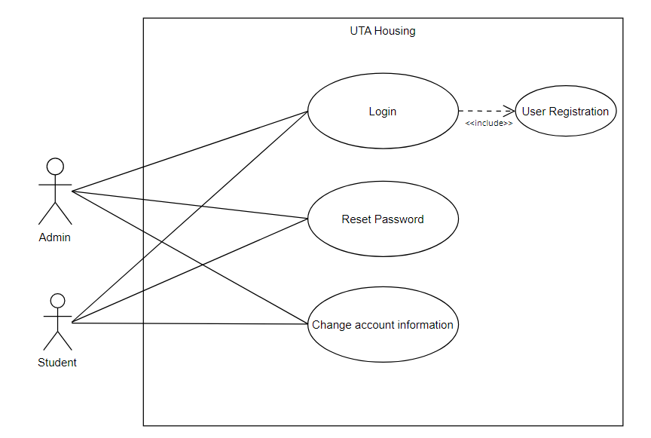

Student specific use cases

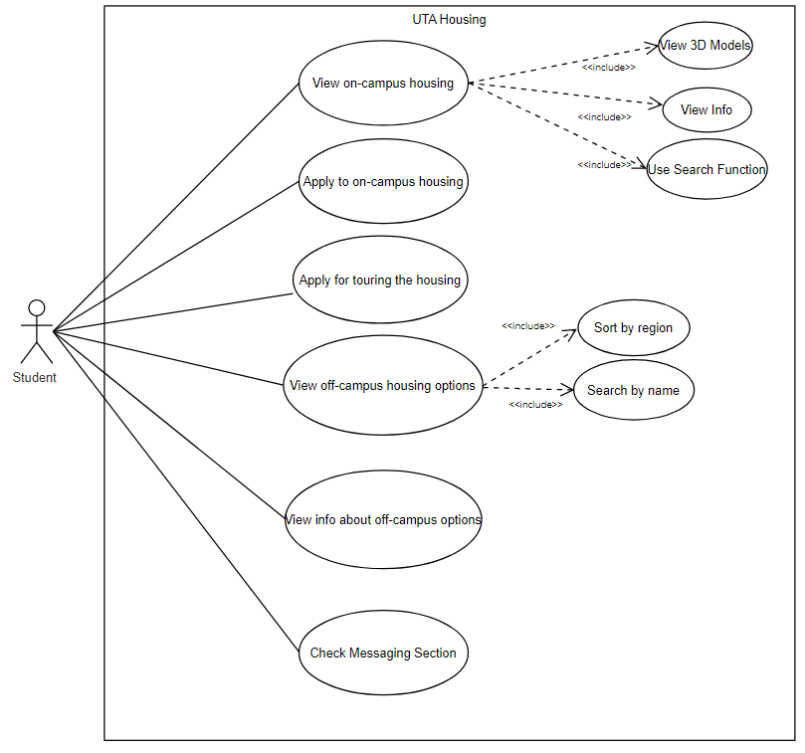

Admin-specific use cases

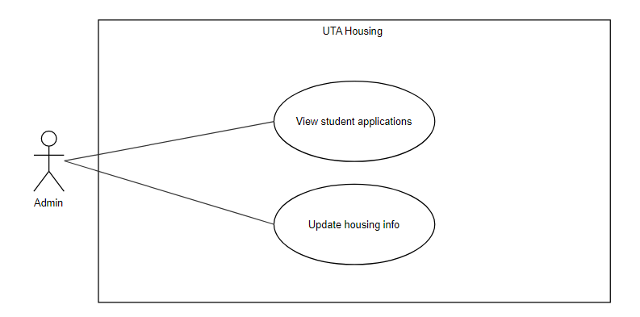

# Requirements to Use Case Traceability Matrix

|  | Priority Weight | UC1 | UC1.1 | UC2 | UC2.1 | UC2.2 | UC2.3 | UC3 | UC4 | UC5 | UC5.1 | UC5.2 | UC6 | UC7 | UC8 | UC9 | UC10 | UC11 |
| --- | --- | --- | --- | --- | --- | --- | --- | --- | --- | --- | --- | --- | --- | --- | --- | --- | --- | --- |
| R1 | 1 | X | X |  |  |  |  |  |  |  |  |  |  |  | X | X |  |  |
| R1.1 | 7 |  |  |  |  |  |  |  |  |  |  |  |  |  | X |  |  |  |
| R1.2 | 8 |  |  |  |  |  |  |  |  |  |  |  |  |  |  | X |  |  |
| R2 | 1 |  |  |  |  |  |  |  | X |  |  |  |  |  |  |  |  |  |
| R2.1 | 1 |  |  |  |  |  |  |  | X |  |  |  |  |  |  |  |  |  |
| R3 | 10 |  |  |  |  |  |  |  |  |  |  |  |  | X |  |  |  |  |
| R3.1 | 10 |  |  |  |  |  |  |  |  |  |  |  |  | X |  |  |  |  |
| R4 | 5 |  |  |  |  |  |  | X |  |  |  |  |  |  |  |  |  |  |
| R4.1 | 5 |  |  |  |  |  |  | X |  |  |  |  |  |  |  |  |  |  |
| R5 | 5 |  |  | X |  |  |  |  |  |  |  |  |  |  |  |  |  |  |
| R5.1 | 6 |  |  |  | X |  |  |  |  |  |  |  |  |  |  |  |  |  |
| R6 | 5 |  |  |  |  | X | X |  |  |  |  |  |  |  |  |  |  |  |
| R7 | 3 |  |  |  |  |  |  |  |  | X |  |  |  |  |  |  |  |  |
| R7.1 | 3 |  |  |  |  |  |  |  |  |  | X |  |  |  |  |  |  |  |
| R7.2 | 3 |  |  |  |  |  |  |  |  |  |  | X |  |  |  |  |  |  |
| R7.3 | 4 |  |  |  |  |  |  |  |  | X |  |  |  |  |  |  |  |  |
| R7.4 | 2 |  |  |  |  |  |  |  |  | X |  |  |  |  |  |  |  |  |
| R8 | 4 |  |  |  |  |  |  |  |  |  |  |  | X |  |  |  |  |  |
| R8.1 | 4 |  |  |  |  |  |  |  |  |  |  |  | X |  |  |  |  |  |
| R8.2 | 4 |  |  |  |  |  |  |  |  |  |  |  | X |  |  |  |  |  |
| R8.3 | 3 |  |  |  |  |  |  |  |  |  |  |  | X |  |  |  |  |  |
| R9 | 3 |  |  |  |  |  |  |  |  |  |  |  |  |  |  |  | X |  |
| R10 | 7 |  |  |  |  |  |  |  |  |  |  |  |  |  |  |  |  | X |
| Score | | 1 | 1 | 5 | 20 | 5 | 5 | 10 | 2 | 9 | 6 | 6 | 15 | 20 | 8 | 9 | 3 | 7 |

NOTE: Priority 1 is highest priority. Work on first

# Increment Matrix

| Use Case | Priority | Effort  (Person-Weeks) | Depends On | Assigned To | Iteration 1  (10/14) | Iteration 2  (11/2) | Iteration 3  (12/5) |
| --- | --- | --- | --- | --- | --- | --- | --- |
| UC1 | 1 | 1 | None | BC |  | 1 |  |
| UC1.1 | 1 | 2 | None | BC | 1 | 1 |  |
| UC2 | 5 | 2 | None | CG |  | 2 |  |
| UC2.1 | 20 | 2 | UC2 | CG |  | 1 | 1 |
| UC2.2 | 5 | 1 | UC2 | CG |  | 1 |  |
| UC2.3 | 5 | 1 | UC2 | CG |  |  | 1 |
| UC3 | 10 | 2 | None | HP |  | 1 | 1 |
| UC4 | 2 | 5 | UC1 | BC |  | 4 | 1 |
| UC5 | 9 | 3 | None | MM,HP |  | 1 | 2 |
| UC5.1 | 6 | 2 | UC5 | MM,HP |  |  | 2 |
| UC5.2 | 6 | 2 | UC5 | MM,HP |  | 1 | 1 |
| UC6 | 15 | 3 | None | MM |  | 2 | 1 |
| UC7 | 20 | 3 | UC1,UC3,UC4 | BC |  | 1 | 2 |
| UC8 | 8 | 1 | UC1 | BC |  |  | 1 |
| UC9 | 9 | 1 | UC1 | BC |  |  | 1 |
| UC10 | 3 | 2 | UC4 | CG,MM,HP |  |  | 2 |
| UC11 | 7 | 2 | UC2,UC5,UC6 | CG,MM,HP |  |  | 2 |
| Total Effort | | 35 |  |  | 1 | 16 | 18 |

1 Person-week=5 hours

Team members: Christopher G, Hanumath P, Marshal M, Bryan C

# Domain Model

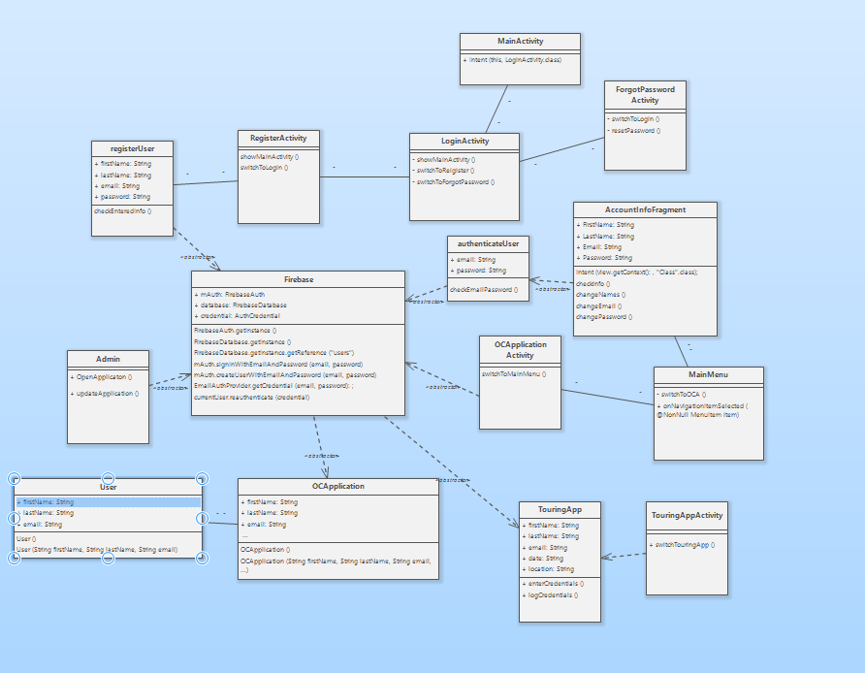

# Expanded Use Cases

EUC 1: Login

| Precondition: The use case assumes that the user is already registered in the app. | |
| --- | --- |
| Actor: User | System: UTA Housing |
| 1. **TUCBW** the user enters their login information and clicks the ‘Login’ button.  3. **TUCEW** the user gets signed in. | 0. System displays the login page.  *2. System validates submitted info and displays a message if the user is not found.(See UIP 1) |
| Postcondition: The user is sent to the home page. | |

EUC 1.1: User Registration

| Precondition: The use case assumes the user has clicked on ‘Register’ on the login page and was redirected to the registration page. | |
| --- | --- |
| Actor: User | System: UTA Housing |
| 1. **TUCBW** the user enters their information and clicks ‘Register’.  3. **TUCEW** the user getting sent to the home menu. | 0: System displays the register page.  *2. System validates submitted info, displays if any information is wrongly entered/already taken, and adds the user information to Firebase if done correctly. (See UIP 1.1) |
| Postcondition: N/A | |

EUC 2: View On Campus Housing

| Precondition: The user is logged in | |
| --- | --- |
| Actor: User | System: UTA Housing |
| 1.**TUCBW** the user on app home and clicks on-campus housing button  3.**TUCEW** the user clicking or searching a housing option | 0. System displays main menu  2.System displays on campus housing listing |
| Post Condition: N/A | |

EUC 2.2: View On Campus Housing information

| Precondition: User is viewing on-campus housing options | |
| --- | --- |
| Actor: User | System: UTA Housing |
| 1.**TUCBW** the user clicks on an on-campus housing option in on-campus housing page  3.**TUCEW** the user is sent to a specified on-campus housing page with information of selected option | 0.System displays on campus housing listing  2.System displays the appropriate housing option |
| Post Condition: N/A | |

EUC 2.3: View On Campus 3D Model

| Precondition: User is viewing a on campus housing option | |
| --- | --- |
| Actor: User | System:UTA Housing |
| 1.**TUCBW** the user clicks 3-D Model  3.**TUCEW** the user is sent to web page of housing model | 0.System displays on campus housing option  2.System redirects user to web page of housing model |
| Post Condition: N/A | |

EUC 3: Apply for touring the housing

| Precondition: The app assumes the User is logged in | |
| --- | --- |
| Actor: User | System: UTA housing |
| 1. **TUCBW**: The user clicks on apply to tour the housing  3. The User enters the email, phone, date, and housing they would like to tour  5. **TUCEW**: The user gets a confirmation to tour the housing they requested | 0. The System displays main page    2. The system displays touring application  4. The system displays a confirmation |
| Post Condition: None | |

EUC 4: Apply to on-campus housing

| Precondition: The use case assumes the user has logged in and is on the main page. | |
| --- | --- |
| Actor: User | System: UTA Housing |
| 1. **TUCBW** the user clicks on ‘apply for on-campus housing’  3. The user fills out the application and clicks on the ‘submit’ button.  5. **TUCEW** the user gets a confirmation of the application | 0: System displays the main page  2. System displays the housing application  *4. System validates submitted info and displays if there is any error found.(See UIP 4) |
| Postcondition: The application is saved into the database for an admin to look at | |

EUC 5: View off-campus housing options

| Precondition: The use case assumes the user has logged in and is on the main page. | |
| --- | --- |
| Actor: User | System: UTA Housing |
| 1. **TUCBW** the user clicks on ‘off-campus housing’ in the home menu  3. **TUCEW** the user clicks the back button or opens a housing profile | 0. System displays main page  2.System displays a list of off-campus housing options |
| Postcondition: N/A | |

EUC 5.1: Filter by region

| Precondition: User is viewing the off-campus housing page | |
| --- | --- |
| Actor: User | System: UTA Housing |
| 1. **TUCBW** the user clicks the “region” button in the header toolbar  3. The user clicks the regions they want to filter by to select them  5. **TUCEW** the user clicks the “region” button again, clicks the back button, or opens a housing profile | 0: System displays the off-campus housing page  2. System opens the region selection menu  4. System adds selected regions to filter list and updates housing options in real time |
| Postcondition: N/A | |

EUC 5.2: Use search function

| Precondition: User is viewing the off-campus housing page | |
| --- | --- |
| Actor: User | System: UTA Housing |
| 1. **TUCBW** the user clicks on the search bar and types the text they want to search  3. **TUCEW** the user clicks the back button or opens a housing profile | 0: System displays the off-campus housing page  2. System updates internal search string and displays matching housing options in real time |
| Postcondition: N/A | |

EUC 6: View profile for off-campus housing

| Precondition: User is viewing the off-campus housing page | |
| --- | --- |
| Actor: User | System: UTA Housing |
| 1. **TUCBW** the user selects a specific housing option to view  3. **TUCEW** the user clicks the ‘back’ button to exit that profile page | 0: System displays the off-campus housing page  2. System displays the appropriate housing option |
| Postcondition: N/A | |

EUC 7: Check Messaging Section

| Precondition: The use case assumes the user has logged in and is on the main page. | |
| --- | --- |
| Actor: User | System: UTA Housing |
| 1. **TUCBW** the user clicking on the messaging section in the home menu  3. The user clicks on their desired option and enters information if needed.  5. **TUCEW** the app displaying messages sent by housing or confirmation of the message sent | 0: System displays the login page.  2. System displays a page letting the user pick either “compose message” or “view messages”  *4. System validates the entered info and updates Firebase DB/ Checks if the user has messages for him |
| Postcondition: Newly created messages are saved to Firebase DB | |

EUC 8: Reset Password

| Precondition: The use case assumes the user also has an account for the app | |
| --- | --- |
| Actor: User | System: UTA Housing |
| 1. **TUCBW** the user clicks on ‘reset password’  3. The user enters the email tied to their account.  5. **TUCEW** the user gets a confirmation that an email was sent to reset their password | 0: System displays the login page.  2. System displays the reset password page  *4. System validates the entered email and notifies Firebase to send an email to the user(See UIP 8) |
| Postcondition: The new password is saved in firebase | |

EUC 9: Change account info

| Precondition: The use case assumes the user has logged in and is on the main page. | |
| --- | --- |
| Actor: User | System: UTA Housing |
| 1. **TUCBW** the user clicks account information in the home menu  3. The user picks an option and completes it  3. **TUCEW** the user getting confirmation after entering new information | 0: System displays the home menu  2. The system displays view info and change name/email/password options  *4. The system validates the given input and updates the account information  5. The system sends the user to the main menu |
| Postcondition: None | |

# 

EUC 10: View Student Applications

| Precondition: Admin is logged in | |
| --- | --- |
| Actor: Admin | System:UTA Housing |
| 1.**TUCBW** the admin clicks on files in the home menu  3.**TUCEW** the admin seeing the completed files | 0. System displays files in the home menu  2.System displays a list of applicants’ files |
| Post Condition: N/A | |

EUC 11: Change Housing info

| Precondition: Admin clicks on change info | |
| --- | --- |
| Actor: Admin | System:UTA Housing |
| 1.**TUCBW** the admin clicks on update Housing button in the home menu  3.**TUCEW** the admin updating the information of housing | 0. System displays admin home  2. System displays update info page  4.System updates value information  5. System sends Admin to home |
| Post Condition: N/A | |

# 

# User Interface Prototypes

UIP 1: Login

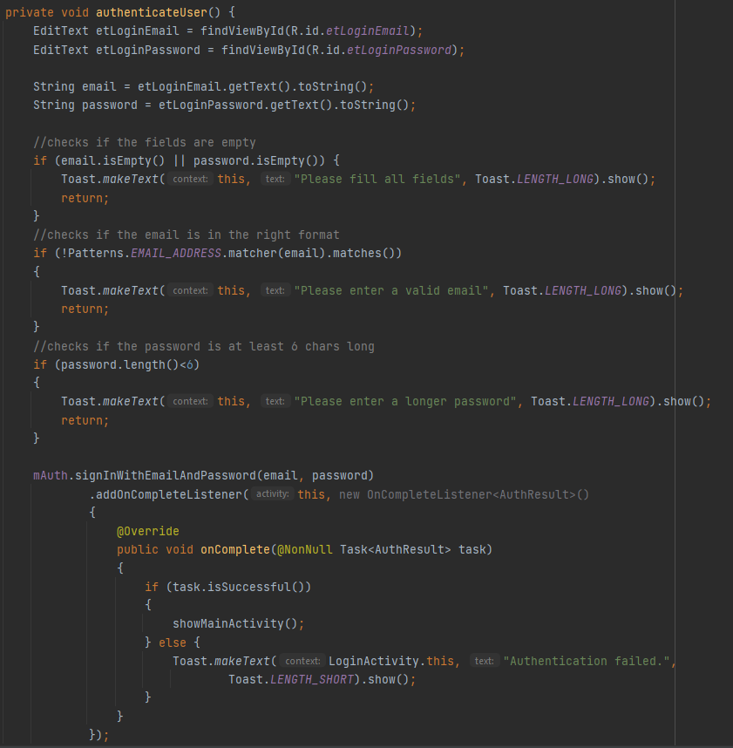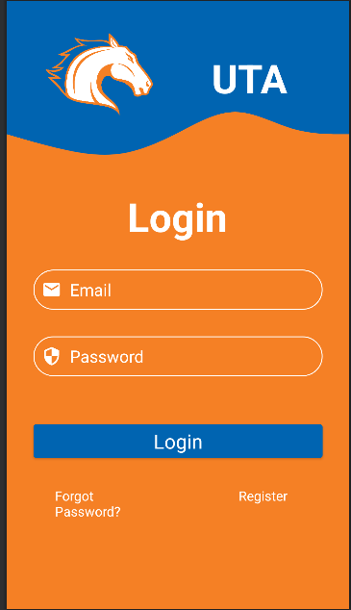

UIP 1.1: User Registration

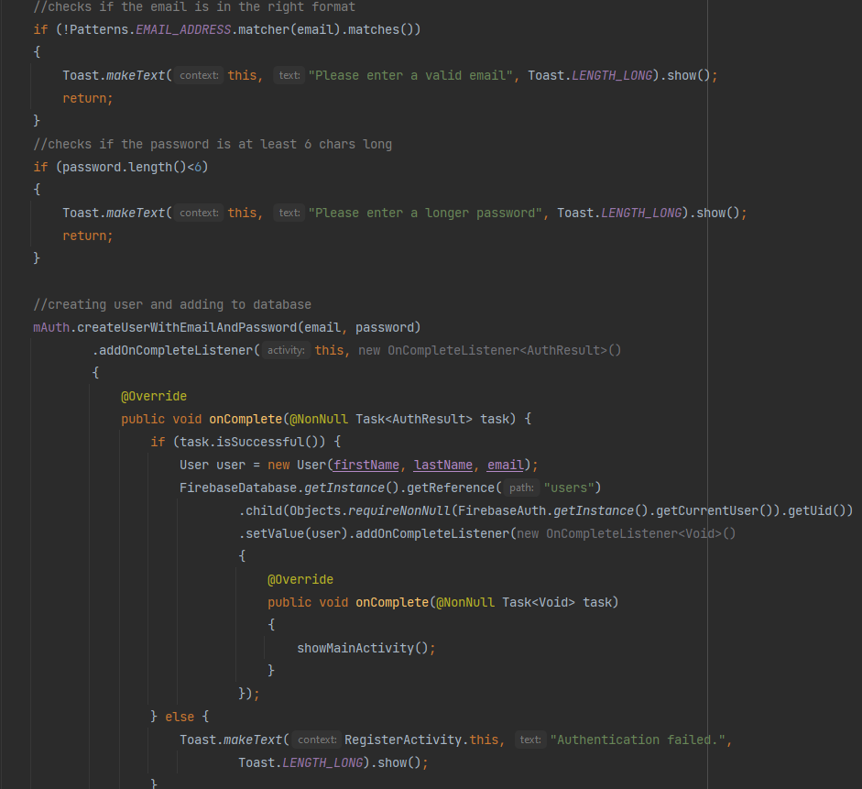

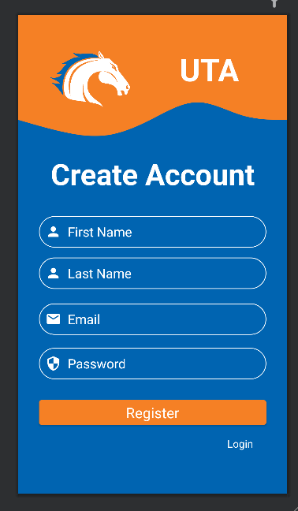

UIP 2: View on campus

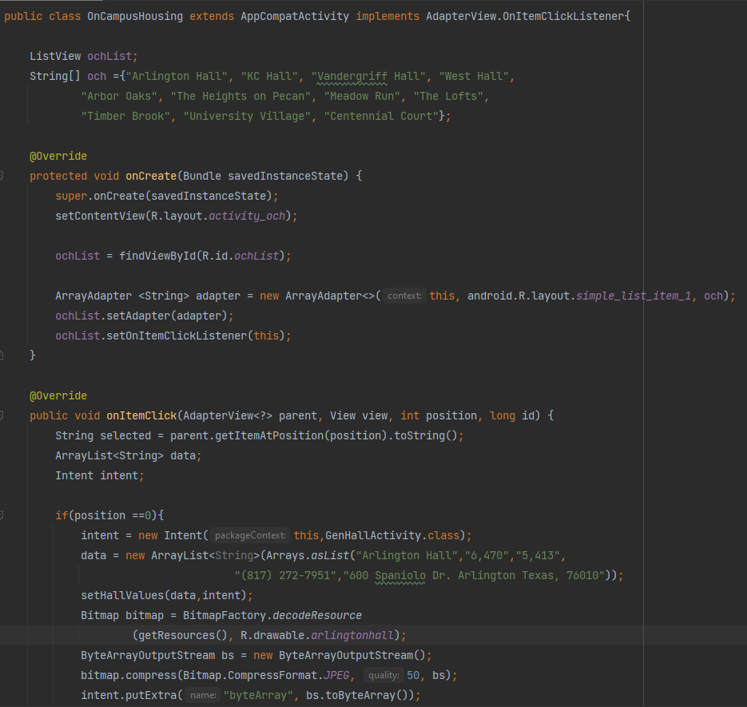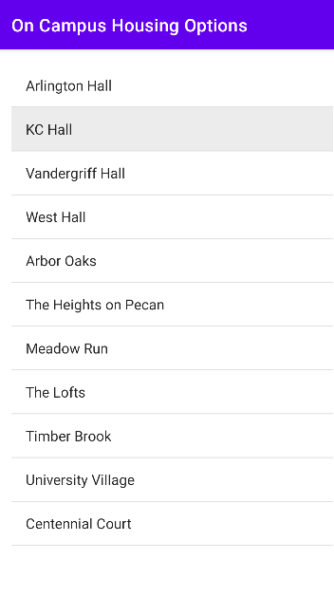

UIP 2.2:View On Campus Housing information

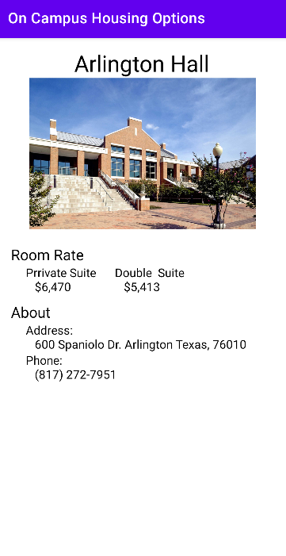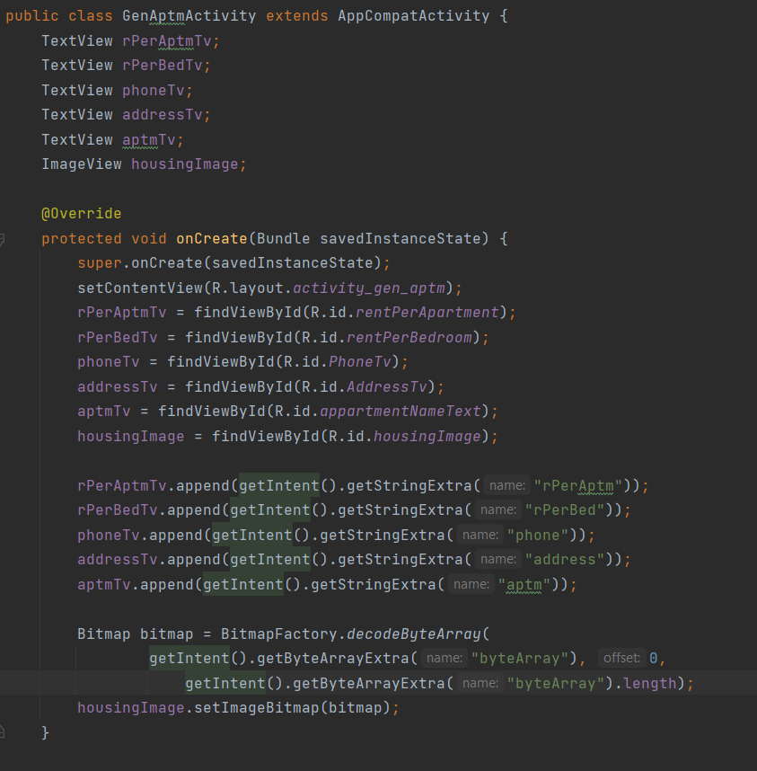

UIP 3: Apply for touring the housing

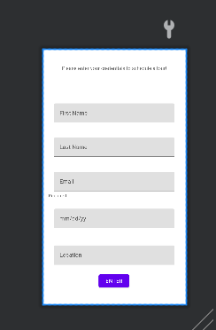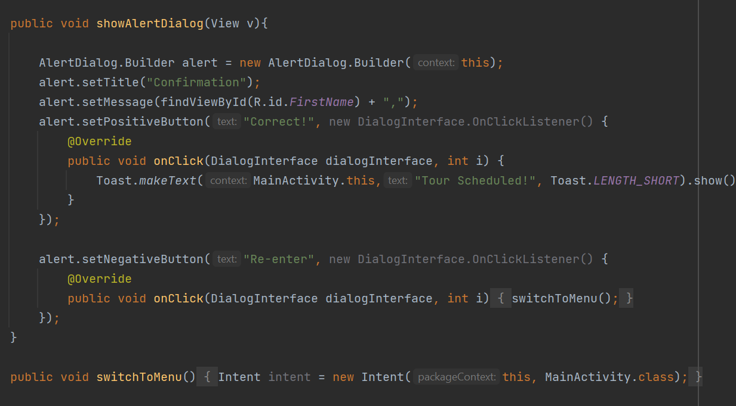

UIP 4: Apply to on-campus housing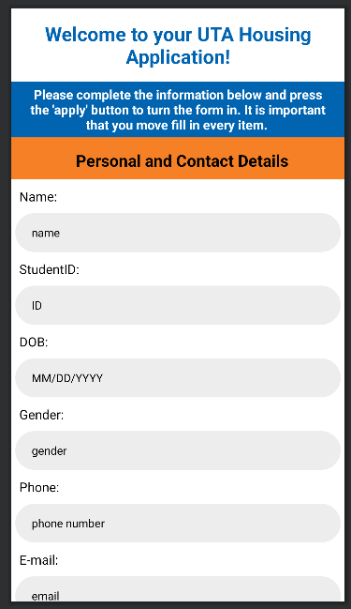

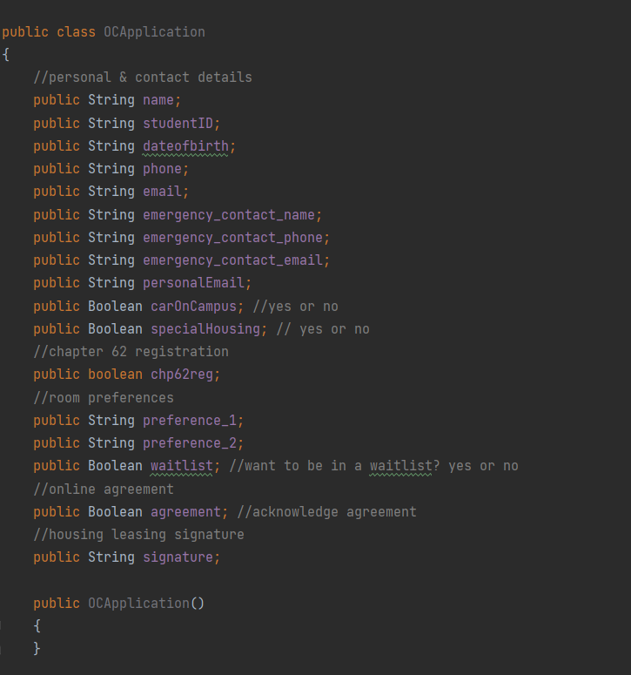

UIP 8: Reset Password

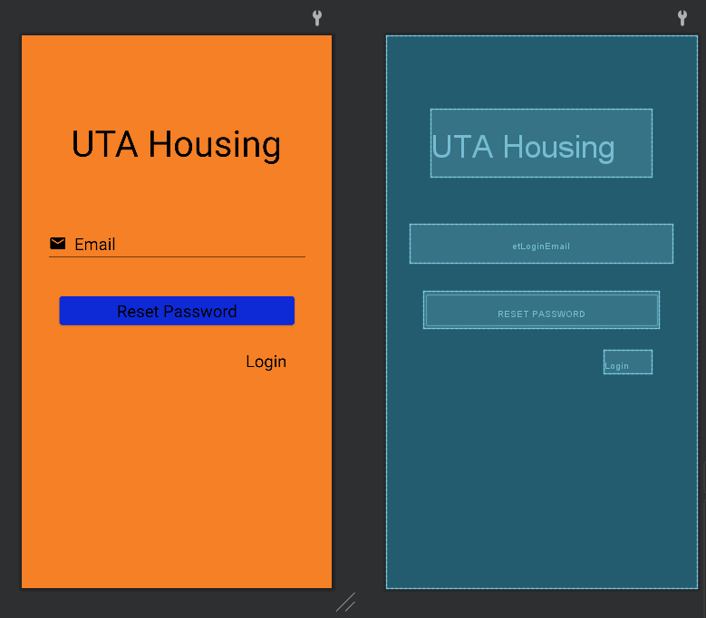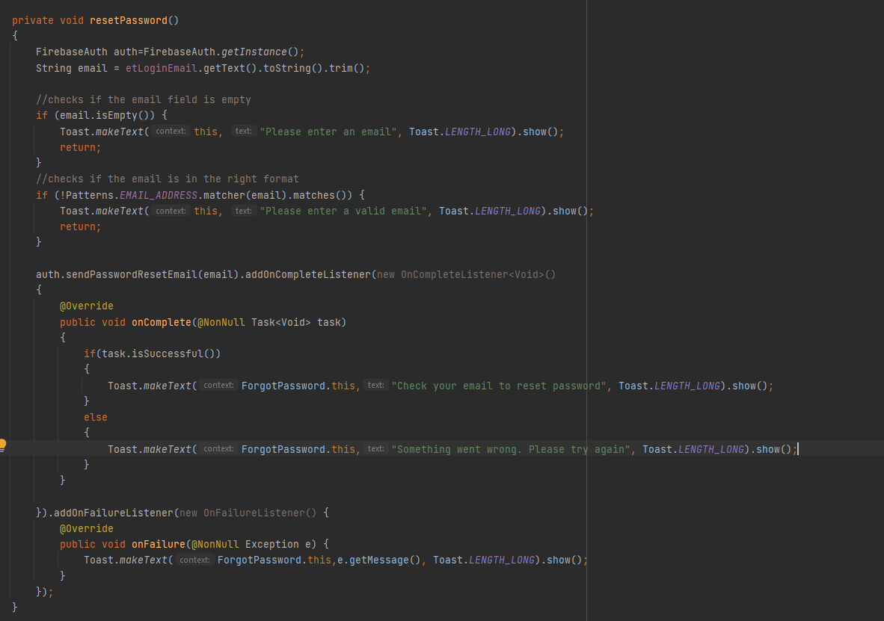

# Sequence Diagrams

UC 1: Login - Analysis Sequence Diagram

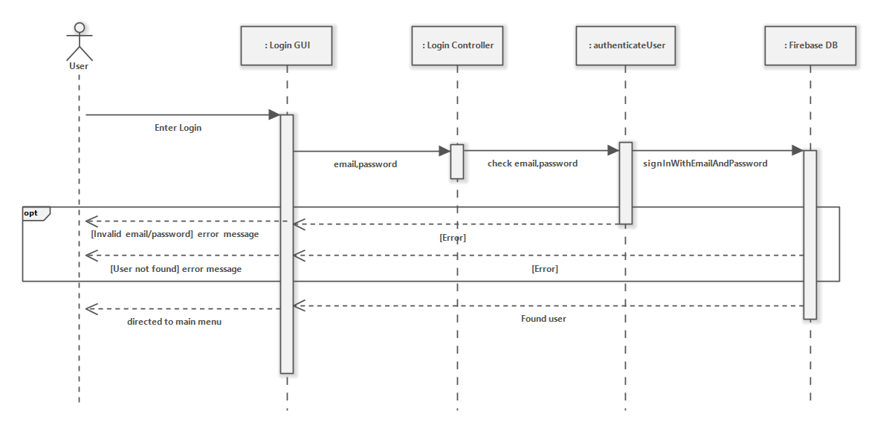

UC 1.1: User Registration - Sequence Diagram

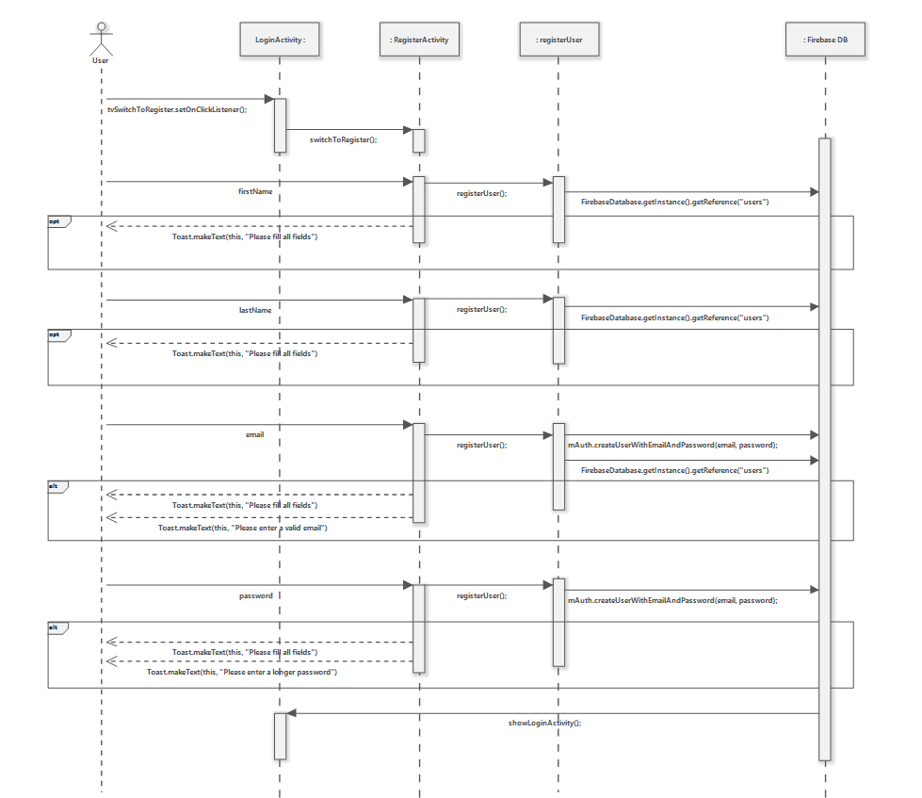

UC 3: Apply for touring the housing - Sequence Diagram

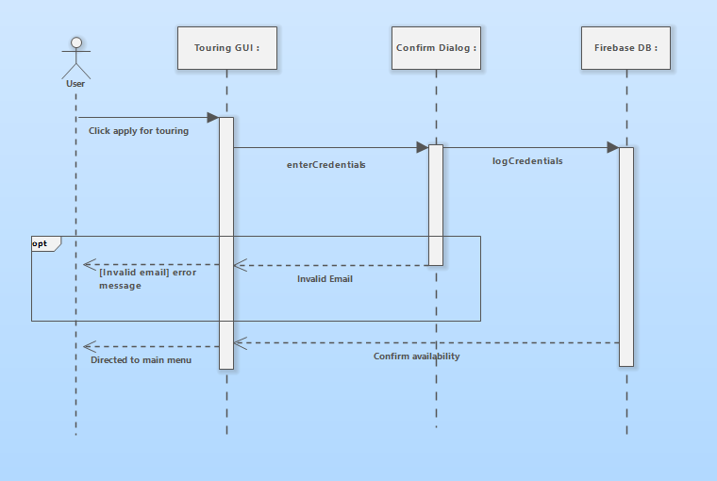

UC 4: Apply to on-campus housing - Sequence Diagram

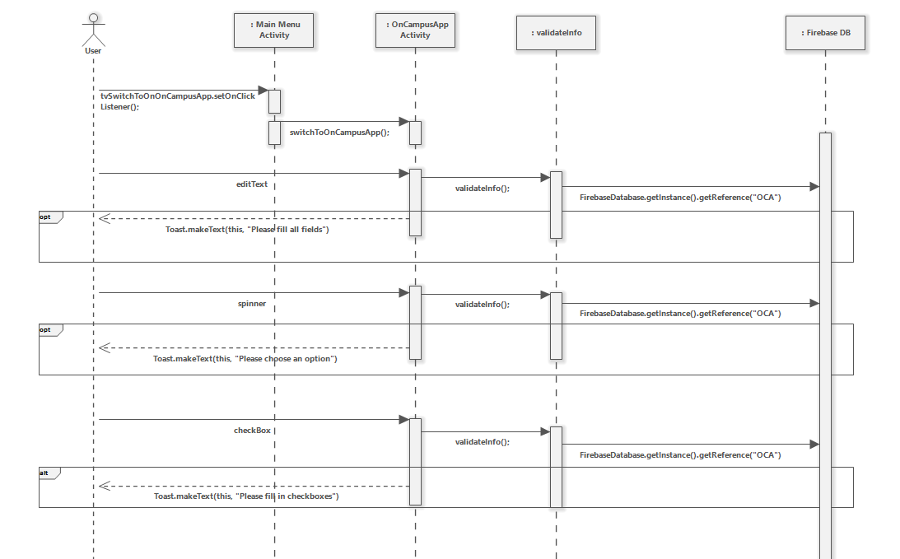

UC 9: Change account info - Sequence Diagram

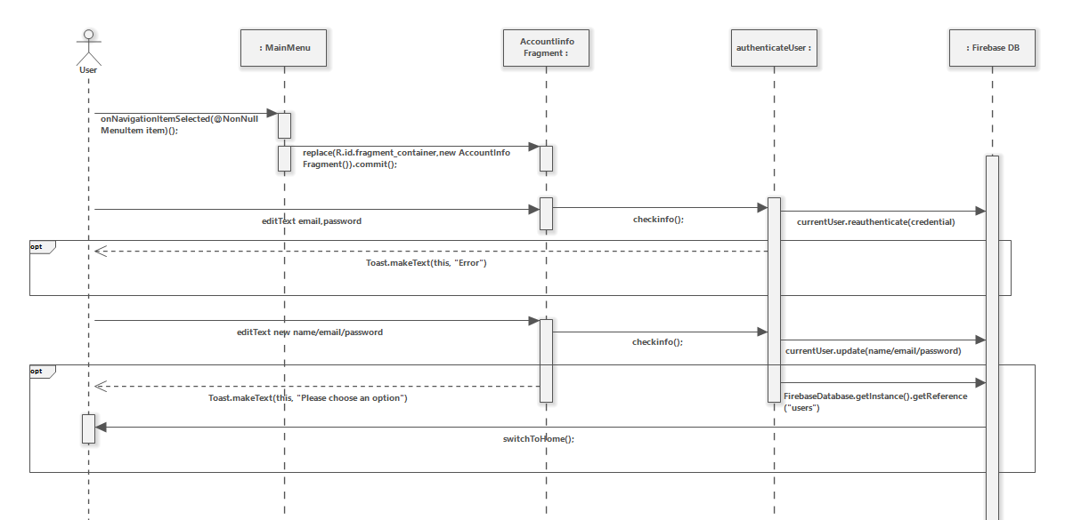

UC 10: View Student Applications - Sequence Diagram

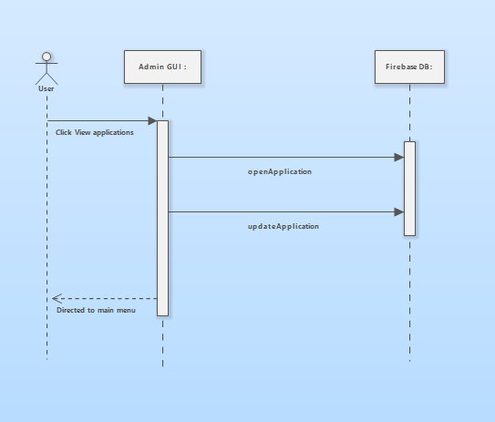

UC 11: Change housing info - Sequence

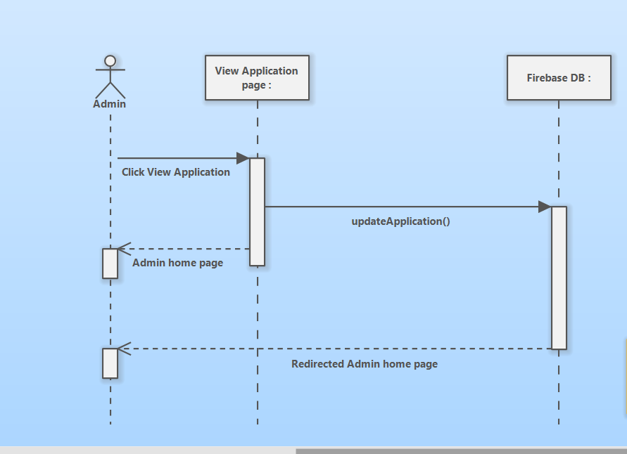

# Design Class Diagram

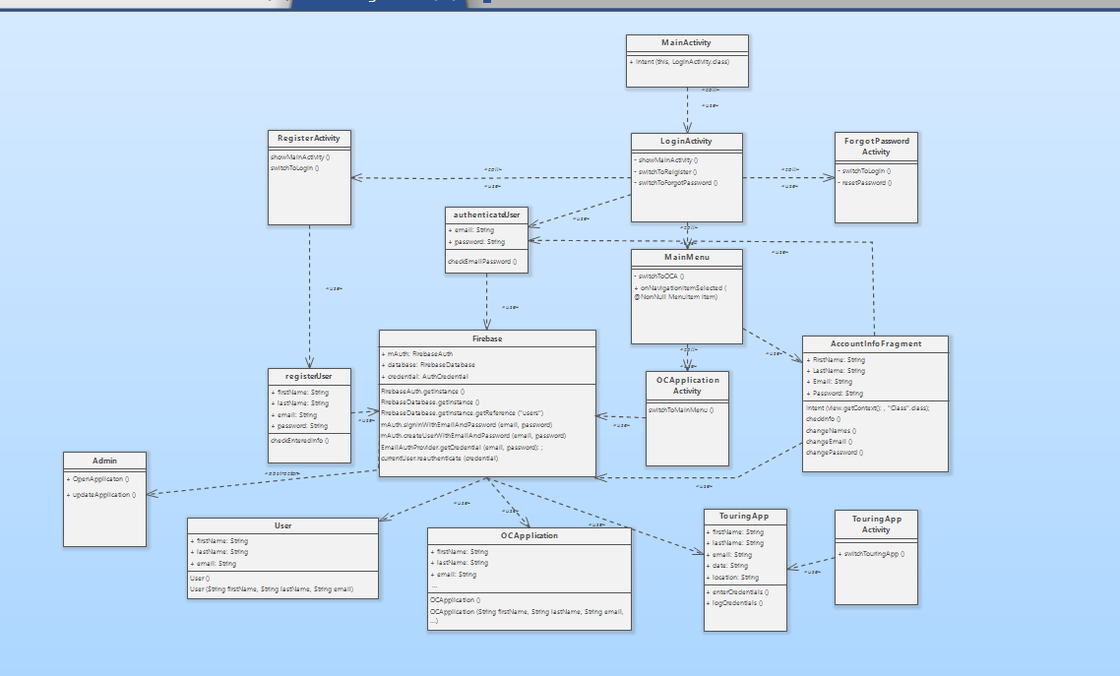

# Video Link

[App Video](https://drive.google.com/drive/folders/1qBHhpf6cxMxN9WjytsR_8elXMRQIZkn9)