Introduction to Linux:

Designing Document Management System

Manual for implementing a workstation through a web-browser interface.

Bryan Yang

Table of Contents

Introduction: 3

Steps: 3

1. Download the latest Ubuntu from the link below:1 3

2. After installing Ubuntu, open the Ubuntu Terminal like image below:1 4

3. Install Recoll using the code below:1 4

4. Create a user to manage the indexing service called *recoll* with following code:1 4

5. Create a directory to files.1 5

6. Put desired PDFs in the directory:1 5

7. Edit *recoll* conf file1 6

8. Make the *recoll* user the owner of the directory: 6

9. Run *recollindex* as user.1 7

10. Install apache and required mod using code below:1 7

11. Install webui using codes below:1 8

12. Edit apache:1 9

13. Restart apache using code below:1 10

14. Open a browser on the host running recoll1 10

Bibliography 10

## Introduction:

Manual for implementing a workstation through a web-browser interface.

All the workstations involved are connected to the same local network.

## Steps:

### Download the latest Ubuntu from the link below:1

<https://ubuntu.com/download>

*Or a preferred Linux system. This manual will go over web-browser interface using Ubuntu.

### After installing Ubuntu, open the Ubuntu Terminal like image below:1

### Install Recoll using the code below:1

*\*sudo apt install recoll python3-recoll*

*Note: If the recoll package does not install successfully, execute the following code:

*sudo apt-get update*

After successfully installing the recoll, the terminal will display this window:

### Create a user to manage the indexing service called *recoll* with following code:1

*sudo adduser recoll*

Reference the image below:

### Create a directory to files.1

*/usr/share/shared_docs/*

Reference the image below:

### Put desired PDFs in the directory:1

*/usr/share/shared_docs/*

Use wget to download the PDFs into the directory.

*sudo apt install wget*

*wget [options] [url]*

Reference the image below:

### Edit *recoll* conf file1

Conf file located at */usr/share/recoll/examples/recoll.conf*. Change the *topdir* to not have trailing slash from *~* to */usr/share/shared_docs*.

Reference the image below:

### Make the *recoll* user the owner of the directory:

*/usr/shrae/shared_docs/*

Reference the image below:

### Run *recollindex* as user.1

Index the files in */usr/share/shared_docs/*

Reference the image below:

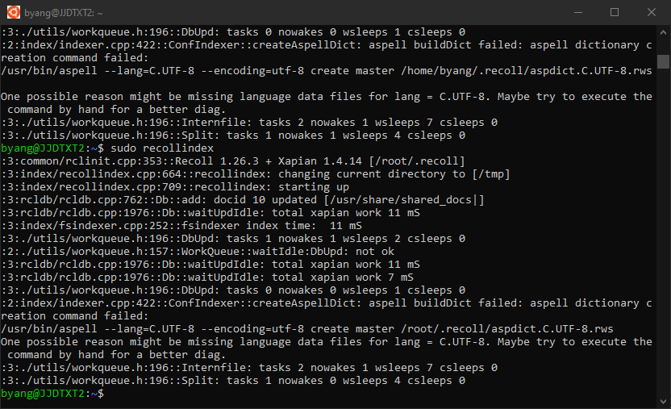

### Install apache and required mod using code below:1

*sudo apt install apache2 libapache2-mod-wsgi-py3*

Reference the image below:

### Install webui using codes below:1

*cd /var/www/*

*sudo wget "https://framagit.org/medoc92/recollwebui/-/archive/master/recollwebui-master.tar.gz"*

*sudo tar -xzvf recollwebui-master.tar.gz*

Reference the image below:

### Edit apache:1

*/etc/apache2/mods-enabled/wsgi.conf*

Reference the image below:

### Restart apache using code below:1

*sudo apachectl retart*

### Open a browser on the host running recoll1

At http://localhost/recoll/

Reference the image below:

## Bibliography

1. “Recoll WebUI with Apache and Nginx from Scratch.” Recoll webui with Apache and Nginx from scratch, 2022. https://www.lesbonscomptes.com/recoll/pages/recoll-webui-install-wsgi.html#apache.