AFFORDABLE HOUSING CAMEROON
Business Concept Plan
Revenue sharing, participant earnings, trust operations, and anti-leakage design
A marketplace where agents, moderators, owners, seekers, payment providers, and the platform each receive clear value from a completed housing journey.
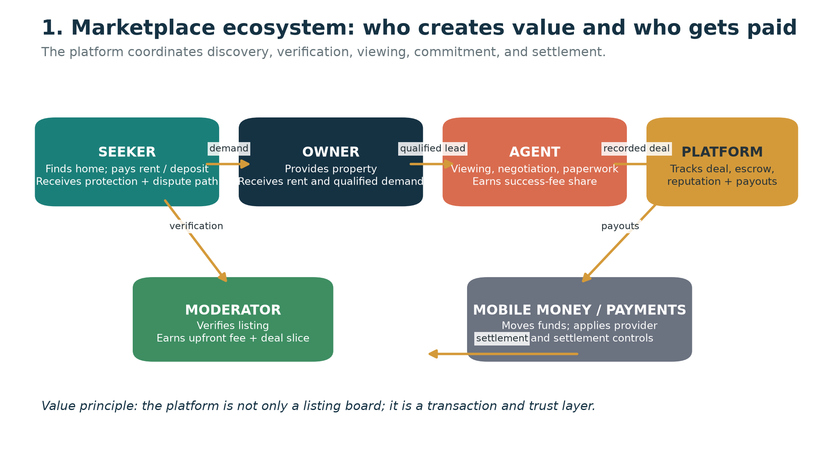
Figure 1. The operating ecosystem and value exchange.

1. Executive concept
Affordable Housing Cameroon should be positioned as a transaction and trust layer for rental housing, not merely as a directory of phone numbers. The platform helps seekers find relevant homes, helps owners and agents receive qualified demand, pays local moderators for credible verification work, and records the transaction so that participants receive protection and reputation value.
The core commercial principle is simple: listing is free to maximize supply; the platform earns when value is created through verification, completed transactions, protected settlement, and later optional services. The figures in this document are illustrative planning assumptions and must be validated with local legal, payment-provider, and market advice before implementation.

2. Participants and how each person earns
Participant | What they contribute | How they earn or benefit | Primary incentive
Seeker | Budget, housing need, attention, feedback | Does not receive a cash payout; earns protection, transparent costs, proof of payment, and a dispute pathway | Find a real home with less wasted time and lower fraud exposure
Owner / landlord | Property, availability, lease terms | Receives rent and deposit owed under the lease; may later pay optional verification or visibility fees | Qualified demand and a clearer path to a serious renter
Agent | Listing, viewing, negotiation, paperwork, deal support | Illustrative 70% of the closed-deal commission pool; repeat/referral opportunities | Tracked deal ownership, protected commission proof, reputation, and demand
Local moderator | Listing verification, field evidence, freshness checks, scam flags | Illustrative verification fee share plus 10% of the closed-deal commission pool | Immediate payment for work plus recurring upside from credible listings
Platform | Discovery, verification records, contact protection, escrow coordination, disputes, analytics | Illustrative 20% of closed-deal commission; verification processing share; escrow handling fee; later optional upsells | Transaction volume, trusted data, repeat use, and scalable revenue
Mobile-money / payment provider | Payment processing and settlement rails | Provider-defined transaction fee; amount must be confirmed in contract | Payment volume and compliant processing

3. Core revenue-sharing model
The primary success-fee model applies when a seeker commits to a property and the transaction reaches the agreed trigger, such as signing and paying the first month plus deposit. The commission pool is separate from the rent and deposit. Rent and deposit belong to the contractual parties; they are not platform revenue.
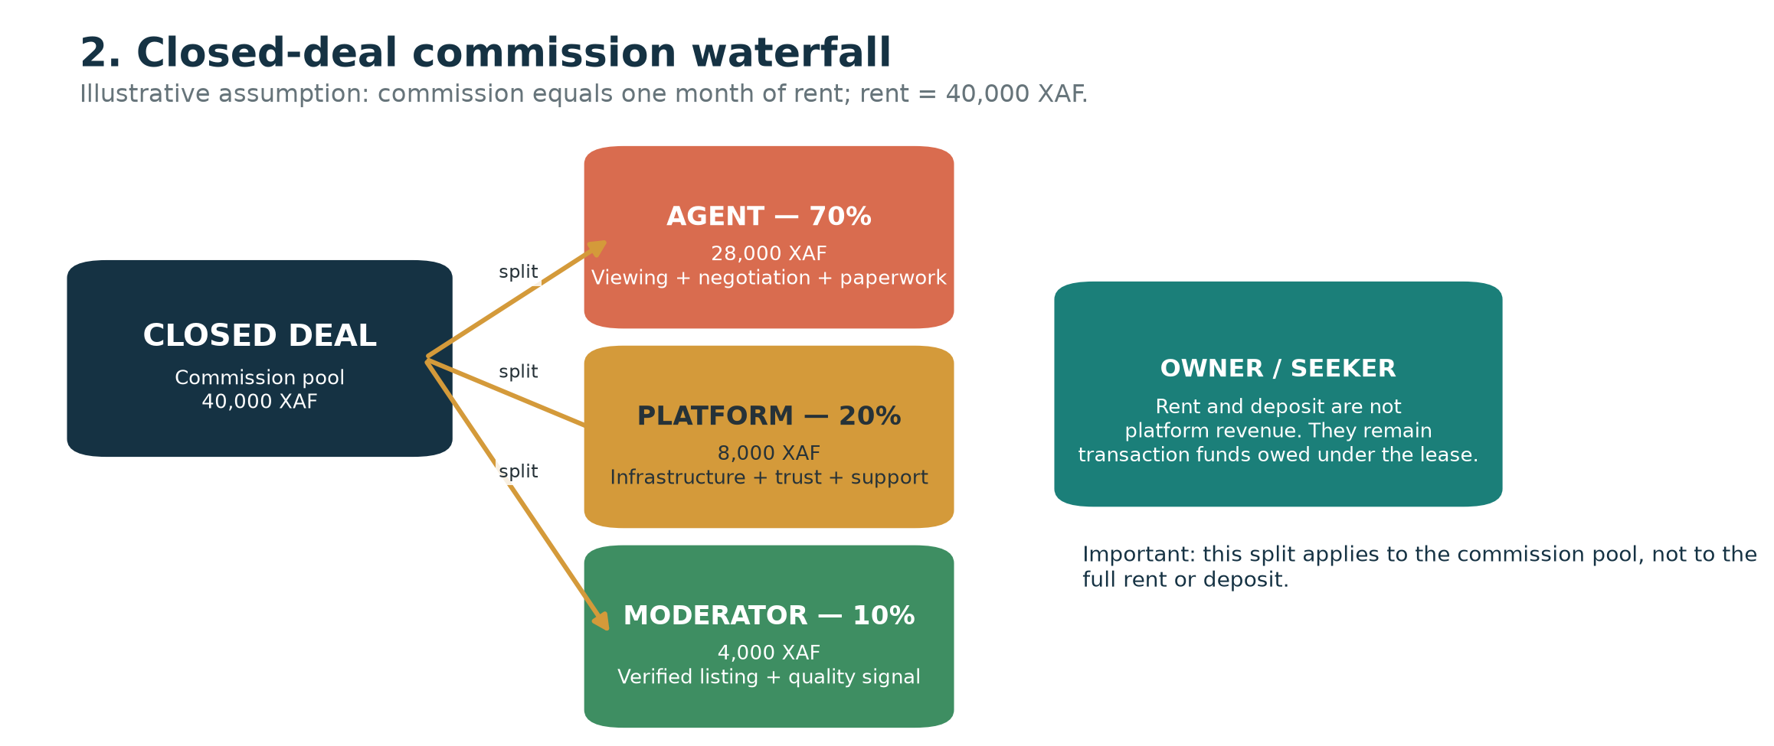
Figure 2. Illustrative 70/20/10 split of a 40,000 XAF commission pool.
Money event | Illustrative amount | Agent | Moderator | Platform | Notes
Closed deal commission pool | 40,000 XAF | 28,000 XAF | 4,000 XAF | 8,000 XAF | Assumes one month of rent as commission; illustrative only
Monthly rent | 40,000 XAF | — | — | — | Rent remains owed under the lease, not split as platform revenue
Deposit / advance | As agreed | — | — | — | Should be handled under documented lease and payment rules

4. Verification-fee model
Verification pays the moderator for work even when a property does not close immediately. This is important because a moderator should not be expected to perform field work for free while waiting for a future transaction.
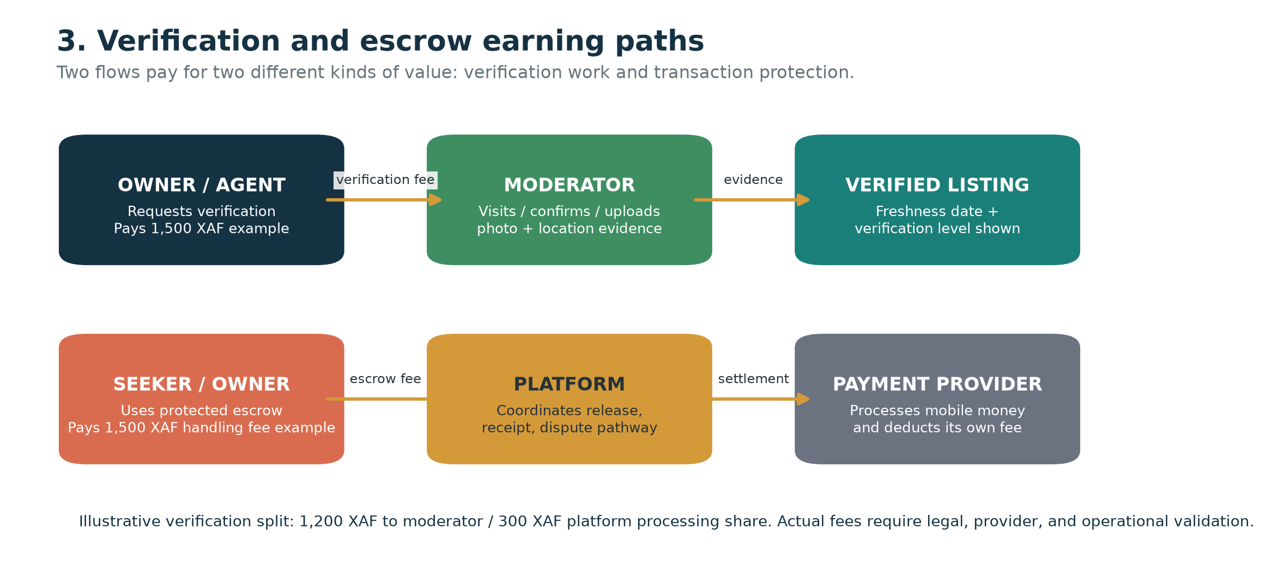
Figure 3. Verification and escrow are separate earning paths.
Fee event | Illustrative gross fee | Moderator share | Platform share | Important control
Listing verification | 1,500 XAF | 1,200 XAF | 300 XAF | Paid for a defined verification task; does not imply legal title certification
Escrow handling | 1,500 XAF | — | Gross handling fee before provider costs | Must be legally and operationally validated; do not treat escrow float as interest revenue

5. How to reduce disintermediation and leakage
Leakage occurs when a seeker and agent meet through the platform and then complete the deal privately. The goal should not be to promise zero leakage. The goal is to make the first transaction safer, more traceable, and more valuable on-platform than off-platform.
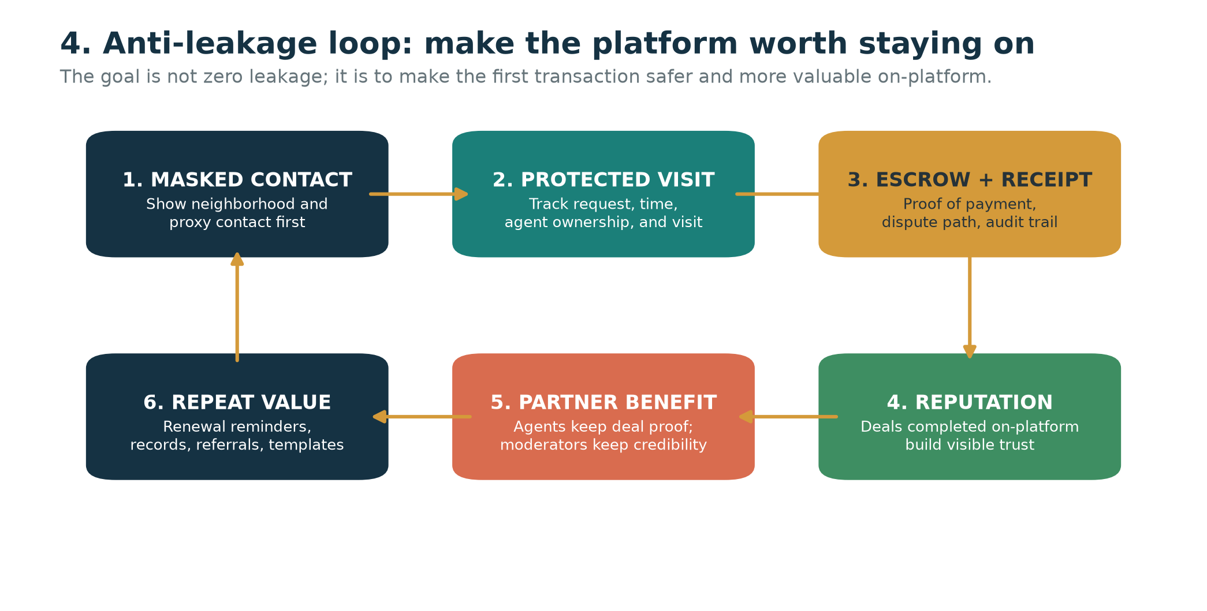
Figure 4. The anti-leakage loop turns platform participation into ongoing value.
Mechanism | Value created | Who benefits
Masked contact and approximate location | Prevents unrestricted scraping and protects the initial lead | Seeker, owner, agent, platform
Timestamped deal ownership | Creates evidence that an agent introduced and worked the lead | Agent
Escrow, receipt, and dispute path | Makes the platform the safer payment route | Seeker and owner
Visible reputation and completed-deal history | Rewards participants who complete transactions on-platform | Agent and moderator
Freshness and verification record | Preserves a credible listing status | Seeker and platform
Repeat services | Adds renewal reminders, records, templates, and referrals | Seeker, agent, platform

6. Illustrative monthly economics
The following example uses five closed deals at an average 40,000 XAF monthly rent and 20 verification jobs at 1,500 XAF each. It is an illustration of mechanics, not a forecast.
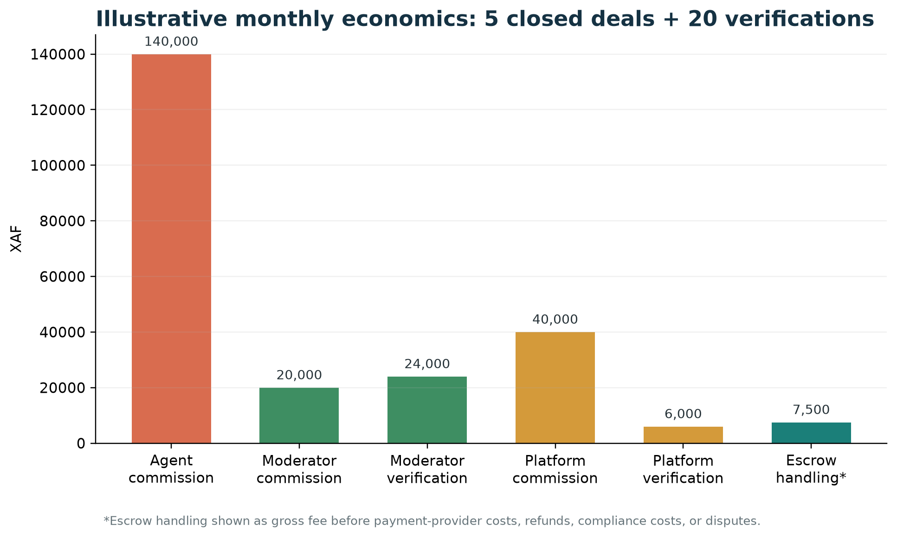
Figure 5. Example gross earnings before operating expenses, provider fees, refunds, and disputes.
Stream | Illustrative monthly volume | Agent / moderator earnings | Platform gross revenue
Closed-deal commission | 5 × 40,000 XAF = 200,000 XAF pool | Agent 140,000 XAF; moderator 20,000 XAF | 40,000 XAF
Verification | 20 × 1,500 XAF = 30,000 XAF | Moderator 24,000 XAF | 6,000 XAF
Escrow handling | 5 × 1,500 XAF = 7,500 XAF | No direct commission assumed | 7,500 XAF gross before provider costs
Illustrative total | — | Agent + moderator = 184,000 XAF | 53,500 XAF gross before costs

7. Earnings examples for individuals
If an agent closes four to six deals per month on rooms with monthly rent between 30,000 and 60,000 XAF, and the commission equals one month of rent, the agent’s 70% share would be approximately 84,000 to 252,000 XAF per month before personal costs. If a moderator verifies 15 to 20 listings per month at a 1,500 XAF fee and receives 1,200 XAF per verification, the verification-only income would be approximately 18,000 to 24,000 XAF, before any closed-deal commission slices.
These are arithmetic examples derived from the assumptions supplied. They are not guaranteed earnings. Actual income depends on demand, property quality, local pricing, agent performance, verification volume, payment costs, disputes, and the final fee policy.

8. Revenue streams by maturity
Revenue stream | Who pays | When to introduce | Platform role
Closed-deal commission share | Transaction participants according to transparent fee policy | Core launch revenue after trust and settlement are working | Take 20% illustrative share of the commission pool
Verification processing share | Owner or agent | Early, once verification is defined and auditable | Coordinate payment record and verification evidence
Escrow handling fee | Seeker, owner, or split according to policy | Only after legal and payment-provider validation | Provide safe settlement, receipts, and dispute process
Featured listings | Owner or agent | Later, after meaningful search traffic exists | Sell visibility separately from verification
Agent subscription tools | Agents | Later, after agents receive measurable value | Offer analytics, lead management, and workflow tools

The platform should not charge seekers to browse or charge owners merely to list during the early marketplace-building stage. Fees should be connected to real value: verification, visibility, settlement protection, or completed transactions.

9. Controls, risks, and safeguards
Risk | Why it matters | Required safeguard
Rubber-stamped verification | A moderator may claim a visit without doing the work | Photo and location evidence, timestamp, random review, seeker feedback
Agent or seeker leakage | The deal may move off-platform after the introduction | Masked contact, timestamped ownership, dispute proof, reputation, fair fees
Escrow misuse | Holding deposits can create legal, financial, and consumer-protection obligations | Use a compliant payment partner; define release, refund, dispute, and reconciliation rules
Unclear commission trigger | Participants may disagree about when a payout is owed | Define “closed deal” in writing and record acceptance evidence
False income expectations | Illustrative numbers may be understood as promises | Label all examples as assumptions and publish actual payout rules
Discriminatory or unsafe listings | Housing conditions may harm seekers | Moderation policy, reporting, removal, escalation, and local legal review

10. Recommended payout sequence
- 1. A property is submitted and remains unpublished until the verification checklist is complete.
- 2. The moderator submits evidence and receives the verification fee according to the approved payout policy.
- 3. A seeker requests contact; the platform records the lead and agent ownership where applicable.
- 4. The agent conducts the viewing and negotiation; the system records progress without exposing unnecessary personal data.
- 5. The parties reach the defined commitment trigger; the platform confirms the transaction evidence.
- 6. The commission pool is calculated and displayed before payout.
- 7. The platform releases the agent, moderator, and platform shares through the approved payment process.
- 8. The seeker and relevant participants can provide feedback, which affects reputation and future visibility.

11. Governance and implementation decisions still required
Before implementation, the founder must confirm the exact commission trigger, who legally pays the commission, whether the 50–100% one-month norm applies to the selected segment, the identity and role of the landlord in each deal, and whether the platform can legally coordinate deposits or escrow through a licensed partner. The 70/20/10 allocation should be treated as a proposed starting assumption, not a final contract.
Decision | Recommended starting position | Why it should be validated
Listing fee | Free | Maximizes early supply
Verification fee | 1,000–2,000 XAF range | Must reflect local travel and verification effort
Commission pool | Transparent percentage or flat amount | Must be acceptable to seekers, owners, and agents
Commission split | 70% agent / 10% moderator / 20% platform illustrative | Must cover support, payment, disputes, and compliance
Escrow | Use licensed provider or defer | Requires legal, consumer-protection, and reconciliation controls

12. Conclusion
The business model works only if every participant can identify a clear exchange of value. Seekers receive safer discovery and payment protection. Owners receive qualified demand. Agents receive tracked opportunities and protected commissions. Moderators receive immediate pay for real verification work and an incentive to preserve quality. Payment providers receive processing volume. The platform earns by coordinating the trusted transaction layer and only later by selling optional visibility or software tools.
The strategic principle is therefore: **build the trust and settlement layer, not just the listing page**. Revenue sharing should be transparent before the first deal, every payout should have a recorded trigger, and every earning estimate should be presented as an assumption until validated through local operations.

Appendix A — Source assumptions
This document is based on the supplied content. The commission split, verification fee, earnings examples, and scale examples are illustrative assumptions from that content and should be validated through local interviews, pilot transactions, payment-provider terms, and professional legal/accounting review. No external market statistic has been presented as a verified fact in this document.

13. Strategic venture assessment
The supplied assessment rates the concept at 7.0 out of 10 as a venture execution plan. This score is an internal strategic opinion, not an independently validated investment rating. It recognizes strong incentive alignment, a realistic transaction-linked revenue model, and a direct response to trust problems in informal rental markets. It also identifies operational leakage, moderator collusion, payment-regulation exposure, and moderator unit-economics risk as launch-critical issues.
Strength | Why it matters | What must still be proven
Agent incentive alignment | A 70% share of the commission pool can make agents partners rather than competitors | The final fee must be accepted by agents and still fund platform operations
Revenue linked to value | Verification and settlement services can produce revenue beyond a closed lease | Fees, refund rules, and payment costs must be tested locally
Trust problem addressed | Field verification directly targets fake listings and lost deposits | Verification must be evidence-based and auditable
Local operating model | Moderators create neighborhood-level coverage | Travel time, density, and moderator retention must be measured

14. Critical loopholes and strategic fixes
Risk / loophole | Failure mode | Professional control
Off-platform settlement | After a viewing, the seeker and agent exchange direct details and pay privately | Offer a digital receipt, traceable transaction history, possible cash-back or protection benefit, and formal dispute evidence for on-platform settlement
Moderator-agent collusion | A moderator rubber-stamps a phantom or poor-quality property for the verification fee | Require photo, timestamp, location evidence; hold payout; apply random second-verifier audits; use seeker feedback
Unlicensed escrow custody | The platform holds deposits or rent without the right partner or approval | Do not hold funds on custom platform servers; route settlement through an appropriate licensed payment partner after legal review
Moderator churn | Transport costs consume the 1,200 XAF verification payout | Batch nearby tasks, target 5–8 properties per trip, and monitor net earnings after transport
High fee leakage incentive | A large commission makes private settlement attractive | Use a transparent, proportionate fee and make on-platform protection measurably valuable

15. Settlement protection architecture
The strongest anti-leakage lever is not surveillance; it is making the platform the safer and more useful path at the moment money changes hands. A seeker should receive a traceable receipt, clear terms, and a defined dispute path. The platform should coordinate the workflow but should not assume that it can legally custody rental funds without an appropriate licensed partner and local review.
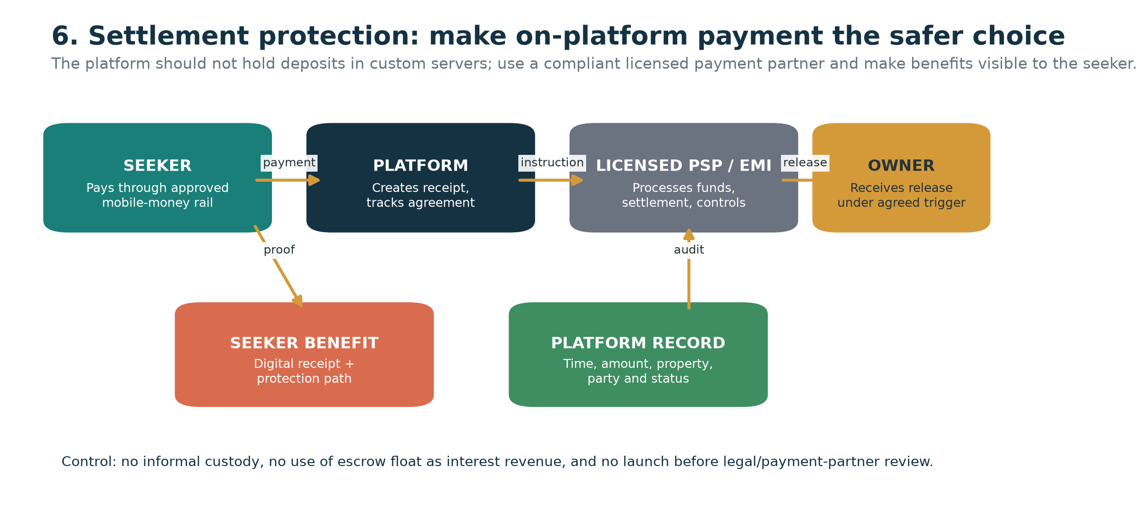
Figure 6. Recommended settlement-protection flow using an approved payment partner.

16. Moderator economics and quality controls
A 1,200 XAF net share can be attractive only when the moderator can complete enough nearby tasks per trip. Geographic batching is therefore both an operational and financial requirement. The platform should assign verification jobs by neighborhood, make travel assumptions visible, and track net earnings after transport rather than reporting gross fee volume alone.
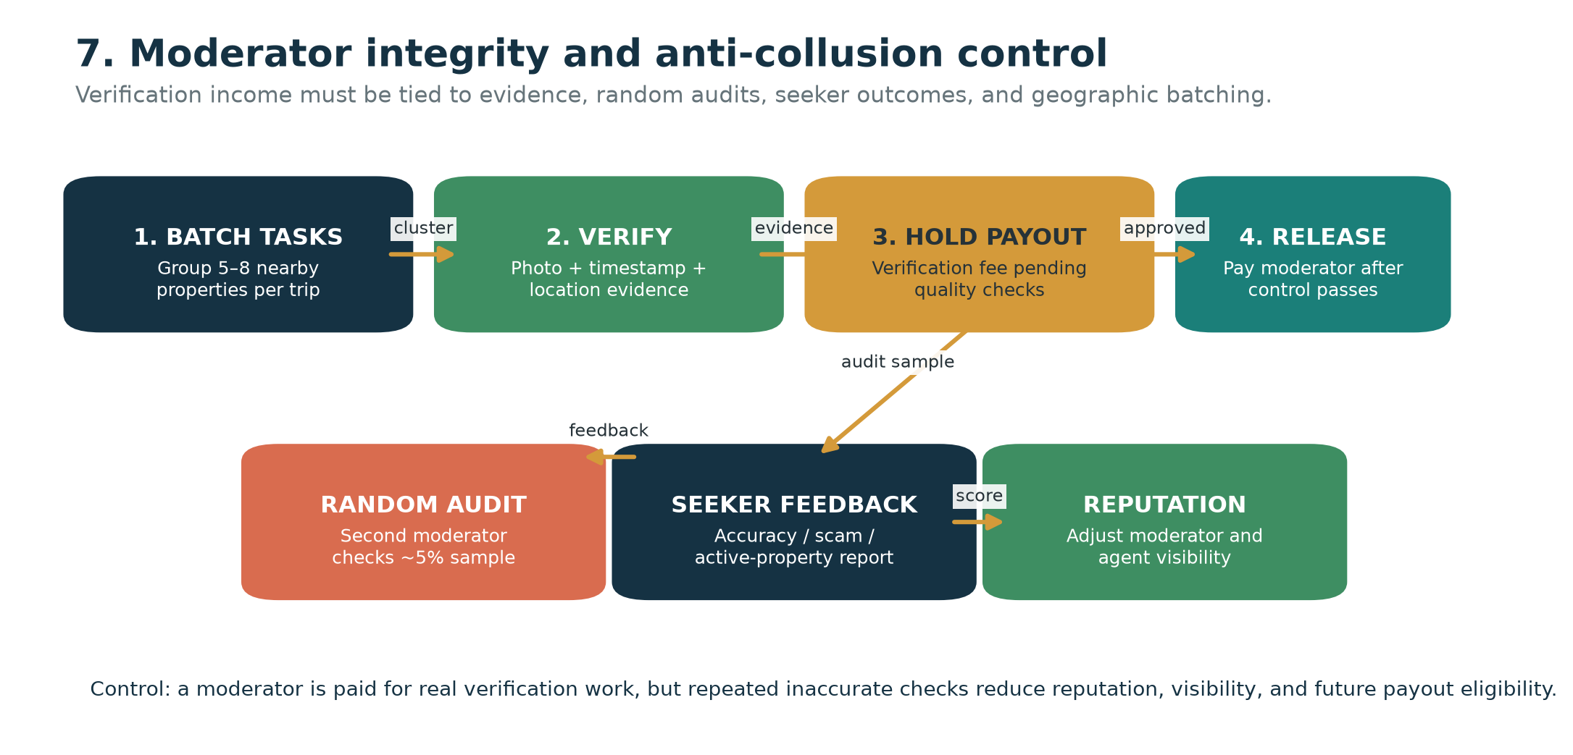
Figure 7. Moderator verification, payout hold, random audit, and reputation loop.
Control | Minimum operating rule | Measurement
Evidence | Photo, timestamp, location evidence, and verification note required | Evidence completeness rate
Payout hold | Verification payout remains pending until control checks pass | Average payout delay and exception rate
Random audit | Second moderator checks a defined sample, suggested starting point 5% | Audit pass rate and discrepancy rate
Seeker feedback | Post-contact or post-visit accuracy feedback collected | Verified-listing complaint rate
Batching | Group 5–8 nearby properties when practical | Properties per trip and net moderator earnings
Escalation | Repeated inaccurate checks trigger review or suspension | Moderator quality score and suspension rate

17. Revised participant earning logic
The original earning model remains valid as a proposed starting structure, but the revised model adds conditions that protect the economics and credibility of every participant.
Participant | Base earning / benefit | New condition added by the assessment
Seeker | Safer search, cost visibility, receipt, and dispute path; possible transaction rebate if approved | The platform must create a visible monetary or legal-protection reason to stay on-platform
Owner | Rent and deposit under the lease; qualified demand | Owner should understand what verification and settlement fees purchase
Agent | 70% illustrative share of closed-deal commission pool | Timestamped deal ownership, reputation, and protection against commission disputes
Moderator | Verification share plus 10% illustrative closed-deal slice | Evidence, payout hold, random audits, batching, and reputation consequences
Platform | 20% illustrative commission share plus verification and settlement-service revenue | Must fund support, disputes, payment costs, compliance, and product maintenance
Payment provider | Provider-defined processing fees | Must be appropriately licensed and contracted for the settlement flow

18. Revised launch gates
The assessment should change the order of implementation. Do not launch escrow, advertise guaranteed protection, or scale moderator recruitment until the relevant operational and legal controls are ready.
Gate | Required evidence before proceeding
Demand and supply | Seekers use the service and owners or agents provide enough legitimate inventory
Commission acceptance | Agents and owners accept the proposed fee and payout trigger
Anti-leakage value | Seekers can identify a concrete benefit to completing settlement through the platform
Moderator economics | Batched work leaves moderators with acceptable net income after transport
Audit integrity | Second-verifier and feedback controls detect inaccurate or suspicious verification
Payment compliance | A qualified payment partner and legal review confirm the settlement design

19. Important regulatory and contractual caution
The supplied assessment correctly identifies escrow as a potentially regulated activity. References to COBAC, BEAC, MTN MoMo, Orange Money, or any other provider should be treated as implementation hypotheses until confirmed through current legal advice, provider documentation, and a formal partnership process. The platform must not hold deposits or rent in an improvised wallet, treat customer funds as operating cash, or promise legal protection that has not been contractually and legally established.

20. Updated conclusion
The concept is commercially promising but execution-sensitive. Its strongest feature is incentive alignment: agents, moderators, and the platform can earn from the same successful housing journey. Its greatest danger is assuming that a listing and a phone number are enough to preserve the transaction. The revised strategy is to build around protected settlement, auditable verification, clustered field operations, and tangible on-platform value for seekers and agents.
The 7.0/10 assessment should therefore be interpreted as: strong concept and incentives, but not yet launch-ready until leakage, collusion, moderator economics, and payment compliance are resolved in a controlled pilot.

