**Assignment 3**

**Description:**

A restaurant chain has reached out to your team to build a reservation system.

**Here are the details:**

* Two categories of users / customers: guest user or registered user.
* Users should be able to search for a table and reserve.
  + User doesn’t need to login to the system to reserve a table. If registered users, they can login.
  + User enters name, phone, email, date and time (date picker), and # of guests for dining and system presents available tables.
  + Tables have maximum capacity limit i.e., 2, 4, 6, or 8.
  + Different combinations are allowed, and owner accommodates the seating, for example: someone requests 8 guests and table for 8 is not available but 2 + 6, or 4+4 is available. System should combine the tables and notify owner they need to combine tables. In this case System reserves both tables.
* If a guest user i.e., not a registered user, system should prompt user to register (Optional) before finalizing the reservation.
* Registered users will have these fields:
  + Name, mailing address, billing address (checkbox if same as mailing address), Preferred Diner # (system generated), Earned points (based on $ spent i.e., $1 is 1 point), preferred payment method (cash, credit, check).
* System should track high traffic days / weekends and a hold fee is required i.e. July 4th will require valid credit card on system to reserve the table.
  + Notify user no show will have minimum $10 charge.

**Assumptions:**

If you make any assumptions to provide good user experience, please list it.

**Answer these questions:**

1. Provide detailed software architecture diagram for the proposed solution. Include all modules you will build and any other modules that you will use from other applications / APIs. (15 points)

Example:

<https://www.edrawsoft.com/software-architecture.html>

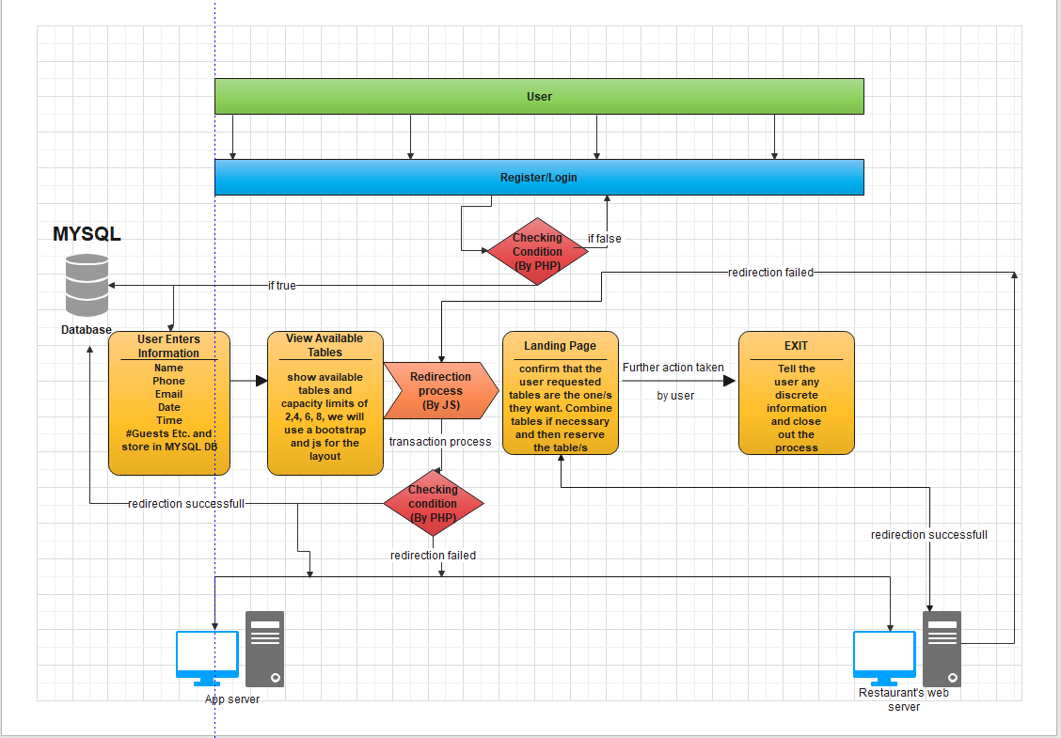

1. What tools / technologies / frameworks you will use to implement the solution? Discuss in detail. (10 points)

**The tools we are using to implement our solution is going to be front end html with java, bootstrap and css when needed. We will use dynamic functions via angular or react when** **needed. For the back end we are going to use PHP and MySQL to store data in a database and to connect the app together. We are using the front end tools to create a user friendly yet powerful app and that is easy to use and put together. All of the fields required will be handled by the html or php libraries and will be easy to connect both front and back end together as they are compatible with each other in a lot of ways. MYSQL will be used to store data as well as retrieve data. The ease of querying data in and out will be essential for building a small but short system for the restaurant.**

**REQUIRED:**

Fill in this table, provide as many details as possible:

|  |  |  |
| --- | --- | --- |
| Group Member Name | What is your contribution? | Discussion Notes |
|  |  |  |
|  |  |  |
|  |  |  |

**What to turn in:**

- Only soft copy uploaded on or before due date.

- No extensions.

- To get full credit provide details and diagrams (when appropriate).