Hello, this is a follow up for the assignment, The group members are Bryan Tieu: Designed Coded and wrote the report.

Here is github repository link: <https://github.com/BryanTieu/SoftwareGroupProject>

You may be able to access the files in the repository in separate folders.

My Design and methodology still stays the same as the time constraint we have is very short as well as the project is not as big however due to the workload required in the amount of time the methodology will not change.

The front end technology we are using are HTML, CSS files and URLs, as well as some JS and JSON function calls. We are mainly using HTML.

Here are some screenshots of the front end:

Login

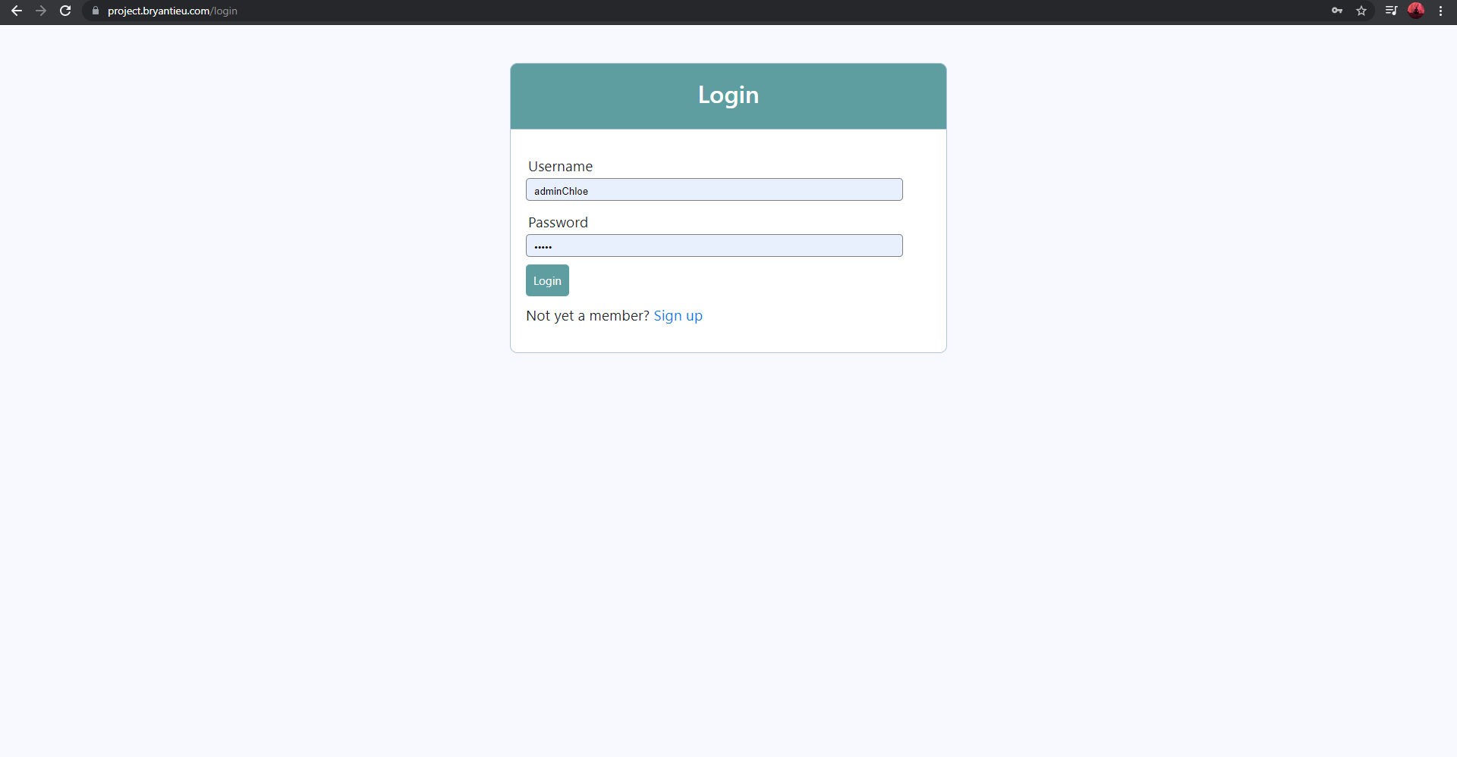

Register:

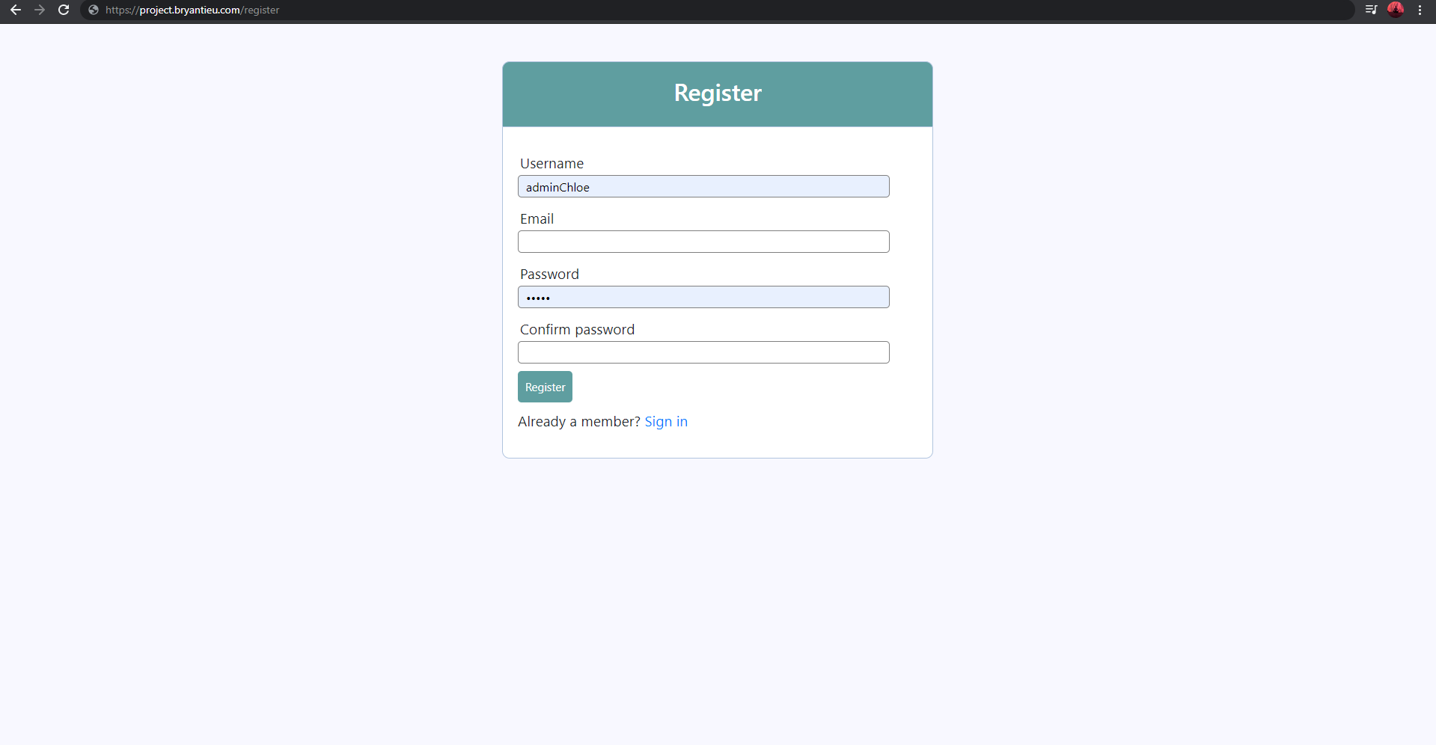

Profile:

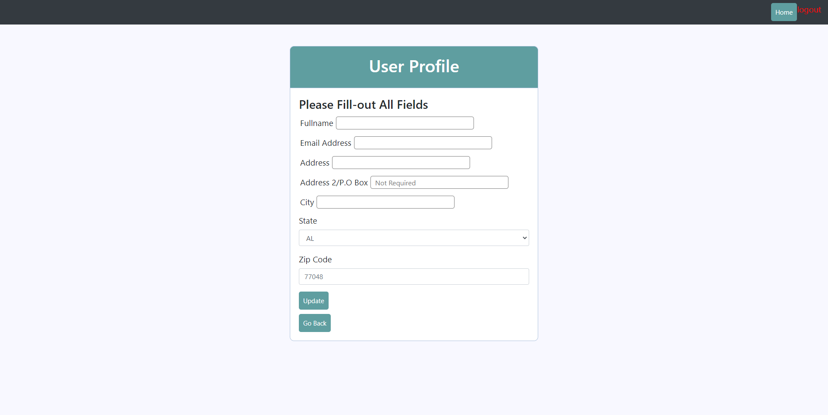

Home:

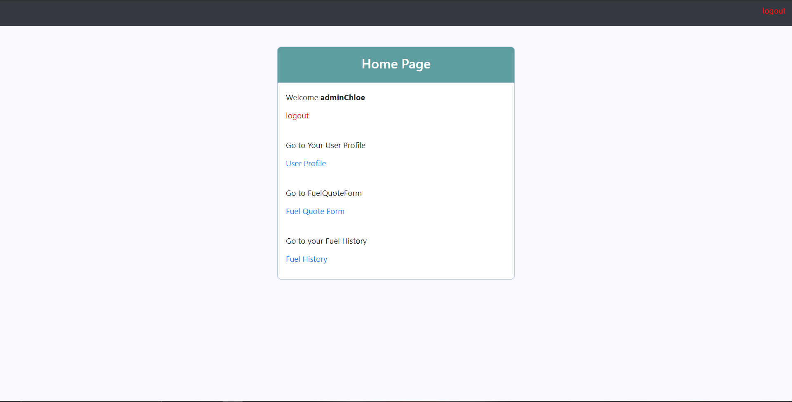

FuelQuoteform:

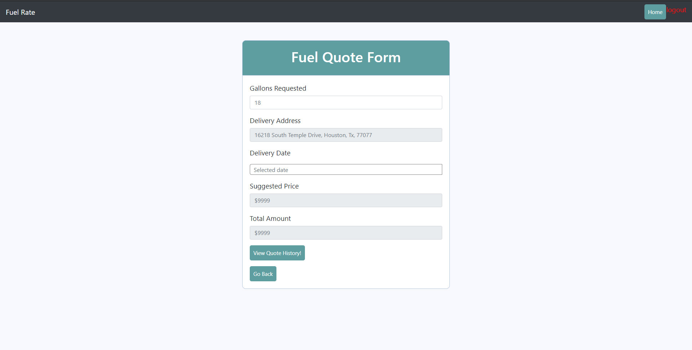

fuelHistory:

