Bryan Nguyen

CS151

Kim

Calendar Application Report

In my model class, I created a HashMap data structure that would be in charge of containing all the data of the application so that the view will be able to call the model in order to get information to fill the calendar and the controller can update the model data structure every time a listener is called. The model also contains an event calendar which stores the events that are created on a specific day. Model also has the method that creates events and adds it to the data structure when the controller class calls it. Model returns all the necessary information in order to display the calendar.

In my view class, I created the GUI that would be displayed to the user. The view class calls the model in order to populate the data for the current month. I used a JFrame and then placed a container object on top. I added a panel that encapsulates a JTable that would contain the calendar. I filled the calendar with days based on what the model class returned. View also creates the frame that contains the create event screen. The create event screen takes input from the user in order to create an event.

In my controller class, it created an instance of view and model and registered the action listeners for the view class. Every time the view class had a button clicked, the controller would register the listener and update the model class.

**Screen 1:**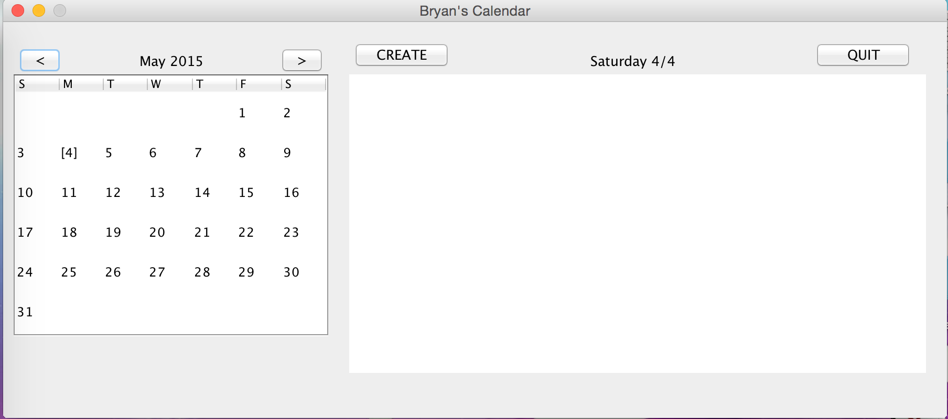

**Screen 2:**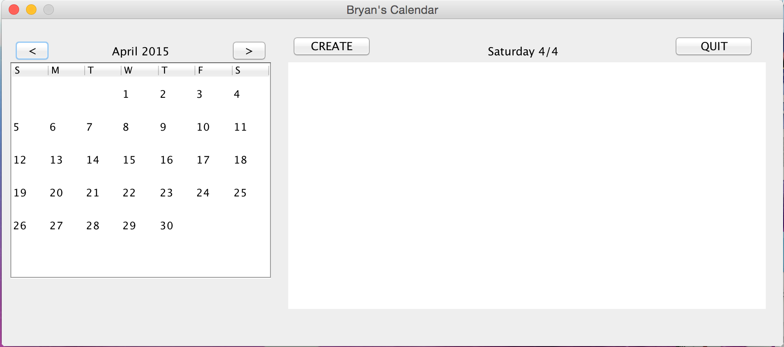

**Screen 3:**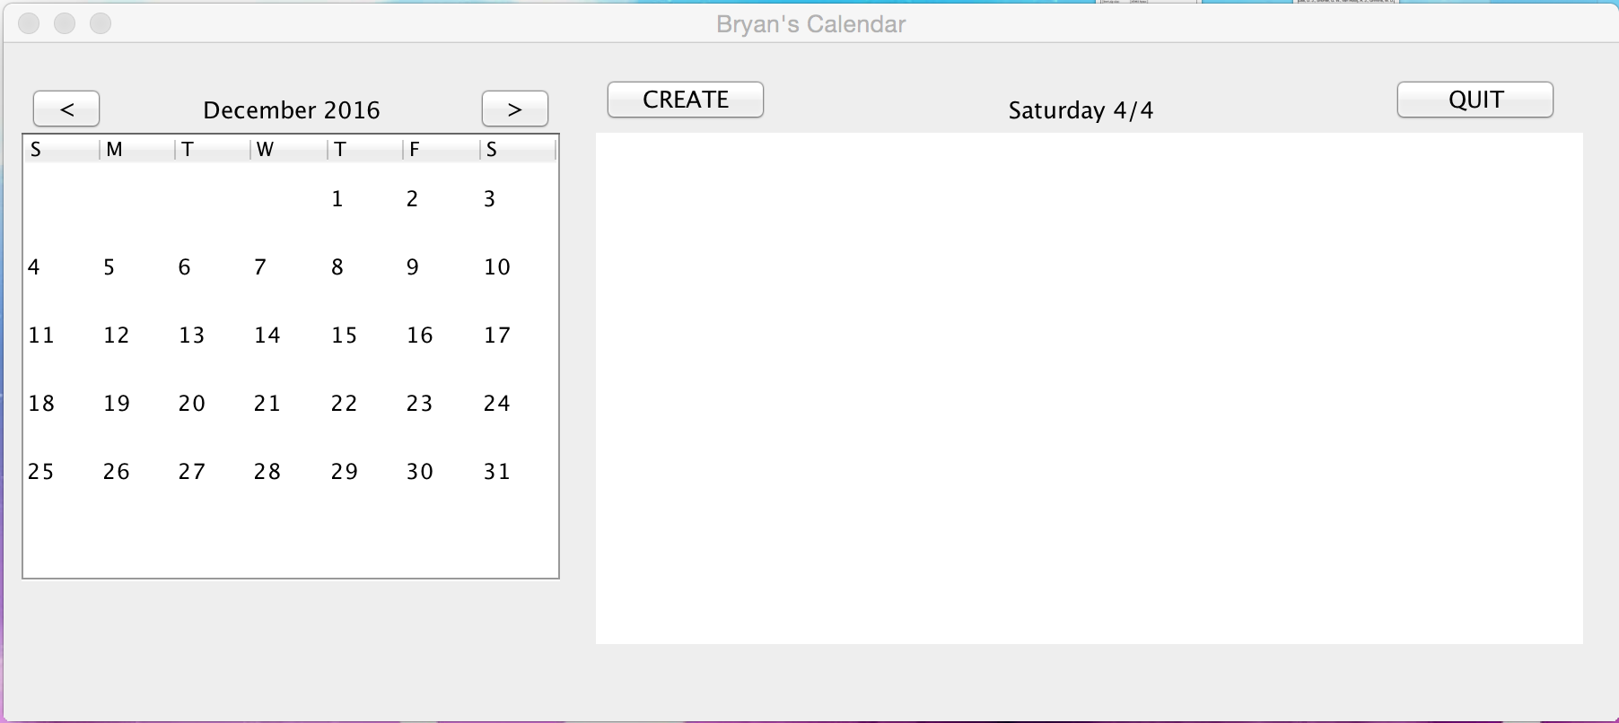

**Screen 4:**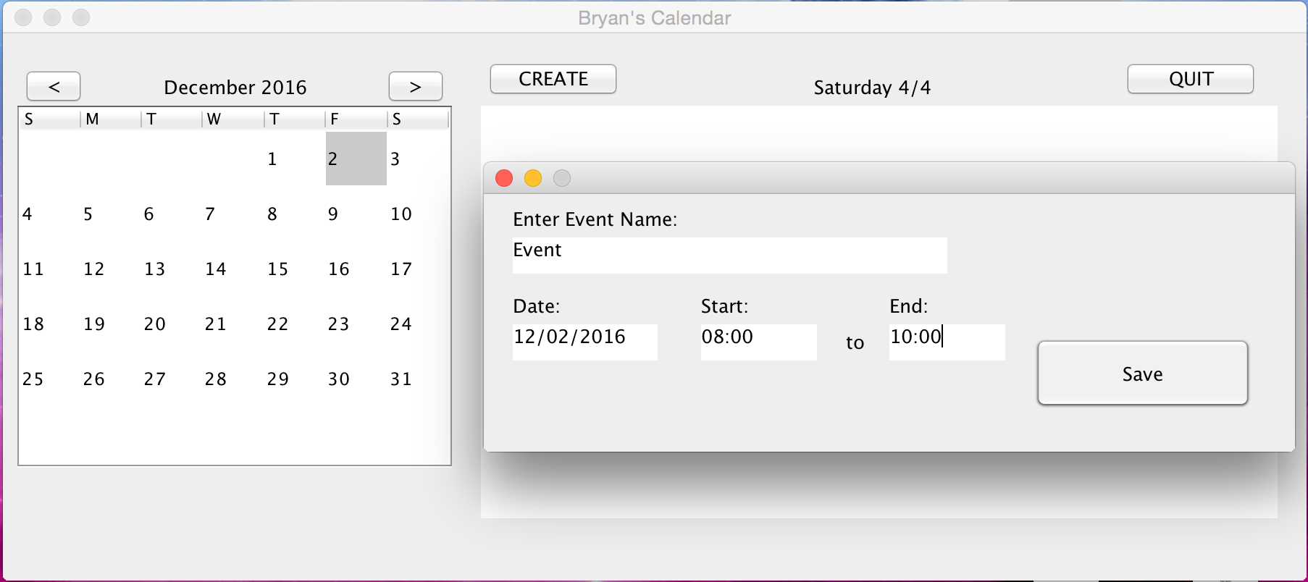

**Screen 5:**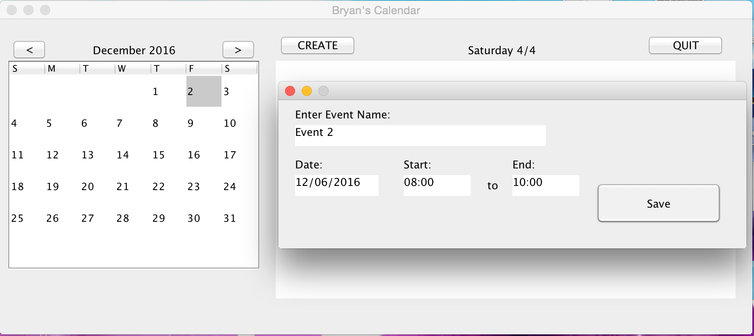

**Screen 6:**