|  |
| --- |
|  |
| The Documentation |
| [Type the document subtitle] |
|  |
| **[Your Name]** |
| **[Pick the date]** |

[Type the abstract of the document here. The abstract is typically a short summary of the contents of the document. Type the abstract of the document here. The abstract is typically a short summary of the contents of the document.]

Table of Contents

[To update the table of contents, right click the message below and select Update Field (F9 on PC, ⌥⌘U on Mac).]

**No table of contents entries found.**

1. Pages
   1. Page Tree

原型导航  
 门店端,运营端  
 签到取件  
 流程图示  
 签到取件流程概述  
 App端  
 产品功能路线概要  
 需求功能导图  
 主界面  
 展示区  
 乐收头条  
 最新活动  
 快速功能区  
 到店签到  
 快捷支付  
 主功能区  
 乐购  
 每日一购  
 我的宝贝  
 电商对接模式参考流程图  
 基础导航区  
 发现  
 乐任务  
 乐邦任务面板_大家的任务  
 接任务  
 乐收任务面板_我的任务  
 我发起的任务详情  
 我接受的任务详情  
 发起任务  
 乐体验  
 乐收微任务迭代1_仅包含代取快递  
 乐帮帮_大家的任务  
 接任务  
 乐帮帮_我的任务  
 我发起的任务详情  
 我接受的任务详情  
 发起任务  
 寄件  
 我的寄件  
 预约寄件  
 收件  
 我的收件  
 我(个人中心)  
 乐积分  
 积分商城  
 积分游戏  
 翻宝贝  
 邀请界面  
 个人中心主界面  
 个人信息完善和修改  
 客服  
 消息中心  
 old  
 主界面  
 注册登录  
 登录(无变化)  
 注册(增加邀请码)  
 登录前功能行为  
 扩展思路(目前不做的东西)  
 杂七杂八  
 文艺范  
 游乐场主界面  
 乐收卡园  
 列表样式  
 乐收读书俱乐部  
 临时想法  
 二手交换  
 包裹等你等得好心痛  
 用户的问题件  
 垃圾桶  
 运单查询

* 1. 乐收微任务迭代1_仅包含代取快递
     1. User Interface

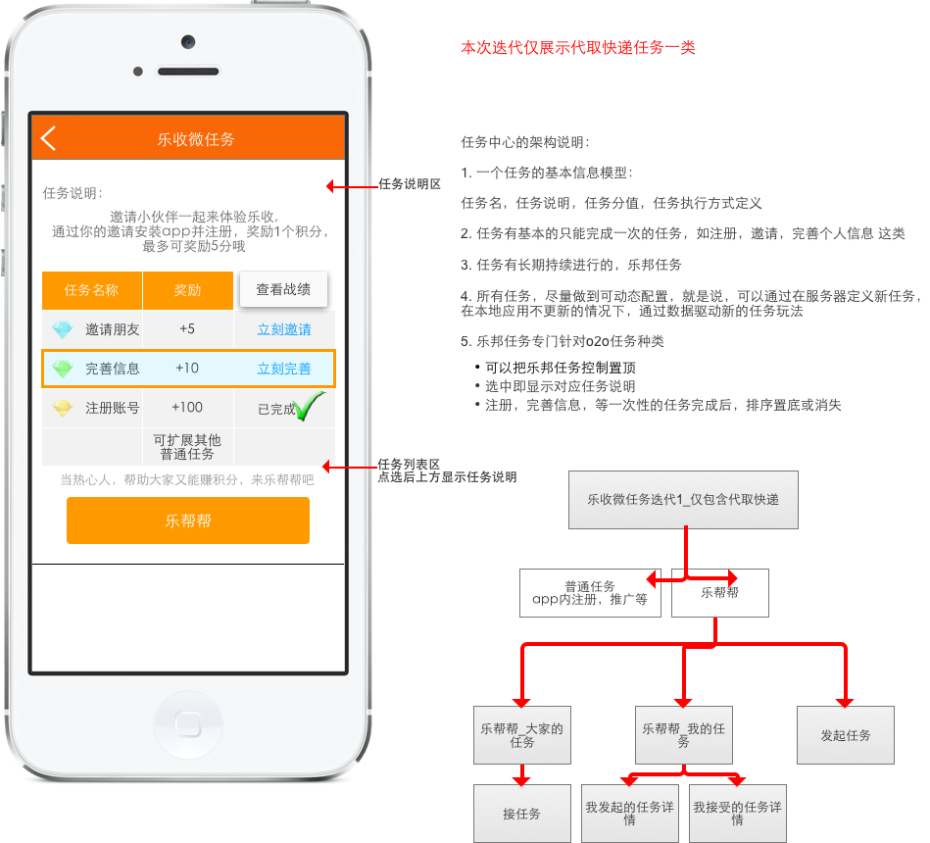

* + 1. 积分规则表
       1. State1
       2. User Interface

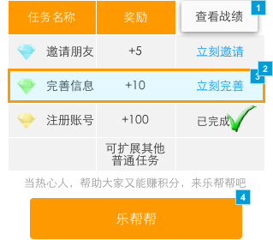

* + - 1. Widget Table

| Footnote | Name | Interactions |
| --- | --- | --- |
| 1 |  | OnClick:  Case 1:  Show 积分战绩 |
| 2 |  | OnClick:  Case 1:  Open 邀请界面 in Current Window |
| 3 |  | OnClick:  Case 1:  Open 个人信息完善和修改 in Current Window |
| 4 |  | OnClick:  Case 1:  Open 乐帮帮_大家的任务 in Current Window |

* + 1. 积分战绩
       1. State1
       2. User Interface

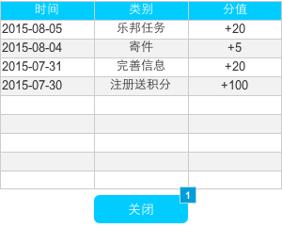

* + - 1. Widget Table

| Footnote | Name | Interactions |
| --- | --- | --- |
| 1 |  | OnClick:  Case 1:  Hide 积分战绩 |

* 1. 乐帮帮_大家的任务
     1. User Interface

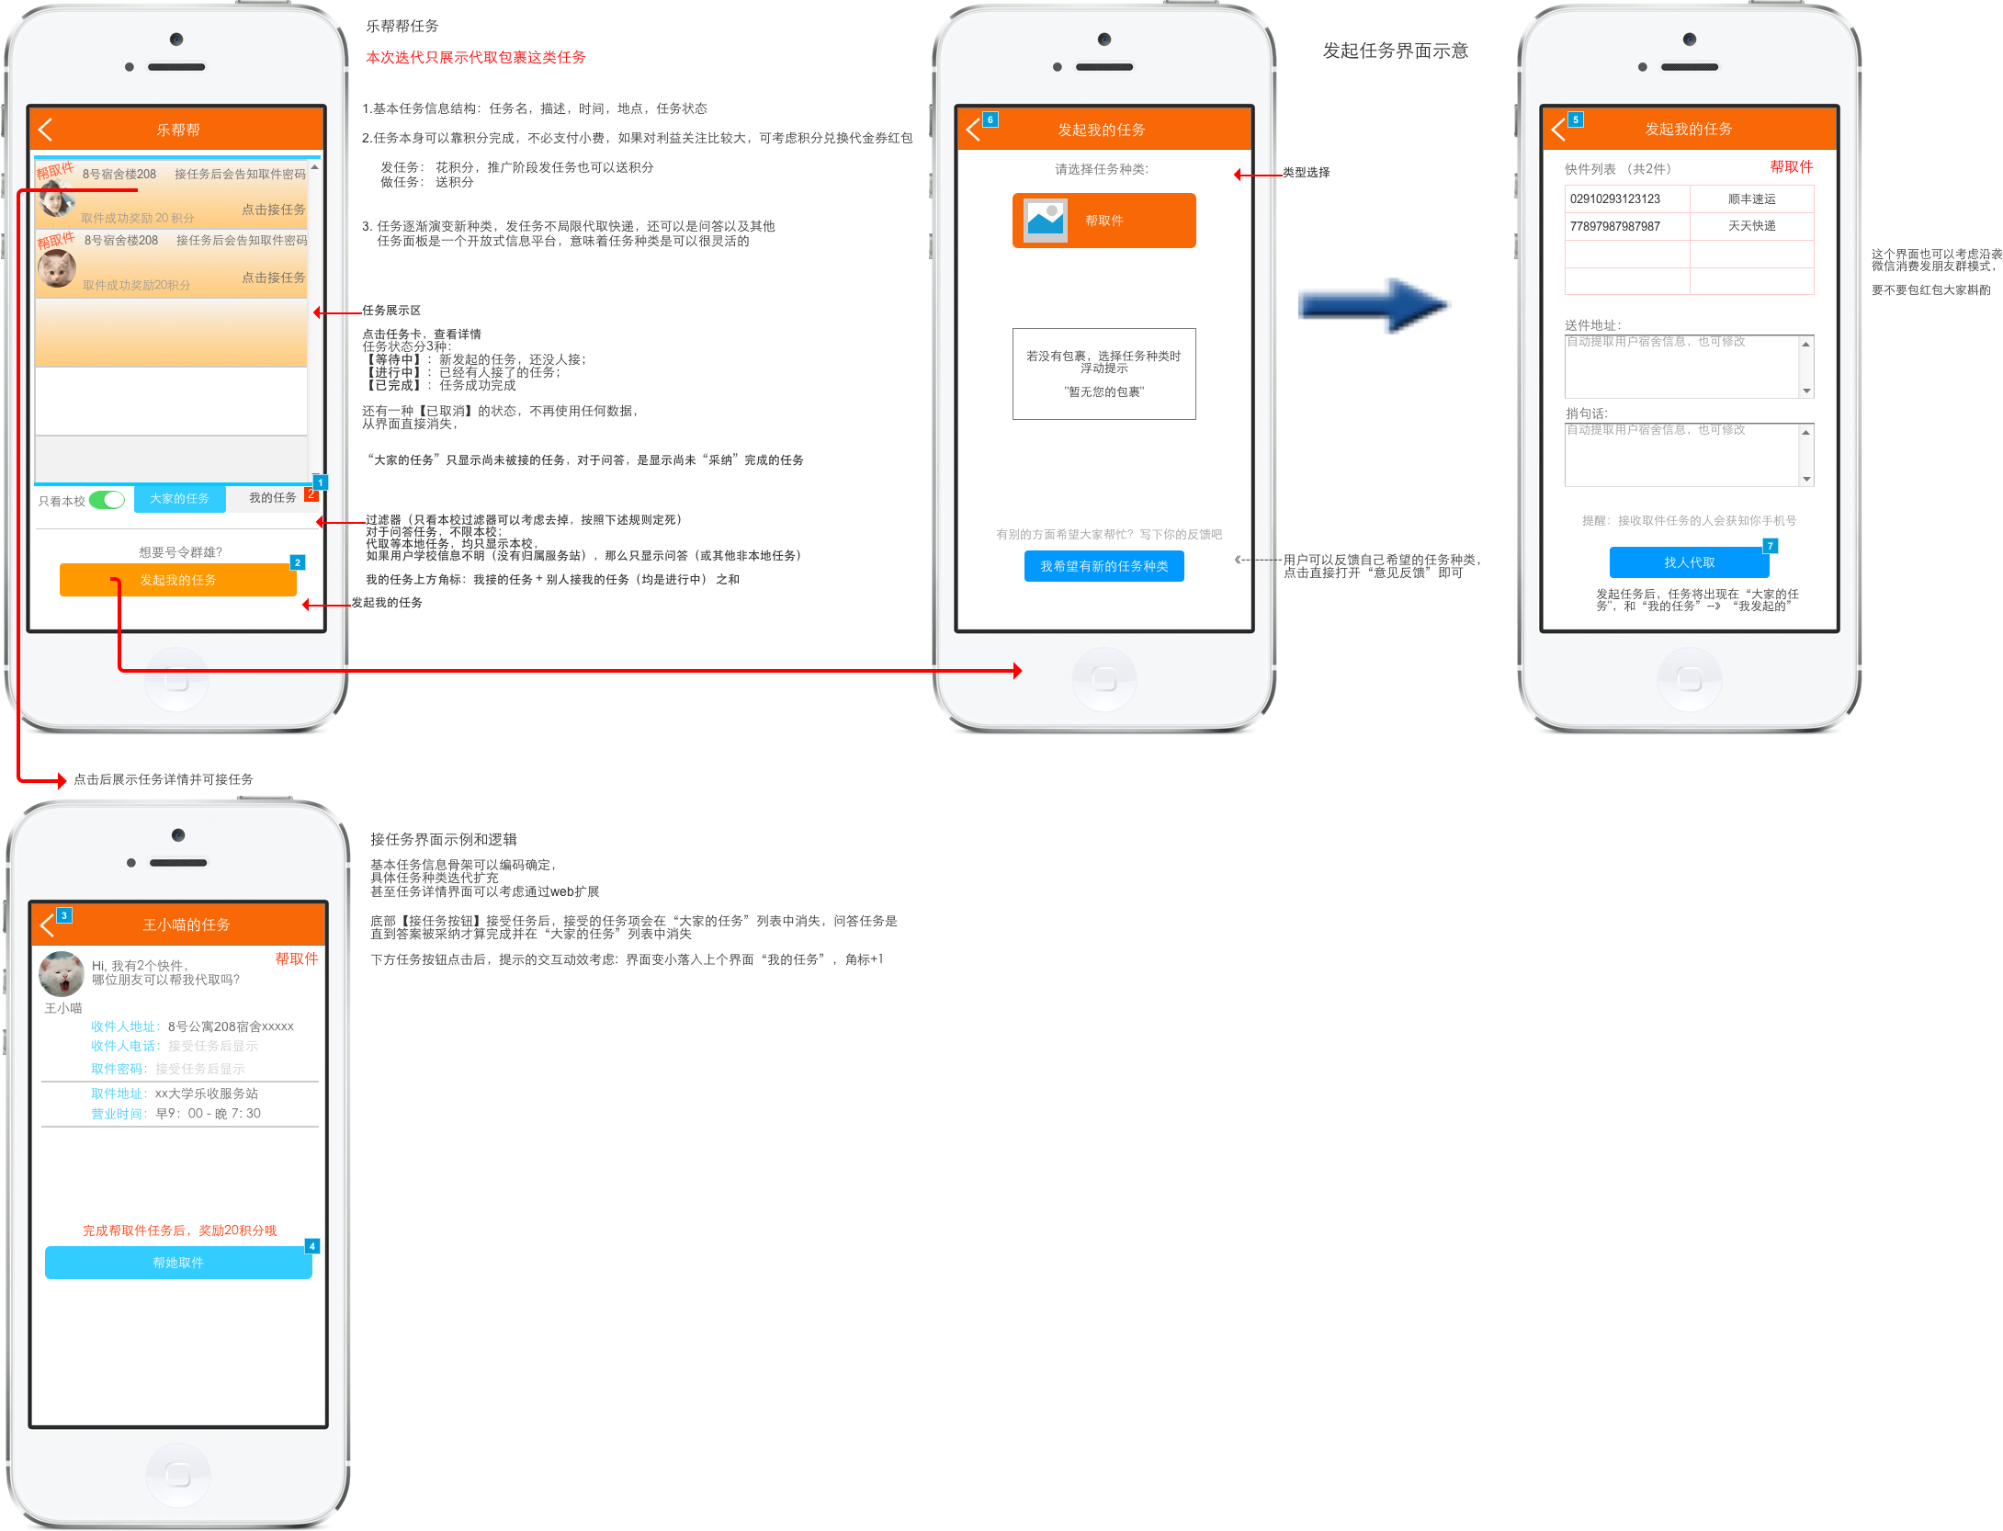

* + 1. Widget Table

| Footnote | Name | Interactions |
| --- | --- | --- |
| 1 |  | OnClick:  Case 1:  Open 乐收任务面板_我的任务 in Current Window |
| 2 |  | OnClick:  Case 1:  Open 发起任务 in Current Window |
| 3 |  | OnClick:  Case 1:  Open Back in Current Window |
| 4 |  | OnClick:  Case 1:  Open 乐帮帮_大家的任务 in Current Window |
| 5 |  | OnClick:  Case 1:  Open Back in Current Window |
| 6 |  | OnClick:  Case 1:  Open Back in Current Window |
| 7 |  | OnClick:  Case 1:  Open 乐帮帮_大家的任务 in Current Window |

* + 1. 乐邦任务卡
       1. State1
       2. User Interface

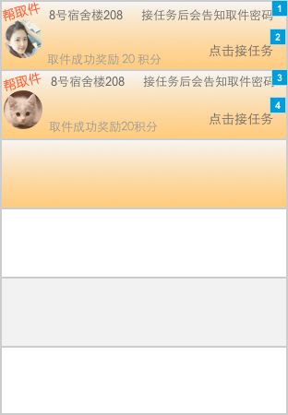

* + - 1. Widget Table

| Footnote | Name | Interactions |
| --- | --- | --- |
| 1 |  | OnClick:  Case 1:  Open 接任务 in Current Window |
| 2 |  | OnClick:  Case 1:  Open 接任务 in Current Window |
| 3 |  | OnClick:  Case 1:  Open 接任务 in Current Window |
| 4 |  | OnClick:  Case 1:  Open 接任务 in Current Window |

* 1. 接任务
  2. 乐帮帮_我的任务
     1. User Interface

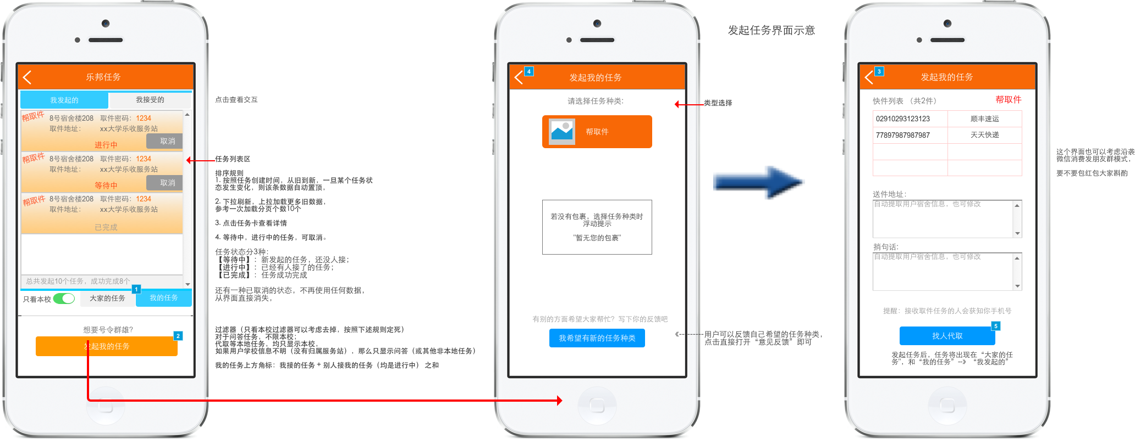

* + 1. Widget Table

| Footnote | Name | Interactions |
| --- | --- | --- |
| 1 |  | OnClick:  Case 1:  Open 乐邦任务面板_大家的任务 in Current Window |
| 2 |  | OnClick:  Case 1:  Open 发起任务 in Current Window |
| 3 |  | OnClick:  Case 1:  Open Back in Current Window |
| 4 |  | OnClick:  Case 1:  Open Back in Current Window |
| 5 |  | OnClick:  Case 1:  Open 乐帮帮_我的任务 in Current Window |

* + 1. 我的任务_选择
       1. 头部选择_我发起的
       2. User Interface



* + - 1. Widget Table

| Footnote | Interactions |
| --- | --- |
| 1 | OnClick:  Case 1:  Set 我的任务_选择 to 头部选择_我接受的, 乐邦任务卡_我的任务 to 我接受的 |

* + - 1. 头部选择_我接受的
      2. User Interface



* + - 1. Widget Table

| Footnote | Interactions |
| --- | --- |
| 1 | OnClick:  Case 1:  Set 我的任务_选择 to 头部选择_我发起的  Set 乐邦任务卡_我的任务 to 我发起的 |

* + 1. 乐邦任务卡_我的任务
       1. 我发起的
       2. User Interface

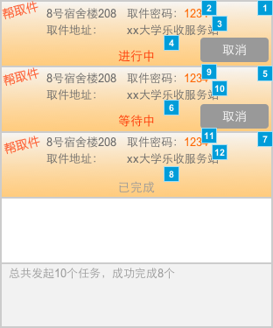

* + - 1. Widget Table

| Footnote | Name | Interactions |
| --- | --- | --- |
| 1 |  | OnClick:  Case 1:  Open 我发起的任务详情 in Current Window |
| 2 |  | OnClick:  Case 1:  Open 我发起的任务详情 in Current Window |
| 3 |  | OnClick:  Case 1:  Open 我发起的任务详情 in Current Window |
| 4 |  | OnClick:  Case 1:  Open 我发起的任务详情 in Current Window |
| 5 |  | OnClick:  Case 1:  Open 我发起的任务详情 in Current Window |
| 6 |  | OnClick:  Case 1:  Open 我发起的任务详情 in Current Window |
| 7 |  | OnClick:  Case 1:  Open 我发起的任务详情 in Current Window |
| 8 |  | OnClick:  Case 1:  Open 我发起的任务详情 in Current Window |
| 9 |  | OnClick:  Case 1:  Open 我发起的任务详情 in Current Window |
| 10 |  | OnClick:  Case 1:  Open 我发起的任务详情 in Current Window |
| 11 |  | OnClick:  Case 1:  Open 我发起的任务详情 in Current Window |
| 12 |  | OnClick:  Case 1:  Open 我发起的任务详情 in Current Window |

* + - 1. 我接受的
      2. User Interface

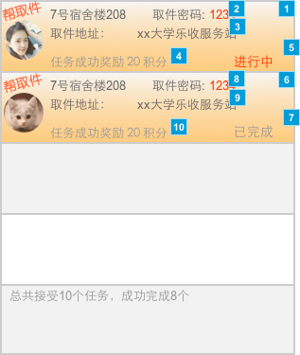

* + - 1. Widget Table

| Footnote | Name | Interactions |
| --- | --- | --- |
| 1 |  | OnClick:  Case 1:  Open 我接受的任务详情 in Current Window |
| 2 |  | OnClick:  Case 1:  Open 我接受的任务详情 in Current Window |
| 3 |  | OnClick:  Case 1:  Open 我接受的任务详情 in Current Window |
| 4 |  | OnClick:  Case 1:  Open 我接受的任务详情 in Current Window |
| 5 |  | OnClick:  Case 1:  Open 我接受的任务详情 in Current Window |
| 6 |  | OnClick:  Case 1:  Open 我接受的任务详情 in Current Window |
| 7 |  | OnClick:  Case 1:  Open 我接受的任务详情 in Current Window |
| 8 |  | OnClick:  Case 1:  Open 我接受的任务详情 in Current Window |
| 9 |  | OnClick:  Case 1:  Open 我接受的任务详情 in Current Window |
| 10 |  | OnClick:  Case 1:  Open 我接受的任务详情 in Current Window |

* 1. 我发起的任务详情
     1. User Interface

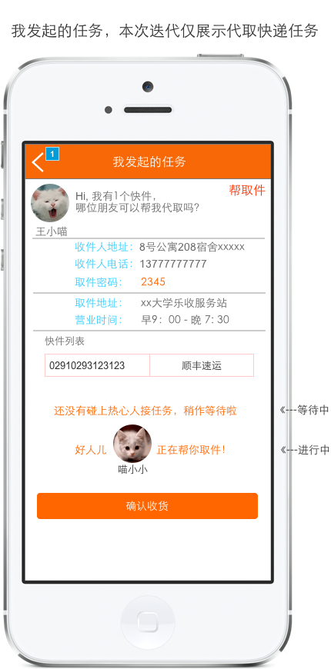

* + 1. Widget Table

| Footnote | Interactions |
| --- | --- |
| 1 | OnClick:  Case 1:  Open Back in Current Window |

* 1. 我接受的任务详情
     1. User Interface

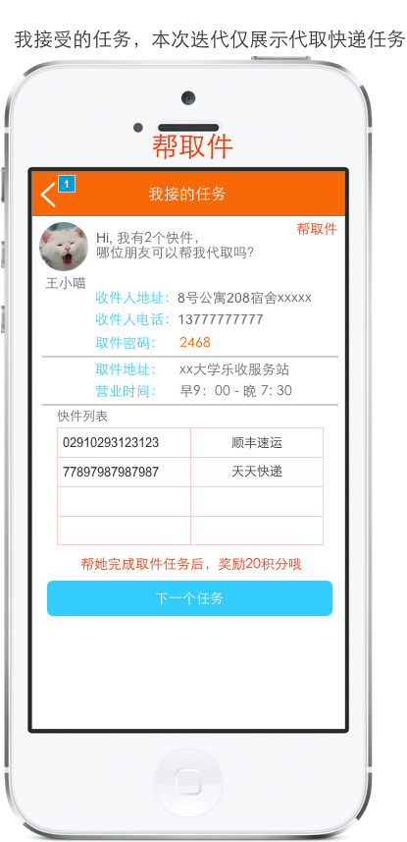

* + 1. Widget Table

| Footnote | Interactions |
| --- | --- |
| 1 | OnClick:  Case 1:  Open Back in Current Window |

* 1. 发起任务
     1. User Interface

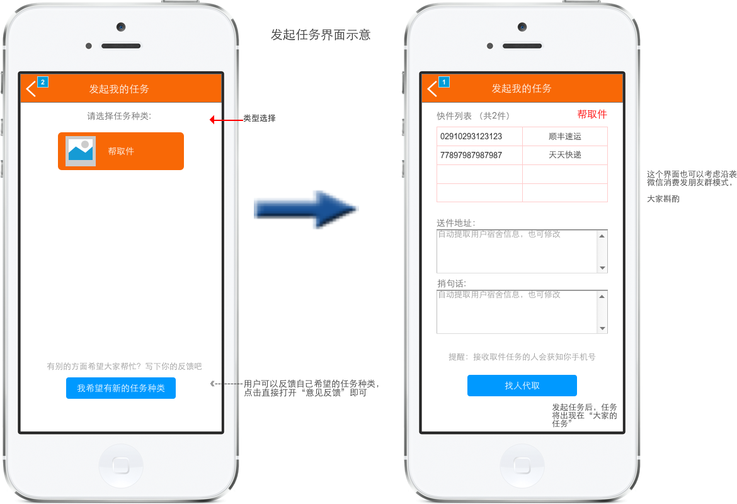

* + 1. Widget Table

| Footnote | Interactions |
| --- | --- |
| 1 | OnClick:  Case 1:  Open Back in Current Window |
| 2 | OnClick:  Case 1:  Open Back in Current Window |

1. Masters
   1. Master List

iphone5s  
iPhone 6 - Navigation Bar BG Color  
Back Chevron - iPhone 6  
page controller  
Action Bar BG Color

* 1. iphone5s
     1. User Interface

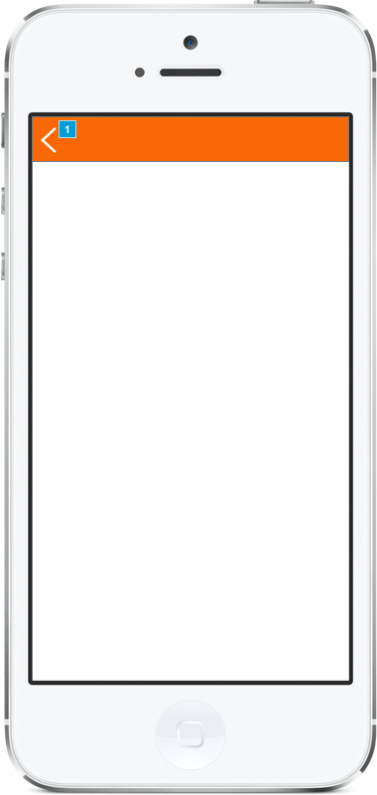

* + 1. Widget Table

| Footnote | Interactions |
| --- | --- |
| 1 | OnClick:  Case 1:  Open Back in Current Window |

* 1. iPhone 6 - Navigation Bar BG Color
     1. User Interface



* 1. Back Chevron - iPhone 6
     1. User Interface



* + 1. Back Chevron
       1. Back Chevron
       2. User Interface



* 1. page controller
     1. User Interface



* 1. Action Bar BG Color
     1. User Interface

