Additions for Iteration 02:

1. In the first release, the text commands to navigate the application were case sensitive. This has been fixed and now any combination of case will effectively navigate the user through the app.
2. The first release had a bug where invalid customerId’s would still return a record, this has been solved by making some queries “deterministic” in the context of mySql; the application will either return the record specified or let the user know that the id has not been found.
3. NEW: The application user can now activate or deactivate customers, essentially a soft delete that prevents additional customer activity while they’re marked as “deactivated”. Notes are expected to continue to be added to deactivated customers in the future for customer management and record keeping around any interactions that may lead to long term deactivation or eventual re-activation of their account within the application.

Printing Shop Application

Contents

Initial Menu 1

Customer Management 2

Adding a Customer 2

Get All Customers 2

Get Customer By Id 2

This application is meant for workers within the print shop to manage customers, products, and orders from customers. It is a console application.

# Initial Menu

The initial menu shows the options for the application:

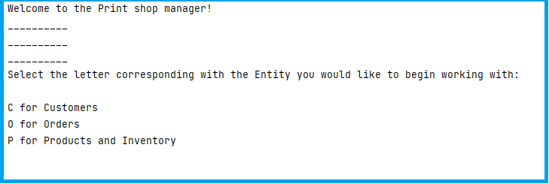

# Customer Management

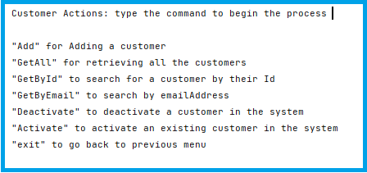

# Adding a Customer

The “Add” selection will walk you through adding the properties for the new customer, and show you the customer that was created after saving to the database. All entries are case insensitive.

1. Required Fields:
2. Email address: this field is not checked against the email server at this version of the application so be sure to accurately type the email.
3. FirstName
4. LastName
5. Once entered, the application will show details about the customer, including their newly created userId:

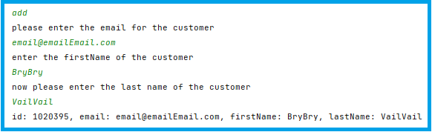

# Get All Customers

Getting all of the customers can be helpful for users that work in the shop when you can’t remember the order number or customer Id and need to manually search for a customer to then search them by Id or update the properties of that customer.

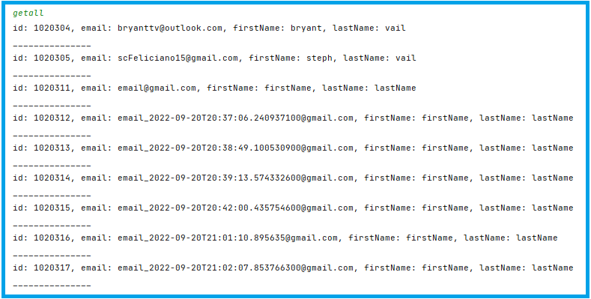

As you can see, the list will continue until all customers are listed

# Get Customer By Id

When needing to update information for a customer over the phone, or when you need to remind yourself of customer contact information, you might find use in looking up the customer by Id from the order invoice or elsewhere.

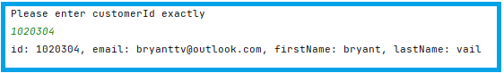

# Deactivate and Reactivate Customers by EmailAddress

1. Deactivate
   1. If the email is entered correctly and the customer is not already deactivated, the app will make the change and print the customer info in the console:

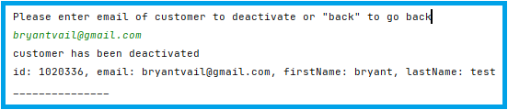

* 1. If the email is not entered correctly, the application will inform the user that the email has not been found and prompt the user again:

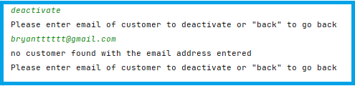

* 1. The customer that is being deactivated cannot already be in a deactivated state or the application will not make a database call and let the user know

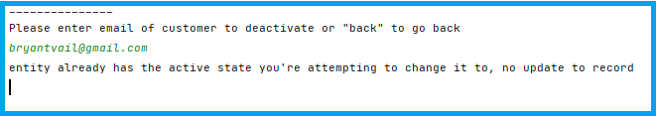

1. Re-Activate
   1. When a customer needs to be re-activated to resume being a trusted customer with access to new orders, select “activate” in the “customer management” menu and enter the email of the customer’s account to activate it

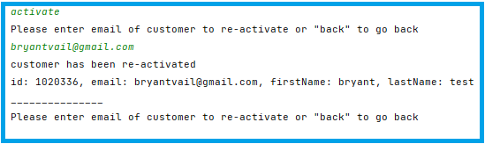

* 1. Same rules and results apply when trying to change the active status of a customer to the existing state in the database: nothing will be executed on the database and the console will inform the user.