**Bryan Velez Moreno**

**SIEM**

* **Task 1**

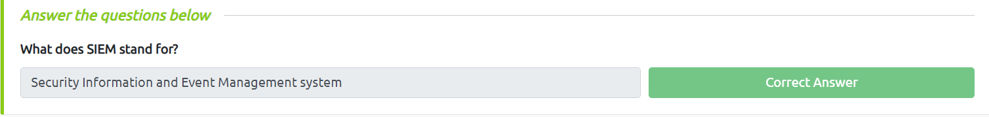

* **Task 2**

* **Task 3**

* **Task 4**

* **Task 5**

