Design Review Package

Bryce Camuso

GRAD 699: Applied Project in Comp Info Science

Harrisburg University of Science and Technology

Method Selection
Functional Requirements
1) The system shall use statistical weighting to create a path-finding algorithm
2) The system shall create a single predator class
3) The predator class must include a pursuit hunting style during the hunting phase
4) The predator class must include an ambush hunting style during the hunting phase
5) The system shall create a rabbit class
6) The system shall create a mouse class
7) The system shall create a bird class
8) The system shall output data in the file format of CSV
9) The system shall output data in an organized table outlined in the CISC 695 project proposal
Non-Functional Requirements
1) The system shall run without errors for at least 10,000 generations.
2) The system shall run to completion of 3 continuous simulations in under 24 hours of runtime.
3) The system shall produce data with the same dominant strategy for all three prey items in 5 runs of all three simulations
4) The system shall include a read me file that includes reproducible steps for running the simulation that will be performed by the academic adviser to verify usability.
5) The system shall run and produce the same dominate strategy for all three prey items on a different computer than the computer building the simulation.
Tech Stack evaluation
This simulation will be using a Python stack with Python libraries for support.
- Workstation/Architectures
  - Personal Desktop
    - Intel(R) Core(TM) i7-4770 CPU @ 3.40GHz 3.40 GHz
    - 16.0 GB RAM
  - IDE: Visual Studio Code
  - Task tracker: Milestone Excel sheet
  - Backup: GitHub
- Computational Resources:
  - Python 3.14.4
  - Git 2.54.0
  - GitHub
  - Microsoft Excel
  - Microsoft Word
  - Zotero
- API/External Systems
  - Python Threading Library (3.14.4)
  - Python Sudo-Random Library (3.14.4)
  - Python Math Library (3.14.4)
  - Mathplotlib (3.10.0)
  - Python CSV Library (3.14.4)
  - Python Time Library (3.14.4)

Testing and Evaluation Design
Class testing
For each class built for this project an accompanying class tester will be made. These testers will handle testing of all public methods in the class using black box testing principles. For this an instance of the class is created in memory and then the methods associated with that class are invoked and assessed against test data created outside the class. These tests will automatically run anytime the class file is called using python testing conventions.
Simulation Testing
For the final simulation it will be tested using benchmark testing. These benchmark tests will be based on the non-functional requirements outlined above. For the first requirement a simple test will be conducted using the rabbit class prey item. This test will run the simulation to 10,000 generations and monitor for errors. If an error occurs, then the test is considered failed. If the simulation runs to 10,000 generations, then the test will check to make sure the correct file was made. If both the simulation ran to completion and the correct file was outputted, then the test is considered a success. Otherwise, this test is considered failed.
The next requirement states that full simulation of 3 continuous prey items shall be computed within 24 hours. To test this the python time library shall be used. A sample of the internal clock shall be taken at start of the first simulation. Upon completion of third simulation a second sample shall be taken and then had the first sample subtracted from it. This will give the total runtime of the full simulation. If the final time is over 24 hours this test is considered failed. Otherwise, it is this test is passed. Additional samples may be taken to find the run time of each simulation. These will not be used to calculate the final time or pass-fail criteria.
The third requirement states that the samples gained from the simulation allow for consistent conclusions to be drawn. For this test each prey item will be tested separately and in full simulation. For each individual prey item 10,000 generations shall be simulated five times. Upon completion of all five simulations, there is a manual review of the final output data. If the dominant strategy remains consistent across all runs the test shall be passed. Otherwise, the test will be failed. This same evaluation shall then be made for the full simulation with all three prey items. If for each of the three prey items all three maintain a consistent dominant strategy the study shall be considered reproducible.
The fourth requirement shall be testing using the projects academic adviser to verify the readability of the read me file. If the project adviser can reproduce the runtime environment for the simulation and run a single simulation without further instruction from the project creator, the test shall be passed. Otherwise, the test will be failed.
The final requirement requires that the simulation is repeatable on a different computer. To test this a different computer will be acquired (either the project creator’s second computer or project adviser’s computer). Once a second computer is selected repository should be cloned onto that computer and run a single simulation. If that simulation on the new computer runs to completion this test shall be passed. Otherwise, the test will be failed.
Edge cases
Edge cases are unlikely to occur in final version of the simulation as the user will have minimal interaction with the program and should only be supplying the initial conditions for the simulation. However, edge cases have been identified in the class files for the program. One major example is in the Animal class file in how it handles each stat. A stat can be bound from a range of 0-100. To test this for edge cases in the class tester tries four values for each setter. These values are -1,0, 100, 101. The values -1 and 101 should cause an error while the values 0 and 100 should be accepted. Similar tests will be made for any values that have similar limits.
Design Rationale
Class Diagram
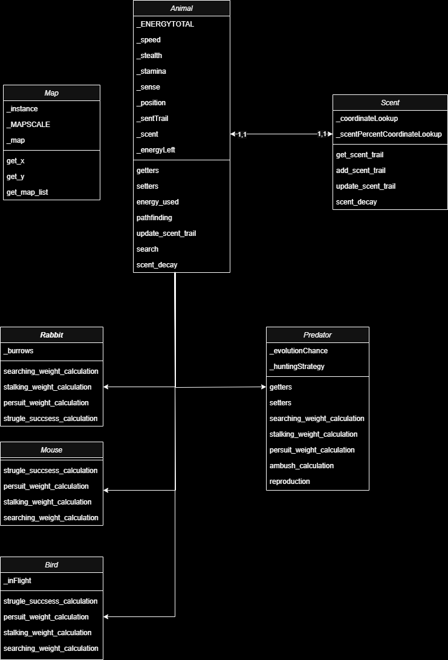

Simulation Runtime
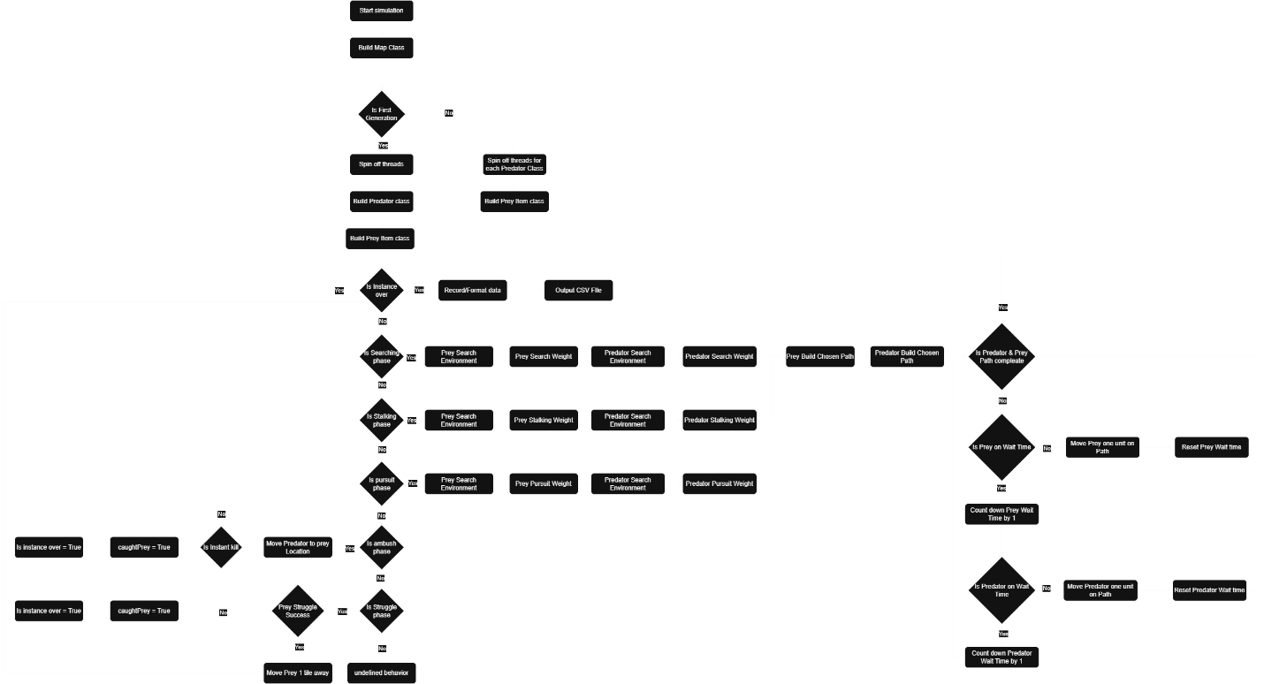

Trade Offs
The main design trade off for this project was choosing a Python tech stack. The Python programing language was chosen for its ease of testing/changing a program and portability of the program. With python being an interpreted langue it does not have to deal with complying files for testing. This allows it to be easily run with small tweaks to the code. Python also has the use of probability due to being an interpreted langue. Any computer with python installed should be able to run the code without issues. These two trades offs made Python the best langue for this project. Addition reasons also include that python is the main langue used in simulations due to its ease of implementation. Finaly it is the langue the creator of this project is most familiar with working in.
Traceability
The functional requirements list above were translated into the class diagram and runtime diagram shown above. For the first functional requirement the weighted path finding was handled in the class and shown in the class diagram. The animal class implements the path-finding algorithm based on the weight generated by the subclasses. For the path-finding algorithm it uses the weights of each tile in its sense range to form a path given its speed to the highest weight regardless of if it can reach it. This means that it will move to the closest tile it can reach to the highest weighted tile. For this algorithm, the weights are determined by the subclass and what phase the simulation is on. For each weight it is determined by how the creature should move during that phase of the simulation. For example, in the stalking phase the predator will prioritize staying hidden while approaching the target by using bushes in the area. While in the pursuit phase the predator is strictly trying to get to the prey item.
For requirements 2-7 each one is shown in the class diagram as different classes with titles. Each class is a subclass of the Animal class and inherits all its methods. The predator class also includes the Ambush and Pursuit weighted functions that are determined by hunting style variable. This variable will control which method is used in the ambush/pursuit phase.
For the requirements 8 & 9 they are shown in the runtime diagram. These requirements are the final output after the instance of the simulation has been completed. Once completed the data will be formatted using python format strings into tables. Once the strings are formatted, they will be written to a CSV file. This CSV file can be specified by the user else it will use a standard name and create/overwrite the file.

AI Usage Log and Academic Integrity
Model | Date | Prompt
Gemini | 6/7 | What should be listed for a software architecture description?

