Simulation of Predatory Evolution Using Evolutionary Game Theory and Statistically Weighted Path Finding.

Bryce Camuso

CISC 699: Applied Project in Computer Information Sciences

Harrisburg University of Science and Technology

Technical Memo
This document shows the early evidence of the project. Currently the project has completed implementation for the Map class and Scent class. The Animal class is 95% as only the energy consumption for moving and sensing needs to be implemented. These three components make up the base of the project as all future classes will be made based on the implementation of these three. As such this little demo shows a single run through of the simulation could look like for debugging.

Sample Outputs/Test Validations
Animal Class Tester Sample
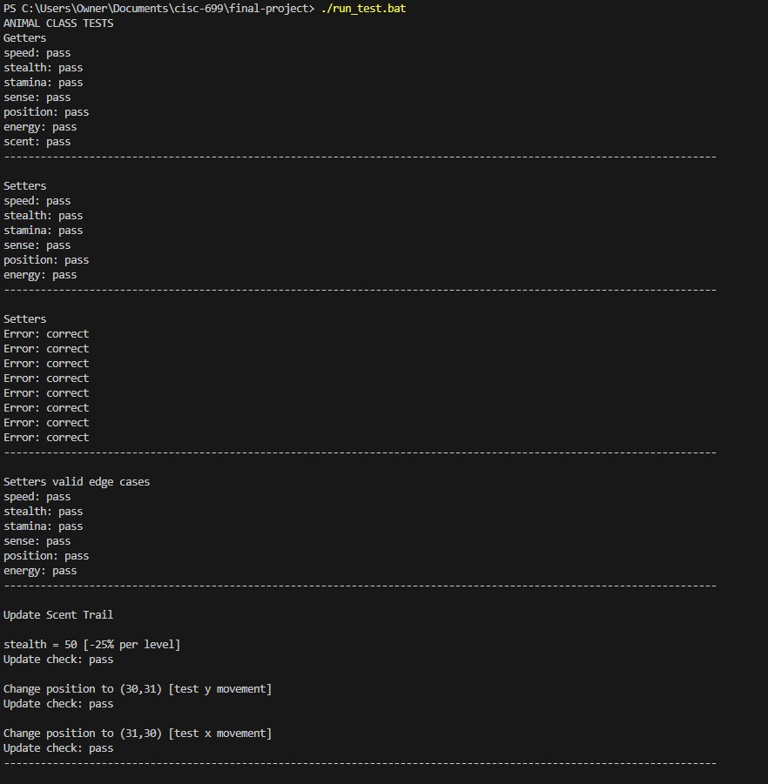
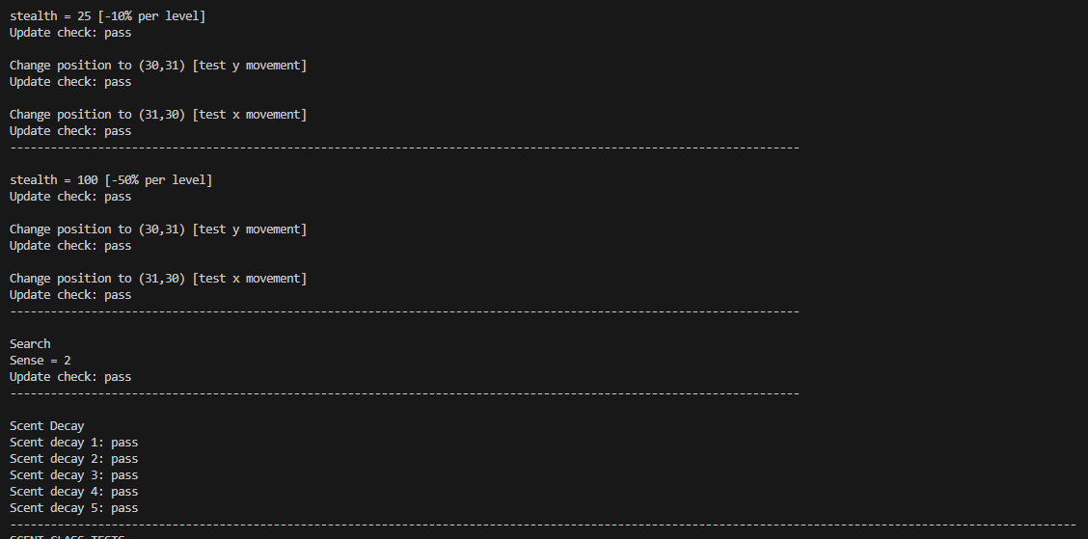
Scent Class Tester Sample
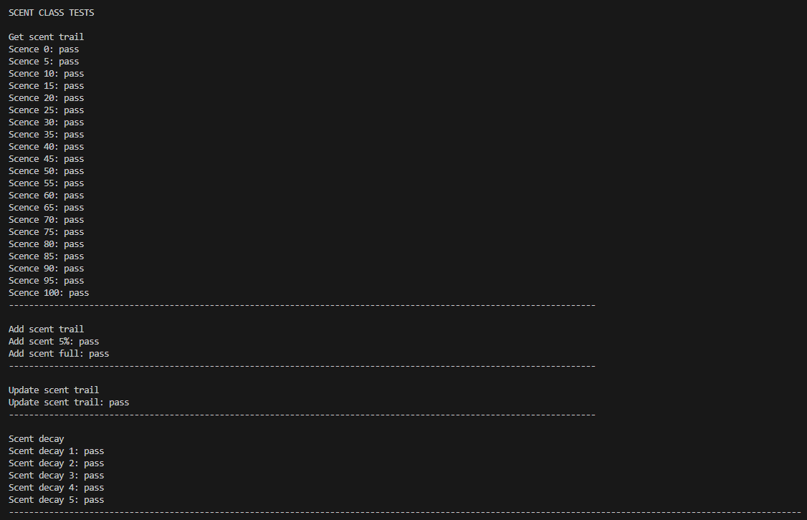

Map Class Tester Sample
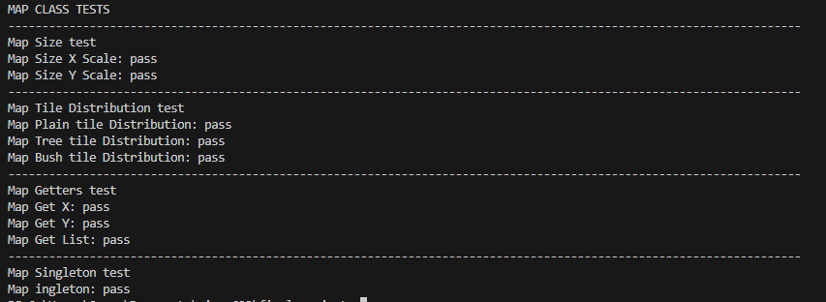
Simulation Test Sampel
Test 1
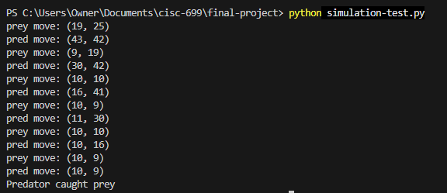

Test 2
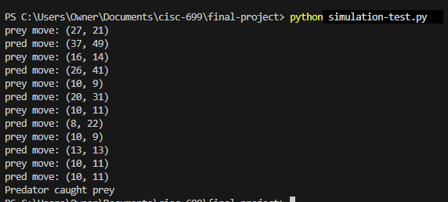
What Needs Improvement
Due to not having the predator and prey classes for the test I had to simulate some of their functions in the test file. This led to me running into a lot of bugs that I have not been able to resolve yet in the completed files. Most of the issues come from a lack of boundary checking when trying to find map tiles. Due to the map receiving a list of values I chose to have it ignore out of bound requests. This means that it does not cause an error when one value is out of bounds in an otherwise correct list. However, this means that boundary checking needs to be done on the side of the calling class. This has not been fully implemented for the path-finding algorithm yet.
An additional problem is a lack of class testing for the path-finding algorithm. Due to limited time, I have not been able to create a full class tester for the methods added to the Animal class in the most recent milestone. I am planning on completing the class tester this week (week 7).
AI log
AI was not used in any part of the project this week. Most of the implementation had been taken care of in previous weeks due to having a trip planned for the entire week. This meant that I had most of implementation done in Week 5. For this week it was simply plugging in what I had already created to create a simple demo. Thus, there was no need for any google searching or AI use.
Model | Date | Prompt | Implementation of Answer
N/A | 6/23 | N/A | N/A

