Simulation of Predatory Evolution Using Evolutionary Game Theory and Statistically Weighted Path Finding.

Bryce Camuso

CISC 699: Applied Project in Computer and Information Science

Harrisburg University of Science and Technology

Abstract
In the study of evolution, one interaction has been observed to be one of the biggest drivers of change. This is the interaction between predators and prey that is studied in predator-prey dynamics. However, in this field, a lot of research has focused on how predators force prey to evolve. This has left a gap in how prey affects predators that hunt them. This study aimed to fill that gap by using a simulation to test two predation strategies against three prey animals. The two predation strategies were the ambush and pursuit strategies. Through the simulation, it was found that the pursuit strategy was favored by the predator population against all three prey animals. However, this was found to be likely due to a bias in how the simulation chooses the best predators. This has led to the need for further testing of this simulation to rectify the bias in the program. Additionally, research is also needed on how other predation strategies would be affected by their choice of prey.

Introduction
Predators are key components of a functioning ecosystem. Without predators, herbivore populations would breed out of control, destroying the local flora (Allesina & Tang, 2012). Predators are also a key force in how prey evolve (Jones & Ellner, 2007). When one evolves a strategy, the other must evolve a counterstrategy. This interplay between predator and prey forms a research branch known as predator-prey dynamics.
Within this branch of research, it has become a well-known fact that both predators and prey evolve in tandem with each other (Jones & Ellner, 2007). So much so that even in Charles Darwin’s original work, he notes the effects of how animals, if they were completely isolated from all external factors, would still evolve to gain advantages over one another (Darwin, 1872/2022). Within this ecological interplay, predators rely on the death of prey to survive. This relationship puts both groups in direct competition with each other for survival. Thus, the branch of predator-prey dynamics was created to understand the complexities of how predators/prey affect each other’s behaviors and evolution (Netz et al., 2022).
In the branch of predator-prey dynamics, there is also a term known as coevolution (Jones & Ellner, 2007). This term refers to the effects that two species have on each other’s evolution (Brans et al., 2022; Jones & Ellner, 2007; Yoshida et al., 2007). Thus, coevolution is one of the major things studied in predator-prey dynamics. Many studies have looked at how the evolution of one creature causes feedback and forces that creature to adapt to that new change (Brans et al., 2022; Jones & Ellner, 2007; Yoshida et al., 2007). In practice, though, such changes take place over thousands of years. That makes it hard to study coevolution on a wide variety of animals. Thus, tools such as simulations have been used to help model theoretical concepts.
Simulations can help bridge the gap between the real world and the theoretical by allowing scientists to model what they hope to study in a more controlled environment. Such simulations have often been used to look at coevolution. In such simulations, both predators and prey are evolving together to model the interplay between species (Netz et al., 2022). Similarly, simulations have been used to model observed behaviors of predator and prey tactics (Qi & Tạ, 2026). Lastly, simulations have been used to look at how prey adapt to predators' behaviors and evolve defense mechanisms (French et al., 2022).
However, previous studies have left a gap in the area of predator-prey dynamics that this paper hopes to fill. Prior studies have overlooked the predator side of evolution, in which the predator evolves to static prey. Such evolution can be helpful to understand how predators contribute to a stable ecosystem (Allesina & Tang, 2012). One such case is when invasive species have taken over an ecosystem. By performing a simulation, researchers can understand how predators help to control the invasive species population. Predators also play an important part in controlling disease in prey populations. Without understanding the role predators play, we can inadvertently put both predator and prey populations at risk. Thus, the goal of this paper is to use a simulation to better understand the evolution of the predator strategies known as ambush and pursuit by modeling land-based predators’ (terrestrial predators) speed and stealth optimizations against three different prey animals.
Literature Review
Origin of evolutionary study
The study of evolution in biology is often traced back to Charles Darwin with his theory of evolution (Darwin, 1872/2022). As part of this theory, he proposed many key ideas that would shape the study of evolution. One such term is natural selection. Natural selection is the process in which, through competition and adaptation to the ecosystem, animals evolve in the wild without human intervention (Darwin, 1872/2022). For the use of this project, natural selection is the foundational principle of study. While some randomization is involved in the survival of wild animals, there are adaptations seen throughout species that allow them to survive in an ecological niche (Cao & Wu, 2021). Through these niche groups of animals, an environment can be created where the populations regulate each other enough so that all species can survive (Allesina & Tang, 2012).
Origins of predator-prey dynamics
In nature, one common way of regulating populations is through predation (Allesina & Tang, 2012). Within an ecosystem, predators hunt and maintain prey populations so that one species does not increase in numbers so much that it destroys its own food source (Allesina & Tang, 2012). This, however, raised the question of why predators would only choose certain prey items and leave other species alone. To answer this question, a branch of study known as predator-prey dynamics was formed. This branch focuses on the interplay between how predators/prey evolve to catch/evade the other (French et al., 2022). This interplay is another foundational principle for this project.
Studies on Coevolution
The interconnectedness of predators and prey has led to extensive research on how the two affect each other’s evolution. Such studies have coined the term coevolution to describe this effect (Brans et al., 2022; Netz et al., 2022; Yoshida et al., 2007). In essence, when one evolves a new strategy, the other evolves a counter to that strategy. This balance is created because a new development may quickly reduce the population of a species, leaving alive only those fit to deal with the new adaptation (Jones & Ellner, 2007). This is an example of rapid evolution (Jones & Ellner, 2007). Other studies have looked at how the environment affects such interactions in coevolution (Brans et al., 2022). Additionally, studies have looked at the general factors that force evolution to take place (Yoshida et al., 2007). Each of these studies looks at a small part of why coevolution takes place.
However, a common point of coevolution studies is how the prey reacts to the effects of predation (French et al., 2022; Jones & Ellner, 2007; Yoshida et al., 2007). Some examples of these studies look at how excessive predation affects the prey or how prey adapts to a predator's hunting schedule (French et al., 2022; Jones & Ellner, 2007). Within these studies, they often look at how predators affect prey or how predators and prey affect each other. This has left a gap in the research on how prey exclusively affects predators. This gap in studies on predators stems from the logistical challenges of conducting large-scale studies on wild populations. (Lennox et al., 2023). Due to factors such as weather and breeding cycles, it is hard to control for a consistent environment in wildlife studies.
Simulations in the study of evolution
This is where simulations have been brought in to help with predator-prey dynamics. In general, simulations are one of the leading tools to help understand the theory of evolution, due to how long evolution takes in most species (Atmar, 1994). This is especially true for the field of predator-prey dynamics. Such simulations sacrifice true accuracy to simplify the problem down for more control over the research environment (Atmar, 1994). This allows researchers to model out problems that would be close to impossible to study otherwise. It also allows us to model out specific behaviors that have been observed, such as grouping behaviors in oceanic fish populations (Qi & Tạ, 2026). In such simulations, researchers can run the simulation millions of times to slightly change behaviors instead of spending hours at sea with only a small chance to observe such grouping behaviors in the wild.
Simulation is also the backbone of the methodology used in this paper. As such, multiple types of simulations were looked at when collecting ideas for this project. Many simulations use contiguous statistical modules to predict patterns of evolution (Cao & Wu, 2021; Chen & Wu, 2023; Huneman, 2014). These models use mathematical equations to represent events and prove outcomes through mathematical processes. In essence, these models simplify problems down into a set of randomly determined variables that, when plugged into a function, predict the process of evolution. In practice, this type of simulation for a predator-prey system would consist of a function that represents the factors that affect the given population. For a wolf population, these factors can represent the population of its prey, how likely an individual wolf is to catch prey, and how likely an individual wolf is to create another wolf. Each of these factors are then represented as variables in the function and used to map out, through simulations, how changes to those variables affect the overall population. The main advantage of these simulations is that they are much more efficient than fully simulated environments. However, that comes with the downside that it is worse at representing more abstract concepts.
The second common form of simulation is discrete simulations. These model the events using code to recreate observed behaviors (Netz et al., 2022; Qi & Tạ, 2026). These models build out simulated environments and creatures to observe how they interact. Instead of predicting broader outcomes, these models allow for more random interactions between the subjects that are being simulated. In practice, a simulation like a predator-prey system would look at building representations of wolves and their prey. These models would be able to perform observed behaviors such as tracking and stalking their prey. This means that for each member of the wolf population in the simulation, a full model of a wolf is made that can act on its own instincts. The main advantage of this simulation is that it allows for closer realism to the subject matter. However, the main limiting factor is that these simulations are highly inefficient and often must limit the size of the simulation. For this paper, a discrete event-driven simulation has been chosen.
Ambush vs Pursuit
Within nature, predators have often been seen to have a general strategy for how they hunt their prey. Different predators have been known to build traps such as webs and wait for prey to get stuck (Michalko & Pekár, 2016). Other predators actively seek out their prey and strike quickly, killing their prey before they can escape (Michalko & Pekár, 2016; Murray et al., 1995). Still others evolve to run down their prey to wear them down enough to kill (Murray et al., 1995). Due to the diverse array of strategies, science has looked at why such strategies come about. Two factors have been determined as the main contributors. The first contributor is the environment the predator is hunting in (Michalko & Pekár, 2016; Murray et al., 1995). To be successful, the predator must be able to use their environment to their advantage when catching prey. The second factor is the prey items that the predator is hunting (Michalko & Pekár, 2016; Murray et al., 1995). If the predator does not have a good strategy designed around its prey, it is bound to fail. Given these two, this paper is looking more closely at the second contributing factor.
To look at how prey affects hunting strategies, two strategies have been chosen for this study. These strategies are pursuit and ambush. While not the only strategies, they are two of the most well-known. They have also been compared before when looking at environmental factors (Murray et al., 1995). Given these factors, these two strategies will act as the basis for this study.
When looking further at the pursuit strategy, one key part of the strategy made itself apparent. This is the predator's ability to run down prey (Anholt et al., 1987). For the pursuit strategy, the predators can outrun or catch up to their prey (Anholt et al., 1987). This means that the predator is built for speed. To represent this, the term speed is used. An animal that uses this strategy is the coyote (Canis latrans). A coyote is known to chase and wear down its prey when hunting (Hayward et al., 2023). This makes it a perfect example of the pursuit strategy.
On the other side, the key part of the ambush strategy is staying hidden (Martin & Hammerschlag, 2012). An ambush predator’s main goal is to deliver a killing strike before its prey gets a chance to fight back. This means that the predator often has to hide itself in some way to get close enough to deliver its killing strike (Martin & Hammerschlag, 2012; Murray et al., 1995). This can be through a mix of camouflage or adaptations to make less noise while moving. To represent this, the term stealth is used. An example of an ambush predator is the Eurasian lynx (Lynx lynx). The lynx uses its brown fur and ability to climb to quickly kill its prey before it is noticed (Krofel et al., 2011). This makes it a perfect example of the ambush strategy.
For predators, their strategies are what they have evolved to be best suited for. This allows an animal to take advantage of prey other predators would have to pass on (Michalko & Pekár, 2016). Though there are still a lot of prey items that multiple predators have evolved to hunt. However, the main difference is the percentage of a predator’s diet a prey item makes up (Hayward et al., 2023; Krofel et al., 2011; Michalko & Pekár, 2016). For each prey item, multiple strategies work but they have varying levels of success (Murray et al., 1995). One such animal is mice, where both the pursuit and ambush strategies have been recorded as successful on the animal (Hayward et al., 2023; Krofel et al., 2011). However, for the chosen model of predators of each strategy, those being the coyote (Cunis latruns) for the pursuit strategy and the lynx (Lynx canadensis) for the ambush strategy, the mice play different roles in their diet. For the coyote, a mouse is a main food source when hunting as an individual (Hayward et al., 2023). For the lynx, a mouse is a secondary source of food (Krofel et al., 2011).
Another example of such prey animals that are favored by one strategy is small birds. For a lynx, small birds act as a common food source when their main prey of ungulates is not found in their hunting area (Krofel et al., 2011). For coyotes, they only catch birds as a rare opportunistic catch (Hayward et al., 2023). One animal that both have an almost even interest in is rabbits (Murray et al., 1995). For rabbits, both strategies of ambush and pursuit have been proven effective (Hayward et al., 2023; Krofel et al., 2011; Murray et al., 1995). For most studies of this kind, they look at how the environment affects the predators' hunting rates and evolution (Brans et al., 2022; Cao & Wu, 2021; Murray et al., 1995; Netz et al., 2022). With the environment being only one of the contributing factors to why predators evolve their hunting strategies, such studies have left a gap in the second contributing factor of prey selection (Michalko & Pekár, 2016). That is why this paper hopes to look at how specifically prey affects the evolution of hunting strategies.
Research questions
With each of these prey animals, this simulation hopes to answer a simple question: Which predator strategy works best on each animal? In a broader sense, this simulation hopes to provide more research into how predators evolve to their prey. To do this, several research questions have been formed and are tested using a simulation.
The first research question posed in this paper is: Given access only to rabbits as prey, how are speed and stealth optimized to evolve the ideal hunter? This question looks at the most common prey that both example predators have in common (Hayward et al., 2023; Krofel et al., 2011; Murray et al., 1995). Given that rabbits are a well-known food source for both, neither strategy should be completely wiped out.
The second research question posed in this paper is: Given access only to mice as prey, how are speed and stealth optimized to evolve the ideal hunter? Due to mice being a more significant dietary element of the coyote, a pursuit predator should have an advantage with this prey item (Hayward et al., 2023). This also follows the logic that ambush predators are more likely to give up a kill if they do not make the kill immediately.
The third research question posed in this paper is: Given access only to small birds as prey, how are speed and stealth optimized to evolve the ideal hunter? Due to birds being a more significant dietary element, as in the example of the lynx, an ambush predator should have an advantage with this prey item (Krofel et al., 2011). This also follows the logic that birds can make an immediate escape from a terrestrial predator and thus must be killed immediately, or it will get away.
The last research question posed in this paper is: How does changing the prey type of a random starting population of predators lead to an optimization in either speed (pursuit predators) or stealth (ambush predators). For this question, not much past research has been done. Given the above examples, it follows that how prey avoids predators will determine whether pursuit predators or ambush predators will gain dominance over the gene pool of the predator population.
Methods
This study ran a discrete event-driven simulation where one prey item is matched up with one predator representing a predation strategy. This was used to test if there is an optimal strategy between Ambush and Pursuit for a predator to use on a mouse, bird, and rabbit. The results were then used to answer a larger question of how changing prey affected the course of the evolution of the predator and if a dominant strategy could be found for each prey item.
Simulation Design Details
To begin to understand how predators evolve to their prey, a discrete event-driven simulation has been chosen. This allows the simulation to break down each movement of a predator and prey as an event that can be tracked. For the simulation, an event is a change in position of either predator or prey. The simulation is also running isolated instances of the environment where one predator is paired with one prey item. This is to decrease competition for prey among predators. In these simulations, each movement cycle consisted of 80 movement opportunities. The animal then has the number of tiles it can move divided by 80 to determine how often it can move each movement cycle. Lastly, the simulation runs until a hunt is considered failed or successful. A hunt is successful if the prey item is caught. A hunt fails if a prey item escapes the predator. If the hunt is successful, the predator reproduces. If the hunt fails, the predator is removed from the population. This general design is repeated three times for each of the different prey types. See Figure 1 for a visual flow chart of the simulation.0

Figure 1
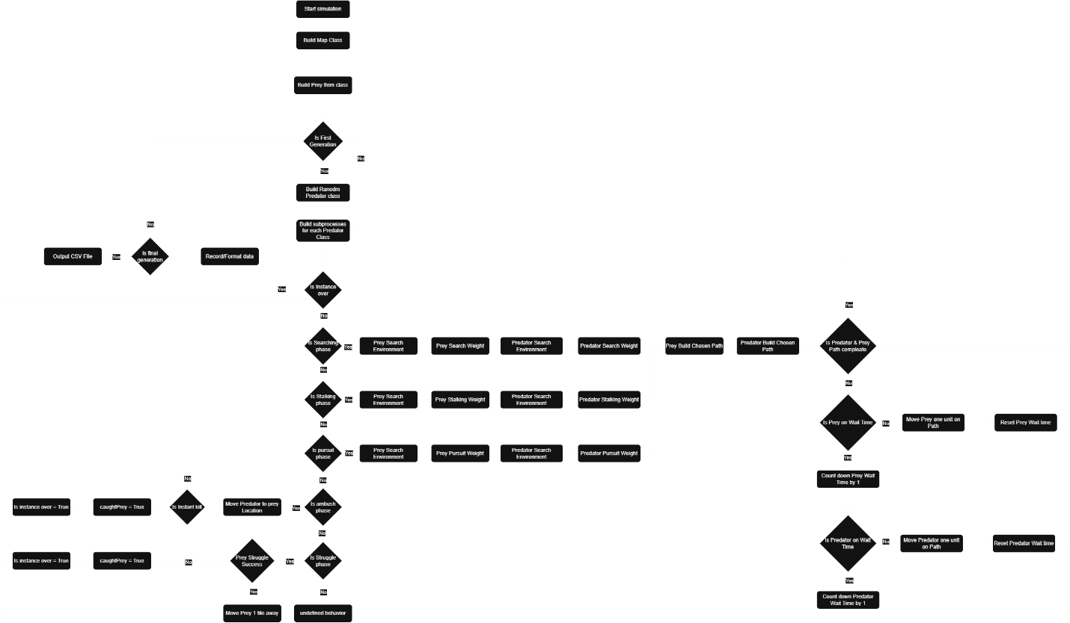
Note. For additional clarity on the main loop of the simulation, see the Simulation Phases section.
Environmental Details
The simulation is run in a 2d grid to simulate a forest floor. Each grid space is filled with one grid tile. These tiles consist of plain tiles, tree tiles, and bush tiles. A plain tile is an open space that both predators and prey can run through. A tree tile is an obstacle that predators and prey need to navigate around. A bush tile can be run through by prey but costs more for a predator to run through. This can make for more dynamic movement when chasing prey. Finally, plant objects are considered as objective points for prey items. These objects are where prey items are navigating to when not under threat of a predator.

Simulation Phases
To help navigate the flow of predator-prey hunting interactions, the simulation is broken down into phases. Each phase defines the interactions that can occur at that point in the simulation. Additionally, only predators can trigger a new phase. The phases will flow through the following pattern: searching, stalking, ambush, pursuit, and struggle. The searching phase will consist of predators trying to find their prey while prey tries to find plants. This phase will end once the predator is within 100 tiles of its prey. The next phase is the stalking phase. The stalking phase consists of the predator trying to get closer to its prey without alerting them. For each predator, they will have to get within a certain range before they can initiate an ambush/pursuit. This range is determined by their ambush range for ambush predators and pursuit range for pursuit predators. If the prey discovers the predator before getting into this range, it goes directly into the pursuit phase regardless of hunting strategy. If the predator is an ambush predator and they have not been spotted during the stalking phase, then the ambush phase is triggered. This phase simply checks if the prey is in ambush range. If the prey is in range, then the predator is moved to the prey’s tile and has a chance to kill the prey without going into the struggle phase. If the prey is not killed, the struggle phase is started, and the simulation continues as normal. If the predator is spotted or a pursuit predator, the pursuit phase is started. This phase consists of the normal movement cycle; however, the paths of both animals are updated any time the other one moves. This is to mimic decision-making seen in a pursuit. The final phase of the simulation is the struggle phase. This phase is triggered when the predator is one tile of distance from the prey. This phase consists of the prey using its remaining energy to try to escape from the predator. If the prey successfully escapes, it is put in the nearest viable tile that is at least 2 tiles away from the predator. This then restarts the pursuit phase without a chance for another ambush. If the prey does not successfully escape, then it is considered caught, and the simulation ends.
Creature Design Details
Creatures are designed according to Object Oriented Programming (OOP) principles of inheritance. This means there are traits that each animal has in common and traits that are specific to the creature. The general traits of animals are listed in the General Animal Design section. These are traits that each animal has in common. For specific traits, they are listed under their specific creature’s section.
General Animal Design
Each animal has general traits in common. This is to help mediate the factors outside of the ambush vs pursuit strategies. To start with, each animal has a limited amount of energy that they can use for that simulation. If that energy ever hits 0, the animal is considered immobile. Each animal will have a range of senses. This range acts as the animal's field of awareness. Anything in the animal's sequence range is passed to the animal for pathfinding. Anything outside of this range can be discovered during pathfinding but cannot be a valid target for the creature. The pathfinding of Animals has also been standardized. Each creature will first evaluate each tile in its sense range. This uses statistical modeling based on the method outlined in Complex eco‐evolutionary dynamics induced by the coevolution of predator–prey movement strategies (Netz et al., 2022). This method calculates the viability of a movement square based on the factors in and around that square. This simulation takes the maximum weight from all the tiles evaluated and selects it as the target for pathfinding.
The pathfinding algorithm chosen is the A* algorithm. The A* pathfinding algorithm was chosen for its efficiency while maintaining the goal-seeking behavior mentioned above (Foead et al., 2021). This made the algorithm an obvious choice to help maintain the efficiency of the program while still creating a path to a desired destination.
Rabbit Design
The Rabbit prey type has two unique attributes that are used. The first attribute is that it has multiple burrow positions. During the rabbit simulation, any bush tile is also considered a burrow tile. The second attribute is that when a predator has been detected, the rabbit will attempt to flee to one of its burrows. Which burrow the rabbit flees to is determined by the rabbit’s position relative to each burrow and the predator’s position. Once the rabbit enters its burrow, it is considered safe, and the hunt has failed.
Mice Design
The mouse prey type doesn’t have any unique attributes itself. Instead, it is the fastest prey animal. This means it has the fastest movement speed compared to the other prey animals. It is also more sensitive than other prey items to predators attempting to stalk it. This gives the mouse a high chance to detect a predator before it can be ambushed.
Bird Design
The bird prey type has one unique attribute. That attribute is its ability to fly. This means it can escape quickly after it has detected a predator. For this situation, because it is a 2D environment, once the bird has taken off, it is considered unreachable. This means it has the quickest escape option of the three prey types. Additionally, a bird can move freely and ignore all tiles to fly directly to targets. This means that it can move through tree tiles while no other animal can.
Plant Design
The plant class in this simulation is used as a target for prey classes when a predator is not chasing them. For each simulation, four plant objects are created and placed in the middle section of the map. This helps push the prey towards the center of the map to allow for more consistent iterations. The plant class also has a scent trail that is only updated once on creation. This means that they have a constant scent trail for the prey to follow.
Pursuit Predator Design
Pursuit predators are forced to take the pursuit phase when hunting. A pursuit predator maximizes its speed to catch their prey. This means that a predator designated as a pursuit predator should focus on using their speed to run down prey. A pursuit predator will also have a range in which it will continue to chase its prey. Once a prey item leaves this range, it is considered too far for the predator to justify continuing the hunt. This is known as the predator's pursuit range.
Ambush Predator Design
Ambush predators are forced to take the ambush phase when hunting. An ambush predator will maximize their stealth trait. This means that a predator designated as an ambush predator should focus on using their stealth to quickly ambush prey.
Experiment Details
Starting population
The starting population of the simulation consists of a 50/50 split of pursuit and ambush predators. Each predator will have a randomly allocated starting range of stats. Finally, each predator will then be paired up with an identical copy of the prey item and an identical map. The map is randomly generated but remains the same for all testing. This is to limit the impact of the environment on the evolution of predators.
Evolution design
The reproduction of predators is done Asexually. To do this, each predator that successfully catches prey will have a chance to produce 0-2 offspring that are genetically identical. However, there is a 10% chance for the offspring to either raise or lower 1 to 3 of their parents’ traits by 1 to 5 units. This is considered a mutation or evolution. Higher stats are also more costly on energy, causing the creature to tire quickly.
Generation design
Generations are defined as the iterations of the simulation. This means that after each predator has caught or failed to catch their prey, the simulation starts again. The next generation consists of the predators that caught prey, with 0-2 offspring, while those that failed to catch prey die off. This incentivizes optimization for the creatures that perform the best against that prey item. Additionally, a population cap was introduced to better optimize the simulation and allow for some competition between predators. When the number of predators exceeds the population cap, the simulation will choose the best candidates to move onto the next generation. This cap is slowly changed over the course of the simulation to increase competition.
To select the best candidates, 2 factors were chosen. The first order/main factor is the average trait of the predators. This is gained by adding all the predators' traits together and then dividing by 4. For the first half of the generation, this factor is maximized to weed out predators that get lucky. The second half of the simulation minimizes this factor to lead to the most efficient and thus most optimized predator for its prey item. The second factor is used to break ties in the first-order factor. The second-order factor consists of a weighted average of three criteria. The first criterion is the number of cycles it took a predator to catch its prey divided by the starting distance between them for normalization. This accounts for 40% of the weight and is primarily affected by the predator's speed and sense. The second criterion is the energy the predator has left. This is divided by an animal's energy total to get a percentage used. This accounts for 20% of the weight and is primarily affected by predators’ stamina. The final criterion is whether the predator was spotted. This is a Boolean value and is thus converted to 0 if false and 1 if true. This accounts for 40% and is primarily affected by the predator’s stealth.
Output Data
The output data for this simulation is a table of each predator in each generation. This data includes the generation as a number, hunting outcome, what strategy the predator was using, the predator’s stats, and what prey the predator was hunting. Each of these outputs is tracked per predator in the generation. The output for hunting outcome is a binary output of 0 or 1. A 0 is produced if the predator fails to catch its prey. A 1 is produced if the predator catches its prey. The strategy a predator uses is output as a string of either ambush or pursuit. The stats are produced as columns with the stat name and the value filled in for each predator. For each stat, they are limited to a value between 1 and 100. Finally, the prey the predator was hunting is given as a string with the name of the prey. An example output table is provided below.
Table 1
Example of Simulation Output Data from First Generation
Generation | Hunting Strategy | Speed | Stealth | Stamina | Sense | Hunting Outcome | Prey Type
0 | ambush | 8 | 49 | 46 | 4 | 0 | Rabbit
0 | pursuit | 4 | 8 | 6 | 51 | 0 | Rabbit

Analytical methodology
To answer the first research question, how predators would evolve when given access to only rabbits as prey, a payoff function will be created from the data collected in a rabbit-only simulation. This payoff function will show how beneficial it was to choose one hunting strategy over the other (Hofbauer & Sandholm, 2011). This function uses data from the final generation as its input to show, after evolution, which strategy became dominant. Additionally, over time, graphs will be made to show the progression of evolution over the generations. This gives an idea of how the population changed over the generations. This same analysis will be repeated on the two subsequent research questions. Those questions are how predators evolve when hunting only mice, and how predators evolve when hunting only small birds.
To show overall trends and answer the final research question, a final analysis was carried out on the full dataset from all three runs of the simulation. From this, a comprehensive payoff matrix can be created to show the results of each predator vs each prey type. Additionally, change over time graphs have been created to show the results of each simulation.
Results
For this experiment, the three prey types were tested one after the other with the same map and a random starting population of 5000 ambush predators and 5000 pursuit predators. The data set comprises 100 generations with a starting population cap of 500 and an ending population cap of 100. The cap was lowered by 20 every two generations until reaching 100. This setup was repeated for all three simulations. The complete data set is held in a file called output_final.csv. MySQL was used to summarize the data into the final form seen in the file called final_sample.csv.

Predators Hunting Rabbits
When testing pursuit and ambush predators against rabbits, pursuit predators took over the population. This takeover happened at generation 22, but the ambush population had declined steadily after generation 3 (Figure 3). The data show that ambush predators require both speed and stealth to catch their prey, while pursuit predators only needed speed (Figure 4).
Figure 2
Average Predator Stats Over Time When Hunting Rabbits
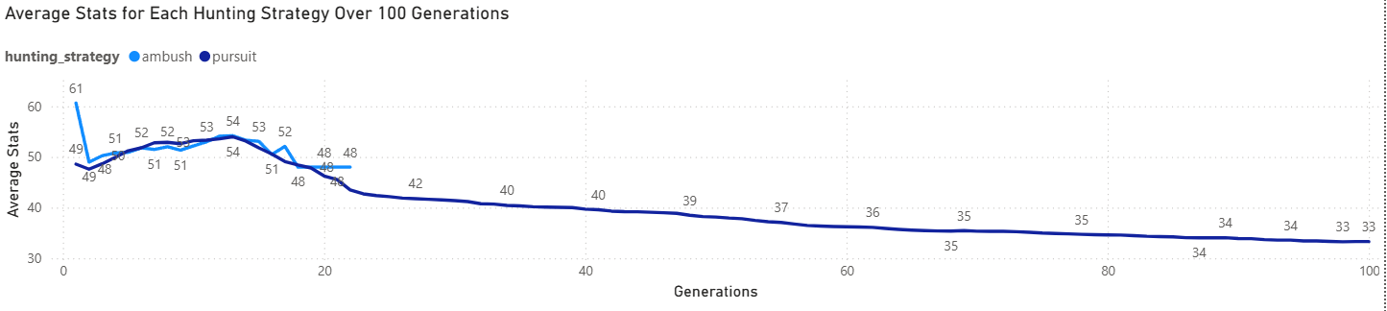
Note. This visualization has generation 0 filtered out due to the random starting population.
Figure 3
Distribution of Predators When Hunting Rabbits
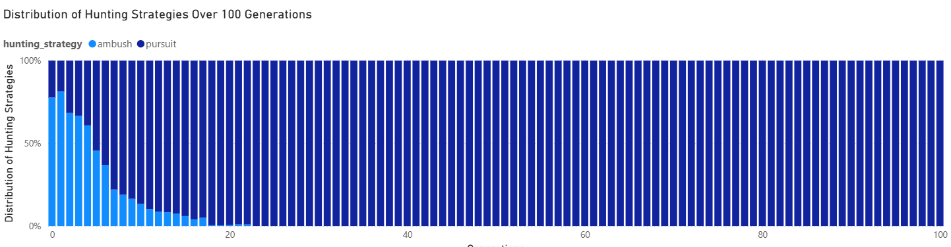
Note. This visualization is filtered for only the predators that successfully caught prey.

Figure 4
Average Stats of Speed and Stealth for Ambush and Pursuit Predators When Hunting Rabbits
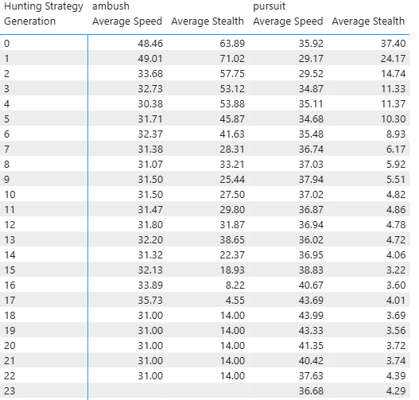
Note. The table was cut at the point when Ambush predators had gone extinct in the population.
Predators Hunting Mice
When testing pursuit and ambush predators against mice, pursuit predators took over the population. This takeover happened at generation 9, with the ambush population quickly decreasing after generation 2 (Figure 6). The data show that stealth was not a very useful trait in this population. Both ambush and pursuit predators chose to maximize speed (Figure 7).

Figure 5
Average Predator Stats Over Time When Hunting Mice
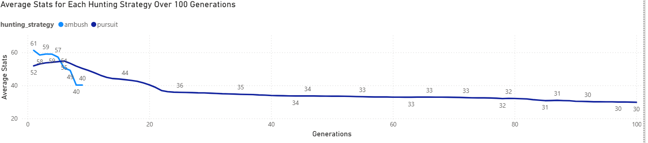
Note. This visualization has generation 0 filtered out due to the random starting population.
Figure 6
Distribution of Predators When Hunting Mice
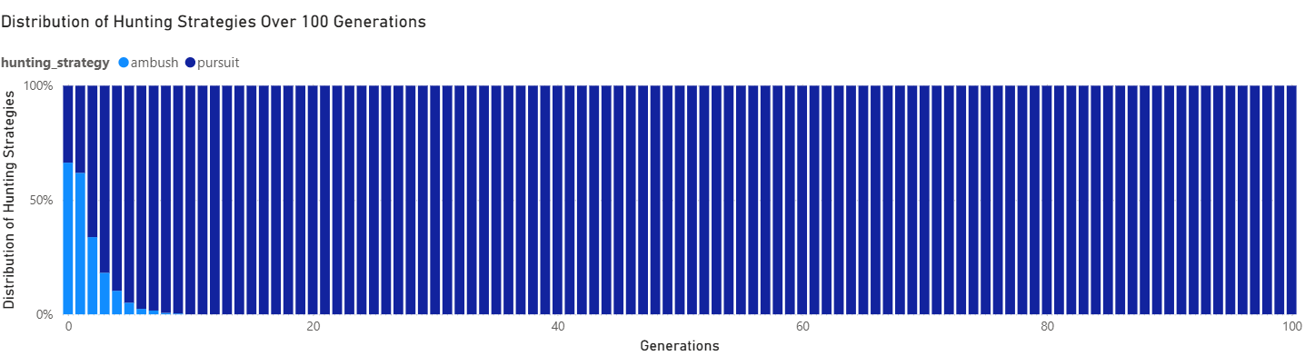
Note. This visualization is filtered for only the predators that successfully caught prey.
Figure 7
Average Stats of Speed and Stealth for Ambush and Pursuit Predators When Hunting Mice
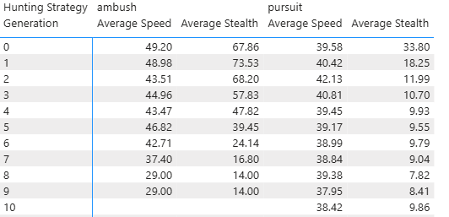
Note. The table was cut at the point when Ambush predators had gone extinct in the population.
Predators Hunting Birds
When testing pursuit and ambush predators against birds, pursuit predators took over the population. This takeover happened at generation 33, with the ambush population holding a majority until generation 24 (Figure 9). This data shows that stealth was prized at first but was outcompeted by lower-speed values of pursuit predators (Figure 10).
Figure 8
Average Predator Stats Over Time When Hunting Birds
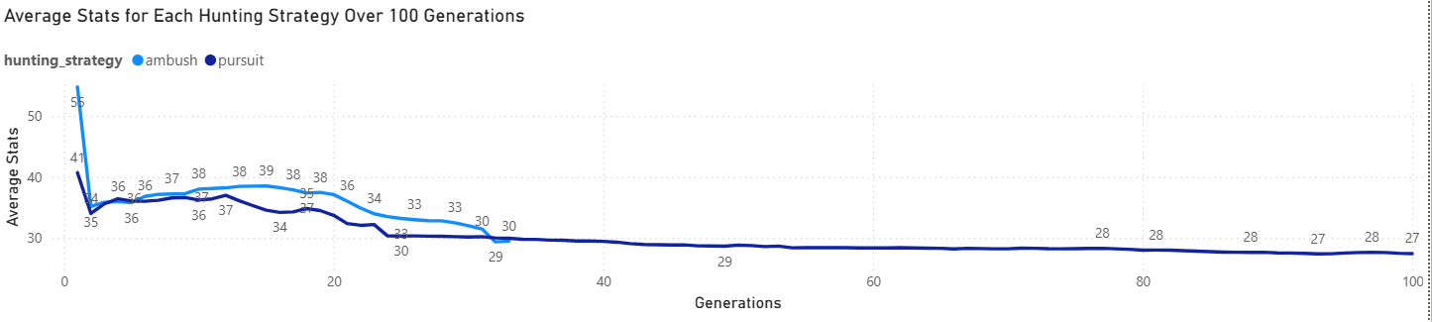
Note. This visualization has generation 0 filtered out due to the random starting population.
Figure 9
Distribution of Predators When Hunting Birds
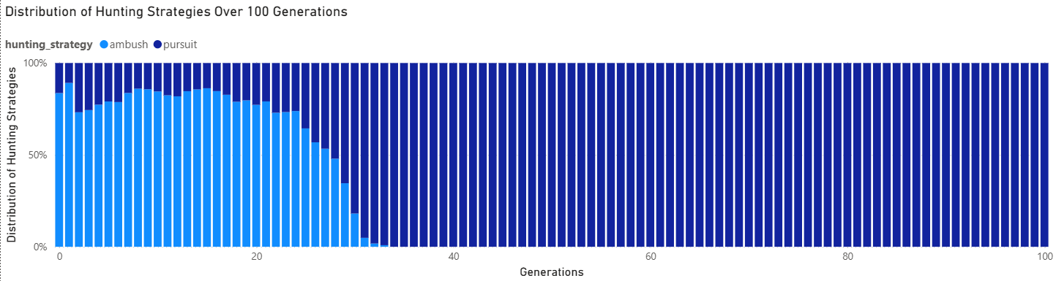
Note. This visualization is filtered for only the predators that successfully caught prey.

Figure 10
Average Stats of Speed and Stealth for Ambush and Pursuit Predators When Hunting Birds
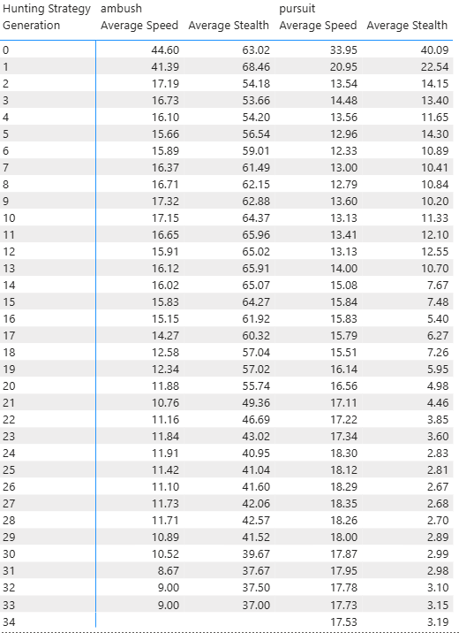
Note. The table was cut at the point when Ambush predators had gone extinct in the population.
Final Outcomes
When looking at the outcomes of the complete simulation, pursuit predators outcompeted ambush predators on every prey type. This can be seen best in the payoff matrix for each prey item (Table 2). Pursuit predators had more payoff potential on average when looking at each prey type.
Table 2
Payoff Matrix for Both Hunting Strategies Vs Each Prey Type
Hunting Strategy | Rabbit | Mouse | Bird
Ambush | 0.496 | 0.243 | 0.433
Pursuit | 0.534 | 0.586 | 0.596
Figure 11
Average Predator Stats Over Time
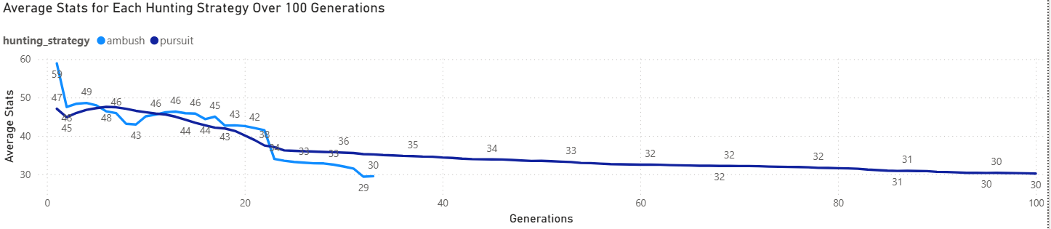
Note. This visualization has generation 0 filtered out due to the random starting population.

Figure 12
Distribution of Predators
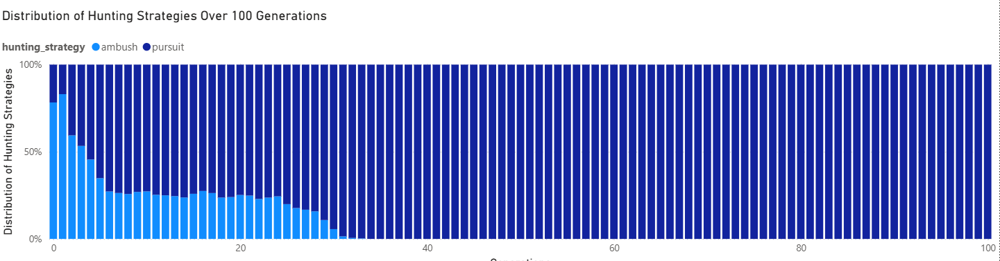
Note. This visualization is filtered for only the predators that successfully caught prey.
Discussion
For each simulation, the predator population was taken over by the pursuit strategy. This is most likely due to a biasing error in the code that selects the best predators for the next generation. While the data is skewed, the initial trends support the initial hypothesis. When looking at the data for the mouse and bird populations, the ambush predators initially follow the expected patterns. For mice, the ambush population was quickly wiped out, which lines up with expected trends. Mice are preferred by pursuit predators (Hayward et al., 2023; Krofel et al., 2011). For birds, the ambush population initially takes over the population before being sharply wiped out. This fits the trends that ambush predators prefer birds over pursuit predators (Hayward et al., 2023; Krofel et al., 2011).
The rabbit population is of particular interest to this study. Rabbits are a main food source in both predator strategies' diets (Hayward et al., 2023; Krofel et al., 2011). Thus, it was used the most in testing for building the simulation. This meant that both strategies were attempted to be balanced against rabbits. In testing without the strategies mixing, the ambush strategy usually took fewer generations to reach the population cap. This is somewhat seen in the final trends, as the ambush strategy in all the simulations performed better in the first two generations.
Limitation
The main limitation of this study is time. Due to the regulations on how the master's program is set up, this project was split into two three-month blocks. The first three months were spent on designing the system and gathering supporting research. The second three months were spent implementing the project. Due to this, the final testing of the system had to be rushed and thus led to skewed results. With more time, more testing could be done to help alleviate the bias towards pursuit predators.
The second main limitation of this study was testing limitations. While this stems from the issue of limited time, the at-scale testing of the project could not be completed due to time constraints. This meant that making sure the system worked took precedence over full-scale correctness. This led to the clear bias seen in the results of the final simulations.
The third limitation of this study was the performance of the simulation. Due to limits in optimizations, the simulation could not be tested at the scales this study hoped to reach. The final simulation was estimated to run in an average of four seconds per predator in the simulation. This meant that larger-scale testing could not be performed within the time limits of this master's program. This also led to the final consideration for what could be reasonably produced in the final dataset in the time frame given.
Conclusions
The main takeaway from this study was to provide an analysis of two predator strategies vs three different prey types. Due to programming errors and time constraints, the simulation had a clear bias toward pursuit predators. However, initial trends suggest that the ambush strategy could follow expected trends if that bias is removed.

Future direction
The most important work for the future of this project is to conduct more full-scale testing with both predator strategies competing. This should help eliminate bias in the final trends of the data. Additionally, more testing to balance the predators within their final environment. The initial map scale of the project was cut back due to performance limitations. This means that traits had to be adjusted to the new map scale. This was not perfected during this project but could be better adjusted in future work. Lastly, more competition metrics could be tested. Due to the design of the simulation, predators do not directly compete. This allows the opportunity to try out different metrics to measure for selecting the best of the population.

References
Allesina, S., & Tang, S. (2012). Stability criteria for complex ecosystems. Nature, 483(7388), 205–208. https://doi.org/10.1038/nature10832
Anholt, B. R., Ludwig, D., & Rasmussen, J. B. (1987). Optimal pursuit times: How long should predators pursue their prey? Theoretical Population Biology, 31(3), 453–464. https://doi.org/10.1016/0040-5809(87)90015-3
Atmar, W. (1994). Notes on the simulation of evolution. IEEE Transactions on Neural Networks, 5(1), 130–147. https://doi.org/10.1109/72.265967
Brans, K. I., Tüzün, N., Sentis, A., De Meester, L., & Stoks, R. (2022). Cryptic eco‐evolutionary feedback in the city: Urban evolution of prey dampens the effect of urban evolution of the predator. Journal of Animal Ecology, 91(3), 514–526. https://doi.org/10.1111/1365-2656.13601
Cao, L., & Wu, B. (2021). Eco-evolutionary dynamics with payoff-dependent environmental feedback. Chaos, Solitons & Fractals, 150, 111088. https://doi.org/10.1016/j.chaos.2021.111088
Chen, M., & Wu, R. (2023). Steady states and spatiotemporal evolution of a diffusive predator–prey model. Chaos, Solitons & Fractals, 170, 113397. https://doi.org/10.1016/j.chaos.2023.113397
Darwin, C. (2022). On the Origin of Species by Means of Natural Selection, or the Preservation of Favoured Races in the Struggle for Life. Google. https://books.google.com/books?id=Crk4Tgz1ot4C (Original work published 1872, John Murray)
Foead, D., Ghifari, A., Kusuma, M. B., Hanafiah, N., & Gunawan, E. (2021). A Systematic Literature Review of A* Pathfinding. Procedia Computer Science, 179, 507–514. https://doi.org/10.1016/j.procs.2021.01.034
French, J. T., Silvy, N. J., Campbell, T. A., & Tomeček, J. M. (2022). Divergent predator activity muddies the dynamic landscape of fear. Ecosphere, 13(2), e3927. https://doi.org/10.1002/ecs2.3927
Hayward, M. W., Mitchell, C. D., Kamler, J. F., Rippon, P., Heit, D. R., Nams, V., & Montgomery, R. A. (2023). Diet selection in the Coyote Canis latrans. Journal of Mammalogy, 104(6), 1338–1352. https://doi.org/10.1093/jmammal/gyad094
Hofbauer, J., & Sandholm, W. H. (2011). Survival of dominated strategies under evolutionary dynamics: Survival of dominated strategies. Theoretical Economics, 6(3), 341–377. https://doi.org/10.3982/TE771
Huneman, P. (2014). Mapping an expanding territory: Computer simulations in evolutionary biology. History and Philosophy of the Life Sciences, 36(1), 60–89. https://doi.org/10.1007/s40656-014-0005-2
Jones, L. E., & Ellner, S. P. (2007). Effects of rapid prey evolution on predator–prey cycles. Journal of Mathematical Biology, 55(4), 541–573. https://doi.org/10.1007/s00285-007-0094-6
Krofel, M., Huber, D., & Kos, I. (2011). Diet of Eurasian lynx Lynx lynx in the northern Dinaric Mountains (Slovenia and Croatia): Importance of edible dormouse Glis glis as alternative prey. Acta Theriologica, 56(4), 315–322. https://doi.org/10.1007/s13364-011-0032-2
Lennox, R. J., Dahlmo, L. S., Ford, A. T., Sortland, L. K., Vogel, E. F., & Vollset, K. W. (2023). Predation research with electronic tagging. Wildlife Biology, 2023(1), e01045. https://doi.org/10.1002/wlb3.01045
Martin, R. A., & Hammerschlag, N. (2012). Marine predator–prey contests: Ambush and speed versus vigilance and agility. Marine Biology Research, 8(1), 90–94. https://doi.org/10.1080/17451000.2011.614255
Michalko, R., & Pekár, S. (2016). Different hunting strategies of generalist predators result in functional differences. Oecologia, 181(4), 1187–1197. https://doi.org/10.1007/s00442-016-3631-4
Murray, D. L., Boutin, S., O’Donoghue, M., & Nams, V. O. (1995). Hunting behaviour of a sympatric felid and canid in relation to vegetative cover. Animal Behaviour, 50(5), 1203–1210. https://doi.org/10.1016/0003-3472(95)80037-9
Netz, C., Hildenbrandt, H., & Weissing, F. J. (2022). Complex eco-evolutionary dynamics induced by the coevolution of predator–prey movement strategies. Evolutionary Ecology, 36(1), 1–17. https://doi.org/10.1007/s10682-021-10140-x
Qi, J., & Tạ, T. V. (2026). Modeling predator-prey dynamics with stochastic differential equations: Patterns of collective hunting and nonlinear predation effects. Alexandria Engineering Journal, 134, 494–507. https://doi.org/10.1016/j.aej.2025.12.038
Yoshida, T., Ellner, S. P., Jones, L. E., Bohannan, B. J. M., Lenski, R. E., & Hairston, N. G. (2007). Cryptic Population Dynamics: Rapid Evolution Masks Trophic Interactions. PLoS Biology, 5(9), e235. https://doi.org/10.1371/journal.pbio.0050235

