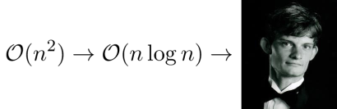Bryce Summers

**Idiosyncratic Design Portfolio**

brycesummers.com| bs3363@nyu.edu| Brooklyn, NY

Work in progress!!

Dear Reader, This portfolio is a work in progress. I haven’t gone about making proper images and putting this documentation together in a meaningful way yet, since that will take longer than the time I have left.

NASA JPL

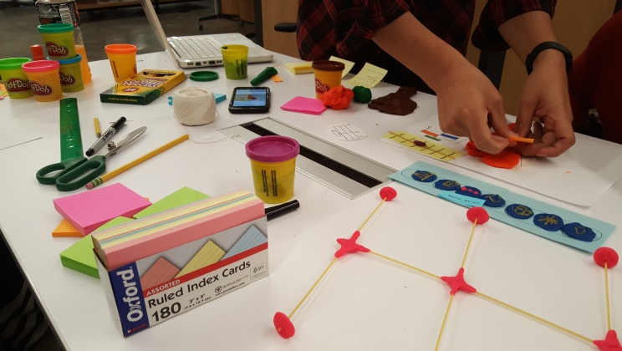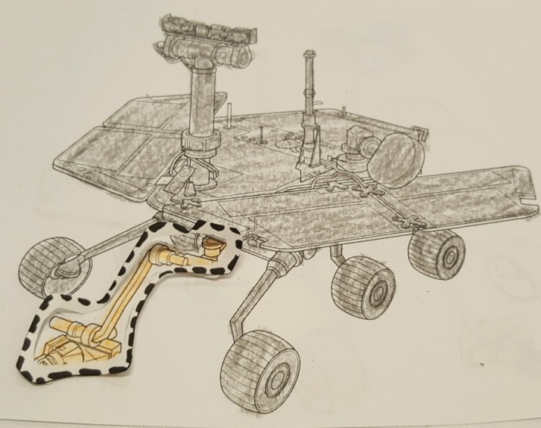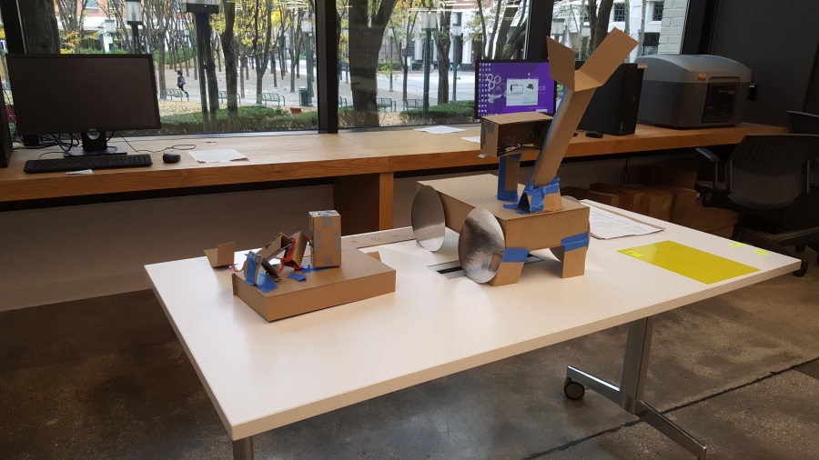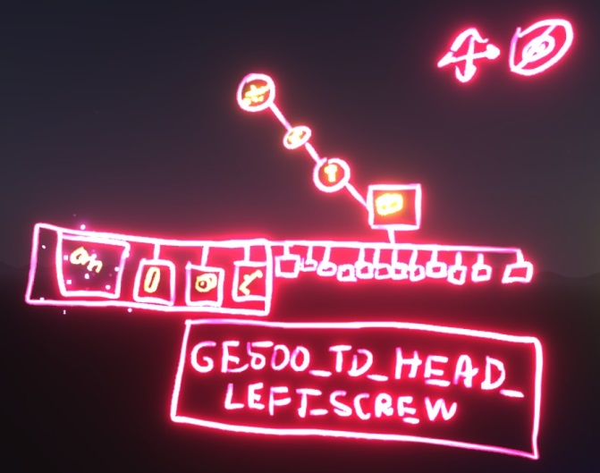

We prototyped user interactions for navigating a hierarchy using the holo lens for the NASA JPL Ops lab.

SimUrban

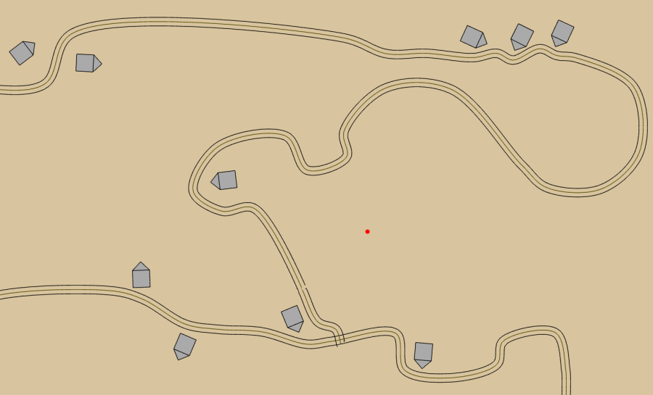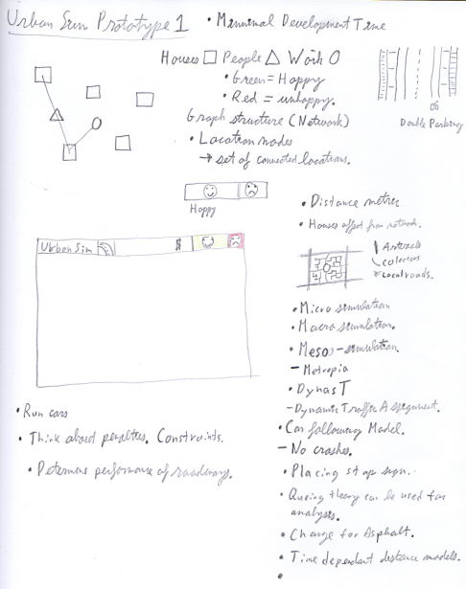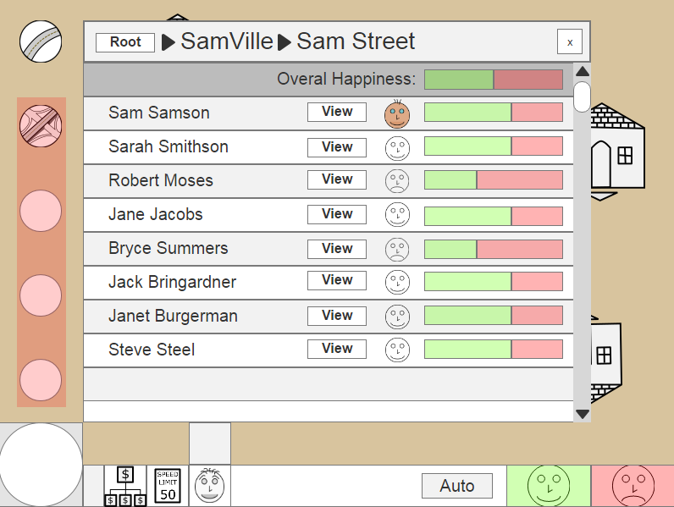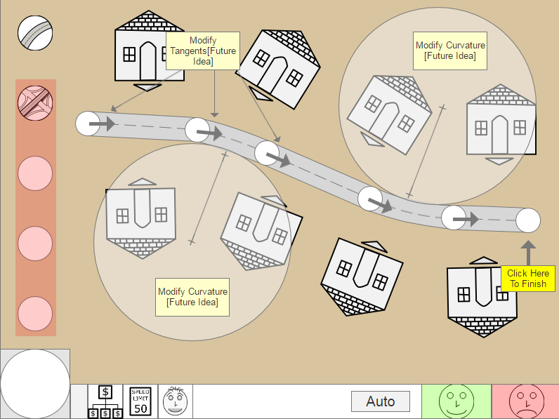

This is a game about designing infrastructure networks.

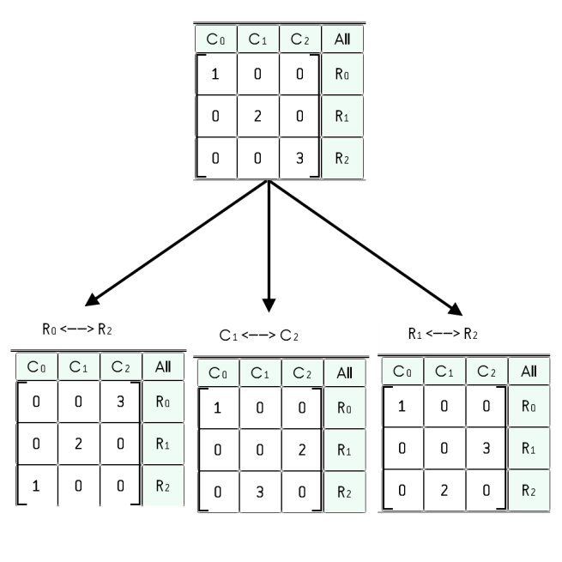Summers CAMP

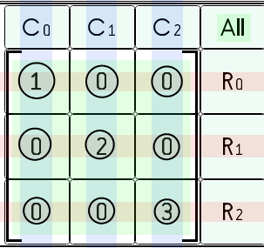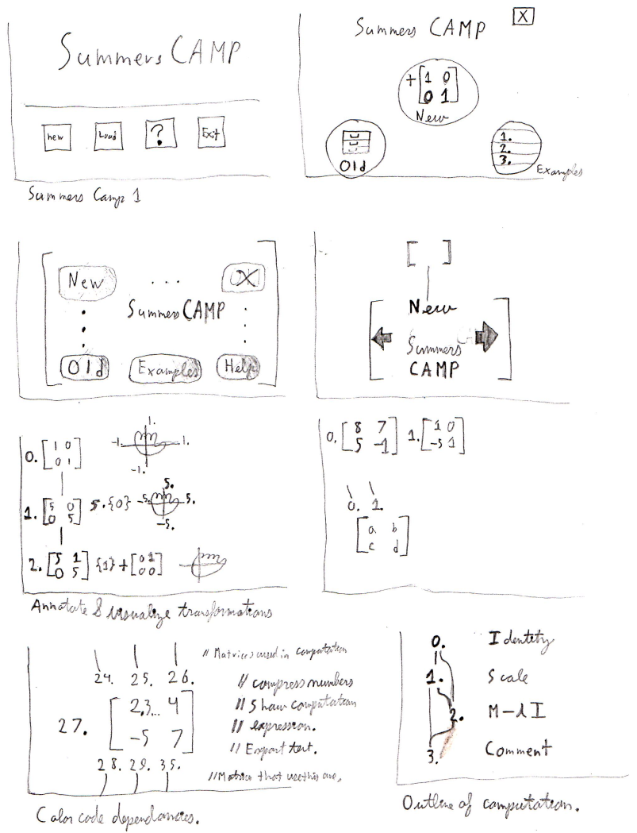

Summers CAMP was funded by a Summer Undergraduate Research Fellowship back in 2013.

I am continuing to work on it with further design iterations.

<http://bryce-summers.github.io/Project_Pages/SummersCAMP.html>

Crane Diagram Automation

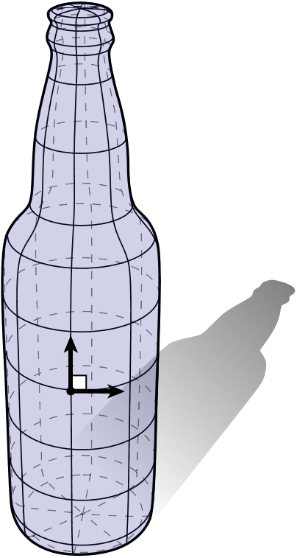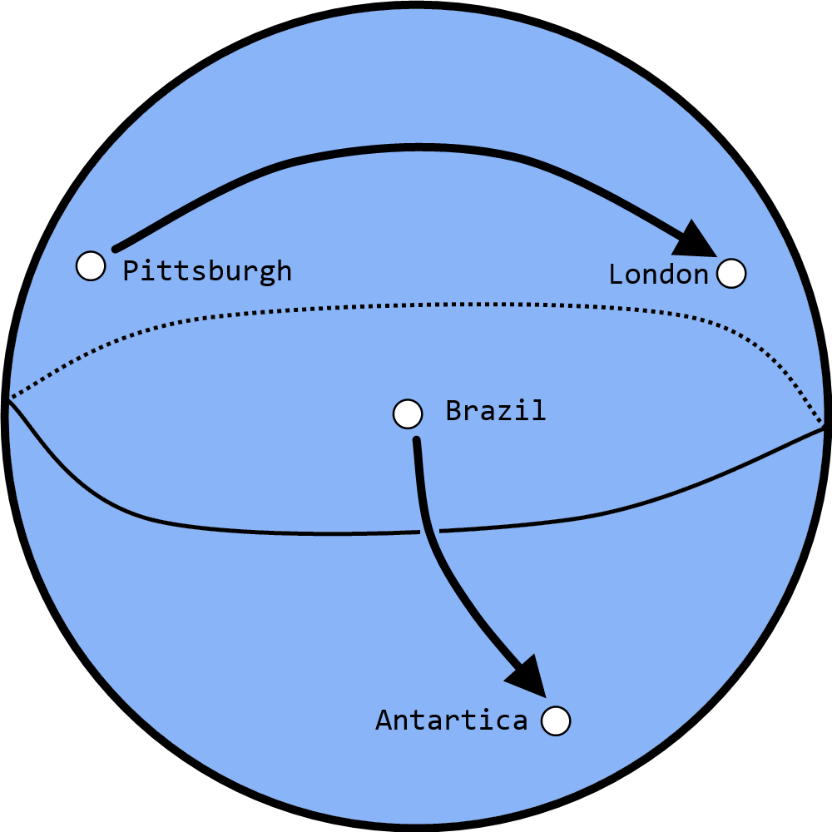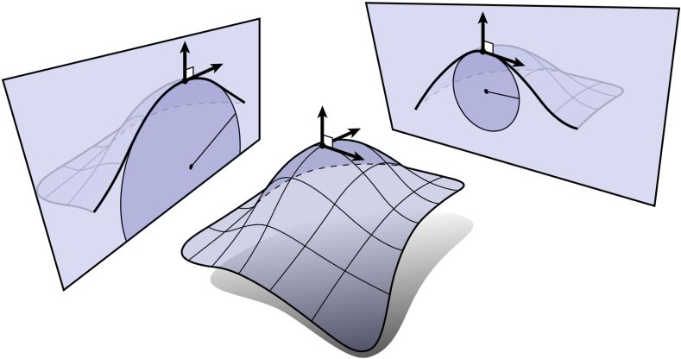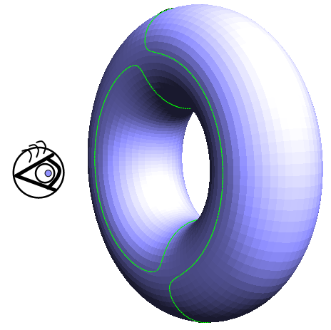

Automating the Generation of beautifully Illustrated 3D Geometry.

<https://bryce-summers.github.io/Design_Portfolio/pages/CraneDiagrams/Extracting_Curves_From_Subdivision_Surfaces.pdf>

Scribble Segmentation

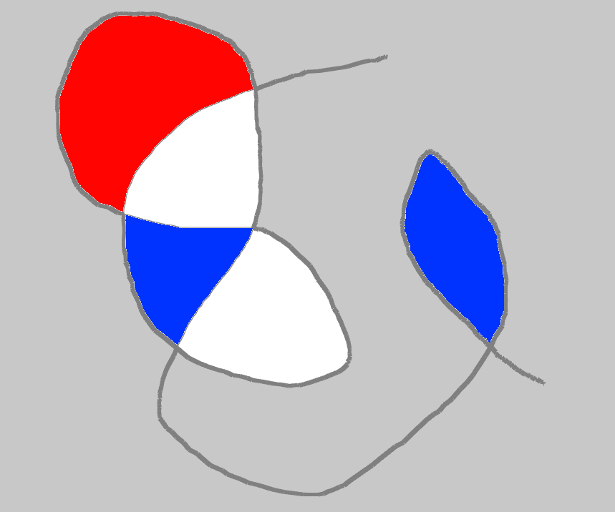

Algorithm that finds all of the faces demarcated by a planar curve. (FIXME: This picture is really ugly.)

<https://github.com/Bryce-Summers/ofxScribbleSegmenter>

Domino Traveling Salesman Problem

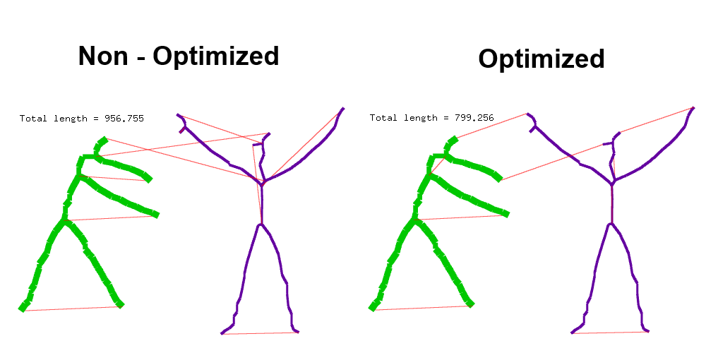

Solves the traveling salesman problem for a group of dominoes.

<https://github.com/Bryce-Summers/ofxLaserTSP>