Plot 1: 10 tasks in each task set and the deadline distribution of [Ci, Ti]
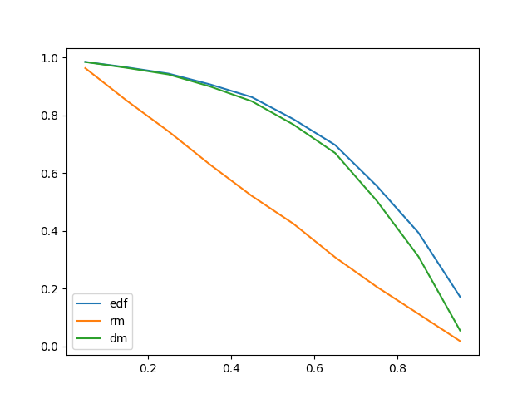
Plot 2: 25 tasks in each task set and the deadline distribution of [Ci, Ti]
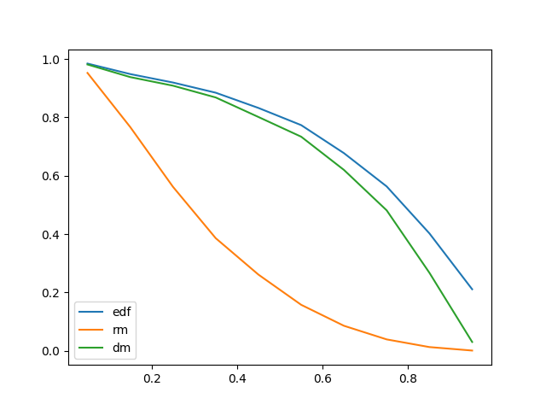
Plot 3: 10 tasks in each task set and the deadline distribution of [Ci+(Ti-Ci)/2,Ti]
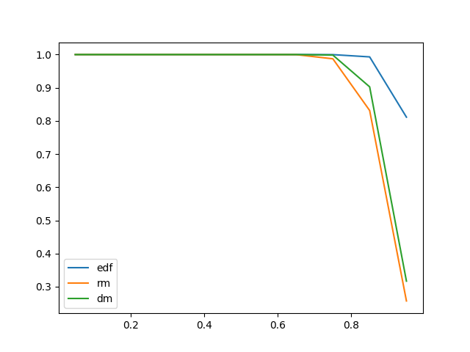
Plot 4: 25 tasks in each task set and the deadline distribution of [Ci+(Ti-Ci)/2,Ti]
