Bryce Callender

<https://github.com/BryceCallender/CS-3700/tree/master/RockPaperScissorsThreaded>

GAME 1 IMPLEMENTATION 1 OUTPUT

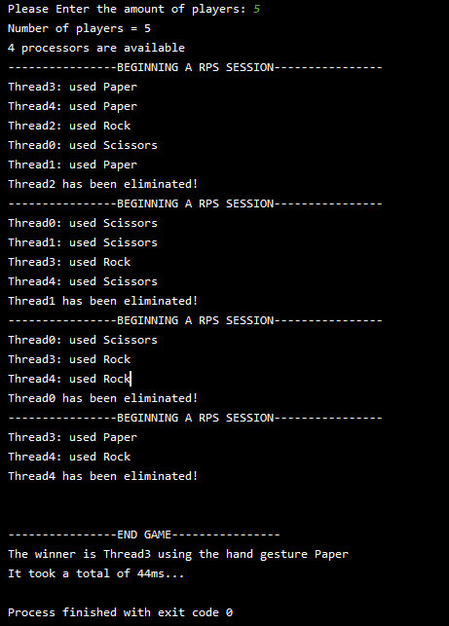

GAME 1 IMPLEMENTATION 2 OUTPUT

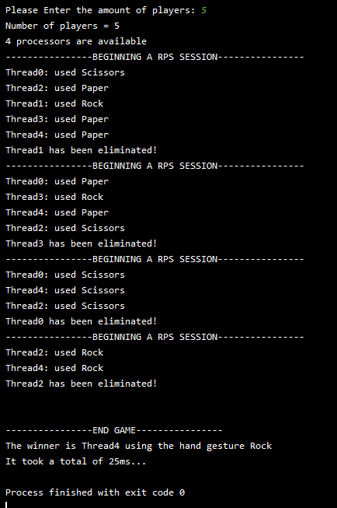

GAME 1 IMPLEMENTATION 3 OUTPUT MEMOIZED

Has the same time as above as making a map and adding to it with only 5 people is just a bit less efficient so it comes out to the same time, but for larger output it is better

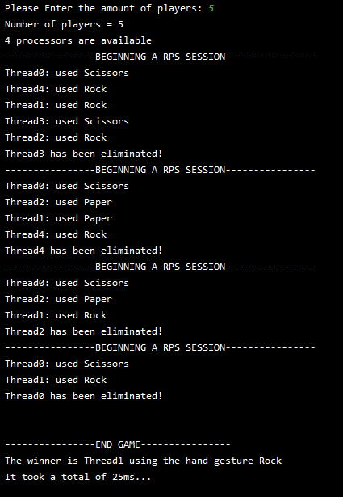

GAME 2 IMPLEMENTATION 1 OUTPUT

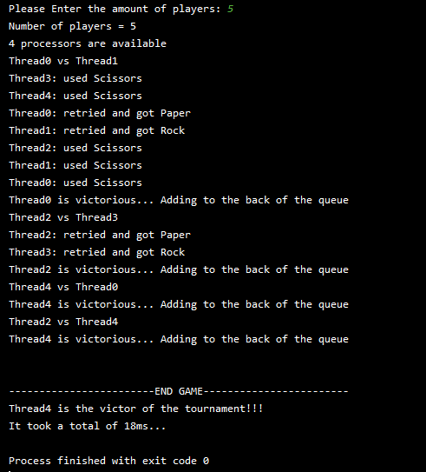

GAME 2 IMPLEMENTATION 2 OUTPUT

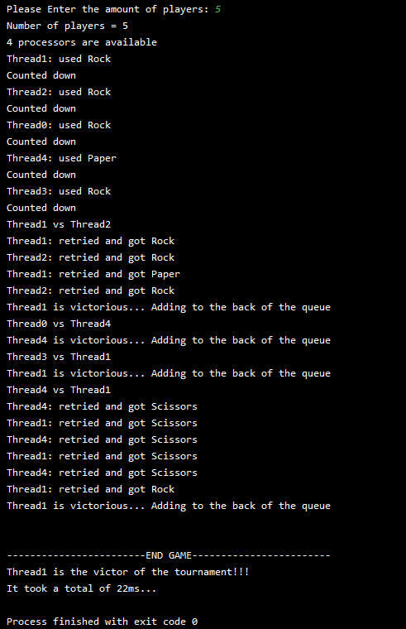

GAME 2 IMPLMENTATION 3 OUTPUT

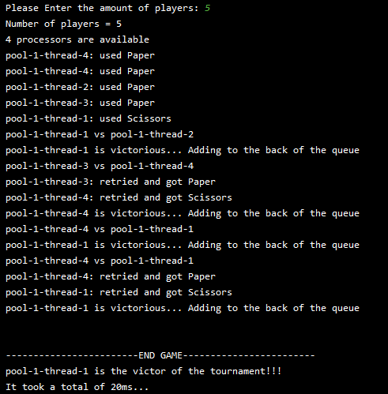

DECLARATION OF INDEPENDENCE

Single Thread



