Bryce Huston

30003673

VERSION 1.0

eMPLOYEES PAYROLL

PRODUCT DESIGN SPECIFICATION

Contents

Introduction 1

1.1 Purpose of the product design specification document 1

General Overview and Design Guidelines/Approach 1

2.1 Assumptions / Constraints / Standards 1

Architecture Design 1

3.1 Logical View 1

3.2 Hardware Architecture 2

3.3 Software Architecture 2

3.4 Security Architecture 2

3.5 Communication Architecture 2

3.6 Performance 2

4 System Design 2

4.1 Use-Cases 2

4.2 Database Design 3

4.3 Data conversions 3

4.4 Application Program Interfaces 3

4.5 User Interface Design 3

4.6 Performance 3

4.7 Section 508 Compliance 3

Product Design Specification Approval 4

|  |  |  |  |  |  |
| --- | --- | --- | --- | --- | --- |
| Version Number 1 | Implemented By | Revision Date | Approved By | Approval Date | Reason |
| 1.0 | Bryce Huston | 05/12/2019 | Stewart Godwin |  | First Design Definition Draft |

# Introduction

## 1.1 Purpose of the product design specification document

The Product Design Specification document documents and tracks the necessary information required to effectively define architecture and system design in order to give the development team guidance on architecture of the system to be developed. The Product Design Specification document is created during the Planning Phase of the project. Its intended audience is the project manager, project team, and development team. Some portions of this document such as the user interface (UI) may on occasion be shared with the client/user, and other stakeholder whose input/approval into the UI is needed. This ensures a smooth hand off once development is complete.

# General Overview and Design Guidelines/Approach

## 2.1 Assumptions / Constraints / Standards

The project much comply with the following

• Use of a Dynamic Data Structure

• Use of Hashing

• Use of a Sorting Algorithm

• Use of a Third Party Library

• Use of a Graphical User Interface

Assumptions that the client will be happy with the project provided

# Architecture Design

## 3.1 Logical View

## 3.2 Hardware Architecture

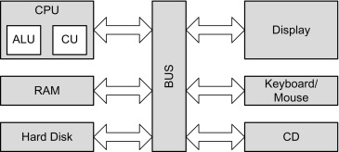

(<https://www.sciencedirect.com/topics/computer-science/hardware-architecture>)

## 3.3 Software Architecture

Software and Logical share the same process, If you go back to 3.1 you can see more information on the software

## 3.4 Security Architecture

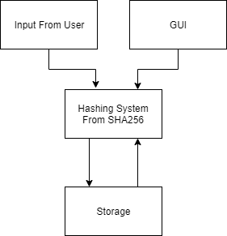

## 3.5 Communication Architecture

The Security and communication share the same process, please visit 3.4 for more information on communication

## 3.6 Performance

At this point in time we can’t measure performance because no code has been written. C# automatically handles memory allocation and garbage disposal at runtime of the application.

# 4 System Design

## 4.1 Use-Cases

Program Use Cases:

* Storing Employees
* Sorting Payroll for Employees
* Display Employee Annual Salary

## 4.2 Database Design

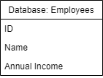

## 4.3 Data conversions

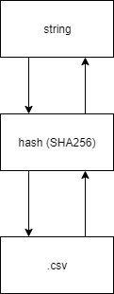

## 4.4 Application Program Interfaces

The employees list will integrated using CSVHelper *(*[*https://joshclose.github.io/CsvHelper/*](https://joshclose.github.io/CsvHelper/)*) Which enables C# to save and read files to a .csv file. With this you can add a employees name, age and annual income and have it save to the .csv file. Now if you close the program and run it again you can simply read the .csv file that has been saved and from the previous session.*

## 4.5 User Interface Design

## 4.6 Performance

At this point in time we can’t measure performance because no code has been written. C# automatically handles memory allocation and garbage disposal at runtime of the application.

## 4.7 Section 508 Compliance

The program will be 508 compliant helping impaired individuals use the program as well. By integrating hover tag allowing text to speech software by reading tags read aloud I can make this happen

# Product Design Specification Approval

The undersigned acknowledge they have reviewed the Employees **Product Design Specification** document and agree with the approach it presents. Any changes to this Requirements Definition will be coordinated with and approved by the undersigned or their designated representatives.

|  |  |  |  |
| --- | --- | --- | --- |
| Signature: |  | Date: | 05/12/2019 |
| Print Name: | Stewart Godwin |  |  |
| Title: | Mr |  |  |
| Role: | Client |  |  |

|  |  |  |  |
| --- | --- | --- | --- |
| Signature: |  | Date: | 05/12/2019 |
| Print Name: | Bryce Huston |  |  |
| Title: | Mr |  |  |
| Role: | Project Manager |  |  |