PROJECT TUTORIAL

Programming AT3 Project

Bryce Huston

30003673

Contents

Admin 1

Main Menu 2

Audio Player 2

Binary Search Tree 3

Payroll Sort 6

Csv Format 8

Communication Via Server – Login Page 15

Hashing 16

# Admin

# Main Menu

# Audio Player

# Binary Search Tree

# Payroll Sort

# Csv Format

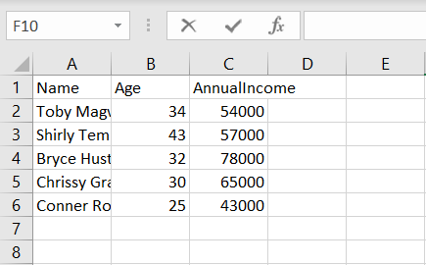

# Communication Via Server – Login Page

# Hashing

