**CEN 4010 Principles of Software Engineering**

*Fall 2021*

Milestone 4 Beta Launch & Reviews

A communication website for students affected by social distancing

**PROJECT NAME**

IQLounge

**TEAM NAME**

Group 15

**TEAM NUMBER**

15

**Student Names**

Bryce Kurek: bkurek2018@fau.edu

Kyle Frudakis: kfrudakis2018@fau.edu

Carlos Castellanos: castellanosc2018@fau.edu

Dunyagozel Durdyyeva: ddurdyyeva2020@fau.edu

James Goedmakers: jgoedmakers2019@fau.edu

**Date**

*11/15/2021*

**Product Summary**

Stay connected and interact with other students during these hard times of social distancing with IQ Lounge. While social interaction has been very limited recently due to the Covid-19 pandemic, IQ Lounge has been specifically designed to provide a platform for students to continue developing new relationships and maintain communication. Feeling connected socially is important for the overall health and wellbeing of an individual, especially during this time of fear and uncertainty. Our goal is to exhibit a safe environment where students can come together to socialize and relax virtually. We provide students with tools and accessibility in order to encourage active interaction in an entertaining fashion.

Currently, IQ Lounge has implemented some key features and will continue to develop additional functions in the near future to continue encouraging social interaction and provide helpful resources to students. Some of our current major committed functions are our account login/creation and also our general discussion chat room.

**Major Committed Functions (Priority 1)**

-*Account Login/Creation*:

The user will be able to create an account with info such as an email, username, password, first name, and last name. If the user already has an account linked to their email, they will not be allowed to make another account with that same email.

-*General Discussion*:

The user will be able to access the general discussion web page. The user can then make a post in the general discussion and view all other previously sent posts by the user or other users.

Despite the fact that there are countless social media applications and websites that encourage social interaction, there has yet to be another product that satisfies the needs that IQ Lounge does. These needs can be referred to as allowing students from all around the world to form relationships with fellow peers at their own school or even in different schools and let their social skills and friendships flourish. By providing unique features such as a general discussion room, private discussion rooms and helpful resources, it allows for these needs to be satisfied.

**IQ Lounge Website:** <https://lamp.cse.fau.edu/~cen4010_fa21_g15/IQLounge/index.html>

**Usability Test Plan**

*General Discussion*

**Test Objectives**

The purpose of this test plan is to retrieve data on one of the primary functions of IQLounge, the system of a user posting a comment in the general discussion room. This includes using the site to navigate to the general discussion room and use the rooms functions, including posting a comment, as well as navigating to other sections of the site. Users should be able to see their comments immediately – not a noticeable wait time - after they upload them. The site should also be easy and intuitive to navigate, requiring no training to use, as a big focus of the interface design is based on usability. Below is a comprehensive list of the objectives that the usability test is based on.

**· Navigation –** the site should be easy and intuitive to use for the average user, specifically to navigate to and from the general discussion room. Navigation that should be tested is the home button to return to the home page, the login button so as to use the login/registration process, and the about us button at the bottom to view our teams about us page.

**· Commenting –** once navigation to the general discussion room has been completed, the user should test the comment panel by writing some test in the test box and clicking on the post button to post their comment. Then should be able to see what they posted reflected on the page.

**· View Comments –** The user should be able to view all the comments that have been posted in the general discussion room simply by navigating to the page, or when posting a comment, all previous comments should still display including the recently created comment.

**Test Plan**

Any given user should have a system capable of running chrome, Microsoft edge, or similar search engine, and an active internet connection.

This test is for the average user, average college student or similar age range of eighteen to twenty-four, as they are the target demographic for our website. These users should not be required to know any in-depth technical knowledge to interact with the site, basic knowledge of how to interact with any website is recommended.

The test shall be conducted from the average user coming to the site after the completion of the login/registration system although not required. At the end of the login system the user is moved to the home page, so the test will start from there.

The task to be completed is posting a comment on the general discussion room and being able to view previous comments posted to the room. Users can do this by arriving on the home page linked below, clicking the go-to button for the general discussion or in the bar above rooms > general discussion, typing text in the comment panel, clicking post. Optionally testing the other buttons on the page at the user's discretion.

The completion criteria is that the user is able to view a comment that they posted to the general discussion in the area below where they typed their comment. This simple completion criteria tells us a few things. That the user could navigate to the general discussion, and that they could post a comment and view it along with the entire comment list prior to their contribution.

[**https://lamp.cse.fau.edu/~cen4010_fa21_g15/IQLounge/index.html**](https://lamp.cse.fau.edu/~cen4010_fa21_g15/IQLounge/index.html)

**Questionnaire Form**

**For each of the questions below, circle the response that best characterizes how you feel about the statement, where 1 = Strongly Agree, 2 = Agree, 3 = Neither Agree nor Disagree, 4 = Disagree, 5 = Strongly Disagree.**

|  | **Strongly Agree** | **Agree** | **Neither Agree nor Disagree** | **Disagree** | **Strongly Disagree** |
| --- | --- | --- | --- | --- | --- |
| **I found easy navigate to the General Discussion** | **1** | **2** | **3** | **4** | **5** |
| **I found it easy to post a comment** | **1** | **2** | **3** | **4** | **5** |
| **I found the site intuitive and easy to interact with** | **1** | **2** | **3** | **4** | **5** |

**2.4 QA Test Plan**

**2.4.1 Test Objective**

The main purpose of the given Test Plan is the testing of a social media website project “IQLounge”. This section provides guidance on planned works to be conducted and terms. The goal of the testing website “IQLounge” is the thorough verification of the most important features with scripts of its usage. All the features of “IQLounge” that are defined in the project proposal document are required to be tested.

**2.4.2 Hardware and software setup**

**Required Hardware:**

* Computer (RAM size over 2GB)
* Internet Connection
* Server
* Mobile devices

**Required Software:**

* Operating System: Windows, Mac OS, Linux
* Browsers: Google Chrome, Safari, Mozilla Firefox, Internet Explorer
* Text editor: Notepad++, Visual Studio Code, Brackets
* Files transfer on the Web: WinSCP tool
* Code hosting platform: Github
* Database: MySQL
* Server Side Language: PHP

**2.4.3 Features to be tested:**

All the features of IQLounge Web App which were defined in software requirements specifications need to be tested.

| **Module Name** | **Applicable Roles** | **Description** |
| --- | --- | --- |
| New Account | User | User is able to login in using email address and password |
| Create Room | User | User is able to create room |
| Discussion Post | User | User is able to post the content on discussion board |
| Edit Account | User | User can edit account details for an existing account |
| Store Posts | System | All data is securely stored in a cloud-based database |
| Credentials encryption | System | Credentials are encrypted and stored in cloud-based database |
| Room Search | User | Search panel allows Rooms search by entering keywords |

**2.4.4 Test Cases and Results**

| **Test #** | **Title** | **Description** | **Input** | **Expected Output** | **Results** | |
| --- | --- | --- | --- | --- | --- | --- |
| **Chrome** | **Safari** |
| **1** | General Discussion page | Verify if a user is able to load General Discussion Page | 1. Create Account to log in (skip if account exists 2. Click Rooms (drop down menu pops up) 3. Click General Discussion | General Discussion Page loads | **Pass** | **Pass** |
| **2** | Discussion Post | Verify if a user is be able to write and post content on discussion page | 1. On Home page click Rooms (drop down menu pops up) 2. Click General Discussion 3. Type “Hello World” in “write a comment…” area 4. Click Post | Post is generated (may have to scroll down to verify) | **Pass** | **Pass** |
| **3** | Date and time of a post | Verify date and time is displayed above user’s post (may have to create a post to verify, see test #2) | 1. On the Home page click Rooms (drop down menu pops up) 2. Click General Discussion | Date and time in format yyyy-mm-dd hh:mm:ss is displayed above user’s post | **Pass** | **Pass** |

**Code Review**

*Peer Review Snippet:*

<!-- Navigation--> <!-- Peer Review: Navigation section is consistent with other pages, good job! -->

<nav class="navbar navbar-expand-lg navbar-light bg-light">

<div class="container px-4 px-lg-5">

<a class="navbar-brand" href="index.html">IQ Lounge</a> <!-- Peer Review: I believe hyper reference should go to home.php instead of index.html -->

<button class="navbar-toggler" type="button" data-bs-toggle="collapse" data-bs-target="#navbarSupportedContent" aria-controls="navbarSupportedContent" aria-expanded="false" aria-label="Toggle navigation"><span class="navbar-toggler-icon"></span></button>

<div class="collapse navbar-collapse" id="navbarSupportedContent">

<ul class="navbar-nav me-auto mb-2 mb-lg-0 ms-lg-4"> <!-- Peer Review: Love the organization!-->

<li class="nav-item"><a class="nav-link active" aria-current="page" href="index.html">Home</a></li>

<li class="nav-item"><a class="nav-link" href="#!">Account</a></li>

<li class="nav-item dropdown"> <!-- Peer Review: Class names are very specific. Well done! -->

<a class="nav-link dropdown-toggle" id="navbarDropdown" href="#" role="button" data-bs-toggle="dropdown" aria-expanded="false">Rooms</a>

<ul class="dropdown-menu" aria-labelledby="navbarDropdown">

<li><a class="dropdown-item" href="discussion.html">General Discussion</a></li>

<li><hr class="dropdown-divider" /></li>

<li><a class="dropdown-item" href="#!">TBA</a></li>

<li><a class="dropdown-item" href="#!">TBA</a></li>

</ul>

</li>

<li class="nav-item"><a class="nav-link" href="#!">Help</a></li>

</ul>

<form class="d-flex"> <!-- Peer Review: Thank you for making this a form (rather than just a button)! will help us in the future! -->

<button class="btn btn-outline-dark" type="submit">Login</button>

</form>

</div>

</div>

</nav>

*Related Communications:*

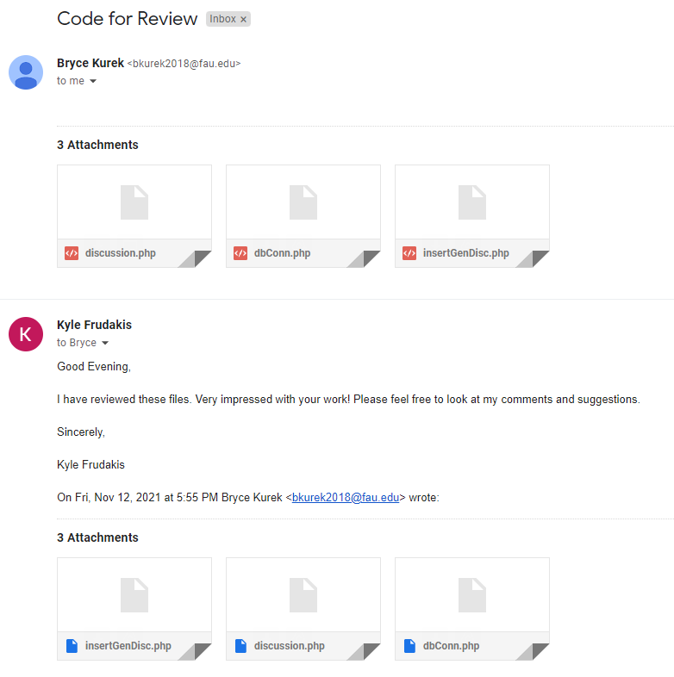

**Self-Check: Best practices for security**

1. **Major Assets:** The only major assets that we will be concerned with protecting is the user account data. User passwords will be encrypted and a backup of user data will be kept. Less significant assets would include the different rooms and their post histories, which may or may not be backed up depending on various limitations such as storage space on the server or backup.
2. **Password Encryption:** Hash encryption is being used to encrypt user passwords in the database. Using the PHP salted hash encryption that is saved to the database and verified ensures that us as the developers of the site, the owner of the database, or anyone with malicious intent do not have access to the passwords of our users.
3. **Input Data Validation:** Input data validation is currently being used in the more important inputs such as user account creation, where users must confirm their account names and passwords by typing them twice in two separate input boxes. If the two inputs do not match, then an error will be displayed and the user will be prompted to try again.

**Self-Check: Adherence to original Non-functional specification**

**Performance:**

1. Requests processed: The site should be able to process at least 10 requests per second under ideal conditions. **ON TRACK**
2. Response time: Site response time when using high-speed internet should average a few hundred milliseconds, and should not exceed 5 seconds under normal load and use conditions. **ON TRACK**
3. Refresh time: Site content should be updated at least once every 30 seconds. **ON TRACK**
4. User Load: Initial rollout of the site should support up to 50 active users. **ON TRACK**
5. Storage requirements: The storage requirements of the core web app should stay fairly minimal, consisting of at most a few dozen megabytes of web code, text, and some supporting images. The database which stores user information such as posts and profile info will be primarily text based, however image uploads are a desired feature dependent on FAU’s Lamp server limitations. Initial implementation of the site will involve a storage limit on the database of around 100 Mb. Although user account data will never be deleted, the database storing user posts may be cleared in some fashion to prevent exceeding storage capacity (i.e. deleting oldest posts first, or just deleting the entire post database when limit is reached). **ON TRACK**
6. Hardware requirements: The system will be running on FAU’s Lamp servers and must not exceed the hardware capabilities of those servers. **ON TRACK**
7. Network requirements: Only text and some images would be sent to user devices, so network requirements are minimal. The system should be usable on connections greater than 1 Mb/s down for users, and the system should be functional on connections greater than 100 Mb/s down, 25 Mb/s up for the hosting server. **ON TRACK**

**Accessibility:**

1. Training time: Users should require no more than a few minutes, ideally no more than 10, to learn how to use all of the site features. **ON TRACK**
2. Help pages: The site homepage will provide a brief overview of functionality and usage instructions. The homepage will also contain a link to a dedicated help page for more detailed instructions and FAQs. **ON TRACK**
3. Support: A support email will be displayed on various parts of the site for users who are seeking additional assistance. **ON TRACK**
4. Interface: The site should be usable without any interactions exceeding text input and clicking, in order to provide a consistent experience between desktop and mobile web use. **ON TRACK**

**Reliability (*FAU Lamp Servers, not really in our control):**

1. Average uptime: Although the site should at least maintain an average uptime of around 90% per day. **ON TRACK**
2. Probability of downtime: The site should experience downtime on average no more than once per day. **ON TRACK**
3. Average time to failure: The site should have less than one hour of downtime per day. **ON TRACK**
4. Time to restart after failure: Restart of the site after a failure should take less than one hour. **ON TRACK**
5. Percentage of events causing failure: Less than 1% of events on the system should cause failure. **ON TRACK**
6. Probability of data corruption on failure: Data corruption should occur on less than 1% of failures. **ON TRACK**
7. Data Protection: More critical data such as user account information will be backed up to a google drive account. Less critical data such as user posts will not be backed up due to its expendable nature. **ON TRACK**
8. Exception Handling: There will be exception handling implemented in all cases where exceptions may occur. **ON TRACK**

**Compatibility:**

1. Supported browsers: The site should function on most Chromium and Firefox based browsers, as well as Safari. Specifically, Google Chrome, Mozilla Firefox, Microsoft Edge, and Apple’s Safari browser will be tested and at least 2 should function with the system without issue. Variants of these browsers, such as Brave, should still work but might not maintain full functionality with the site. **ON TRACK**
2. Supported devices: The site should work on all mobile versions of the above mentioned browsers: Chrome, Firefox, Edge, and Safari. **ON TRACK**
3. Supported Operating Systems: The site should work on Linux, Windows, and Mac OS computers, as well as Android and iOS mobile devices using one of the supported browsers mentioned above. **ON TRACK**
4. Target-Dependent Statements: No target-dependent statements will be used in the initial rollout of the system. **ON TRACK**
5. Coding standards: The system will follow coding standards for HTML 5, CSS3/CSS4, MySQL, Javascript, PHP 8, and Python 3. **ON TRACK**
6. Naming Conventions: The system will follow the standard naming conventions for each respective programming language. **ON TRACK**

**Security:**

1. Login/Password System: Users will be able to create an account with a login and password of their choice. **DONE**
2. Encryption: No encryption will be used in the system. No sensitive data is required by the users to use the web app. *Passwords will be encrypted. **DONE**
3. Access Control: Front and back end code modification will only be accessible to the development team members. Users should not be able to modify the site code in any way. **DONE**
4. Spam Protection: Users will be asked to solve a simple math equation in order to create an account. **ON TRACK**
5. Resource Utilization: A MySQL database will be used to store data pertaining to users, such as user posts and profile information. The database will be hosted by lamp.cse.fau.edu and will be accessed with PHP based logins and passwords. **DONE**