CIVE202- Civil Engineering Analysis II – Project 3 Written Technical Report
Spring 2026
Bryce Ripley
March 3, 2026

Table of Contents
Introduction 3
Methods 3
Selected Variables and Reasoning 3
NHTS Variables 3
NGSIM Variables 4
Plot Construction Methods 4
NHTS Bar Chart 4
NHTS Histogram 5
NHTS Boxplot 5
NGSIM Time Series Plots 6
IDM Simulation Plots 6
Methods Used 7
Data Cleaning 7
Trajectory Selection 7
IDM Simulation 8
Results and Discussion 8
NHTS Bar Chart: Vehicles per Household by Income Category 8
NHTS Histogram: Distribution of Vehicle Age 8
NHTS Boxplot: Vehicles per Household by Urban and Non-Urban Households 9
NGSIM Follower Speed vs. Time 9
NGSIM Follower Position vs. Time 10
NGSIM Actual vs. Simulated Follower Speed 10
NGSIM Actual vs. Simulated Follower Position 11
Conclusion 11

Introduction
The federal Highway administration (FHWA) is responsible when it comes to understanding national travel behavior, roadway performance, and overall vehicle dynamics. This project aims to support these understandings by analyzing two major datasets. The first dataset being the National Household Travel Survey (NHTS), which focuses on household-oriented travel data, and then Next Generation Simulation (NGSIM) dataset, which holds vehicle trajectory data that is collected every .1 seconds. The objectives of this project were to visualize traffic patterns from the NHTS dataset, analyze real world leader-follower driving behaviors from the NGSIM dataset, and implement the Intelligent Driver Model (IDM) so simulated car following behaviors could be compared to the real-world trajectory observed in the NGSIM dataset. All work was completed using Python and was completed in a transparent and reproducible workflow that is simple, easy to use and is suitable for FHWA use.

Methods

Selected Variables and Reasoning

NHTS Variables
The following variables were selected from the NHTS dataset for analysis:
- Household_income – This variable was selected so households could be categorized depending on their economic standing in society.
- Vehicles_per_household – Vehicles per household was selected as it is a direct reflection of vehicle how accessible mobility is to a household.
- Vehicle_age – This variable was used so that unrealistic car ages could be filtered out which could potentially skew our data and limit the validity of our data.
- Urban – Urban was include so for our analysis we could directly target one group and focus on just the urban households within our comparisons.
All these variables were chosen for the main purpose of directly relating households to transportation patterns and could be analyzed among different income groups across the US.

NGSIM Variables
The following variables were selected from the NGSIM dataset for analysis:
- Time – Time is required for all requested time-series visualizations.
- Leader_speed(m/s) and follower_speed(m/s) – These variables are used to evaluate speed behavior and initialization of the IDM simulation.
- Leader_position(m) and followr_position(m) – Both variables required for position behavior analysis as well as the gap calculations that are needed later down the line.
- Leader_acc(m/s^2) and follower acc(m/s^2) – Both variables are key when understanding driver behaviors
- Trajectory_number – This variable was necessary as we isolated a single vehicle trajectory to base our analysis off of. In this case it was trajectory 4.
- Gap_distance (computed) – Gap distance isn’t a raw data variable but was instead calculated as it is needed for the IDM modeling and understanding of vehicle spacing.
All variables chosen will provide a clear picture of leader and follower dynamics and allow for analysis of real vs simulated driving behaviors.

Plot Construction Methods

NHTS Bar Chart
The NHTS data was grouped by household income category, and then the mean number of vehicles per household was calculated for each group. Following that, a bar chart was created by request using Matplotlib and Seaborn, so a clear visualization of how vehicle ownership varies across income levels could be evaluated. Along with this, labels, titles, and proper color adjustments were added to add clarity and neatness.
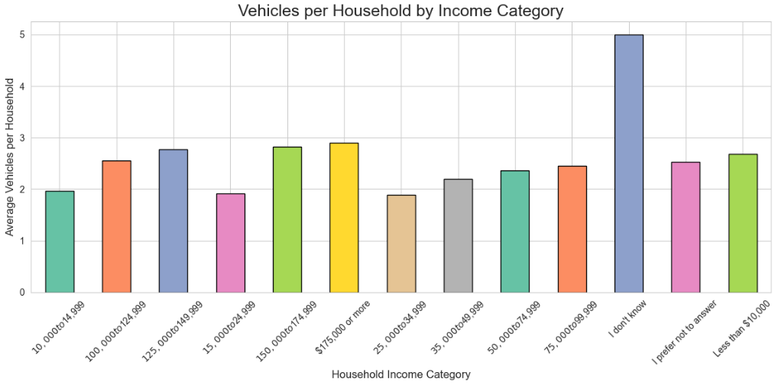
Figure 1: Vehicles Per Household by Income Category

NHTS Histogram
The NHTS histogram was created by selecting the vehicle age variable from the dataset and showing how vehicle age is distributed across the sample. A histogram was then created by using Seaborn histogram plot function which allowed both the bars and a smooth curve to be displayed. The number of bins, color and edge style was adjusted to improve neatness and readability to convey a clear and easy to read message.
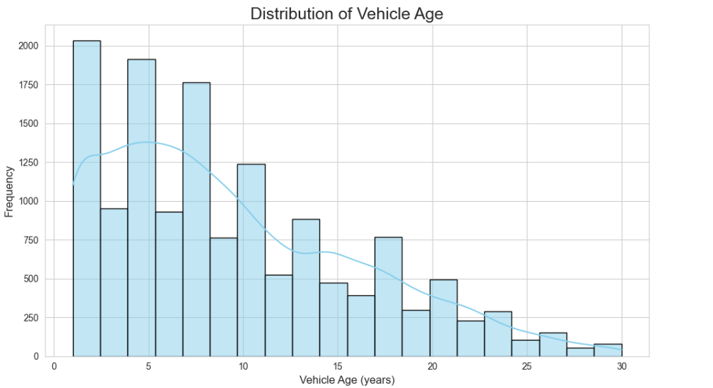
Figure 2: Distribution of Vehicle Age

NHTS Boxplot
For the boxplot, the NHTS dataset was grouped by the urban variable so that the number of vehicles could be compared between both urban and nonurban households. Following that, a boxplot was created so the user can visualize the samples spread, median, maxes and minimums. A color palette was then applied to decipher each subset and then titles and legends were added.
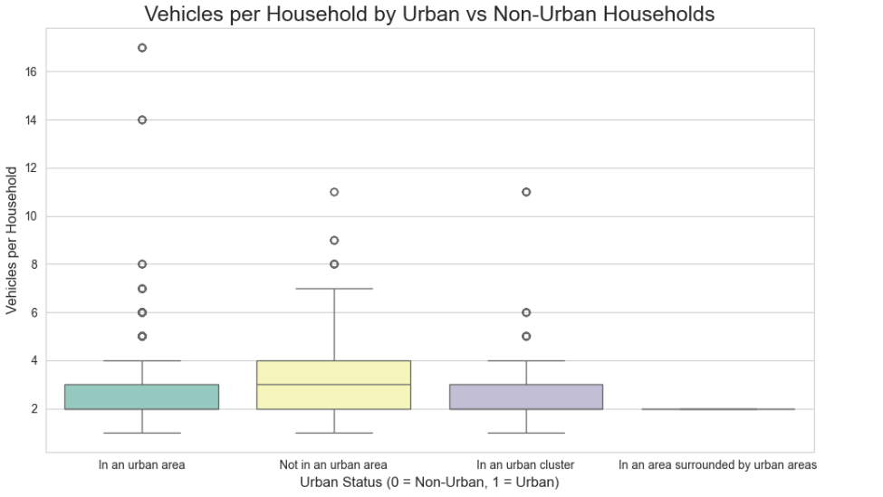
Figure 3: Vehicles per Household by Urban and Non-Urban Households

NGSIM Time Series Plots
Two time series plots were created using the cleaned NGSIM subset and following trajectory 4.
- Follower Speed vs Time
- Follower Position vs Time
These plots were created using line graphs with the same consistent formatting.
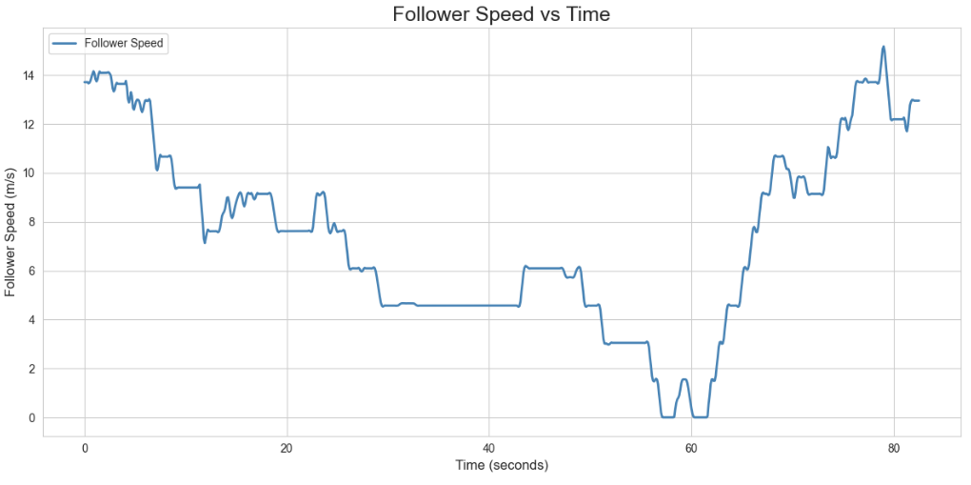
Figure 4: Follower Speed vs. Time
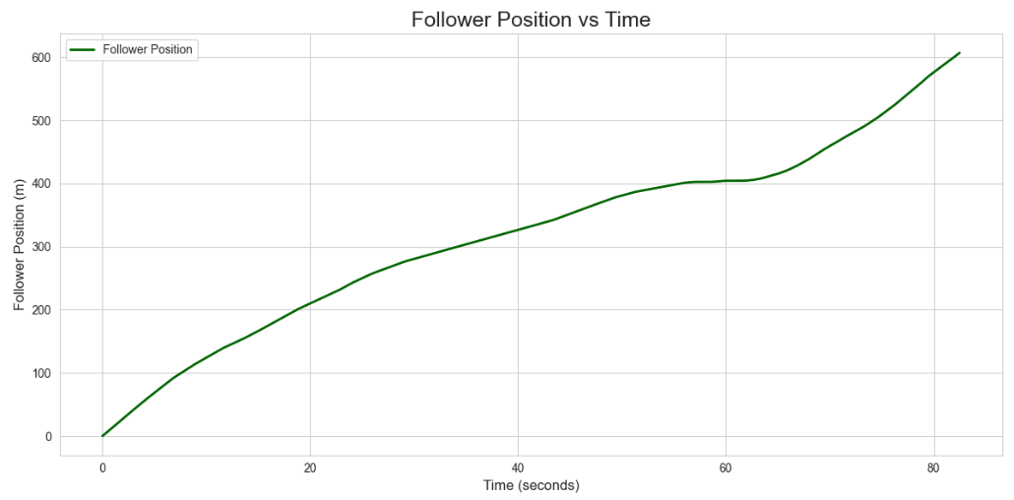
Figure 5: Follower Position vs. Time

IDM Simulation Plots
The IDM simulation was created so that predicted follower speed and positions could be visualized compared to actual values. These predictions were plotted against the actual NGSIM data to evaluate how closely our created model matches real world driving behaviors.
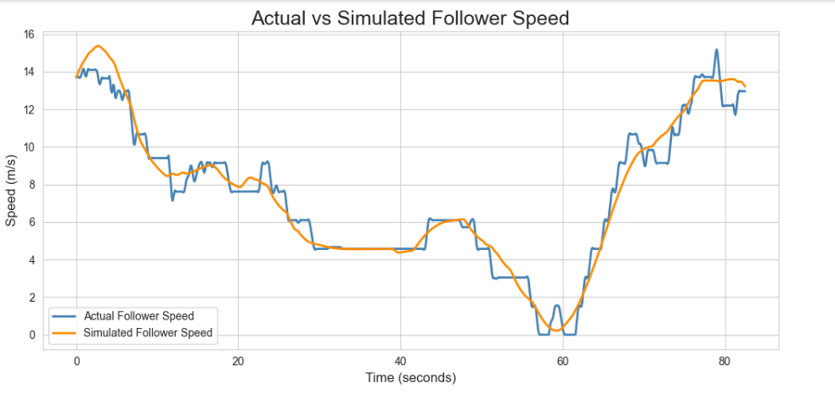
Figure 6: Actual vs. Simulated Follower Speed
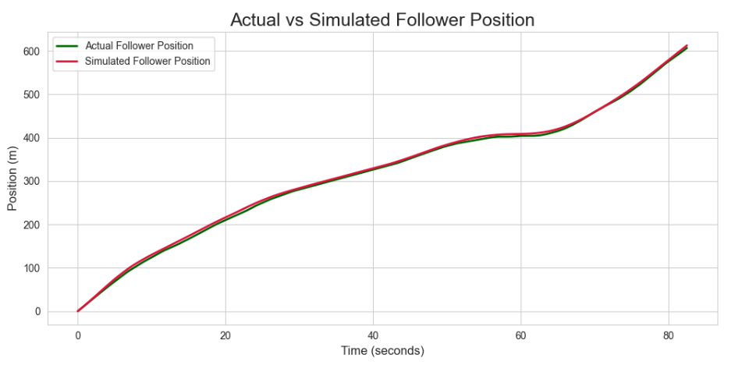
Figure 7: Actual vs. Simulated Follower Position

Methods Used

Data Cleaning
Outliers were removed from the NHTS dataset, meaning vehicles above the age of 30 years were ignored, and missing values in key variables needed were dropped from both datasets to avoid irregular data patterns. NGSIM time was also normalized making it start at zero, and the gap distance was computed using simple calculations.

Trajectory Selection
Trajectory 4 was selected for analysis to ensure that the dataset was consistent throughout the analysis and could make valid conclusions for one trajectory.

IDM Simulation
The IDM model was implemented using parameters such as desired speed, minimum gap distance, time headway, maximum acceleration, and a comfortable deceleration. The model consistently updated the followers speed and position based on the leader’s behavior and the desired spacing.

Results and Discussion

NHTS Bar Chart: Vehicles per Household by Income Category
Key findings
The bar chart in figure 1 shows the average number of vehicles per household across various income ranges according to the National Household Travel Survey. The overall trend is somewhat to be expected: as income increases, vehicle ownership generally rises. Lower income households typically own around two vehicles while higher income households tend to own around three vehicles. This pattern aligns with usual expectations as higher income households often tend to have more drivers meaning more transportation needs, thus giving that higher income household more of a reason to occupy numerous vehicles. One main notable aspect is the “I don’t know” category, which displays an unusually high average vehicle ownership of roughly 5 vehicles per household. This is more than likely a result of improper responses or a very small number of respondents for that given category.
Relevance
From a transportation and planning perspective, this visualization highlights how economic status plays a part in transportation and access to it. Lower income households are more likely to rely on shared vehicles or public transits which has great influence on public transit planning. On the flip side, higher income areas may contribute to larger vehicle usage meaning more roadway usage and possible causes for congestion. Understanding these patterns are key for the FHWA to anticipate driver behavior, resource availability, and design of transportation systems to best serve the public.

NHTS Histogram: Distribution of Vehicle Age
Key Findings
Figure 2, the NHTS histogram displays the distribution of vehicle ages in the NHTS dataset. The histogram shows a clear right skewed pattern, with the highest counts being around vehicles in the age of 0 to 5 years old. As vehicle age continues to increase, we can see that the number of vehicles drops and becomes less common. The smooth curve that was also applied is there to solidify this claim that there are far more newer vehicles compared to those of older ages. The distribution is what we expect considering new vehicle trends continue to grow in today’s economy with everyone wanting the latest and greatest.
Relevance
From a transportation perspective, this distribution provides good insight of vehicle turnover, as well as emission information. I say this because older vehicles aren’t up to date with emissions laws all the time, and having a large amount of older non-emission regulated vehicles can give reasoning for other environmental problems. Understanding how vehicle age is distributed can also help planners make assumptions to infrastructure demands and vehicle ownership trends.

NHTS Boxplot: Vehicles per Household by Urban and Non-Urban Households
Key Findings
Figure 3 compares the distribution of vehicles per household among urban and non-urban households within the NHTS dataset. The boxplot does show clear differences in both urban and non-urban households, with non-urban households tending to have higher median vehicle ownership and a much wider spread of values. On the other hand, urban households have a tighter cluster around the lower vehicle count which is what we expect considering they have more access to public transit leaving less of a reliability on personal transit. In contrast, non-urban households and suburban households both show higher medians which may give insight that these areas tend to own more vehicles.
Relevance
From a transportation engineering perspective, these differences display the need for transportation in different areas across states and nations. Higher vehicle ownership in non-urban areas hints at more roadway design interest, more parking, and urban areas relying on more public transit. Understanding these patterns help planners anticipate the need for certain infrastructure and the designing of correct systems to manage the flow of traffic correctly.

NGSIM Follower Speed vs. Time
Key Findings
Figure 4 shows the follower vehicles speed over time for the selected NGSIM trajectory 4. The plot shows a realistic pattern of car following behavior with the follower beginning at a speed of roughly 14 m/s and gradually decelerating with several fluctuation, not smooth. The follower then comes to a stop around 60 seconds in where after a few seconds it accelerated with many small fluctuations in speed. These fluctuations are very reflective of natural driving behavior in response to their leader vehicle behavior, traffic conditions and spacing changes. The smoothness smooth trend and continuity also reflects that the NGSIM data was cleaned and inputted correctly for this analysis.
From a transportation engineering perspective, this type of speed vs time profile is very valuable when it comes to understanding driver reactions, acceleration behavior, and traffic flow patterns. Periods of deceleration and near stops give reasoning that congestion may have occurred, or drivers encounter traffic signals. These insights are very important for driver modeling and evaluating safety conditions of cars following designs. One important note is that this plot serves as a basis for the upcoming IDM simulation to later be compared against.
Relevance

NGSIM Follower Position vs. Time
Figure 5 represents the follower vehicles position over time for the selected NGSIM trajectory 4. The curve shows a smooth and steady increase in positioning beginning right around zero meters and reaching over 600m near the ending at 80 seconds. The slight variations in the curve are direct reflections of the speed fluctuations that were observed around the flat portion of figure 2’s follower speed vs time indicating no speed meaning no position change. The consistency between the follower’s speed and position confirms that the trajectory is working as expected and that the followers’ movements are both continuous and free of outlying data.
Viewing this plot from a transportation engineering standpoint, this position vs. time profile gives good insights to how a following vehicle progresses along the road under real traffic conditions. The smoothness of the trajectory shows that the car is following the leader with no excessive/abrupt stops or outlandish maneuvers. This is especially important for evaluating the dataset for the upcoming IDM simulation and as previously stated serves as a baseline comparison for future simulations. Overall, figure 3 helps set a common ground for understanding the follower’s longitudinal movement and helps support the validity of the dataset.

NGSIM Actual vs. Simulated Follower Speed
Key findings
Figure 6 compares the actual follower speed that was previously recorded, to the follower speed that we generated in the Intelligent Driver Model (IDM). The two curves follow the same overall pattern as both curves follow the same pattern: same speed increases when increasing, and same speed decreases when decreasing in speed. This indicated that the IDM created can read vehicle dynamics correctly and simulate car following behavior. One major difference is that the simulated speed does not match every individual point as the actual follower speed plot. The alignment of major points such as peaks and valleys suggest that the model is still effective at simulating real world driver behavior.
Relevance
When viewing this simulation from a transportation engineering standpoint, comparing both the simulated and actual driver speed lets us know how well the IDM can approximate real world human-like driving patterns. The differences between actual and simulated speeds can be represented by several variables that couldn’t be captured by the model like lane changes, and reaction times. Having said that, the very close similarity between the actual and simulated follower speed can be useful for IDM in traffic simulations, safety analysis, and vehicle calibrations.

NGSIM Actual vs. Simulated Follower Position
Key findings
Figure 7 compares the actual follower position that was previously recorded, to the follower position that we simulated in the IDM. Both curves show a steady upward trend over time indicating continuous forward movement over time. The simulated trajectory is almost the exact same as the actual trajectory, hinting that the IDM can reproduce the position of the follower vehicle extremely well. While small deviations appear at certain time intervals, the alignment of both curves to be nearly exact shows that the IDM model captures position data extremely well.
Relevance
From a transportation engineering point of view, this comparison shows how effective IDM can be when it comes to approximating positioning in relation to the leader vehicle. Differences between the actual and simulated follower position again is likely a lack of different reaction times and or lane changing of the follower vehicle. However, the tight alignment of both curves again solidifies not only the validity of the IDM’s positioning but makes it so future car manufactured can trust this position vs. time data and implement it in the future.

Conclusion
This project combined national traffic data paired with real time trajectory data with the aim of evaluating traffic trends and the performance of the car following model. The NHTS analysis displayed how household income, geographic location, and vehicle ages influence vehicular ownership across the U.S. These findings provide a deep insight into a broad pattern related to transportation, and how as engineers we can evaluate these findings to better plan for roadway demand, emissions and accessibility. The NGSIM trajectory analysis takes traffic data but is related to more real-world driving behaviors by giving follower vehicle dynamics under real time traffic conditions. By implementing the IDM and comparing actual vs. simulated trajectories, this project showed that the IDM can obtain realistic acceleration, deceleration, and ideal spacing between the leader vehicles. Together, this analysis shows how plotting traffic data can make assumptions about traffic patterns much more clear, visible, easier to interpret, and better support findings made for years to come.

