CIVE202- Civil Engineering Analysis II – Project 4 Written Technical Report
Spring 2026
Bryce Ripley, Nick Meier
April 21, 2026

Table of Contents
Introduction 3
Methods 4
Acquire Data 4
Clean and Process Data 5
Create Alternative Risk Definition 5
Summary Statistics and County Aggregation 6
Geospatial Processing and Mapping 6
Exporting Cleaned Data 7
Results 7
Mean NRI Risk Score by County (Idaho) 7
Mean Alternative Risk Score by County (Idaho) 8
NRI vs Alternative Risk Score by County (Idaho) 8
Mean NRI Risk Score by County (Montana) 9
Mean Alternative Risk Score by County (Montana) 10
NRI vs Alternative Risk Scores by County (Montana) 10
NRI Risk Score by Census Tract (Idaho) 11
Alternative Risk Score by Census Tract (Idaho) 12
NRI Risk Scores by Census Tract (Montana) 13
Alternative Risk Scores by Census Tract (Montana) 14
NRI Categorical Risk Rating by Census Tract (Montana) 14
NRI Categorical Risk Rating by Census Tract (Montana) 15
Conclusion 16
References 16

Introduction
Natural Hazards introduce persistent and uneven risks to communities across the United States that influence public safety, planning of infrastructure, and long-term resilience strategies. To support national scale risk communications, the Federal Emergency Management Agency (FEMA) developed the National Risk Index (NRI), which is a collective framework that makes estimations based of the risk of a natural disaster for every U.S. Census tract. The NRI uses three major components in their risk index, Expected Annual Loss (EAL), Social Vulnerability, and Community Resilience to create percentage-based scores and categorical ratings that then allow communities to compare their risks to other communities nationwide. These scores are then used by federal, state, and local agencies to pinpoint areas for funding for mitigation, emergency readiness, or even long-term resilience planning.
Though the NRI does provide a standard and transparent method, it is however a collective index which unintentionally becomes based off assumptions, weightings, and the data sources used to create the index. As a result, the question comes up regarding whether the NRI introduces categorical bias which is essentially systematic differences in how risk is portrayed across communities, states or certain groups. Understanding these biases is extremely important especially when it comes to ensuring that a certain area, population, or demographic area doesn’t get misinterpreted in the risk index and therefore doesn’t receive the proper attention it deserves in relation to the potential hazards its prone to.
Within this project, Risk Averse LLC commissioned an independent sensitivity analysis to evaluate how the NRI’s risk classifications compare to an alternative risk definition that is created using the same datasets. By changing inputs and the overall structure of the risk calculation, this analysis will cover how sensitive the NRI’s conclusions are to certain choices and whether alternative definitions produce different worthy results. Our study was based around Idaho and Montana and was chosen due to their similar geographic features but still have different demographics and overall hazard indexes. Using the Census tract level NRI data, CDC Social Vulnerability Index (SVI) data, and FEMA metadata, our analysis will consist of creating a new risk definition that combines expected annual loss, social vulnerability, and a community’s resilience to produce one total definition.
The goals of this technical report are to cover methods used to clean, merge, and analyze the datasets, compare the NRI’s risk detention to our new risk definition, identify potential sources of bias in both definitions, and interpret the differences and how they can further affect communities and funding decisions. With a good analysis of statistical data created, county comparisons, and spatial mapping, we will be able to provide a transparent and reproducible conclusion on how risk is defined and the effects they have on the public they represent.

Methods
This analysis followed a fully transparent and reproducible python-based workflow that consisted of downloading, cleaning, merging, and analyzing Census tract level risk data for Idaho and Montana. All work was conducted using pandas, NumPy, GeoPandas, matplotlib, and seaborn all in a created Jupyter notebook. Methods and steps are listed below:

Acquire Data
Four main datasets were used in this analysis
  - National Risk Index Census Tract Tables
    - NRI_Table_CensusTracts_Idaho.csv
    - NRI_Table_CensusTracts_Montana.csv
    - These files were used as they have FEMA’s tract-level Expected Annual Loss (EAL), Social Vulnerability, Community Resilience, and composite risk scores which are used later.
  - CDC Social Vulnerability Index County Level Data
    - Idaho_county.csv
    - Montana.csv
    - These files were used as they contain county level SVI composite scores, more specifically (RPL_THEMES), which were later merged into the NRI dataset.
  - NRI Metadata Dictionary
    - NRIDataDictionary(in).csv
    - This was used to understand the variable definitions and ensure that the correct variables were being selected for this analysis.
  - NRI Census Tract Shapefile
    - NRI_Shapefile_CensusTracts.shp and the associated files
    - This was used so geospatial maps of risk scores could be created.
All files were placed in the workflow and imported using pandas.read_csv() and gpd.read_file().

Clean and Process Data
  - Handling Missing Values
The NRI dataset used -9999 to indicate missing values. These values were instead replaced with NaN and any columns containing only missing values were dropped.
The SVI dataset uses -999 as an indication, these values were also replaced with NaN and then filled with zeros.
  - Ensure the correct Join Key
The NRI dataset identifies counties using STCOFIPS, where the SVI dataset used STCNTY. Both fields were then converted to a string and a new STCOFIPS column was created in the SVI dataset so that it matched the NRI data’s format.
  - Merge the NRI and SVI Data
For Montana and Idaho, the NRI and SVI datasets were merged using an inner join on STCOFIPS. This then created two complete and cleaned datasets noted by the following:
- id_complete for Idaho
- mt_complete for Montana

Create Alternative Risk Definition
To evaluate the sensitivity and methodology in the original risk definition, an alternative risk score was developed using three components:
- Expected Annual Loss (EAL_VALT) – total annualized loss across all hazards.
- Social Vulnerability Index (SVI) – CDC composite score (RPL_THEMES).
- Community Resilience (RESL_SCORE) – converted into a resilience factor.
The resilience factor was defined as the following:
$$Resilience_factor=1- \frac{RESL_SCORE}{100}$$

The alternative risk definition was then calculated as the following:
$$my_risk=EAL_VALT×SVI×Resilience_factor$$

This specific risk definition was created as it varies proportionally with expected losses, higher or lower vulnerability and a communities resilience factor. This definition is different from FEMAS weighting scale but still aligns with it on a base level.

Summary Statistics and County Aggregation
For each state, summary statistics were created for:
- FEMA’s collective risk score (RISK_SCORE)
- The alternative risk score (my_risk)
County level mean risk values were also computed using groupby() to help in comparisons across the geographic areas. These aggregated values were then used to later create:
- Bar charts of NRI risk by county
- Bar charts of alternative risk by county
- A normalized side by side comparison of each
In order to normalize the data, the alternative risk score was scaled on a scale of 1-100 so that comparisons could be made with the NRI’s percent ranking.

Geospatial Processing and Mapping
The NRI Census tract shapefile was imported along with the corresponding files and imported using GeoPandas and projected to a standard U.S. national projection (ESRI:102003). The TRACTFIPS field was then converted to a string format, making it so that the it was compatible with the merged datasets.
Alternative risk scores for Idaho and Montana were merged into the shapefile and produced a composite geospatial dataset containing the following:
- NRI continuous risk score
- NRI categorical risk rating
- Alternative risk score
Six maps were then generated
- NRI continuous risk for Idaho and Montana
- Alternative risk for Idaho and Montana
- NRI categorical risk ratings for both Idaho and Montana
All maps used consistent color schemes for each and box padding to ensure it was readable.

Exporting Cleaned Data
The final cleaned datasets and the county level summaries were exported as follows:
- Idaho_merged_clean.csv
- Montana_merged_clean.csv
- Idaho_county_risk_summary.csv
- Montana_county_risk_summary.csv
These files ensure all methods follow correct reproducibility and any future analysis by Risk Averse, LLC.

Results

Mean NRI Risk Score by County (Idaho)
Figure 1 shows that the NRI has defined natural hazard risks in Idaho and is unevenly distributed across counties having the highest mean scores in more rural mountainous areas. Adams County has the highest average NRI risk followed by Idaho, Valley, and Clearwater Counties which are all regions that contain more rugged terrain that are associated with more wildfires, winter storms, and overall hazard exposures. On the other hand, Ada County, which is Idaho’s most populated county, shows the lowest mean NRI risk score which shows how FEMA’s method to define risk does incorporate resilience and loss mitigation into their risk. Overall, the NRI suggest that Idaho’s highest risk is concentrated in lower population areas and less risk in higher population areas which is good for establishing base comparison graph for later plots.
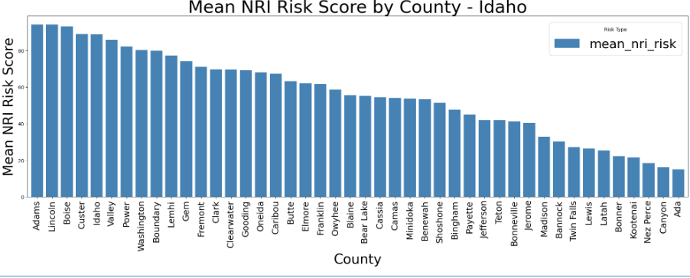
Figure 1: Mean NRI Risk Score by County (Idaho)

Mean Alternative Risk Score by County (Idaho)
Figure 2 represents the alternative risk method for Idaho counties and shows a visibly different trend compared to the NRI results. With this new formulation applied that contains Expected Annual Loss, Social Vulnerability, and a resilience-adjusted factor, Elmore County now has the highest mean alternative risk score followed by Jerome, Minidoka and Canyon County. These counties all higher social vulnerability and lower resilience scores in common which is why we see them have a higher mean risk score. On the other hand, counties such as Oneida, Clark, and Boise show to have the lowest risk scores which are due to a low expected annual loss in $ and have stronger resilience factors. Compared to the NRI results, this formula shifts its risk scores to communities that are expected to have a higher annual loss, are more vulnerable to a hazard, or are less community resilient which highlights how methodology choices can influence risk across communities and counties.
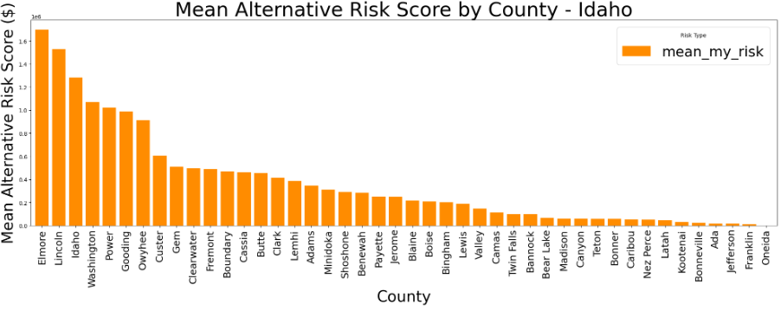
Figure 2: Mean Alternative Risk Score by County (Idaho)

NRI vs Alternative Risk Score by County (Idaho)
Figure 3 compares Idaho’s county level NRI risk score with our new normalized alternative risk scores which reveal some major differences in both approaches. While the NRI has counties such as Adams, Idaho, and Valley as relatively high risk, our alternative risk score has counties like Elmore, Jerome, and Minidoka as areas with higher social vulnerability and a lower community resilience which is going to spike up the expected loss. On the other hand, some counites that appear as high risk under the NRI such as clearwater or Lemhi fall in the middle ground on our alternative risk score thanks to a higher reliance and lower vulnerability. The comparison between the two shows how the NRI’s percentile-based method tends to focus on hazard exposure and adaptation to that hazard. These differences in risk calculation methods represent how risk classifications can change dramatically depending on how you classify risk and whether you take into account a community’s resilience, expected annual loss or social vulnerability.
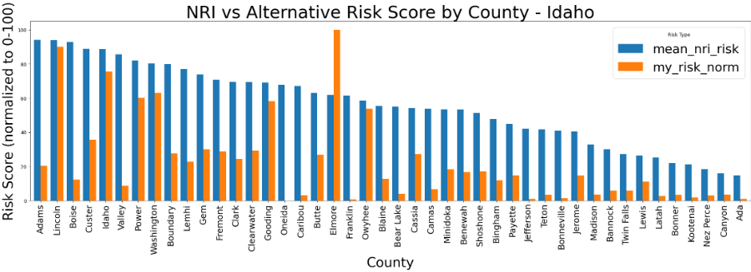
Figure 3: NRI vs Alternative Risk Score by County (Idaho)

Mean NRI Risk Score by County (Montana)
Figure 4 shows the distribution of FEMA’s NRI risk score across different counties in Montana revealing that Ravalli County has the highest mean NRI risk followed closely by Sweet Grass, Phillips and Valley Counties. These high scores are likely due to those counties having more exposures to wildfires, severe weather and other hazards that are common amongst those terrains. In contrast, counties such as Petroleum, Golden Valley and Yellowstone show to have the lowest NRI risk scores which are likely a result of a low expected annual losses and a stronger resilience. Similar to Idaho, the NRI tends to classify rural counties as higher risk compared to higher population areas because hazards tend to affect those areas more in terms of economic loss instead of their sensitivity to the hazard. This figure is great as it again sets a baseline for how Montana’s risk is going to change with a new risk definition that incorporates other aspects.
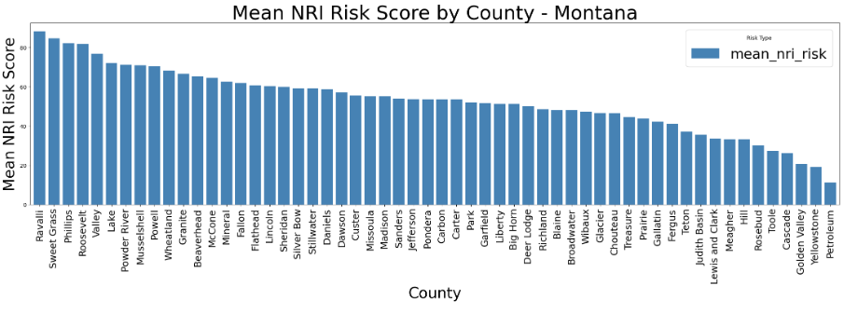
Figure 4: Mean NRI Risk Score by County (Montana)

Mean Alternative Risk Score by County (Montana)
Figure 5 shows the distribution of our alternative risk score across Montana Counties showing a pattern that is quite different from the NRI base results. Under this formulation which raises expected annual loss in counties with higher social vulnerability and lower resilience, Roosevelt County now has the highest alternative risk score, followed by Ravalli, Lake, and Lincoln counties. These counties all have higher vulnerabilities and lower reliance’s in common which is why their risk scores are much higher than others. Conversely, counties such as Petroleum, Garfield, and Meagher are on the significantly lower end of the risk score due to a low expected annual loss such like the NRI. Compared to the NRI rankings, our formula shifts its risk emphasis to communities where economic sensitivity is high and adaptations to a given hazard are low.
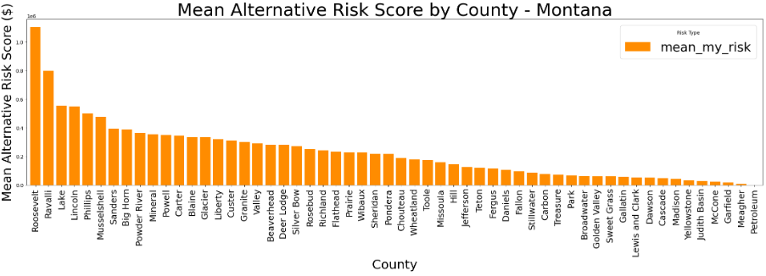
Figure 5: Mean Alternative Risk Score by County (Montana)

NRI vs Alternative Risk Scores by County (Montana)
Figure 6 is a plot comparing Montana’s county level Nri risk scores with the normalized alternative risk definition which reveals important differences in how the two approaches classify risk. While the NRI had counties such as Ravalli, Sweet grass and Phillips as high risk, the alternative definition has counties such as Roosevelt, Ravalli and Lake counites as a result of high resilience and lower vulnerability. In many counties, the NRI scores are higher than the alternative definition which again is a representation of FEMA’s focus on hazard exposure and loss potential rather than social sensitivity. In contrast, the alternative risk method highlights communities that are more vulnerable, less resilient and would be hit more by a hazard in terms of annual losses. This comparison shows how risk defined by physical hazard exposure (NRI) or risk defined by the interaction of losses, vulnerability, and resilience (my risk) can influence a counties risk score.
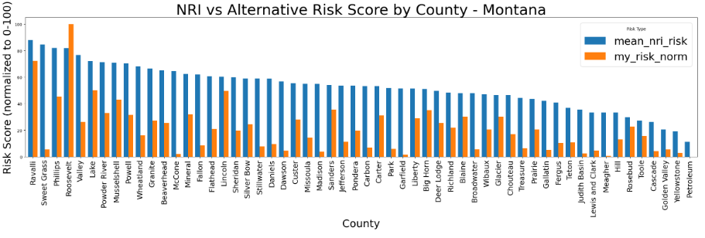
Figure 6: NRI vs Alternative Risk Scores by County (Montana)

NRI Risk Score by Census Tract (Idaho)
Figure 7 shows the spatial distribution of FEMA’s Nri continuous risk scores across Idaho’s census tracts which reveal a clear clustering of high-risk areas. Higher NRI risk scores appear near the western side of Idaho where wildfire exposures are heavy and severe weather is quite common which contributes to higher modeled losses. Several tracts in the central area show deep red shading indicating risk scores on the max end of the NRI scale. On the other hand, many tracts in the southeastern side of Idaho show lower risk scores as these are areas with less hazards mentioned prior and have a greater community resilience factor. The map does a great job of showing how Idaho’s physical geography depending on remote areas, forests and complex areas can skew FEMA’s NRI risk score.
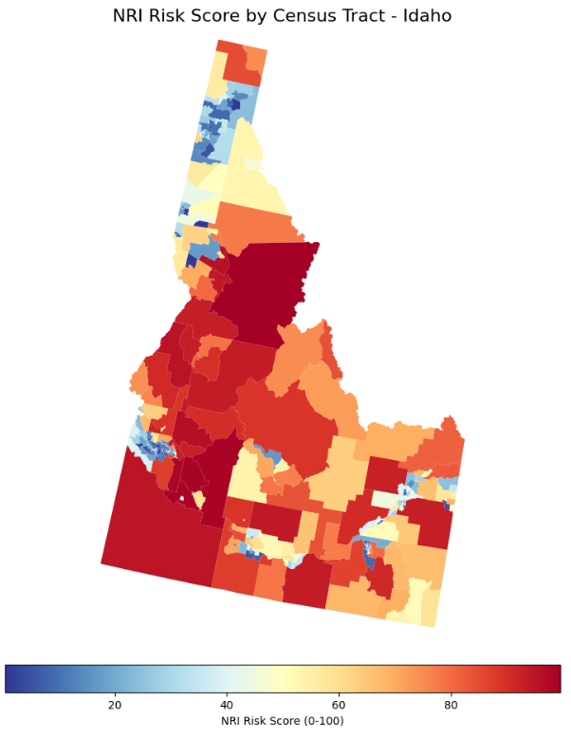
Figure 7: NRI Risk Score by Census Tract (Idaho)

Alternative Risk Score by Census Tract (Idaho)
Figure 8 represents the spatial distribution of the alternative risk score across Idaho’s census tracts which indicate a pattern that is different from FEMA’s NRI map above. Higher alternative risk values appear in a few tracts across the southwestern side of Idaho in areas where annual losses are related to higher social vulnerability or lower resilience. These tracts display orange and red shading, indicating a higher risk under our new risk definition which matches the NRI definition as well. In contrast, many of the northern, more rural tracts show lower risk scores which are likely due to low expected annual losses due to a stronger resilience factor or a lower social vulnerability. Compared to the NRI distribution, this map turns its focus to communities that are more socially and economically sensitive to a hazard which is major role in shaping risk as a whole.

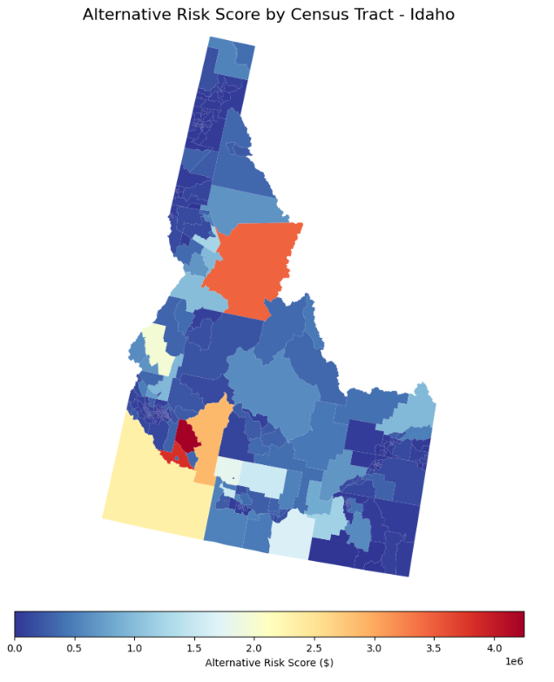
Figure 8: Alternative Risk Score by Census Tract (Idaho)

NRI Risk Scores by Census Tract (Montana)
Figure 9 shows the spatial distribution of FEMA’s NRI risk scores across Montana’s census tracts which show a clear pattern of high-risk clusters in the northeastern parts of Montana. Census tracts in the northeastern as well as the western parts show to have the deepest red shading as they contain mountainous terrains and are then exposed to more wildfires, winter storms, and hazards in general. In contrast, the central portion of Montana exhibits the lowest NRI risk rating as they are less prone to hazards or have lower expected annual losses. Overall, the NRI’s spatial pattern puts light on Montana’s physical geography for FEMA’s risk classification with it influences their risk classifications heavily.
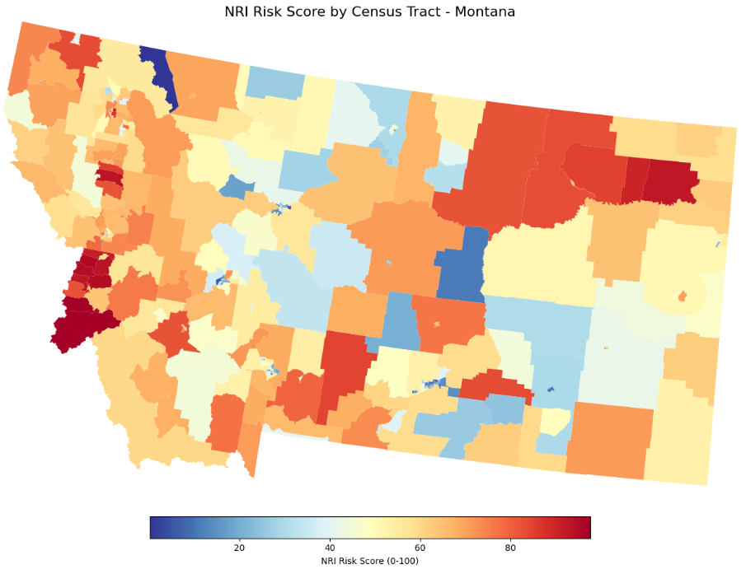
Figure 9: NRI Risk Score by Census Tract (Montana)

Alternative Risk Scores by Census Tract (Montana)
Figure 10 shows the spatial distribution of the alternative risk definition cross census tracts in Montana revealing a pattern that’s slightly different form than the NRI risk score. Higher alternative risk values appear in only a few census tracts that are spread out in the northeastern, western and northwestern areas of Montana. These areas are likely linked to lower resilience factors, higher vulnerability, or a higher expected annual loss when to comes to hazard exposure. In contrast, most of the central areas of Montana display lower alternative risk scores which is mainly due to more population and lower expected annual losses. Compared to the NRI’s risk definition, again, our risk definition shift from purely hazard driven risk and moves toward communities where social and economic sensitivity plays a larger role in shaping overall risk.

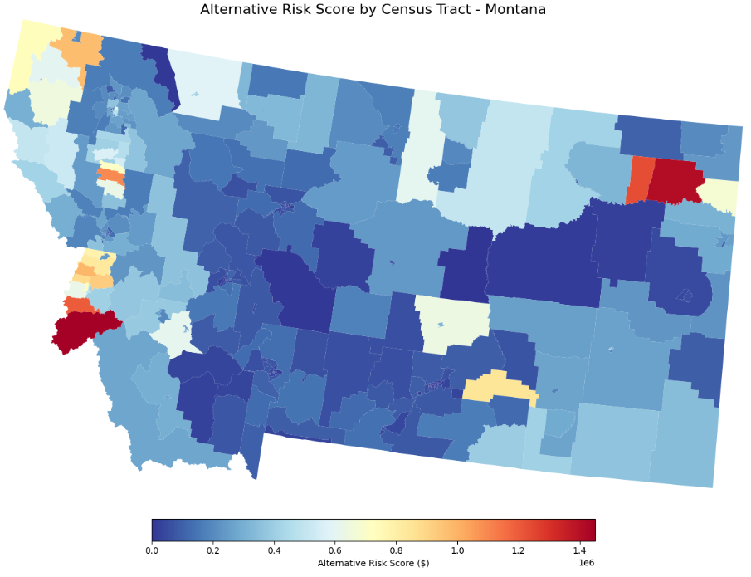
Figure 10: Alternative Risk Score by Census Tract (Montana)

NRI Categorical Risk Rating by Census Tract (Montana)
Figure 11 represents FEMA’s categorical NRI Risk Rating for Idaho census tracts and displays a clear spatial visual in how risk is classified across the state. Several tracts in the northern regions of Idaho fall in the Relatively or very low risk rating. In contrast, much of the southwestern side of Idaho represents either Moderate to above risk ratings indicating lower resilience factors and more expected losses related to hazards. This categorical map does a great job of simplifying the previously continuous NRI scores and puts it into a broader class that’s easier to read and directly pinpoints areas of high and low risk.
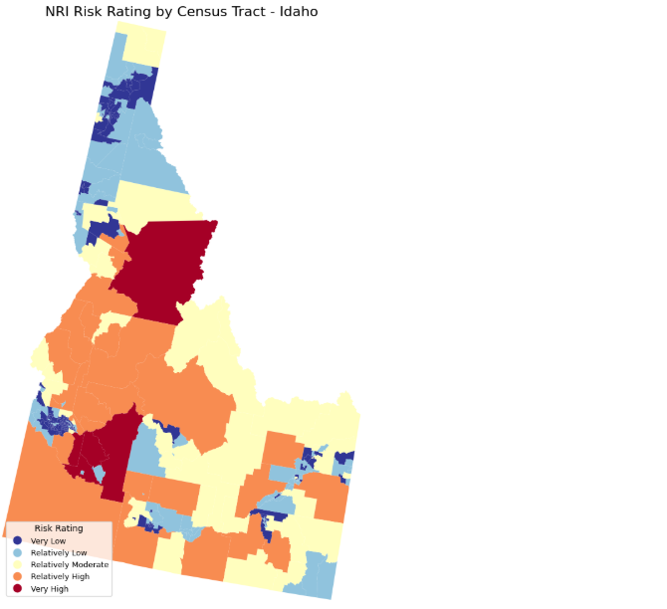
Figure 11: NRI Categorical Risk Rating by Census Tract (Idaho)

NRI Categorical Risk Rating by Census Tract (Montana)
Figure 12 is our final figure, and it shows FEMA’s categorical risk rating across Montana census tracts that shows a clear domination of Very Low and Relatively Low classifications, especially throughout the eastern plains and much of central Montana. Higher rated tracts are only found on one tract in the Northeastern end of Montana, as well as a few tracts on the western end. These tracts are most likely high due to past conflicts regarding hazards which will directly influence their resilience, social vulnerability, or expected annual losses causing a higher risk rating in those tracts. Compared to the continuous NRI map, the categorical version simplifies these patterns into broader classifications making the maps much easier to read and depict trends from.

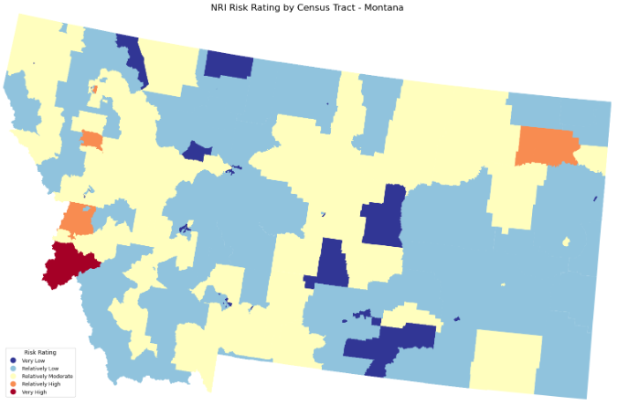
Figure 12: NRI Categorical Risk Rating by Census Tract (Montana)

Conclusion
This project compared FEMA’s National Risk Index (NRI) with an alternative risk definition based more on vulnerability across the states Idaho and Montana at both the county and Census Tract level. The NRI was constantly putting more emphasis on hazard exposure and really only focused on losses which produced higher risk ratings in mountainous regions, and more wildfire and severe storm regions in these states. In contrast, our alternative risk definition directed the risk definition to a combination of expected annual losses in communities, with higher social vulnerability and lower resilience either raising or lowering the risk scores produced. This is evident when viewing figures 1-6 on how some counties that were low or high risk based on the NRI were opposite when viewed under out risk rating. The tract level maps further supported these ideas as the NRI mainly focused on physical hazards that were based on geography aspects, the alternative risk definition we created again was driven by socioeconomic sensitivity rather than hazard intensity alone. Combined, these results show that a community’s risk rating depends heavily on how the risk definition is classified to begin with and displays what happened when you do or do not include a community’s vulnerability and resilience into a risk equation. Furthermore, incorporating multiple variables into your risk rating provides users with a more complete understanding of community level risk and can better help decisionmakers choose where proper funding needs to be provided, and where it can be lifted based on whether a community is expected to lose more or less than what the NRI classifies it as.

References
ATSDR. (n.d.). Retrieved from PLace and Health - Geospatial Research, Analysis, and Services Program (GRASP): https://www.atsdr.cdc.gov/place-health/php/svi/svi-data-documentation-download.html
FEMA. (n.d.). Retrieved from National Risk Index for Natural Hazards: https://www.fema.gov/flood-maps/products-tools/national-risk-index

