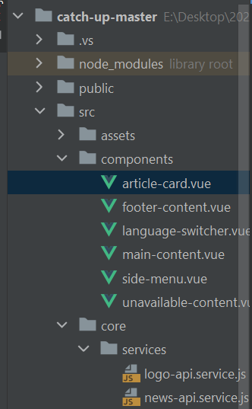
*article-card.vue
<template>
<v-card class="ma-2 elevation-1" hover>
<v-img class="white--text align-end" cover
:src="article.urlToImage"
:alt="article.title"
gradient="to bottom, rgba(0,0,0,.1), rgba(0,0,0,.5)">
<v-card-title class="ma-3 text-white" v-text="article.title"></v-card-title>
</v-img>
<v-card-text class="ma-2">
{{ article.description }}
</v-card-text>
<v-card-actions class="ma-2">
<v-chip v-if="article.source.url" color="primary"
size="x-small" link
:href="article.source.url" target="_blank">
{{ article.source.name }}
</v-chip>
<v-chip v-else color="primary" size="x-small">{{ article.source.name }}</v-chip>
<v-spacer></v-spacer>
<v-btn icon="mdi-reddit" class="text-red"/>
<v-btn icon="mdi-twitter" class="text-blue-lighten-1"/>
<v-btn icon="mdi-facebook" class="text-blue-darken-4"/>
<v-btn icon="mdi-google-plus" class="text-red"/>
<v-btn icon="mdi-linkedin" class="text-blue-darken-4"/>
<v-spacer></v-spacer>
<v-btn small replace color="info" v-bind:href="article.url" target="_blank">{{ $t('read-more') }}</v-btn>
</v-card-actions>
</v-card>
</template>
<script>
export default {
name: "article-card",
props: {
article: null
}
}
</script>
<style scoped>
</style>

*footer-content.vue
<template>
<v-row justify="center" no-gutters class="flex-column">
<v-col class="ml-3 text-center">
Copyright &copy; 2022. ACME Studio
</v-col>
<v-col class="ml-3 mt-3 text-center">
{{ $t('authoring-phrase.intro') }} <v-icon icon="mdi-heart" class="text-red"/>
{{ $t('authoring-phrase.use') }} <a class="text-white" href="https://next.vuetifyjs.com" target="_blank">Vuetify</a>
{{ $t('authoring-phrase.author', { brand: "ACME"}) }}
</v-col>
</v-row>
</template>
<script>
export default {
name: "footer-content"
}
</script>
<style scoped>
</style>

*language-switcher.vue
<template>
<v-btn-toggle v-model="$i18n.locale">
<v-btn size="small" class="text-white"
v-for="lang in languages"
:value="lang">{{ lang }}</v-btn>
</v-btn-toggle>
</template>
<script>
export default {
name: "language-switcher",
data() {
return {
languages: ['en', 'es']
}
}
}
</script>
<style scoped>
</style>

*main-content.vue
<template>
<v-container>
<v-row>
<v-col v-for="article in articles" :key="article.title">
<article-card :article="article"/>
</v-col>
</v-row>
</v-container>
</template>
<script>
import ArticleCard from "./article-card.vue";
export default {
name: "main-content",
components: {ArticleCard},
props: {
articles: Array
}
}
</script>
<style scoped>
</style>

*side-menu.vue
<template>
<v-navigation-drawer v-model="drawer" fixed app clipped>
<v-list density="comfortable" class="pt-3 white--text">
<v-list-item v-for="source in sources"
:key="source.id"
@click="onSourceSelected(source)">
<v-list-item-avatar start rounded>
<v-avatar>
<v-img class="elevation-7 mb-1"
:src="source.urlToLogo"
:alt="source.name"/>
</v-avatar>
</v-list-item-avatar>
<v-list-item-title class="mx-2">{{ source.name }}</v-list-item-title>
</v-list-item>
</v-list>
</v-navigation-drawer>
</template>
<script>
import { NewsApiService } from "../core/services/news-api.service";
export default {
name: "side-menu",
props: {
drawer: Boolean
},
data() {
return {
sources: [],
errors: [],
newsApi: new NewsApiService()
}
},
created() {
this.newsApi.getSources()
.then(response => {
this.sources = response.data.sources;
this.sources.map(source => source.urlToLogo = this.newsApi.getUrlToLogo(source));
console.log(`data: ${ response.data.sources }`);
})
.catch(e => {
this.errors.push(e);
});
},
methods: {
onSourceSelected(source) {
this.$emit('source-selected', source);
}
}
}
</script>
<style scoped>
</style>

*unavailable-content.vue
<template>
<v-row class="flex-column text-center">
<v-col class="text-h4">{{ $t('unavailable-news') }}</v-col>
<v-col v-for="error in errors" class="text-h6">{{ error }}</v-col>
</v-row>
</template>
<script>
export default {
name: "unavailable-content",
props: {
errors: null
}
}
</script>
<style scoped>
</style>

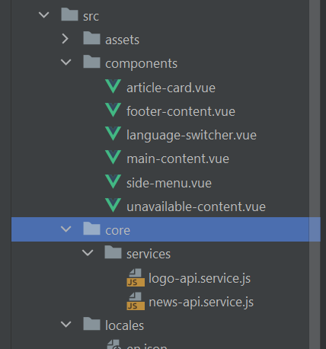

*logo-api.service.js
export class LogoApiService {
getUrlToLogo(source) {
return `https://logo.clearbit.com/${ new URL(source.url).host}`;
}
}

*news-api.service.js
import { LogoApiService } from "./logo-api.service";
import axios from "axios";
const http = axios.create({
baseURL: 'https://newsapi.org/v2/'
});
export class NewsApiService {
apiKey = 'fecf4feeffa64e4da682e7d268612ce5';
logoApi = new LogoApiService();
getSources() {
return http.get(`top-headlines/sources?language=en&apiKey=${this.apiKey}`);
}
getArticlesForSource(sourceId) {
return http.get(`top-headlines?sources=${sourceId}&apiKey=${this.apiKey}`);
}
getUrlToLogo(source) {
return this.logoApi.getUrlToLogo(source);
}
}

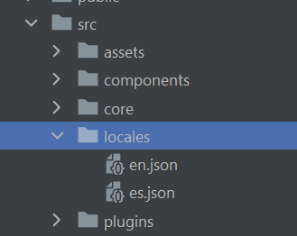

*en.json
{
"read-more": "Read More",
"unavailable-news": "News Service is unavailable now",
"authoring-phrase": {
"intro": "Made with",
"use": "using",
"author": "by {brand} Developer Team"
}
}

*es.json
{
"read-more": "Ver más",
"unavailable-news": "Servicio de noticias no disponible en este momento",
"authoring-phrase": {
"intro": "Hecho con",
"use": "utilizando",
"author": "por el Equipo de Desarrollo de {brand}"
}
}

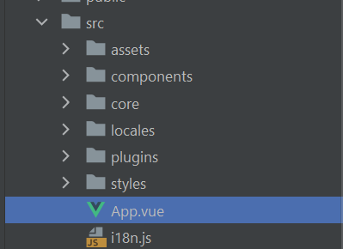

*App.vue
<template>
<v-app theme="light">
<v-app-bar app color="primary">
<v-app-bar-nav-icon @click="drawer=!drawer"></v-app-bar-nav-icon>
<v-app-bar-title>CatchUp</v-app-bar-title>
<v-spacer></v-spacer>
<template v-slot:append>
<language-switcher/>
</template>
</v-app-bar>
<side-menu :drawer="drawer" v-on:source-selected="setSource"></side-menu>
<v-main>
<v-container fluid>
<unavailable-content v-if="errors.count > 0" :errors="errors"/>
<main-content v-else :articles="articles"></main-content>
</v-container>
<v-footer color="primary">
<footer-content/>
</v-footer>
</v-main>
</v-app>
</template>
<script>
import { NewsApiService } from "./core/services/news-api.service";
import SideMenu from "./components/side-menu.vue";
import MainContent from "./components/main-content.vue";
import UnavailableContent from "./components/unavailable-content.vue";
import FooterContent from "./components/footer-content.vue";
import LanguageSwitcher from "./components/language-switcher.vue";
export default {
name: 'App',
components: {
LanguageSwitcher,
FooterContent,
UnavailableContent,
MainContent,
SideMenu,
},
data() {
return {
drawer: false,
articles: [],
errors: [],
newsApi: new NewsApiService()
};
},
created() {
console.log('created');
this.getArticlesForSource('bbc-news');
},
methods: {
// On Source selected
setSource(source) {
this.drawer = !this.drawer;
this.getArticlesForSourceWithLogo(source);
},
// Fetch articles from source id
getArticlesForSource(sourceId) {
this.newsApi.getArticlesForSource(sourceId)
.then(response => {
this.articles = response.data.articles;
console.log(response.data);
})
.catch(e => {
this.errors.push(e);
})
},
// Fetch articles from selected source
getArticlesForSourceWithLogo(source) {
this.newsApi.getArticlesForSource(source.id)
.then(response => {
this.articles = response.data.articles;
this.articles.map(article => article.source.url = source.url);
})
.catch(e => {
this.errors.push(e);
})
}
}
}
</script>

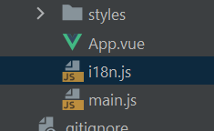

*i18n.js
import {createI18n} from "vue-i18n";
import en from "./locales/en.json";
import es from "./locales/es.json";
const i18n = createI18n({
legacy: false,
locale: 'en',
fallbackLocale: 'en',
globalInjection: true,
messages: { en, es }
});
export default i18n;
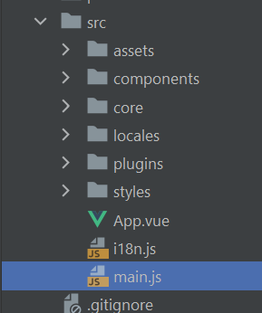
*main.js
import { createApp } from 'vue'
import App from './App.vue'
import vuetify from './plugins/vuetify'
import { loadFonts } from './plugins/webfontloader'
import i18n from './i18n';
loadFonts().then();
createApp(App)
.use(vuetify)
.use(i18n)
.mount('#app')
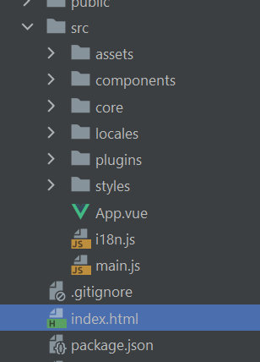

*index.html
<!DOCTYPE html>
<html lang="en">
<head>
<meta charset="UTF-8" />
<link rel="icon" href="/favicon.ico" />
<meta name="viewport" content="width=device-width, initial-scale=1.0" />
<title>CatchUp</title>
</head>
<body>
<div id="app"></div>
<script type="module" src="/src/main.js"></script>
</body>
</html>

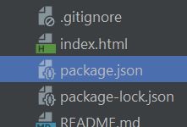

{
"name": "catch-up-with-vue",
"version": "0.0.0",
"private": true,
"scripts": {
"serve": "vite preview",
"build": "vite build",
"dev": "vite",
"preview": "vite preview"
},
"dependencies": {
"@mdi/font": "5.9.55",
"axios": "^0.26.1",
"roboto-fontface": "*",
"vue": "^3.2.25",
"vue-i18n": "^9.1.9",
"vuetify": "^3.0.0-beta.0",
"webfontloader": "^1.0.0"
},
"devDependencies": {
"@intlify/vite-plugin-vue-i18n": "^3.4.0",
"@vitejs/plugin-vue": "^2.3.0",
"@vuetify/vite-plugin": "^1.0.0-alpha.0",
"sass": "^1.38.0",
"sass-loader": "^10.0.0",
"vite": "^2.9.0",
"vue-cli-plugin-vuetify": "~2.4.8",
"vuetify-loader": "^2.0.0-alpha.0"
}
}
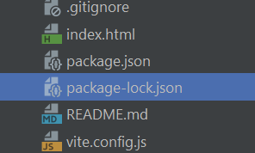
*package-lock.json
{
"name": "catch-up-with-vue",
"version": "0.0.0",
"lockfileVersion": 2,
"requires": true,
"packages": {
"": {
"name": "catch-up-with-vue",
"version": "0.0.0",
"dependencies": {
"@mdi/font": "5.9.55",
"axios": "^0.26.1",
"roboto-fontface": "*",
"vue": "^3.2.25",
"vue-i18n": "^9.1.9",
"vuetify": "^3.0.0-beta.0",
"webfontloader": "^1.0.0"
},
"devDependencies": {
"@intlify/vite-plugin-vue-i18n": "^3.4.0",
"@vitejs/plugin-vue": "^2.3.0",
"@vuetify/vite-plugin": "^1.0.0-alpha.0",
"sass": "^1.38.0",
"sass-loader": "^10.0.0",
"vite": "^2.9.0",
"vue-cli-plugin-vuetify": "~2.4.8",
"vuetify-loader": "^2.0.0-alpha.0"
}
},
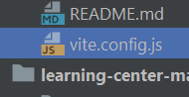
*vite.config.js
import { defineConfig } from 'vite'
import vue from '@vitejs/plugin-vue'
import vuetify from '@vuetify/vite-plugin'
import {vueI18n} from "@intlify/vite-plugin-vue-i18n";
const path = require('path')
// https://vitejs.dev/config/
export default defineConfig({
plugins: [
vue(),
// https://github.com/vuetifyjs/vuetify-loader/tree/next/packages/vite-plugin
vuetify({
autoImport: true,
}),
// Vue I18n setup
vueI18n({
include: path.resolve(__dirname, "@locales/**")
})
],
define: { 'process.env': {} },
resolve: {
alias: {
'@': path.resolve(__dirname, 'src'),
},
},
/* remove the need to specify .vue files https://vitejs.dev/config/#resolve-extensions
resolve: {
extensions: [
'.js',
'.json',
'.jsx',
'.mjs',
'.ts',
'.tsx',
'.vue',
]
},
*/
})

