HCM Extracts
Tuesday, January 3, 2023
9:01 PM

Feed XML to Report Template:

Run Extract, take note of Instance Name
Once done, go to report template on OTBI Catalog
Select Report Template > Schedule > Input Instance name > Input Report Job name > Return
Select Report Template > History >

OR Open > Input flow instance name > Apply

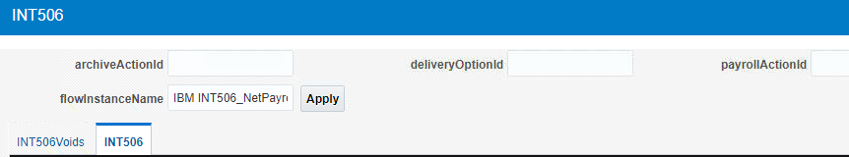

-------------

How to update extract on Extract Flow:

If you have a new version of a current extract and did some changes, you can update the flow to call the new extract while still using the old flow pattern.

Home > Data Exchange > Refine Extracts > Search for the flow pattern > Edit the original version >
Go to task > Report Category > Basis value > change to the new extract name.

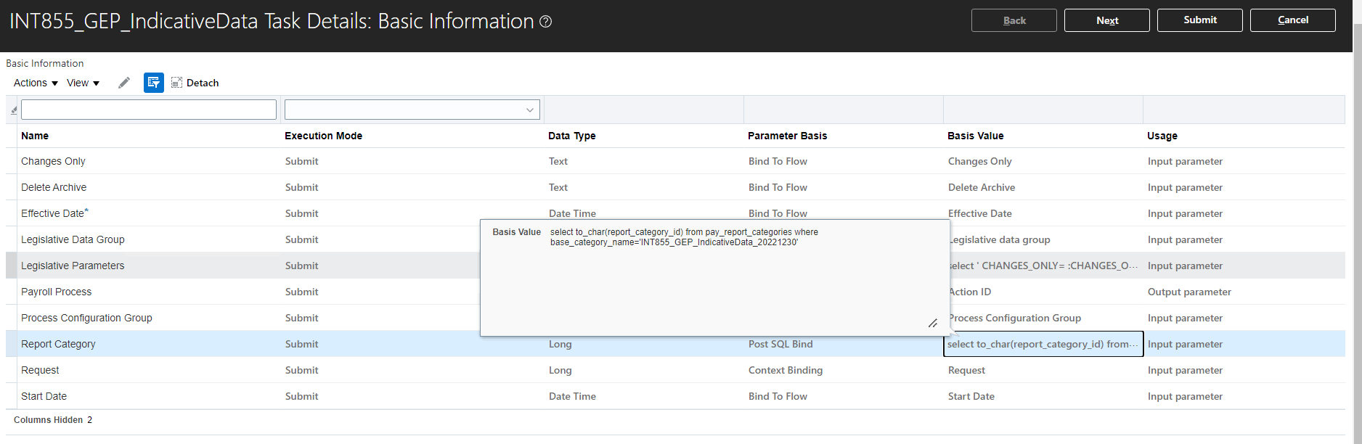

-----------------------

Changes Only (template):
Compare old values to present value
Tagname_OLD = old value from last run

Ex.
IF Substr(DepartmentID,1,5) != Substr(DepartmentID_OLD,1,5)
THEN 'Y'
ELSE 'N'
END IF

Changes only extract modes: [ref]

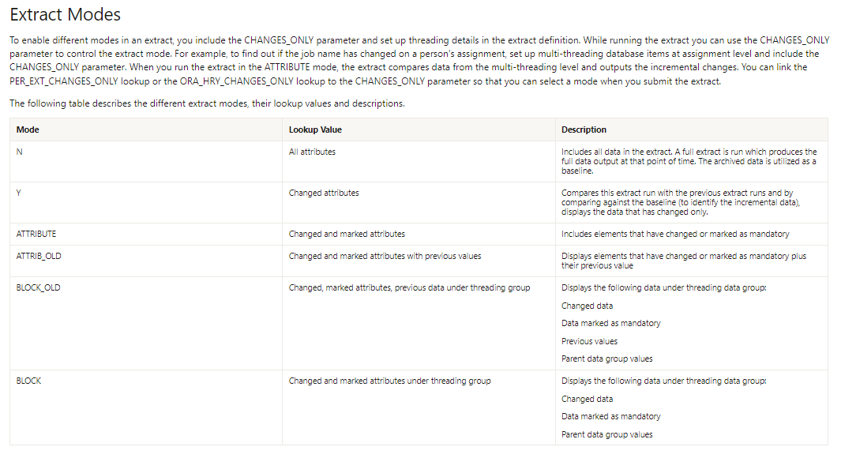

Aggregation via Summary element (for sum, count, avg, etc.)

Note: Attribute to be aggregated should be on a different Data Group, but it should be a child of the Data group wherein the summary element would exist.
For example from image below: Summary element is on Payments (parent), while RunResultValue attribute on on Run Results (child)

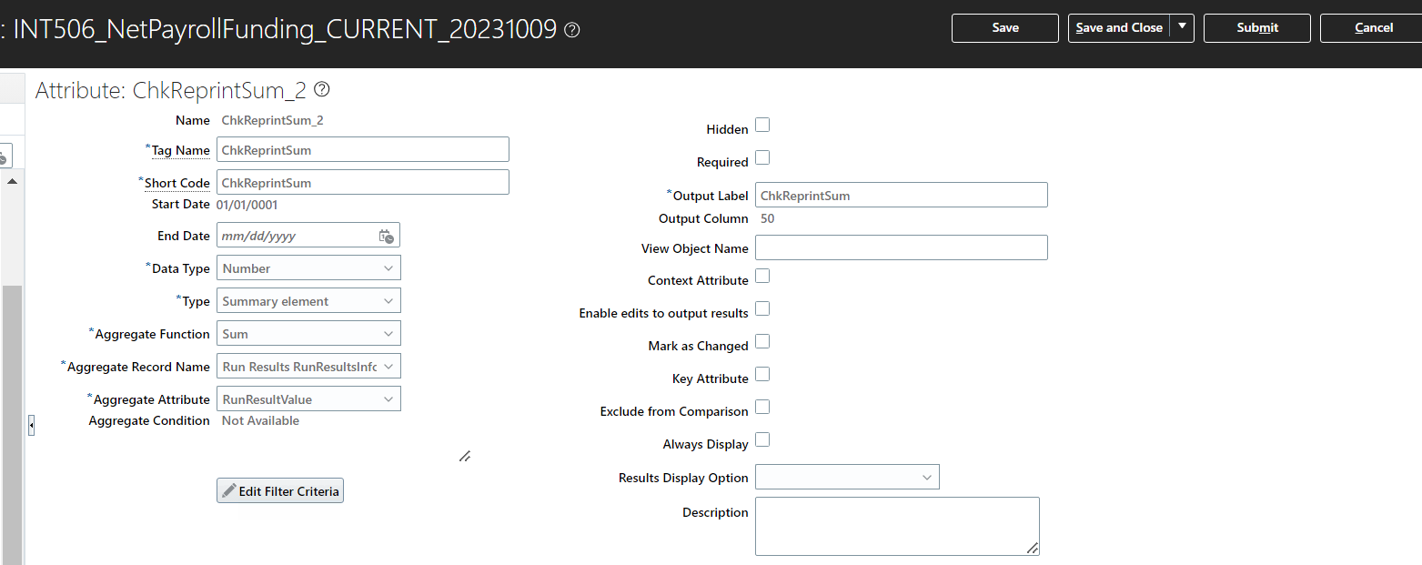

Aggregation via Report template

From Badet:
Custom > Human Capital Management > Interface templates > INT577A ACH

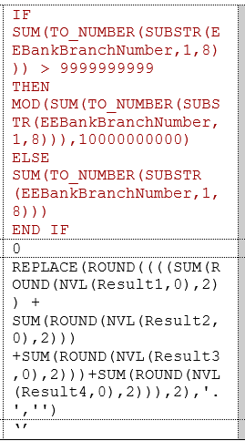

Connecting User Entities (UE)

Check the involved UEs on View User Entity Details, and get the possible DBIs wherein both of them can be connected. The DBI should exist on both of the UE.

You can connect them using Connections on the Data Group tab on the extract itself.
If the parent has multiple children UE:
  - setup Hierarchy Traversal records on the Parent UE
  - connect via Connections on the Data Group tab
  - On the traversal record, choose the children on the Next Data Group option.

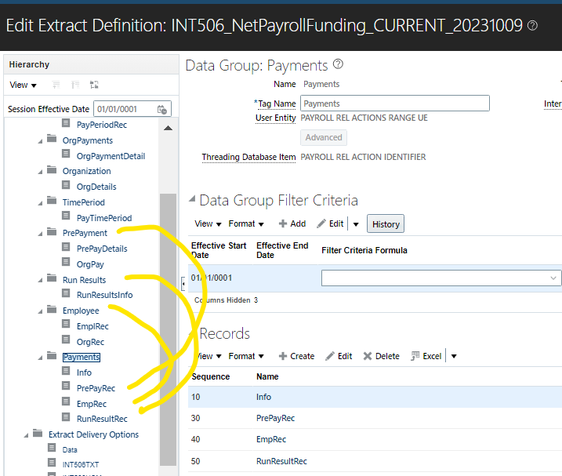

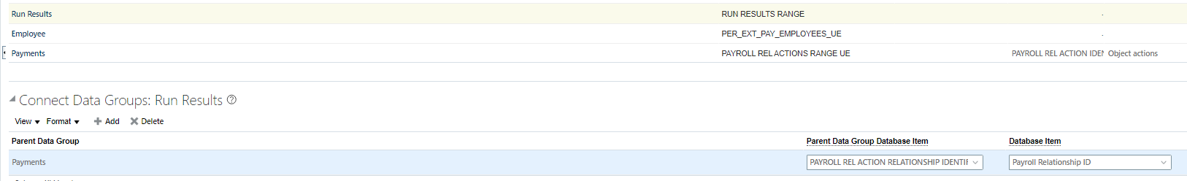

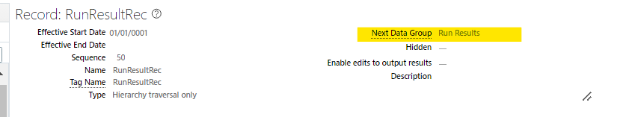

Extract Rule (notes)

  - Extract Rule attribute should be on the last part of the sequence with the record to make sure that the value being passed are populated first before the Extract rule is processed.
[Ref: FLSA not getting fetched problem by Pam on INT200]

Retrieving Balances on Extract

Ref: RITM0481259 / INT402
The ATTRIBUTES are always the same for any balance used on the extract, and every attribute is required to get the RUN value.

