Group Contract

GROUP NAME: Fri 13-16_09

Contact Information

Name | SID | UniKey | Email
Yuchuan Hu | 540145821 | yuhu0662 | yuhu0662@uni.sydney.edu.au
Mingxiang Zhang | 540082261 | mzha0541 | mzha0541@uni.sydney.edu.au
Bing Zhou | 540134319 | bzho0907 | bzho0907@uni.sydney.edu.au
Yuhang Ding | 530215792 | ydin4490 | ydin4490@uni.sydney.edu.au
Shengming Cui | 530549789 | scui0452 | scui0452@uni.sydney.edu.au

In the following sections, all group members should agree on the undertakings and how exactly they are to be achieved, before the item is ticked. Undertakings can be reworded if desired.

Agreed? Please ✔
1. Attendance | We agree to attend all group meetings punctually and any extra scheduled meetings as necessary. | [ ]
a. Please enter realistic meeting times.
b. What are acceptable unavoidable absences? Record here.
2. Participation | We undertake to participate fully and work as a team. | [ ]
a. What exactly does this mean?
b. How will you demonstrate that this is taking place?
3. Group Conflict | We will discuss any problems, listen carefully to all points of view and negotiate a solution. | [ ]
a. Where will such discussions be recorded?
b. How will you demonstrate agreement?
4. Task Rehearsal | We will ensure that each group member is ready for the Group Demo. | [ ]
a. How?
b. Provide details of when and where this rehearsal might take place.
5. Task Allocation | We will distribute the work fairly and equitably. | [ ]
a. Specifically, who will do what aspects of the rest of the task?
6. Anything Else? |  | [ ]

We understand that once this contract is signed and submitted, there is no opportunity to switch groups. We agree to resolve all group matters internally and acknowledge that unfair contribution does not guarantee individual mark scaling.

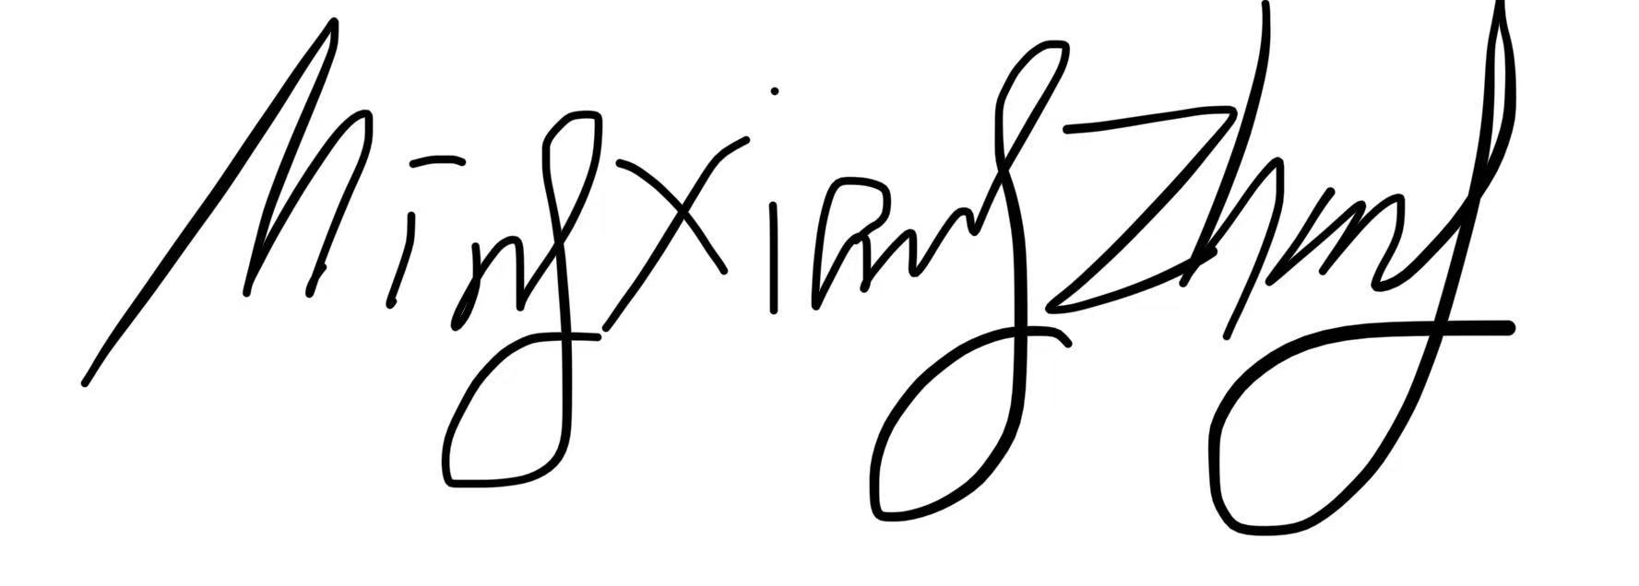
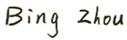
Name & Signature: __________________________

Date: ____2025/8/28__________

