|  |  |
| --- | --- |
|  |  |
|  |  |
|  |  |
|  |  |
|  |  |

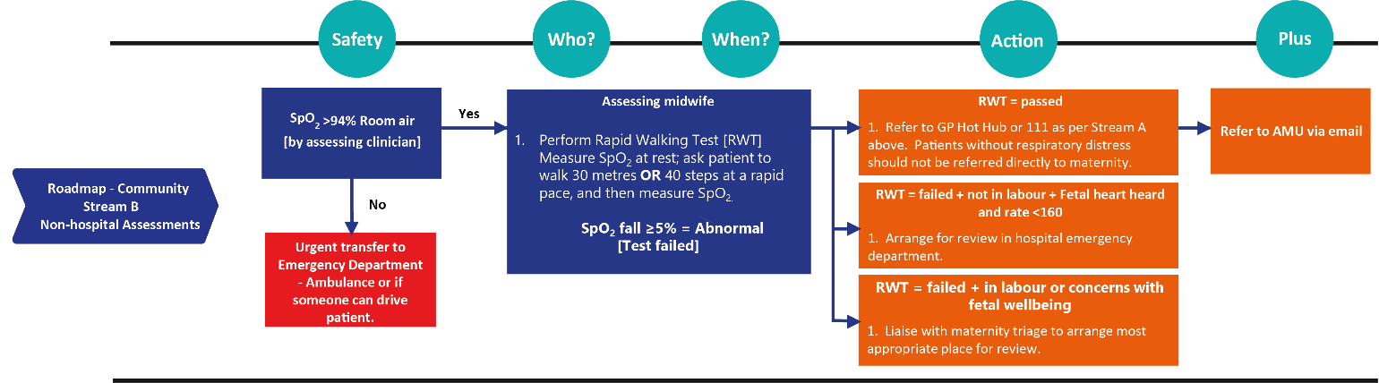

|  |  |
| --- | --- |
| **Situation** |  |
|  |  |
| **s1** |  |
| **s2** |  |

|  |  |
| --- | --- |
| **Recommendation** |  |
|  |  |
| **r1** |  |
| **r2** |  |
| **r3** |  |
| **r4** |  |
| **r5** |  |
| **r6** |  |
| **r7** |  |
| **r8** |  |
| **r9** |  |

|  |  |
| --- | --- |
| **Assessment** |  |
|  |  |
| **a1** |  |
| **a2** |  |
| **a3** |  |
| **a4** |  |
| **a5** |  |
| **a6** |  |
| **a7** |  |
| **a8** |  |
| **a9** |  |

|  |  |
| --- | --- |
| **Date** |  |
| **Time** |  |
| **Setting** |  |
| **Staff name** |  |
| **Staff role** |  |

|  |  |
| --- | --- |
| **Background** |  |
|  |  |
| **Name** |  |
| **NHS number** |  |
| **Date of birth** |  |
| **Mobile phone** |  |
| **AN PN** |  |
| **EDD Del** |  |

**COVID Triage**