WDD 430 – Measuring Web Performance
The “heavy” Audit
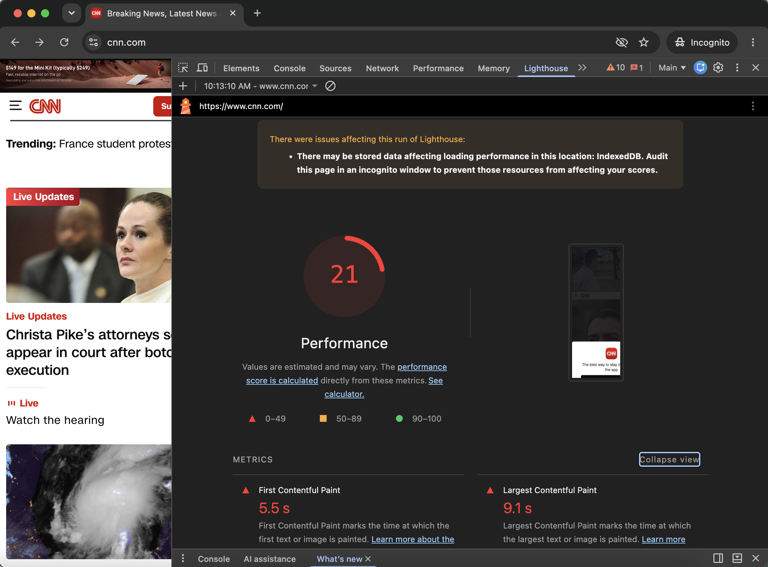
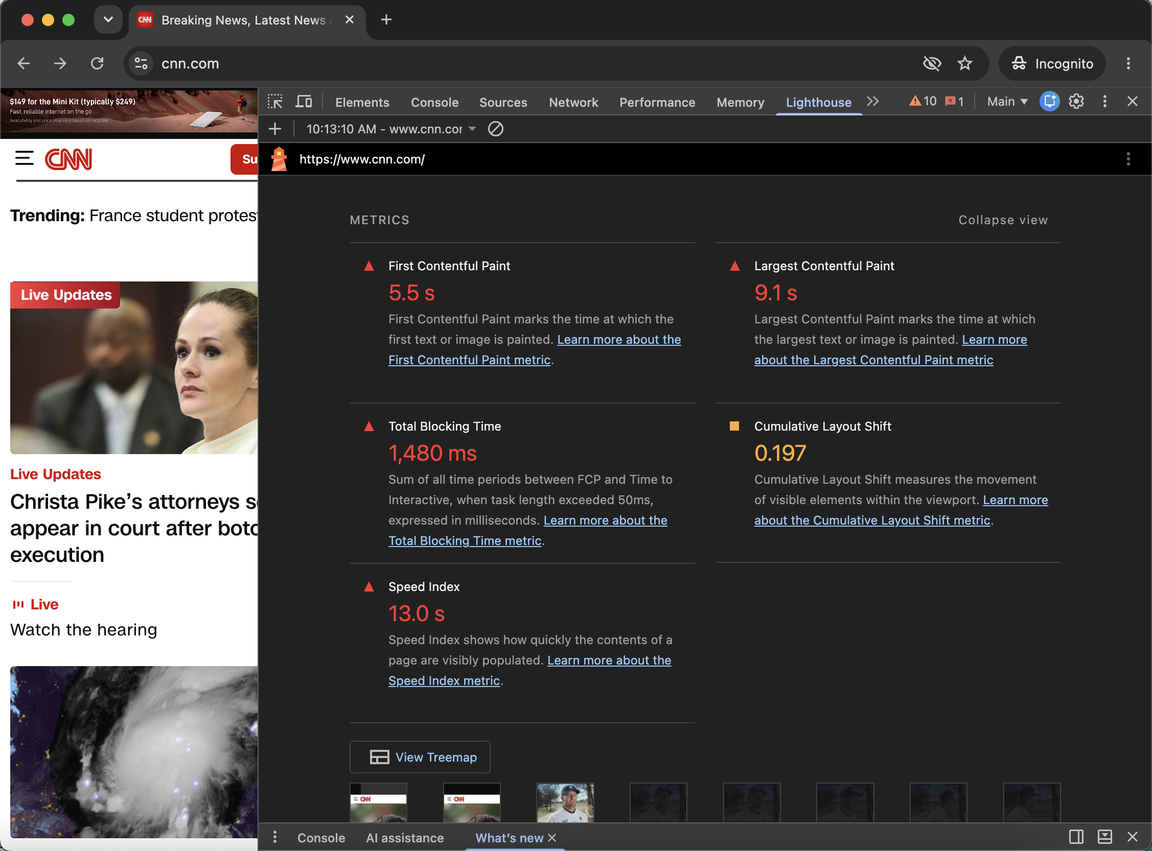
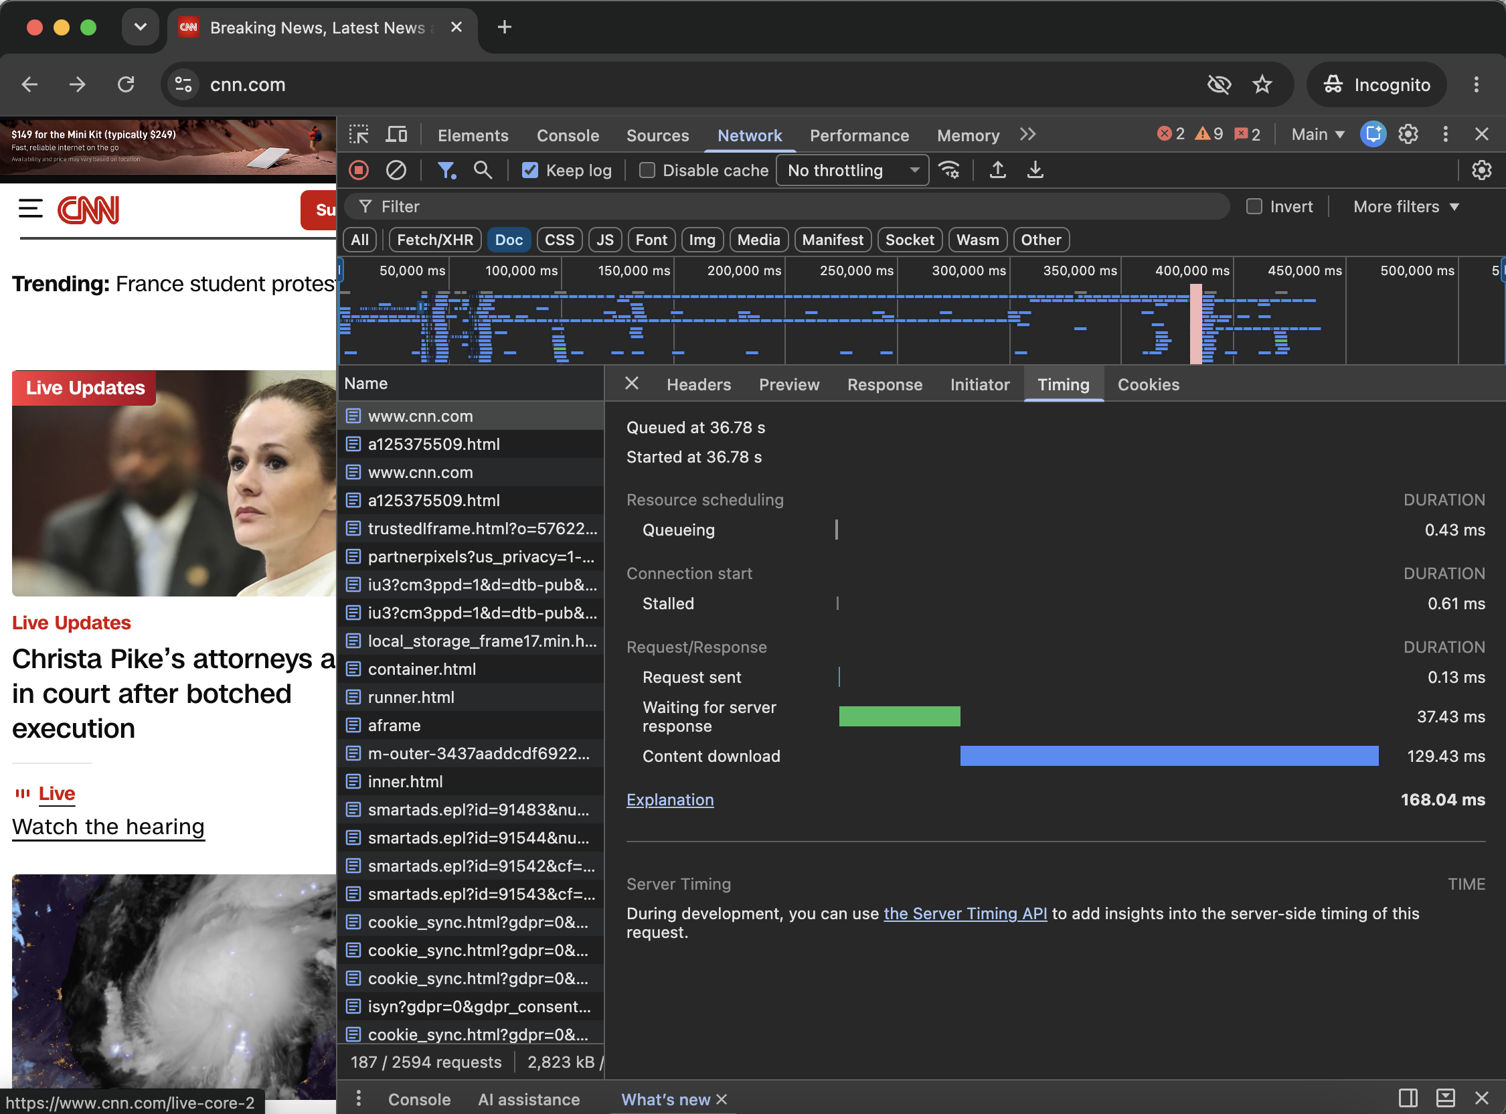
Svelte vs. React Performance Testing
For this activity, I created simple Svelte and React projects with Vite and tested how they performed. I measured hot reload, production bundle sizes, and Lighthouse performance in both production and development mode. The biggest thing I noticed was how much better the production builds performed compared to the development versions.

Svelte Results
HMR test: I changed the heading in App.svelte and timed how long it took to update in the browser after saving. My manual stopwatch time was 1.23 seconds (1,230 ms). Since I used a stopwatch, this also includes my reaction time.

Svelte Production Build
Metric | Result
Performance Score | 100
Largest Contentful Paint (LCP) | 1.2 s
Total Blocking Time (TBT) | 0 ms
Cumulative Layout Shift (CLS) | 0
Speed Index | 0.9 s
JavaScript Bundle | 30.88 kB (12.43 kB gzip)
CSS Bundle | 4.10 kB (1.46 kB gzip)
Build Time | 637 ms

The Svelte production build did really well. It got a perfect 100 performance score, and the LCP was under the 2.5 second goal.
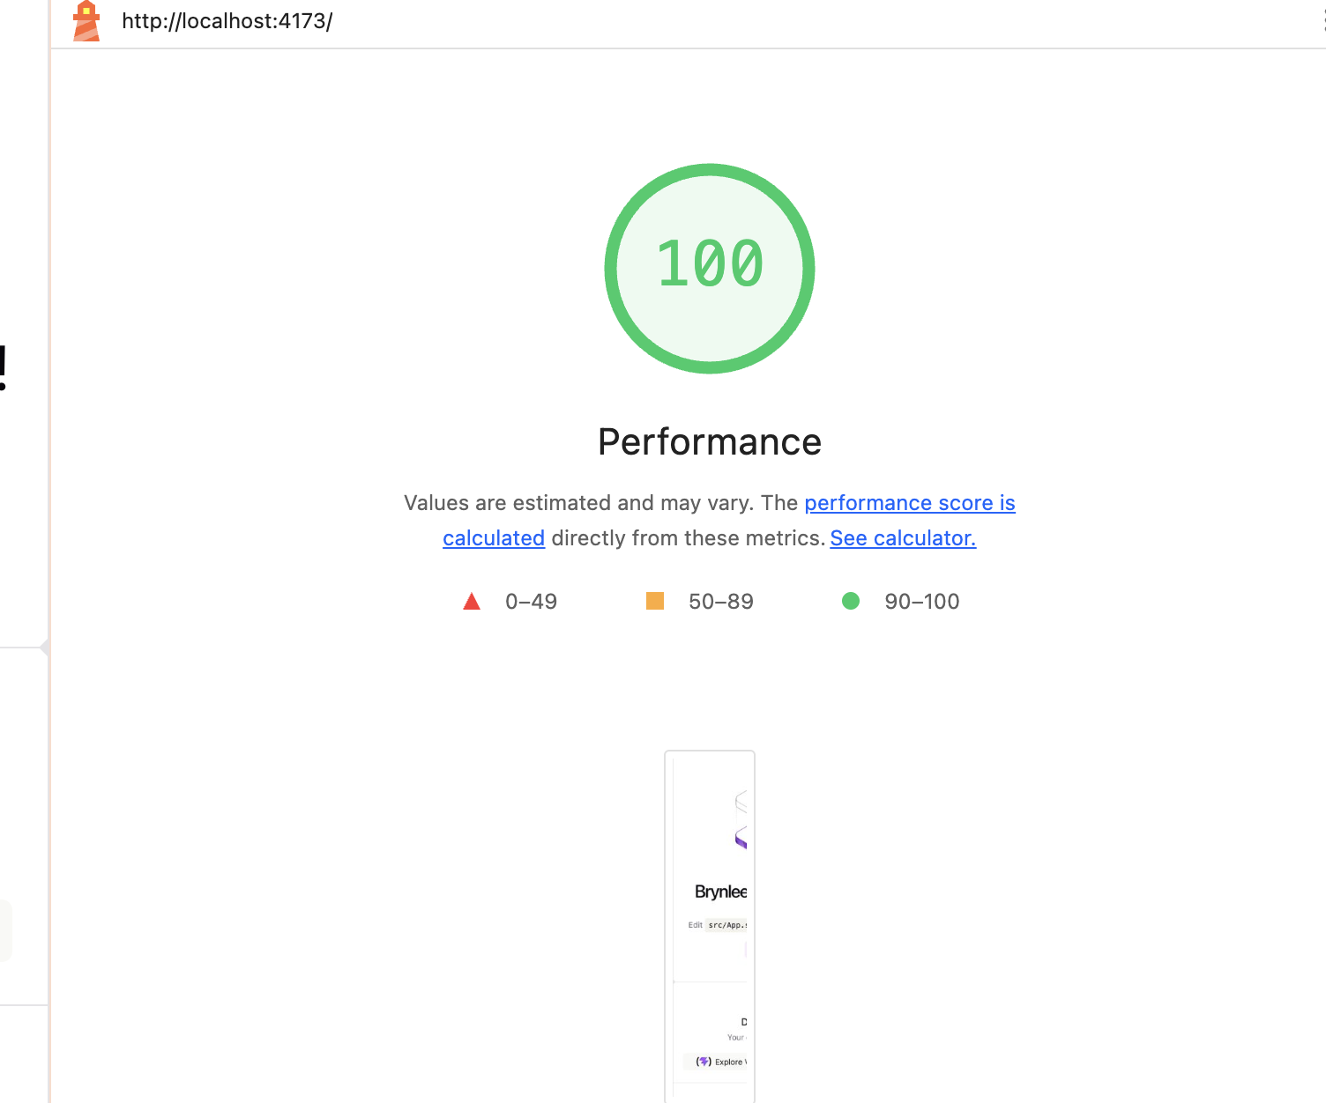
Svelte production Lighthouse performance score.
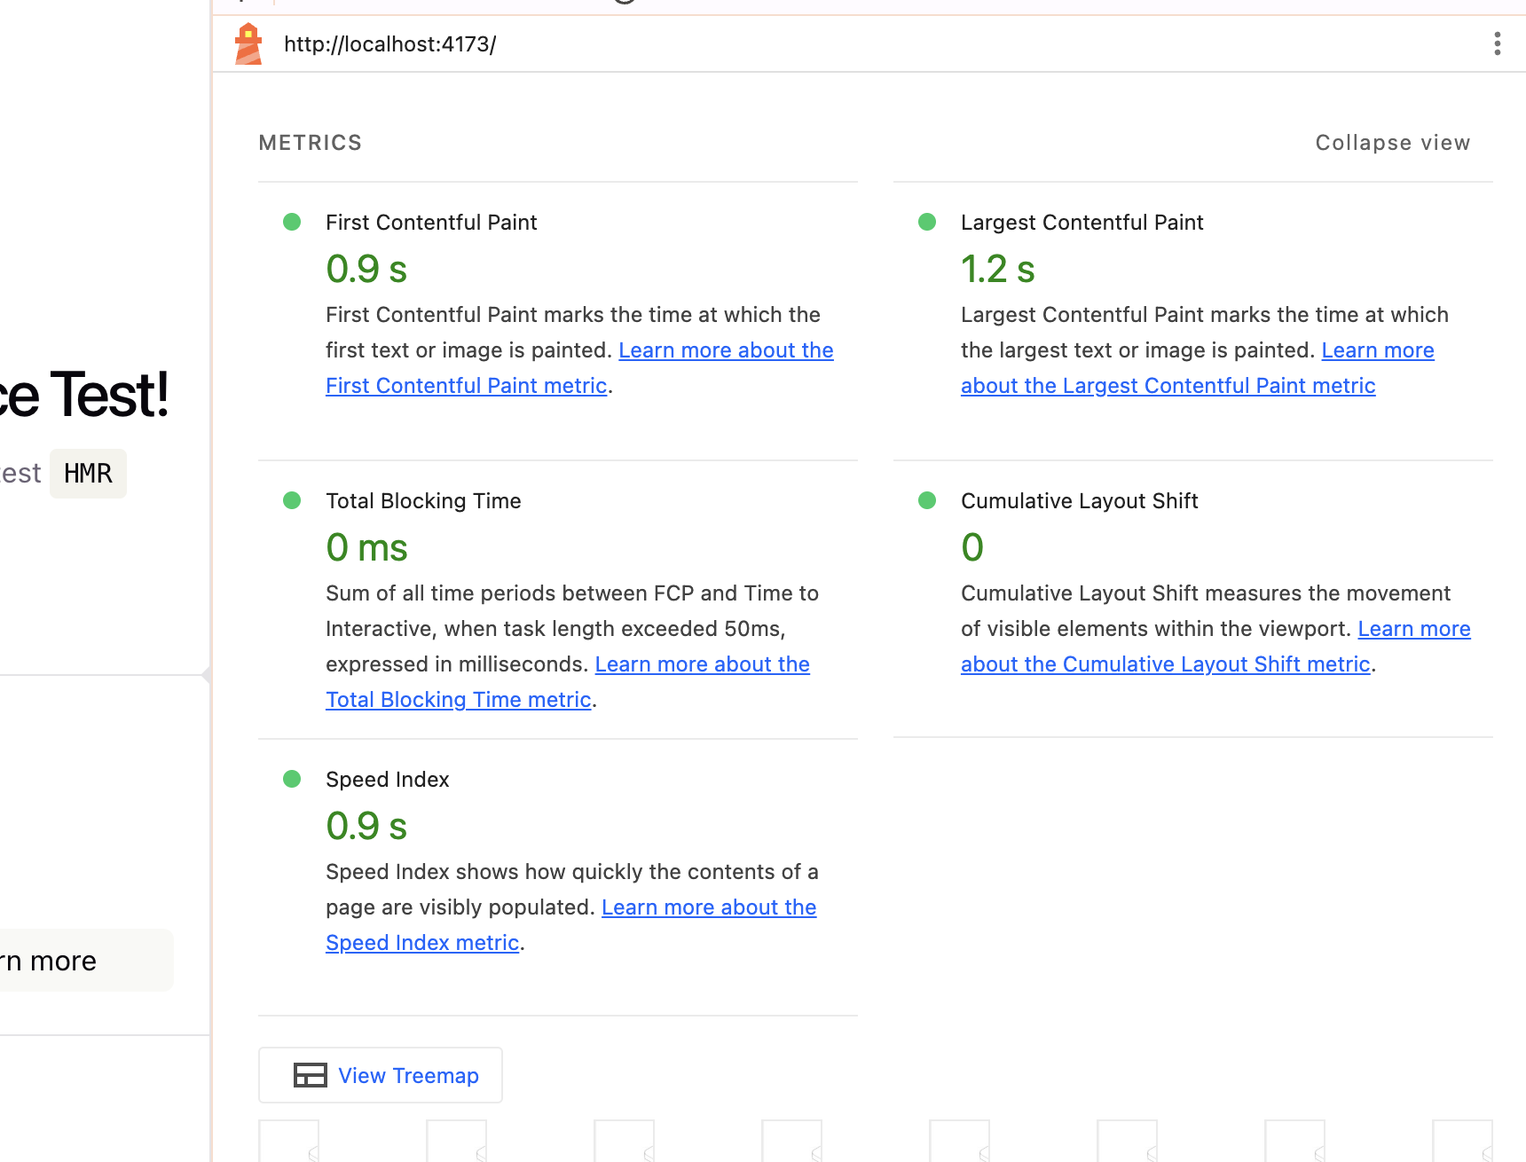
Svelte production Lighthouse metrics.

Svelte Development Mode
Metric | Result
Performance Score | 60
Largest Contentful Paint (LCP) | 10.2 s
Total Blocking Time (TBT) | 0 ms
Cumulative Layout Shift (CLS) | 0
Speed Index | 5.9 s

The development version was a lot slower in Lighthouse. This made it really clear why we should use the production build when we are measuring the performance users will actually get.
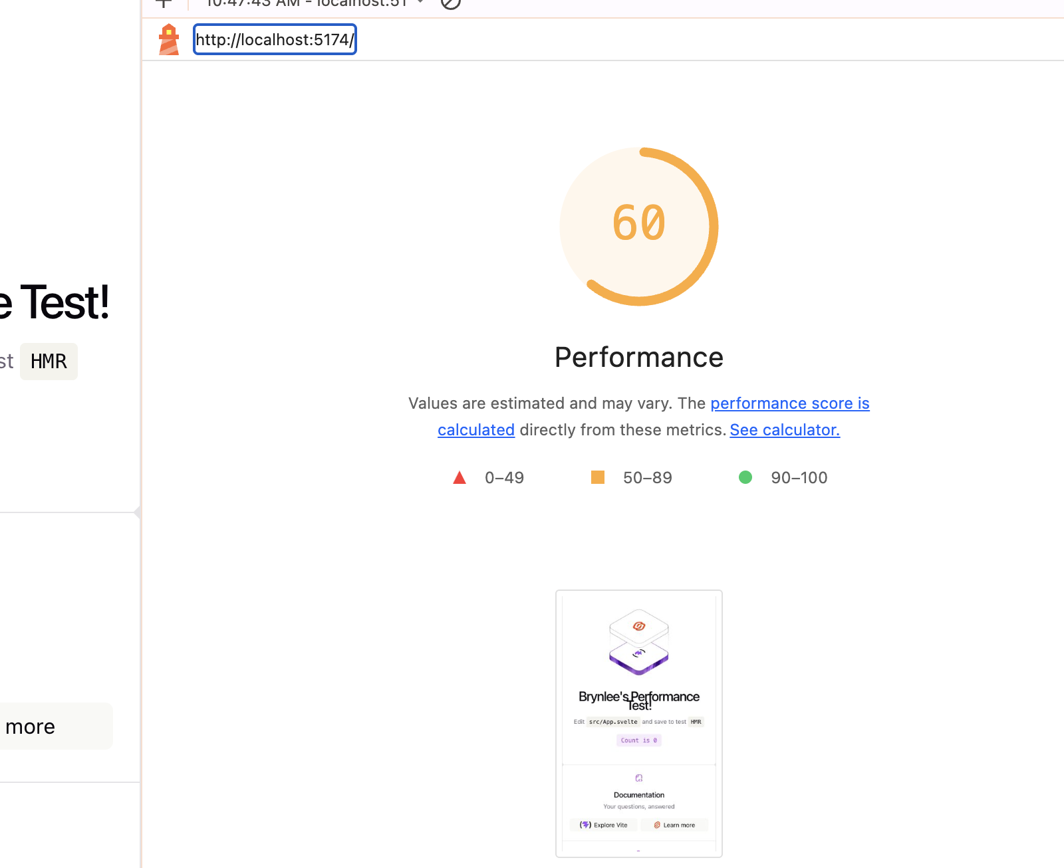
Svelte development Lighthouse performance score.
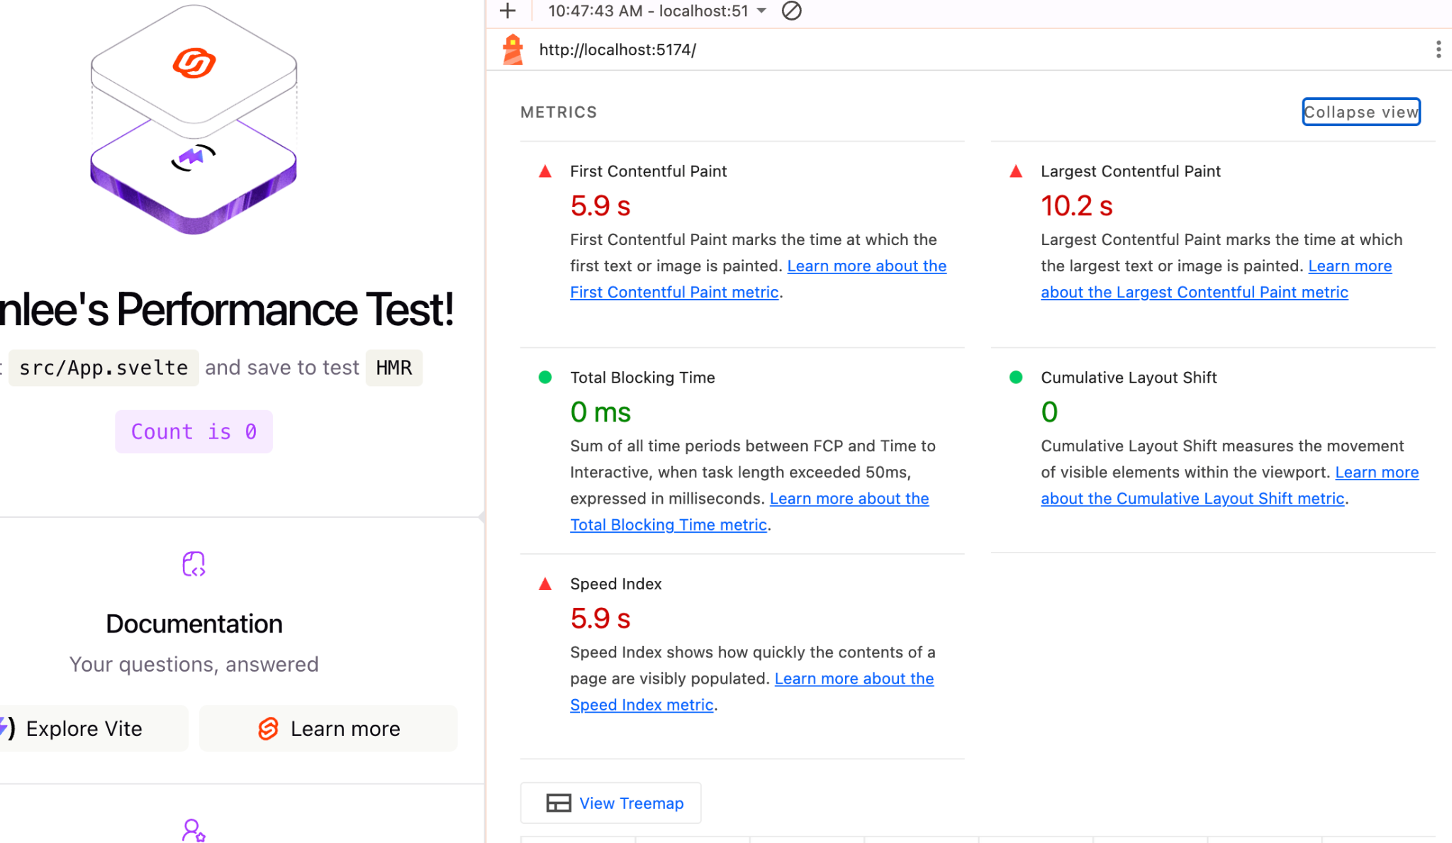
Svelte development Lighthouse metrics.

React Results
HMR test: I changed the heading in App.jsx and timed the browser update after saving. My manual stopwatch time was 1.41 seconds (1,410 ms). Just like Svelte, this includes some reaction time.

React Production Build
Metric | Result
Performance Score | 100
Largest Contentful Paint (LCP) | 1.7 s
Total Blocking Time (TBT) | 0 ms
Cumulative Layout Shift (CLS) | 0
Speed Index | 1.2 s
JavaScript Bundle | 222.47 kB (69.29 kB gzip)
CSS Bundle | 4.10 kB (1.47 kB gzip)
Build Time | 283 ms

React also got a perfect 100 performance score in production. Its production page was still really fast, but its JavaScript bundle was quite a bit larger than Svelte's in this simple starter project.
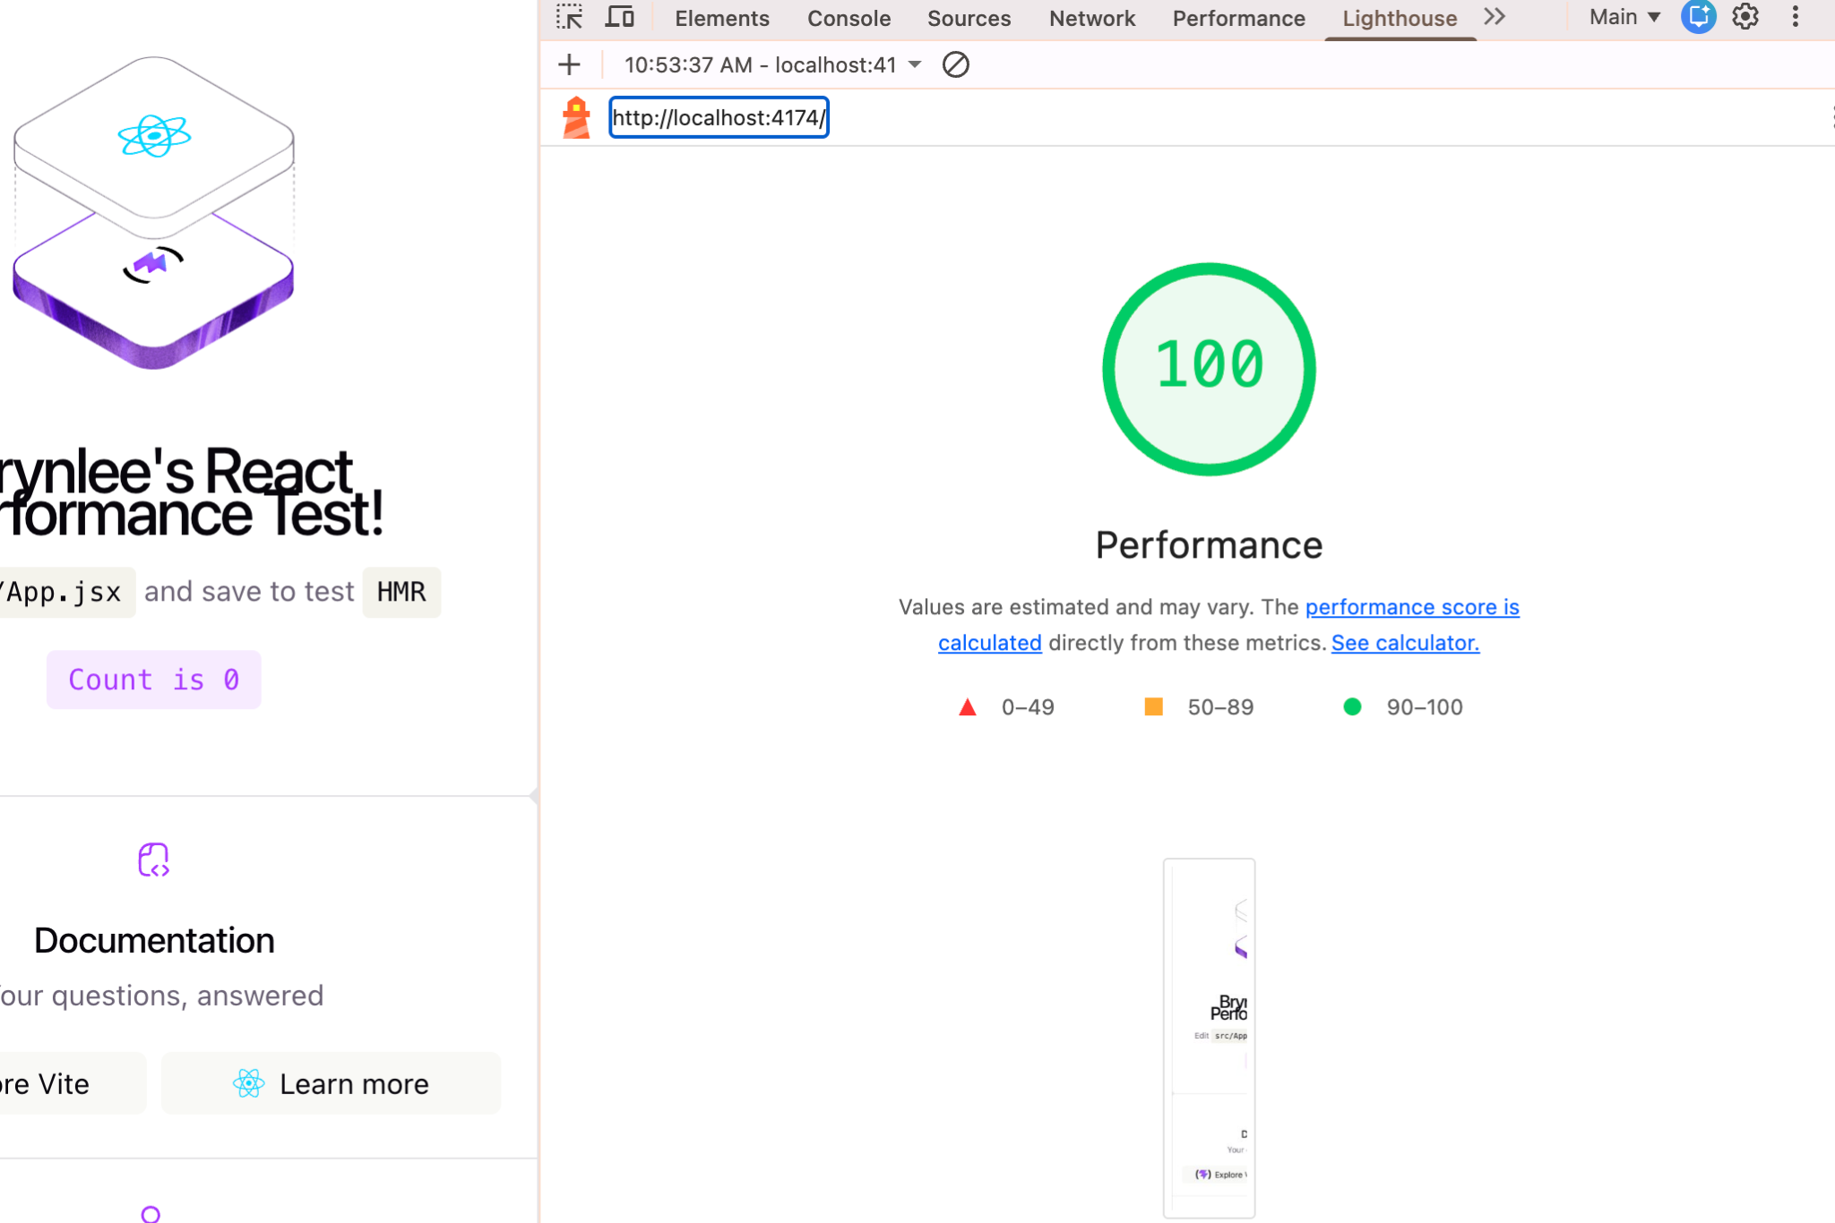
React production Lighthouse performance score.
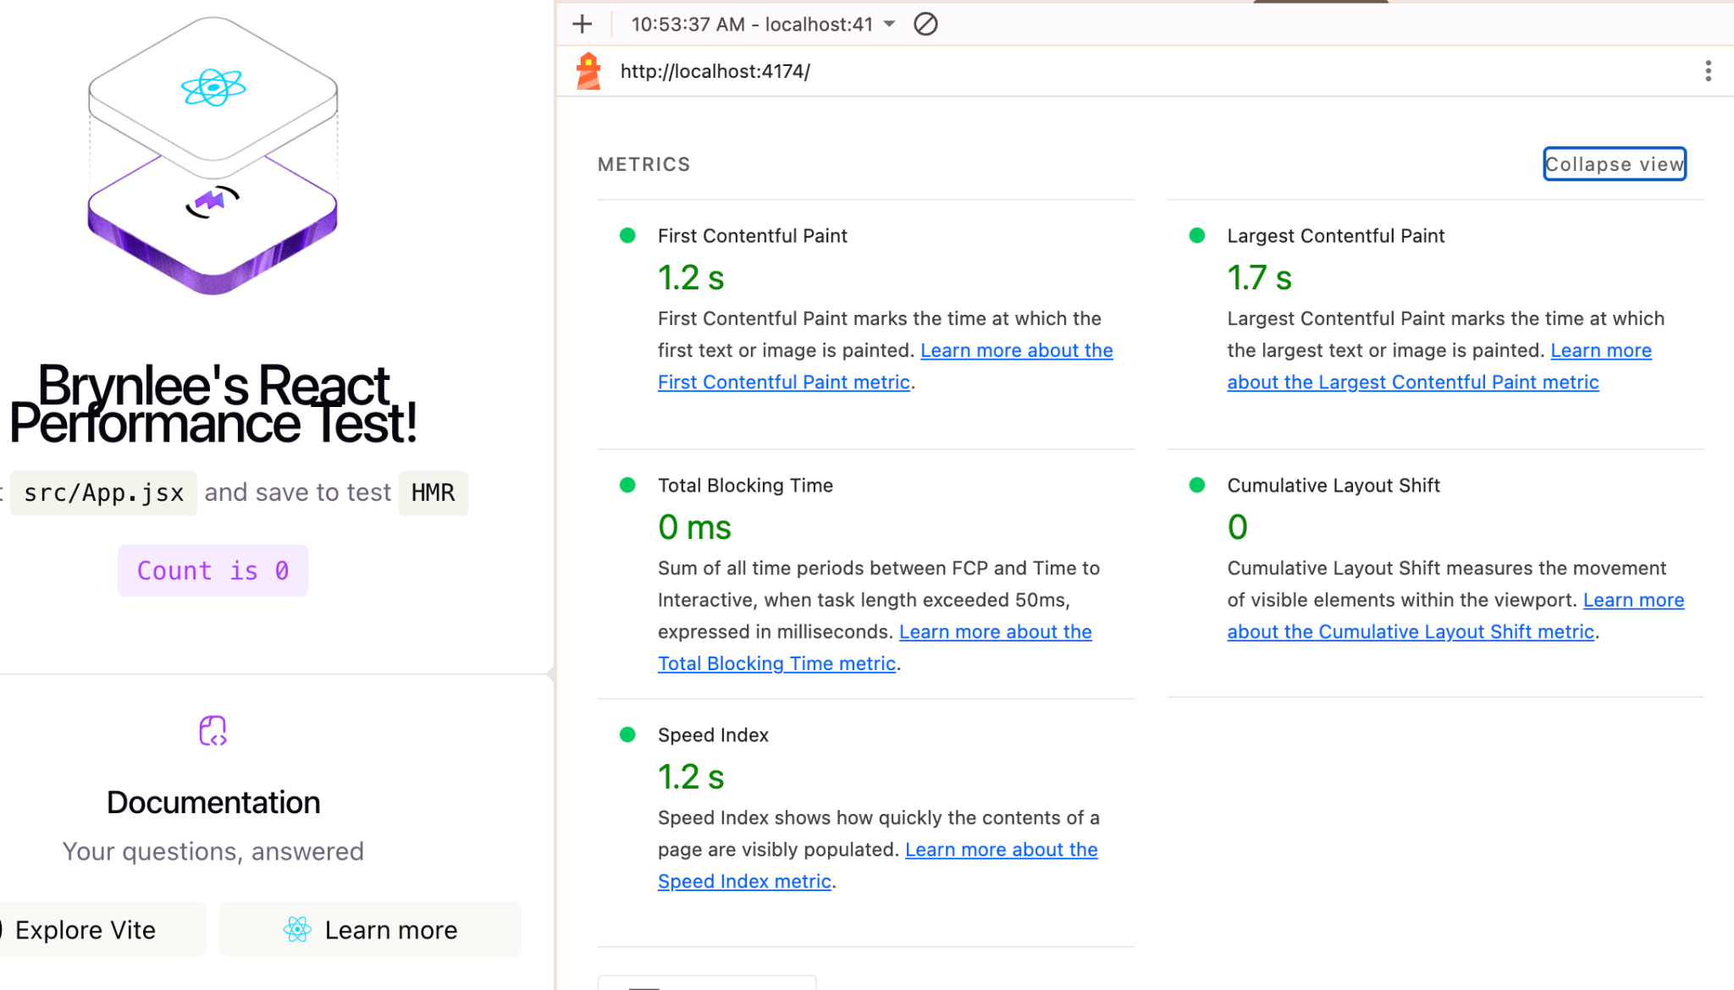
React production Lighthouse metrics.

React Development Mode
Metric | Result
Performance Score | 56
Largest Contentful Paint (LCP) | 20.4 s
Total Blocking Time (TBT) | 0 ms
Cumulative Layout Shift (CLS) | 0
Speed Index | 11.0 s

React's development Lighthouse test was also much slower than its production build. The production score went from 100 down to 56 in development mode.
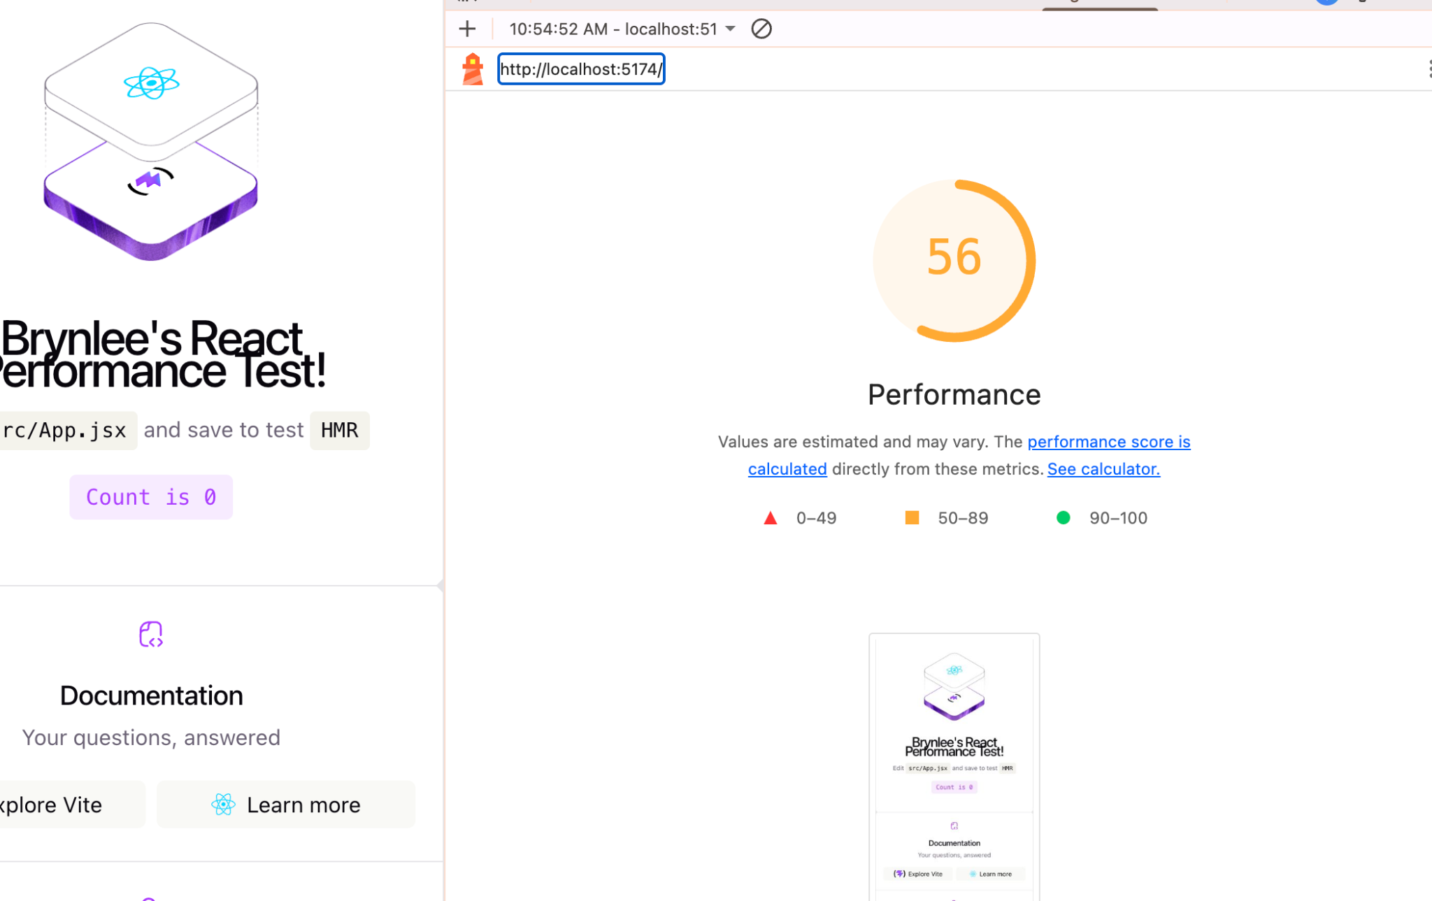
React development Lighthouse performance score.
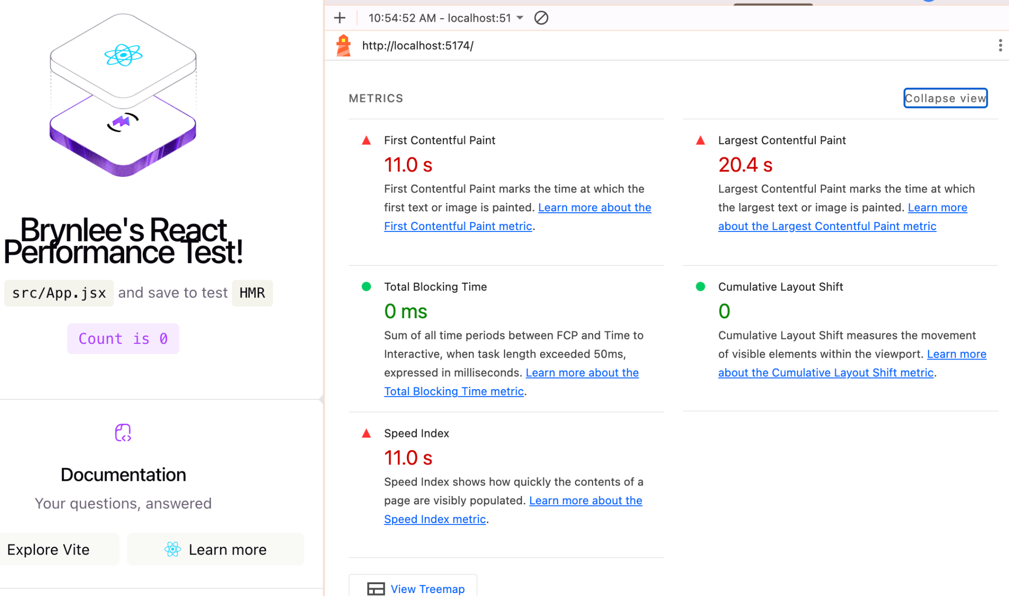
React development Lighthouse metrics.

Overall Comparison
Metric | Svelte | React
Production Performance | 100 | 100
Production LCP | 1.2 s | 1.7 s
Production TBT | 0 ms | 0 ms
Production CLS | 0 | 0
Production Speed Index | 0.9 s | 1.2 s
JavaScript Bundle | 30.88 kB | 222.47 kB
CSS Bundle | 4.10 kB | 4.10 kB
HMR (manual) | 1.23 s | 1.41 s
Development Performance | 60 | 56

What I Learned
• Both Svelte and React got a 100 Lighthouse performance score when I tested the production builds.
• Svelte had a much smaller JavaScript bundle in these starter projects: 30.88 kB compared to React's 222.47 kB.
• The development versions performed way worse in Lighthouse than the production builds.
• This helped me see why bundle size should be measured after running npm run build instead of just looking at the source files.
• My HMR tests felt almost instant in the browser, but my manual stopwatch times were 1.23 seconds for Svelte and 1.41 seconds for React because reaction time affects the measurement.
• Overall, both production builds were fast, but Svelte was lighter in this specific test.

Debrief Discussion
1. LCP vs. TTFB
Can you have a fast LCP if your TTFB is slow?
Not really. The website has to wait for the server first, so if the server takes a while to respond, everything else is going to take longer too.
2. Bundle Size
Why do we measure the build size instead of the files in the src folder?
The build size is what actually matters because that is what gets sent to the browser. When we build the project, it cleans everything up and gets rid of stuff we don't need.
3. CLS (Stability)
Why does CLS matter if it doesn't measure speed?
Because even if a website loads fast, it can still be super annoying if everything is jumping around. A website feels a lot better when everything stays where it is supposed to while it loads.

