FIT 5195 Major Assignment

Student name: Yue Zhang Student ID: 30976316
Student name: Lei Hu Student ID: 30841933

GROUP ASSIGNMENT COVER SHEET
Student ID Number | Surname | Given Names
30841933 | Hu | Lei
30976316 | Zhang | Yue
* Please include the names of all other group members.
Unit name and code | FIT5195 Business intelligence and data warehousing
Title of assignment | FIT5195 Major Assignment
Lecturer/tutor | Soon Lay-Ki / Arif Hidayat & Shuyi Sun
Tutorial day and time | Tue 3:00pm – 5:00pm | Campus Clayton
Is this an authorised group assignment? Yes No
Has any part of this assignment been previously submitted as part of another unit/course? Yes No
Due Date Week 9, Wednesday 5-May-2021, 11:55pm |  | Date submitted 5-May-2021
All work must be submitted by the due date. If an extension of work is granted this must be specified with the signature of the lecturer/tutor.
Extension granted until (date) ................................ Signature of lecturer/tutor ................................................................
Please note that it is your responsibility to retain copies of your assessments.
Intentional plagiarism or collusion amounts to cheating under Part 7 of the Monash University (Council) Regulations

Plagiarism: Plagiarism means taking and using another person’s ideas or manner of expressing them and passing them off as one’s own. For example, by failing to give appropriate acknowledgement. The material used can be from any source (staff, students or the internet, published and unpublished works).

Collusion: Collusion means unauthorised collaboration with another person on assessable written, oral or practical work and includes paying another person to complete all or part of the work.

Where there are reasonable grounds for believing that intentional plagiarism or collusion has occurred, this will be reported to the Associate Dean (Education) or delegate, who may disallow the work concerned by prohibiting assessment or refer the matter to the Faculty Discipline Panel for a hearing.
Student Statement:
- I have read the university’s Student Academic Integrity Policy and Procedures.
- I understand the consequences of engaging in plagiarism and collusion as described in Part 7 of the Monash University (Council) Regulations http://adm.monash.edu/legal/legislation/statutes
- I have taken proper care to safeguard this work and made all reasonable efforts to ensure it could not be copied.
- No part of this assignment has been previously submitted as part of another unit/course.
- I acknowledge and agree that the assessor of this assignment may for the purposes of assessment, reproduce the assignment and:
- provide to another member of faculty and any external marker; and/or
- submit it to a text matching software; and/or
- submit it to a text matching software which may then retain a copy of the assignment on its database for the purpose of future plagiarism checking.
- I certify that I have not plagiarised the work of others or participated in unauthorised collaboration when preparing this assignment.
Signature ..........Yue Zhang.................Lei Hu................................................... Date……05/05/2021………………………………
* delete (iii) if not applicable

Signature ___Yue Zhang _______Date:_____ 05/05/2021_______ Signature ______________________________Date:________

Signature ___Lei_Hu_______________Date:______ 05/05/2021_____ Signature _______________________________Date:_______

Signature ___________________Date:_____________________ Signature _______________________________Date:_______

Privacy Statement
The information on this form is collected for the primary purpose of assessing your assignment and ensuring the academic integrity requirements of the University are met. Other purposes of collection include recording your plagiarism and collusion declaration, attending to course and administrative matters and statistical analyses. If you choose not to complete all the questions on this form it may not be possible for Monash University to assess your assignment. You have a right to access personal information that Monash University holds about you, subject to any exceptions in relevant legislation. If you wish to seek access to your personal information or inquire about the handling of your personal information, please contact the University Privacy Officer: privacyofficer@adm.monash.edu.au

Contribution Declaration Form
(to be completed by all team members)

Please fill in the form with the contribution from each student towards the assignment.

1 NAME AND CONTRIBUTION DETAILS

Student ID | Student Name | Contribution Percentage
30841933 | Lei Hu | 50%
30976316 | Yue Zhang | 50%

List of parts that each student did:
1. Lei Hu: Data clean 50%, Star schema 50%, Implementation 50%, Report Writing 50%
2. Yue Zhang: Data clean 50%, Star schema 50%, Implementation 50%, Report Writing 50%

2 DECLARATION

We declare that:
- The information we have supplied in or with this form is complete and correct.
- We understand that the information we have provided in this form will be used for individual assessment of the assignment.

3 SIGNATURE

Signatures

Day Month Year
Date
05 / 05 / 2021

ORACLE accounts :
Yue Zhang :
Username : S30976316 Password : student
Lei Hu :
Username : S30841933 Password : student

Table of Contents

Preparation stage. 5
a) The E/R diagram of the operational database 5
b) Data cleaning process 5
Designing the data warehouse by drawing star/snowflake schema. 23
c) Two versions of star/snowflake schema diagrams 23
d) The reasons of the choice of SCD type for temporal dimension 23
e) A short explanation of the difference among the two versions of star/snowflake schema. 23
Implement the two versions star/snowflake schema using SQL. 24
a) SQL statements (e.g. create table, insert into, etc) to create the star/snowflake schema Version-1 24
b) SQL statements (e.g. create table, insert into, etc) to create the star/snowflake schema Version-2 38
c) Screenshots of the tables that you have created; this includes the contents of each table that you have created. If the table is very big, you can show only the first part of the data. 41

Preparation stage.

a) The E/R diagram of the operational database
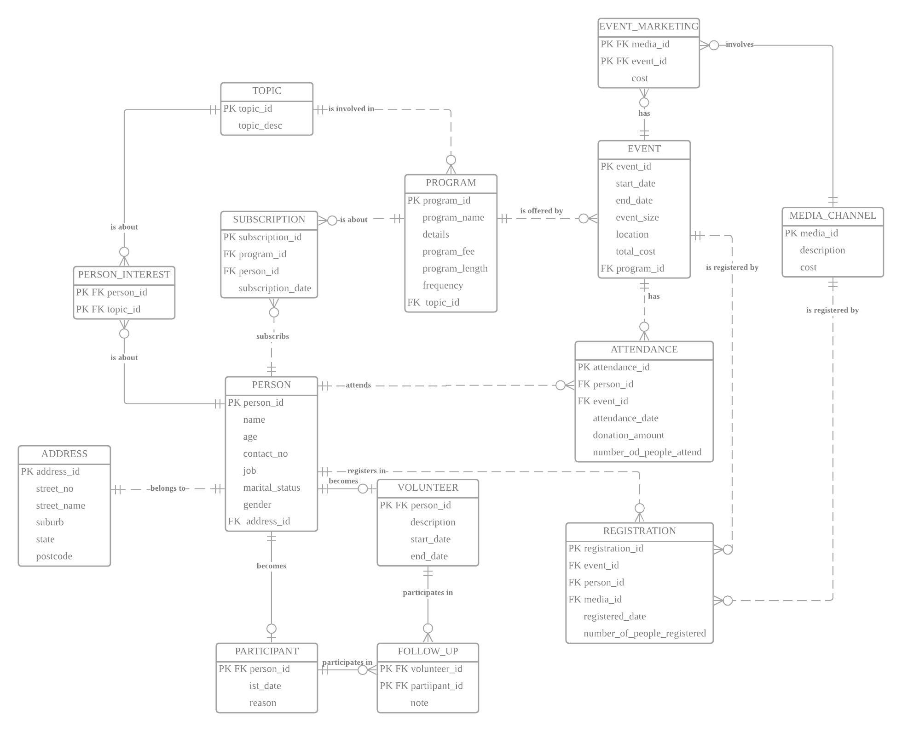

b) Data cleaning process
Before cleaning, we copy all tables from the Monexplore and save them in our own account to explore and clean, the code for copy is as below:
create table topic as select * from monexplore.topic;
create table program as select * from monexplore.program;
create table event as select * from monexplore.event;
create table media_channel as select * from monexplore.media_channel;
create table person as select * from monexplore.person;
create table address as select * from monexplore.address;
create table person_interest as select * from monexplore.person_interest;
create table subscription as select * from monexplore.subscription;
create table attendance as select * from monexplore.attendance;
create table registration as select * from monexplore.registration;
create table event_marketing as select * from monexplore.event_marketing;
create table volunteer as select * from monexplore.volunteer;
create table participant as select * from monexplore.participant;
create table follow_up as select * from monexplore.follow_up;
- Duplication:
Error 1: duplicate results in Person table: person id ‘PE057’, ‘PE078’, ‘PE021’ has duplicate records.
- Code to identify it:
select person_id, count(*)
from person
group by person_id
having count(*) > 1; -- id pe057, pe078, pe021
select * from person
where person_id = 'PE057'; -- dupilicate
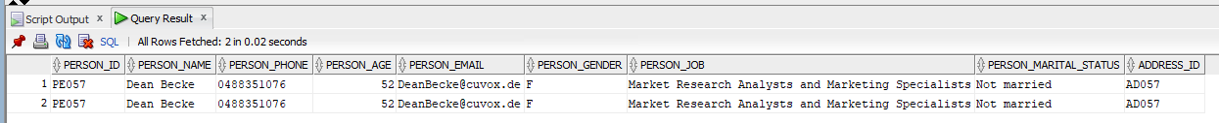
select * from person
where person_id = 'PE078'; -- dupilicate
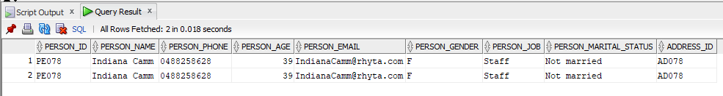
select * from person
where person_id = 'PE021'; -- dupilicate
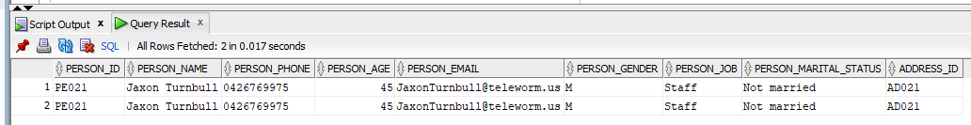
- Code to clean it:
--clean
drop table person;
create table person as select distinct * from monexplore.person;
Before deleting: each person id has 2 same records.
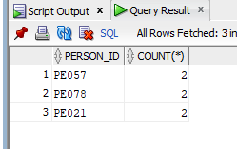
After cleaning: No person id with records more than 1.
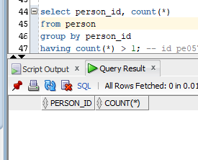
Error 2: duplicate results in Subscription table: subscription id ‘SU021’, ‘SU243’ has duplicate records.
- Code to identify it:
select subscription_id, count(*)
from subscription
group by subscription_id
having count(*) > 1; --id su021, su243
--check for each record
select * from subscription
where subscription_id = 'SU021'; -- dupilicate
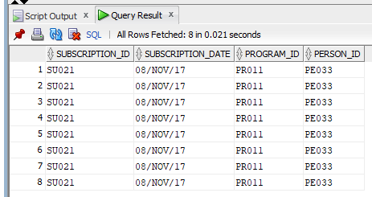
select * from subscription
where subscription_id = 'SU243'; -- dupilicate
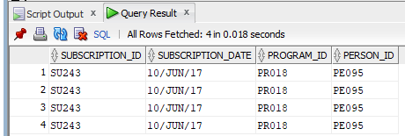
- Code to clean it:
--clean
drop table subscription;
create table subscription as select distinct * from monexplore.subscription;
Before deleting: each subscription has more than 1 same records.
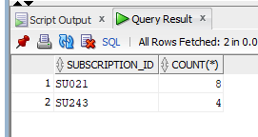
After cleaning: No subscription id with records more than 1.
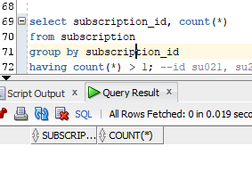
- Null values:
Error 3: PK null error, one record that Pk(media_id) is null in media table.
- Code to identify it:
select * from media_channel where media_id is null;
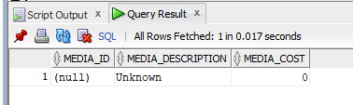
- Code to clean it:
--clean
delete from media_channel where media_id is null;
Before deleting: One null record.
After cleaning: No null pk record.
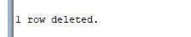
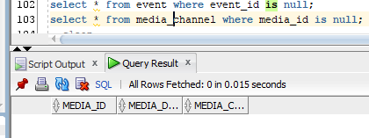
Error 4: other attributes null error, in topic table, there topic T010 has null topic_description, since this record only has two column: id and description, so if description is missing, it will influence the business analysis when we create data warehouse, because we need description to help us know what is topic T010 and help further decision making.
- Code to identify it:
select * from topic; -- one null in description
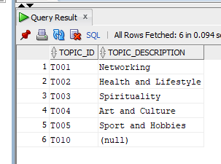
- Code to clean it:
delete from topic where topic_description is null;
Before deleting: One null record.
After cleaning: No null record.
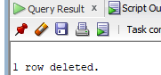
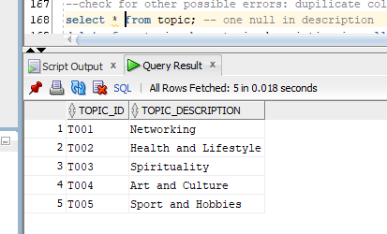
- Relationship:
Error 5: In event table, there are two program_id (PR000, PR020) that are not in program table. However, one event must belongs to one program, so we can not just set fk to be null, so we need to delete those invalid fk records.
- Code to identify it:
select * from event
where program_id not in (select program_id from program);--program id pr000, pr020
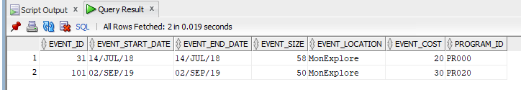
- Code to clean it:
delete from event where program_id in ('PR000', 'PR020');
Before deleting: PR000, PR020 is not as a program_id in program table but it is in event table.
After cleaning: No invalid foreign key.
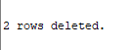
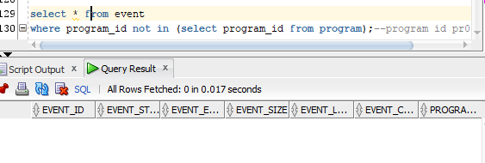
Error 6: In attendance table, there are two event_id (31, 101) that are not in event table, it is because that we delete in error 5 because of the fk error in event, so 31 and 101 are not in event table now. However, one attendance must belongs to one event, so we can not just set fk to be null. Also, we do not know the event 31 and 101 information, so we can not manually add event 31 and 101 to event table and we need to delete those invalid fk records.
- Code to identify it:
select * from attendance
where person_id not in (select person_id from person)
or event_id not in (select event_id from event);--event id 101,31
- Code to clean it:
delete from attendance
where person_id not in (select person_id from person)
or event_id not in (select event_id from event);
Before deleting: 31, 101 is not as a event_id in event table but it is in attendance table.
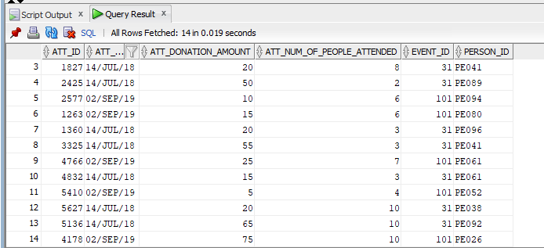
After cleaning: No invalid foreign key.
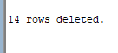
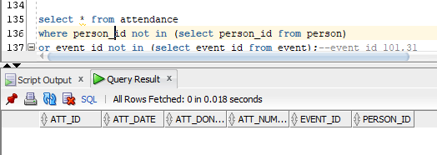
Error 7: In registration table, there are two event_id (31, 101) that are not in event table, it is because that we delete in error 5 because of the fk error in event, so 31 and 101 are not in event table now.. However, one registration must belongs to one event, so we can not just set fk to be null. Also, we do not know the event 31 and 101 information, so we can not manually add event 31 and 101 to event table and we need to delete those invalid fk records.
- Code to identify it:
select * from registration
where person_id not in (select person_id from person)
or event_id not in (select event_id from event)
or media_id not in (select media_id from media_channel);--event id 101,31
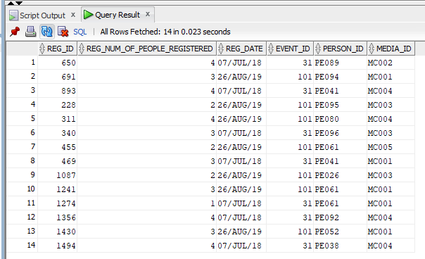
- Code to clean it:
delete from registration
where person_id not in (select person_id from person)
or event_id not in (select event_id from event)
or media_id not in (select media_id from media_channel);
Before deleting: 31, 101 is not as a event_id in event table but it is in attendance table.
After cleaning: No invalid foreign key.
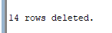
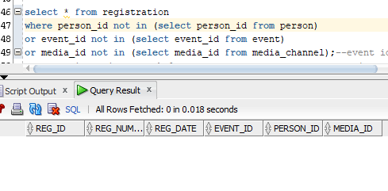
Error 8: In volunteer table, there are two person_id (PE000, PE110) that are not in person table. However, one volunteer must belongs to one person, so we can not just set fk to be null, so we need to delete those invalid fk records.
- Code to identify it:
select * from volunteer --- *** ERROR ***
where person_id not in(select person_id from person);
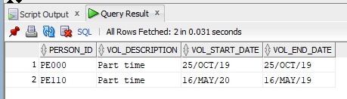
- Code to clean it:
delete from volunteer
where person_id not in(select person_id from person);
Before deleting: PE000, PE110 is not as a person_id in person table but it is in volunteer table.
After cleaning: No invalid foreign key.
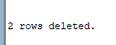
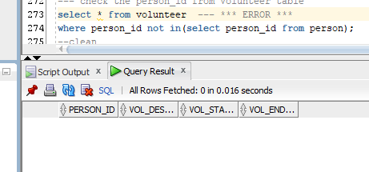
Error 10: In person_interest table, the topic_id (T010) that are not in topic table, which is because that we delete topic T010 in the previous stage and regard this topic as an error, and one person_interest must belongs to one topic, so we can not just set fk to be null, so we need to delete those invalid fk records.
- Code to identify it:
select * from person_interest
where person_id not in (select person_id from person)
or topic_id not in (select topic_id from topic);--T010
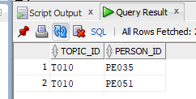
- Code to clean it:
delete from person_interest
where person_id not in (select person_id from person)
or topic_id not in (select topic_id from topic);--T010
Before deleting: T010 is not as a topic_id in topic table but it is in person_interest table.
After cleaning: No invalid foreign key.
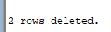
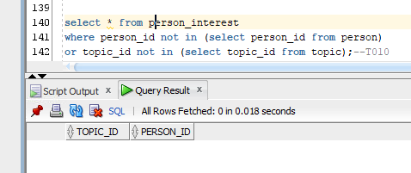
Error 10: In event_marketing table, the event_id (101) that are not in event table, it is because that we delete in error 5 because of the fk error in event, so 101 is not in event table now.. However, one event_marketing must belongs to one event, so we can not just set fk to be null, so we need to delete those invalid fk records.
- Code to identify it:
select * from event_marketing --- *** ERROR ***
where event_id not in(select event_id from event);
select event_id from event;
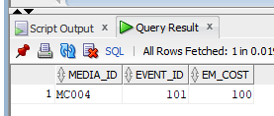
- Code to clean it:
delete from event_marketing
where event_id not in(select event_id from event);
Before deleting: 101 is not as a event_id in event table but it is in event_marketing table.
After cleaning: No invalid foreign key.
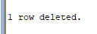
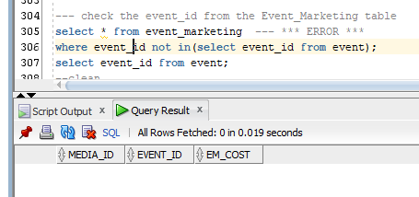
- Incorrect values:
Error 11: In attendance table, there is one record that has att_date in 18/OCT/2021, which is in the future, but attendance only records the person and other related information that has already attended the event, so it cannot happen in the future, so it is an error. Also, we need to analyse this table in time dimension, so it influence our data warehouse, so we need to delete because we do not know which is the correct date.
- Code to identify it:
select * from attendance
where to_date(att_date, 'DD-MON-RR') > current_date; ---**** ERROR **** one at 18/oct/21
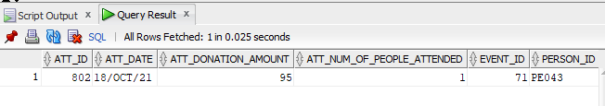
- Code to clean it:
delete from attendance
where to_date(att_date, 'DD-MON-RR') > current_date;
Before deleting: One record has incorrect att_date.
After cleaning: No incorrect date in this table.
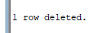
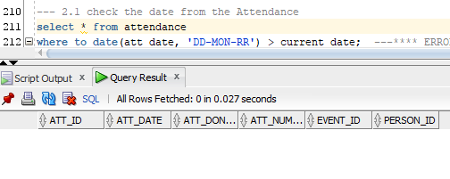
Error 12: In attendance table, there are two records (att_id 639, 1001) that have att_donation_amount that is negative number, but for att_donation_amount, it should not be negative, so it is an error. Also, we need to analyse this table using donation amount as a fact measure, so it influences our data warehouse, so we need to delete because we do not know which is the correct date.
- Code to identify it:
select * from attendance ---**** ERROR **** attid 639:-25, attid1001:-5
where att_donation_amount < 0;
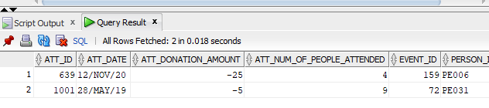
- Code to clean it:
delete from attendance
where att_donation_amount < 0;
Before deleting: Two records have negative att_donation_amount.
After cleaning: No incorrect date in this table.
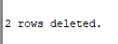
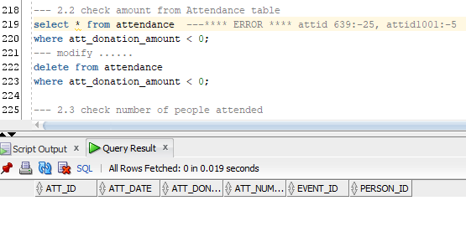
Error 13: In event table, there are two records (event_id 11, 47) that has event_size is negative number, but for event_size, it should not be negative, so it is an error. Also, we need to analyse this table using event size dimension, so it influences our data warehouse, so we need to delete because we do not know which is the correct date. Also, we should delete the records in other table (event_marketing, attendance, registration) that has event_id 11 and 47 to keep relationship correct.
- Code to identify it:
select * from event ---- **** ERROR **** event id 11:-10, event id 47: -75
where event_size < 0;
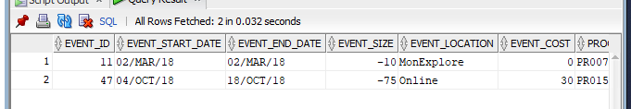
- Code to clean it:
delete from event_marketing where
event_id in (select event_id from event
where event_size < 0);
delete from attendance where
event_id in (select event_id from event
where event_size < 0);
delete from registration where
event_id in (select event_id from event
where event_size < 0);
delete from event ---- **** ERROR **** event id 11:-10, event id 47: -75
where event_size < 0;
Before deleting: Two records have incorrect event_size.
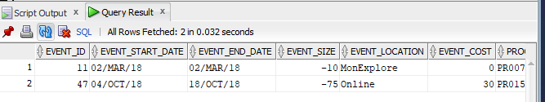
After cleaning: No incorrect date in this table and other table.
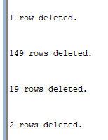
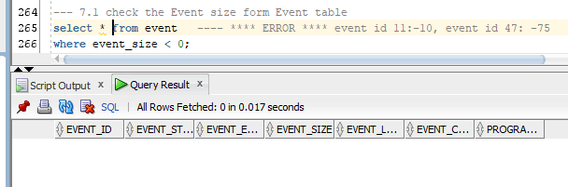
Error 14: In event table, there is one record that has event start date is after the end date, so it is an error. Also, we need to analyse this table in time dimension, so it influences our data warehouse, so we need to delete because we do not know which is the correct date. Also, we should delete the records in other table (event_marketing, attendance, registration) for this incorrect event by event id to keep relationship correct.
- Code to identify it:
select * from event --- **** Error **** event id 162, 163
where TO_DATE(event_start_date, 'DD-MON-RR') > TO_DATE(event_end_date, 'DD-MON-RR');
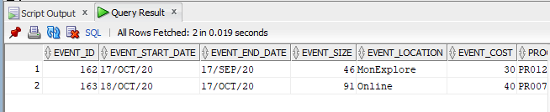
- Code to clean it:
delete from event_marketing where
event_id in (select event_id from event
where TO_DATE(event_start_date, 'DD-MON-RR') > TO_DATE(event_end_date, 'DD-MON-RR'));
delete from attendance where
event_id in (select event_id from event
where TO_DATE(event_start_date, 'DD-MON-RR') > TO_DATE(event_end_date, 'DD-MON-RR'));
delete from registration where
event_id in (select event_id from event
where TO_DATE(event_start_date, 'DD-MON-RR') > TO_DATE(event_end_date, 'DD-MON-RR'));
delete from event ---- **** ERROR **** event id 11:-10, event id 47: -75
where TO_DATE(event_start_date, 'DD-MON-RR') > TO_DATE(event_end_date, 'DD-MON-RR');
Before deleting: One record has incorrect att_date.
After cleaning: No incorrect date in this table.
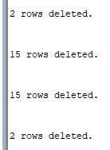
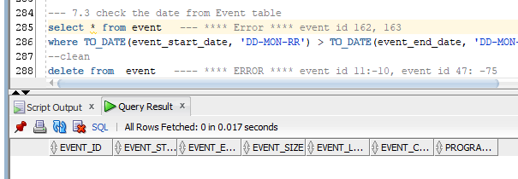
Error 15: In volunteer table, there are four records that have start date is after the end date, so it is an error, so we need to delete because we do not know which is the correct date. Also, we should delete the records in other table (follow_up) for this incorrect volunteer to keep relationship correct.
- Code to identify it:
select * from volunteer --- *** ERROR ***
where to_date(vol_start_date,'DD-MON-RR') > to_char(vol_end_date,'DD-MON-RR');
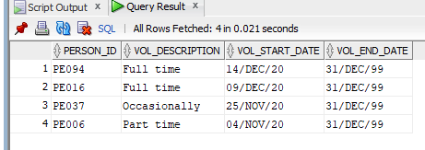
- Code to clean it:
delete from follow_up
where person_id in (select person_id from volunteer
where to_date(vol_start_date,'DD-MON-RR') > to_char(vol_end_date,'DD-MON-RR'));
delete from volunteer
where to_date(vol_start_date,'DD-MON-RR') > to_char(vol_end_date,'DD-MON-RR');
Before deleting: Four records has incorrect start date and end date.
After cleaning: No incorrect date in this table.
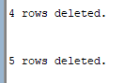
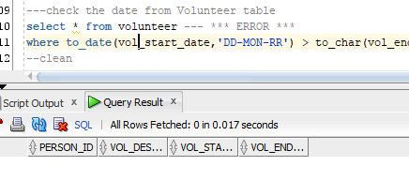

Designing the data warehouse by drawing star/snowflake schema.

c) Two versions of star/snowflake schema diagrams
Level 2:
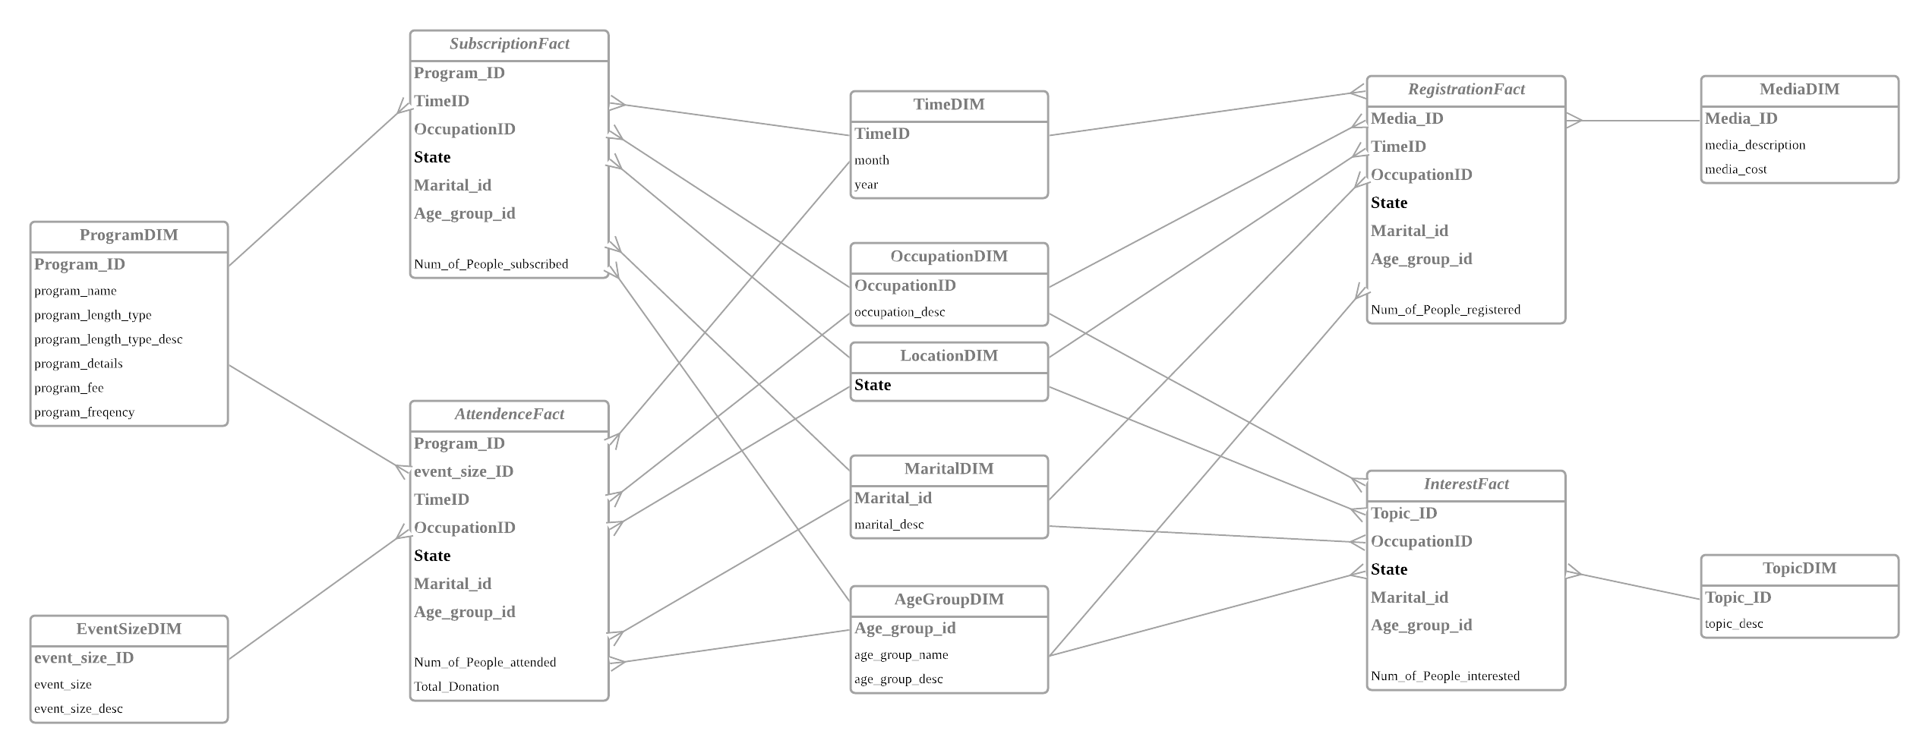
Level 0:
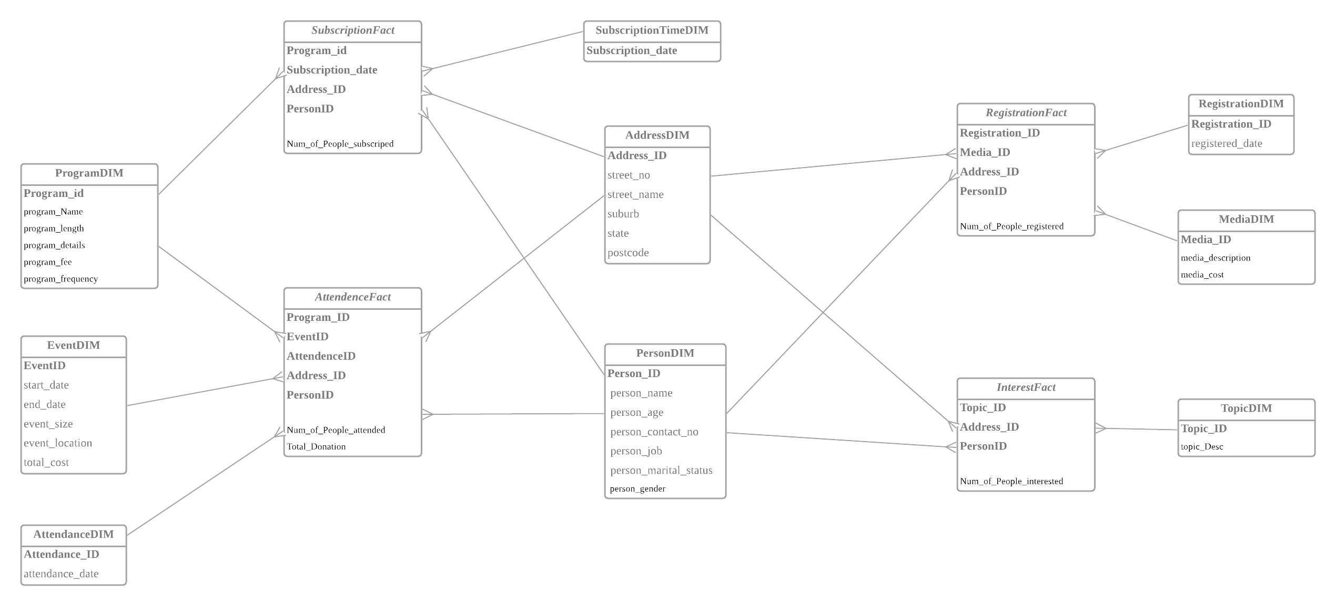

d) The reasons of the choice of SCD type for temporal dimension
No SCD in the two star schemas.

e) A short explanation of the difference among the two versions of star/snowflake schema.
- Version 1- High Aggregation(Level 2)
In Version 1, we design four fact tables including five fact measures according to their shared dimensions. As you can see in output a) level 2, we put the Fact Measure Number of People Attended and Total Donation into one Fact Table, because they came from the same Table in the operation database. For other fact measures, we put them into separate fact tables, because they have unique and different dimensions compared to others. AS for the Dimension Table, the OccupationDim, LocationDim, MaritalDim and AgeGroupDim are the common dimension for all fact measures, and they are come from the Person’s demographic information in Person table, we separate them to keep a high level of aggregation for fact table. Also, in ProgramDIM, we break the original program length into program_length_type and program_length_type description to help us analyse the program length type (short, medium, long) for the fact, and rest of the dimensions connection can be shown as the figures.
- Version 2- No Aggregation(Level 0) & Differences Between Version 1 and Version 2
In Version 2, we keep the fact tables the same as the Version 1. Considering in Version 2 the information should be in detail, so we create the PersonDim and add the personal information like PersonID and Name. What's more, to simplify the dimension table, we also move the Occupation Dimension, Marital Dimension and AgeGroup Dimension into the PersonDim to lower down the level of aggregation. In addition, we using the Address instead of State to keep low aggregation.
For InterestFact, we use Address, Person and Topic as the dimension, which keeps no aggregation in this fact table.
For RegistrationFact, considering that one person in the same day can register to the same event many times because one event has different sessions, so we add a new dimension called RegistrationDIM to help keep no aggregation.
Similar to AttendanceFact, we add a new dimension called AttendanceDIM to help keep no aggregation, because one person can attend to the same event in the same day many times. In addition, the EventSize dimension is changed to Event dimension to lower down the aggregation.
For SubscriptionFact, we use the original Program to create ProgramDIM to keep the no aggregation, and we change the Time dimension to SubscriptionTime dimension which stores the subscription date instead of month and year in level 2.
It is important to note that we store date separately for subscriptionFact, RegistrationFact and AttendaneFact, this is because that the date information is different in different tables (in level 2, month and year is relatively more common through different fact tables), and it is better to keep them separately to reduce the amount of records that stored in time dimension, and the date for RegistrationFact and AttendaneFact can be stored in RegristraionDIM and AttendanceDIM respectively, and it is also easy to retrieve.
The version 1 is a high aggregation star schema, which can provide some general suggestions for decision makers. For example, we can easily check what is the most famous program according to different age groups.
However Version 2 is No aggregation star schema, which is similar to the operational database records but in different structure. With Version 2, the manager can also access the single records without going back to query in the operational database which can improve the efficiency.

Implement the two versions star/snowflake schema using SQL.

a) SQL statements (e.g. create table, insert into, etc) to create the star/snowflake schema Version-1

---create the EventSizeDim
drop table eventsizedim;
create table eventsizeDim
(event_size_ID varchar2(2) not null,
event_size varchar2(20) not null,
event_size_desc varchar2(50) not null
);

insert into EventSizeDim values('1', 'Short', 'less than 10 people');
insert into EventSizeDim values('2', 'Medium','Between 11 and 30 people');
insert into EventSizeDim values('3', 'Large','More than 30 people');

select * from eventsizedim;

--- create OccupationDim
drop table OccupationDim;
create table OccupationDim
(occupationID varchar2(2) not null,
occupation_desc varchar2(20) not null
);

insert into occupationdim values('1', 'Student');
insert into occupationdim values('2', 'Staff');
insert into occupationdim values('3', 'Conmmunity');

---create locationDim
drop table locationDim;
create table locationdim as
select distinct address_state as state from address;

--- create maritaldim
drop table maritaldim;
create table maritaldim
( marital_id varchar2(2) not null,
marital_desc varchar2(50) not null
);

insert into maritaldim values ('1', 'Not married');
insert into maritaldim values ('2', 'Divorced');
insert into maritaldim values ('3', 'Married');

--- create agegroupdim
drop table agegroupdim;
create table agegroupdim
( age_group_id varchar2(2) not null,
age_group_name varchar2(50) not null,
age_group_desc varchar2(50) not null
);
insert into agegroupdim values ('1', 'Child', '0-16 years old');
insert into agegroupdim values ('2', 'Young adults', '17-30 years old');
insert into agegroupdim values ('3', 'Middle-aged adults', '31-45 years old');
insert into agegroupdim values ('4', 'Old-aged adults', 'Over 45 years old');

select * from agegroupdim;

---- create mediadim
drop table mediadim;
create table mediadim as
select * from media_channel;

---- create topicdim
drop table topicdim;
create table topicdim as
select * from topic;

---- create timedim
drop table time_1;
drop table time_2;
drop table time_3;
drop table time_4;
drop table time_5;
drop table timedim;

create table time_1 as
select to_char(subscription_date, 'MON-YYYY') as timeid,
to_char(subscription_date, 'MON') as month,
to_char(subscription_date, 'YYYY') as year
from subscription;

create table time_2 as
select to_char(event_start_date,'MON-YYYY') as timeid,
to_char(event_start_date, 'MON') as month,
to_char(event_start_date, 'YYYY') as year from event;

create table time_3 as
select to_char(event_end_date,'MON-YYYY') as timeid,
to_char(event_end_date, 'MON') as month,
to_char(event_end_date, 'YYYY') as year
from event;

create table time_4 as
select to_char(att_date,'MON-YYYY') as timeid,
to_char(att_date, 'MON') as month,
to_char(att_date, 'YYYY') as year
from attendance;

create table time_5 as
select to_char(reg_date, 'MON-YYYY') as timeid,
to_char(reg_date, 'MON') as month,
to_char(reg_date, 'YYYY') as year
from registration;

insert into time_1 select * from time_2;
insert into time_1 select * from time_3;
insert into time_1 select * from time_4;
insert into time_1 select * from time_5;

create table timedim as
select distinct * from time_1;

--- create programdim
drop table programdim;
create table programdim as
select program_id, program_name, program_details, program_fee,program_length, program_frequency
from program;

alter table programdim
add program_length_type varchar2(10)
add program_length_type_desc varchar2(50);

update programdim
set
program_length_type = 'Short', program_length_type_desc = 'Less than 3 sessions'
where program_length in ('1 session','2 sessions');

update programdim
set
program_length_type = 'Medium', program_length_type_desc = 'Between 3 to 6 sessions'
where program_length in ('3 sessions','4 sessions','5 sessions','6 sessions');

update programdim
set
program_length_type = 'Long', program_length_type_desc = 'More than 6 sessions'
where program_length not in ('1 session','2 sessions','3 sessions','4 sessions','5 sessions','6 sessions');

alter table programdim
drop column program_length;

--- create subscriptionFact
drop table subscriptionFact;
drop table subscriptionFacttemp;

create table subscriptionFacttemp as
select s.subscription_id, pr.program_id, to_char(s.subscription_date,'MON-YYYY') as timeid, pe.person_job, ad.address_state as state,
pe.person_marital_status, pe.person_age
from program pr, subscription s, person pe, address ad
where pr.program_id = s.program_id and s.person_id = pe.person_id
and pe.address_id = ad.address_id;

alter table subscriptionFacttemp
add occupationid varchar2(2)
add marital_id varchar2(2)
add age_group_id varchar2(2);

update subscriptionFacttemp
set
occupationid = '1' where person_job = 'Student';

update subscriptionFacttemp
set
occupationid = '2' where person_job = 'Staff';

update subscriptionFacttemp
set
occupationid = '3' where person_job not in('Student','Staff');

update subscriptionFacttemp
set
marital_id = '1' where person_marital_status = 'Not married';

update subscriptionFacttemp
set
marital_id = '2' where person_marital_status = 'Divorced';

update subscriptionFacttemp
set
marital_id = '3' where person_marital_status = 'Married';

update subscriptionFacttemp
set
age_group_id = '1' where person_age between '0' and '16';

update subscriptionFacttemp
set
age_group_id = '2' where person_age between '17' and '30';

update subscriptionFacttemp
set
age_group_id = '3' where person_age between '31' and '45';

update subscriptionFacttemp
set
age_group_id = '4' where person_age > 45;

select * from subscriptionFacttemp;

create table subscriptionFact as
select program_id, timeid, state ,occupationid, marital_id, age_group_id,
count(subscription_id) as Num_of_People_subscribed
from subscriptionFacttemp
group by program_id, timeid, state ,occupationid, marital_id, age_group_id;

---- create registrationFact
drop table registrationFact;
drop table registrationFacttemp;

create table registrationFacttemp as
select re.reg_id, to_char(re.reg_date, 'MON-YYYY') as timeid, pe.person_job, ad.address_state as state,
pe.person_marital_status, pe.person_age, re.media_id
from registration re, person pe, address ad, media_channel me
where re.media_id = me.media_id and re.person_id = pe.person_id
and pe.address_id = ad.address_id;

alter table registrationFacttemp
add occupationid varchar2(2)
add marital_id varchar2(2)
add age_group_id varchar2(2);

update registrationFacttemp
set
occupationid = '1' where person_job = 'Student';

update registrationFacttemp
set
occupationid = '2' where person_job = 'Staff';

update registrationFacttemp
set
occupationid = '3' where person_job not in('Student','Staff');

update registrationFacttemp
set
marital_id = '1' where person_marital_status = 'Not married';

update registrationFacttemp
set
marital_id = '2' where person_marital_status = 'Divorced';

update registrationFacttemp
set
marital_id = '3' where person_marital_status = 'Married';

update registrationFacttemp
set
age_group_id = '1' where person_age between '0' and '16';

update registrationFacttemp
set
age_group_id = '2' where person_age between '17' and '30';

update registrationFacttemp
set
age_group_id = '3' where person_age between '31' and '45';

update registrationFacttemp
set
age_group_id = '4' where person_age > 45;

create table registrationFACT as
select timeid, state ,occupationid, marital_id, age_group_id, media_id,
count(reg_id) as Num_of_People_registered
from registrationFacttemp
group by timeid, state ,occupationid, marital_id, age_group_id, media_id;

---- create intersetFact
drop table interestFact;
drop table interestFacttemp;

create table interestFacttemp as
select person_interest.person_id, pe.person_job, ad.address_state as state,
pe.person_marital_status, pe.person_age, person_interest.topic_id
from person_interest, person pe, address ad, topic
where person_interest.person_id = pe.person_id and person_interest.topic_id = topic.topic_id
and pe.address_id = ad.address_id;

alter table interestFacttemp
add occupationid varchar2(2)
add marital_id varchar2(2)
add age_group_id varchar2(2);

update interestFacttemp
set
occupationid = '1' where person_job = 'Student';

update interestFacttemp
set
occupationid = '2' where person_job = 'Staff';

update interestFacttemp
set
occupationid = '3' where person_job not in('Student','Staff');

update interestFacttemp
set
marital_id = '1' where person_marital_status = 'Not married';

update interestFacttemp
set
marital_id = '2' where person_marital_status = 'Divorced';

update interestFacttemp
set
marital_id = '3' where person_marital_status = 'Married';

update interestFacttemp
set
age_group_id = '1' where person_age between '0' and '16';

update interestFacttemp
set
age_group_id = '2' where person_age between '17' and '30';

update interestFacttemp
set
age_group_id = '3' where person_age between '31' and '45';

update interestFacttemp
set
age_group_id = '4' where person_age > 45;

create table interestFACT as
select state ,occupationid, marital_id, age_group_id, topic_id,
count(person_id) as Num_of_People_interested
from interestFacttemp
group by state ,occupationid, marital_id, age_group_id, topic_id;

------ create attendencefact
drop table eventtemp;
create table eventtemp as
select * from event;

alter table eventtemp
add event_size_id varchar2(2) ;

update eventtemp
set event_size_id = '1' where event_size between '0' and '10';

update eventtemp
set event_size_id = '2' where event_size between '10' and '30';

update eventtemp
set event_size_id = '3' where event_size > 30;

drop table attendanceFact;
drop table attendanceFacttemp;
select * from attendanceFacttemp;

create table attendanceFacttemp as
select att.att_id, to_char(att.att_date, 'MON-YYYY') as timeid, pe.person_job, ad.address_state as state,
pe.person_marital_status, pe.person_age, pr.program_id, ev.event_size_id, att.att_donation_amount
from program pr, person pe, address ad, eventtemp ev, attendance att
where att.event_id = ev.event_id and ev.program_id = pr.program_id
and att.person_id = pe.person_id
and pe.address_id = ad.address_id;

alter table attendanceFacttemp
add occupationid varchar2(2)
add marital_id varchar2(2)
add age_group_id varchar2(2);

update attendanceFacttemp
set
occupationid = '1' where person_job = 'Student';

update attendanceFacttemp
set
occupationid = '2' where person_job = 'Staff';

update attendanceFacttemp
set
occupationid = '3' where person_job not in('Student','Staff');

update attendanceFacttemp
set
marital_id = '1' where person_marital_status = 'Not married';

update attendanceFacttemp
set
marital_id = '2' where person_marital_status = 'Divorced';

update attendanceFacttemp
set
marital_id = '3' where person_marital_status = 'Married';

update attendanceFacttemp
set
age_group_id = '1' where person_age between '0' and '16';

update attendanceFacttemp
set
age_group_id = '2' where person_age between '17' and '30';

update attendanceFacttemp
set
age_group_id = '3' where person_age between '31' and '45';

update attendanceFacttemp
set
age_group_id = '4' where person_age > 45;

drop table attendanceFact;
create table attendanceFact as
select program_id, timeid, event_size_id, state ,occupationid, marital_id, age_group_id,
count(att_id) as Num_of_People_attended,
sum(att_donation_amount) as Total_donation
from attendanceFacttemp
group by program_id, timeid, event_size_id, state ,occupationid, marital_id, age_group_id;

select * from interestfact;
select * from registrationfact;
select * from attendancefact;
select * from subscriptionfact;

select * from programdim;
select * from eventsizedim;
select * from timedim;
select * from occupationdim;
select * from locationdim;
select * from maritaldim;
select * from agegroupdim;
select * from mediadim;
select * from topicdim;

b) SQL statements (e.g. create table, insert into, etc) to create the star/snowflake schema Version-2
--using the cleanned table in data_clean process
drop table programdim;
drop table eventdim;
drop table attendancedim;
drop table subscriptiontimedim;
drop table addressdim;
drop table persondim;
drop table registrationdim;
drop table mediadim;
drop table topicdim;
drop table subscriptionfact;
drop table attendancefact;

--level 0
--ProgramDIM
select * from program;
create table ProgramDIM as select
program_id, program_name, program_details, program_fee, program_length, program_frequency
from program;

--EventDIM
select * from event;
create table EventDIM as select
event_id, event_start_date as start_date, event_end_date as end_date,
event_size, event_location, event_cost as total_cost
from event;

--AttendanceDIM
select * from attendance;
create table AttendanceDIM as select
att_id, att_date from attendance;

--SubscriptionTimeDIM
select * from subscription;
create table SubscriptionTimeDIM as select
distinct subscription_date from subscription;

--AddressDIM
select * from address;
create table AddressDIM as select * from address;

--PersonDIM
select * from person;
create table PersonDIM as select person_id, person_name, person_age,
person_email, person_gender, person_job, person_marital_status
from person;

--RegistrationDIM
select * from registration;
create table RegistrationDIM as select reg_id, reg_date
from registration;

--MediaDIM
select * from media_channel;
create table MediaDIM as select * from media_channel;

--TopicDIM
select * from topic;
create table TopicDIM as select * from topic;

--SubscriptionFact
create table SubscriptionFact as select
s.subscription_date,
p.program_id,
pe.person_id,
a.address_id,
count(s.subscription_id) as numer_of_people_subscriped
from subscription s, program p, person pe, address a
where s.program_id = p.program_id
and s.person_id = pe.person_id
and pe.address_id = a.address_id
group by s.subscription_date, p.program_id, pe.person_id, a.address_id;

--AttendanceFact
create table AttendanceFact as select
at.att_id, p.program_id, pe.person_id, a.address_id, e.event_id,
sum(at.att_num_of_people_attended) as numer_of_people_attended,
sum(at.att_donation_amount) as total_donation
from attendance at, program p, person pe, address a, event e
where e.program_id = p.program_id
and at.person_id = pe.person_id
and pe.address_id = a.address_id
and at.event_id = e.event_id
group by at.att_id, p.program_id, pe.person_id, a.address_id, e.event_id;

--RegistrationFact
create table RegistrationFact as select
re.reg_id, pe.person_id, a.address_id, m.media_id,
sum(re.reg_num_of_people_registered) as numer_of_people_registered
from registration re, media_channel m, person pe, address a
where re.person_id = pe.person_id
and pe.address_id = a.address_id
and re.media_id = m.media_id
group by re.reg_id, pe.person_id, a.address_id, m.media_id;

--InterestFact
create table InterestFact as select
pe.person_id, a.address_id, t.topic_id,
nvl(count(*),0) as numer_of_people_registered
from person_interest pi, topic t, person pe, address a
where pi.person_id = pe.person_id
and pe.address_id = a.address_id
and pi.topic_id = t.topic_id
group by pi.topic_id, pe.person_id, a.address_id, t.topic_id;

c) Screenshots of the tables that you have created; this includes the contents of each table that you have created. If the table is very big, you can show only the first part of the data.
- Level 2:
select * from programdim;
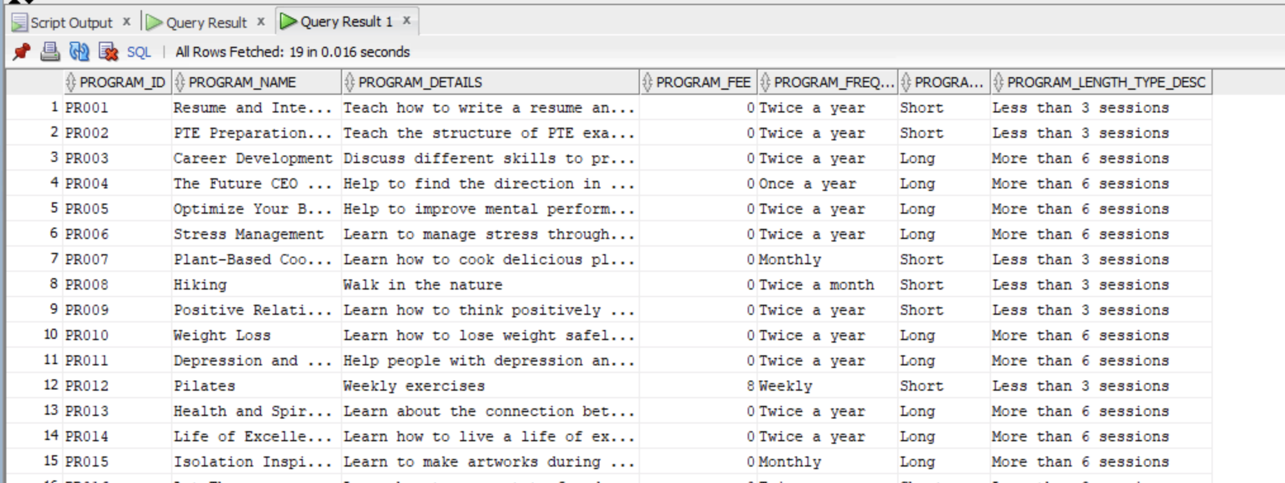

select * from eventsizedim;
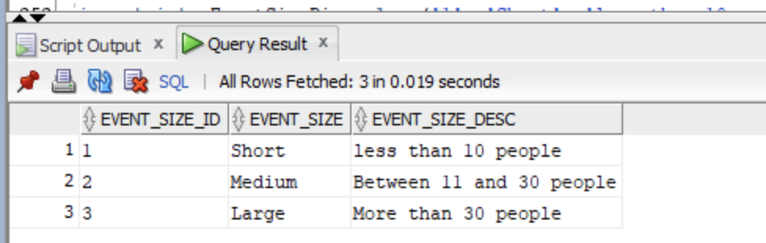
select * from timedim;
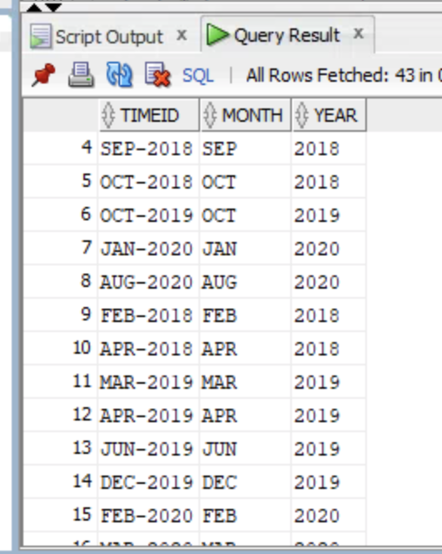
select * from occupationdim;
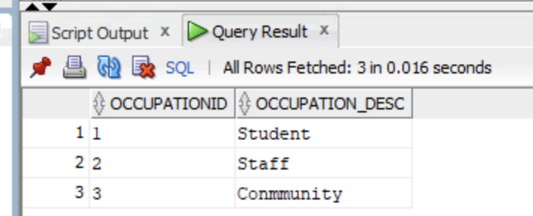
select * from locationdim;
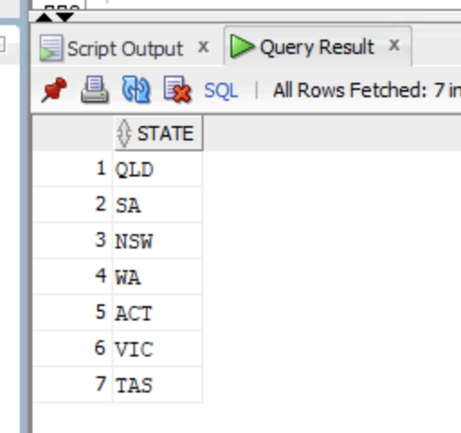
select * from maritaldim;
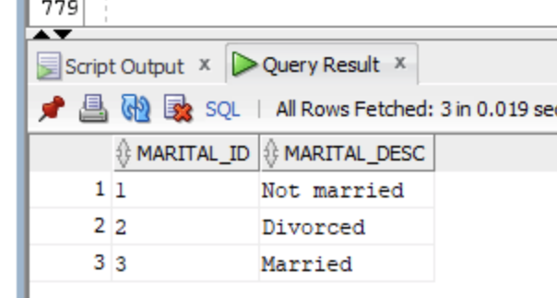
select * from agegroupdim;
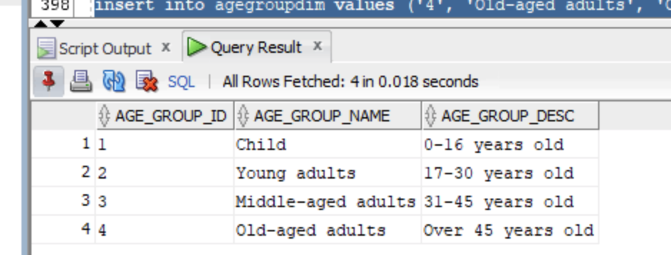
select * from mediadim;
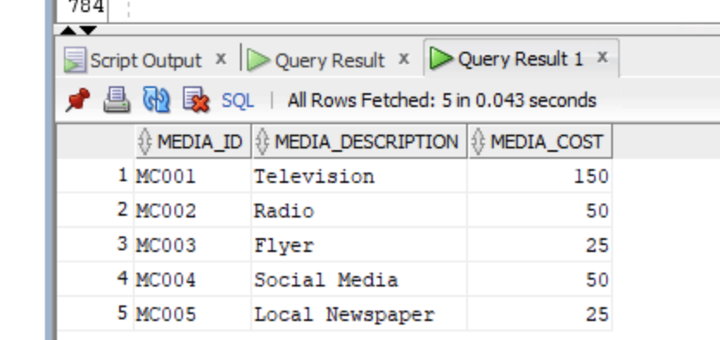
select * from topicdim;
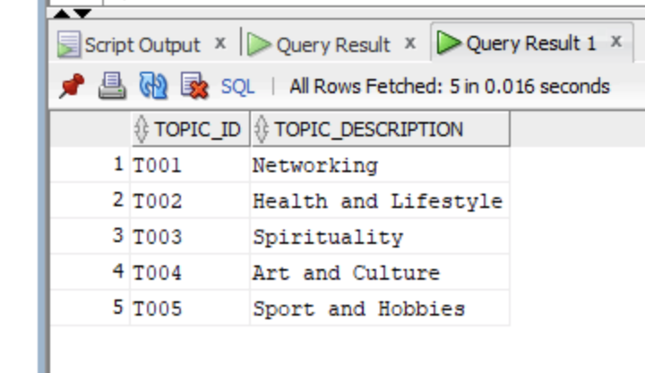

select * from interestfact;
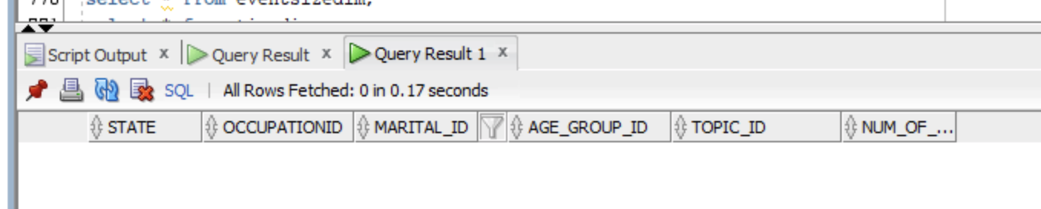
select * from registrationfact;
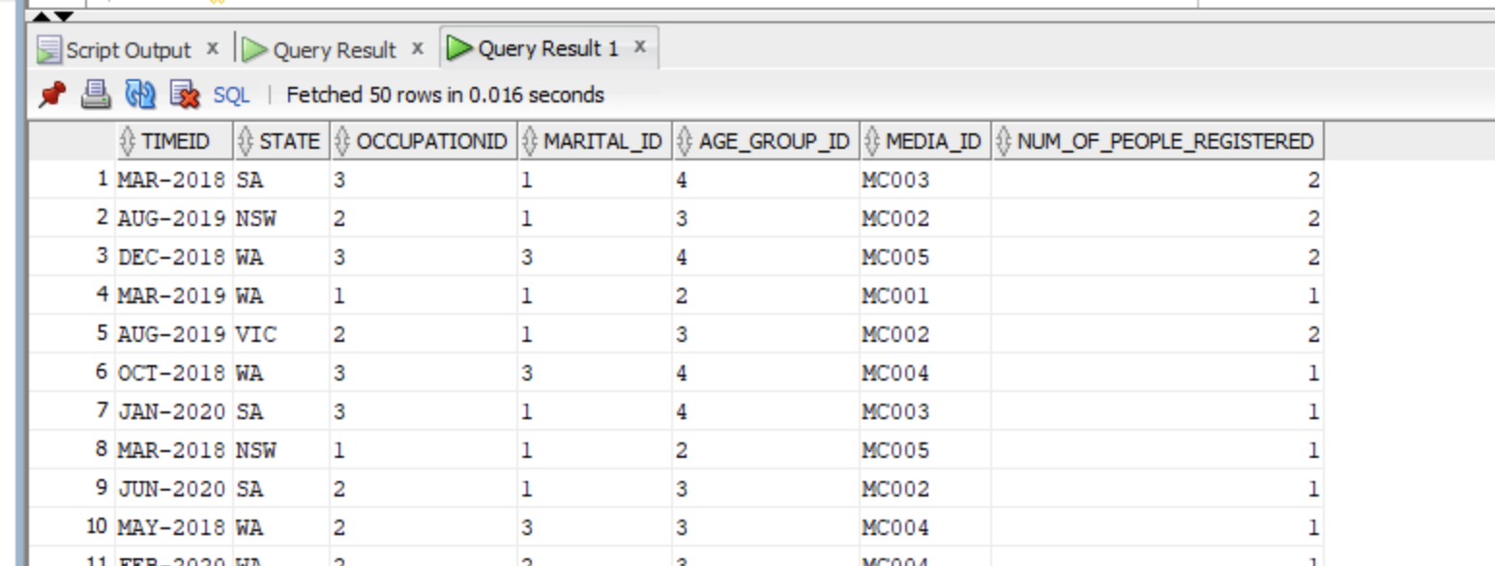
select * from attendancefact;
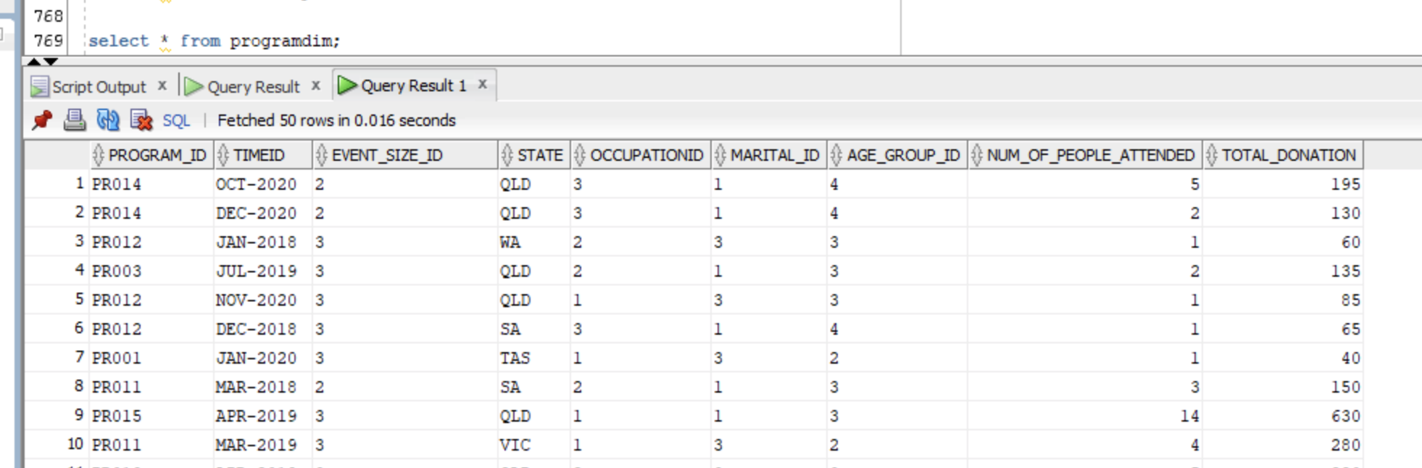
select * from subscriptionfact;
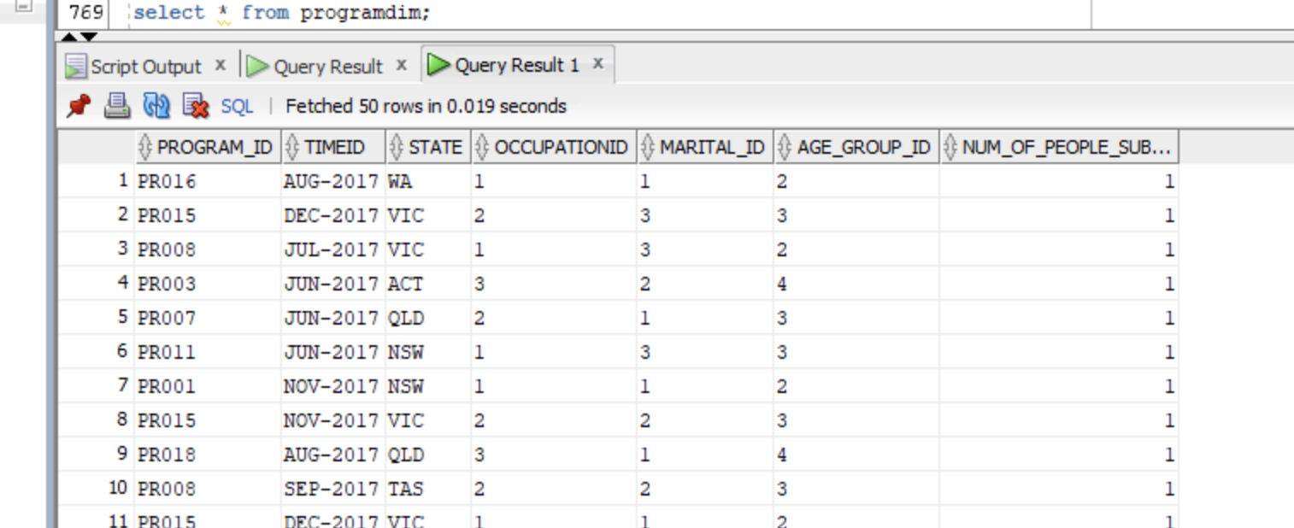

- Level 0:
select * from programdim;
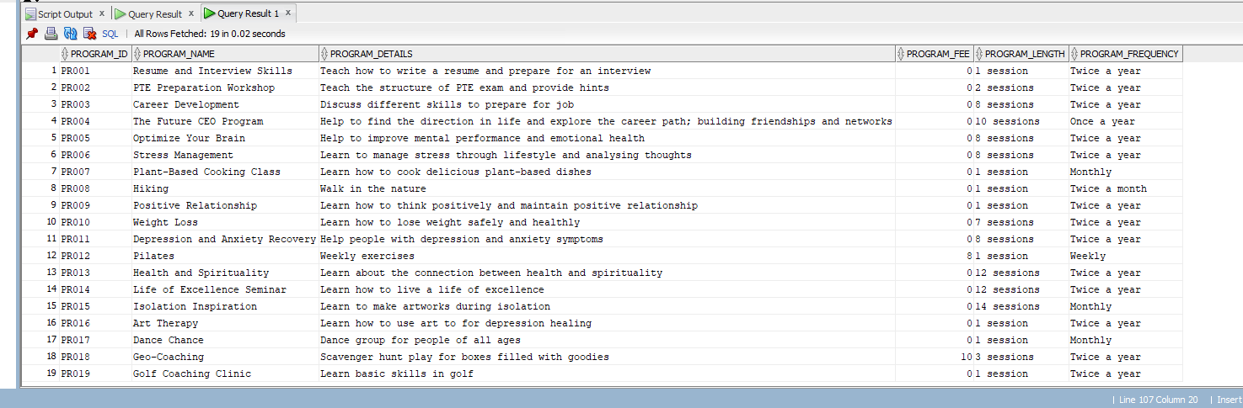
select * from eventdim;
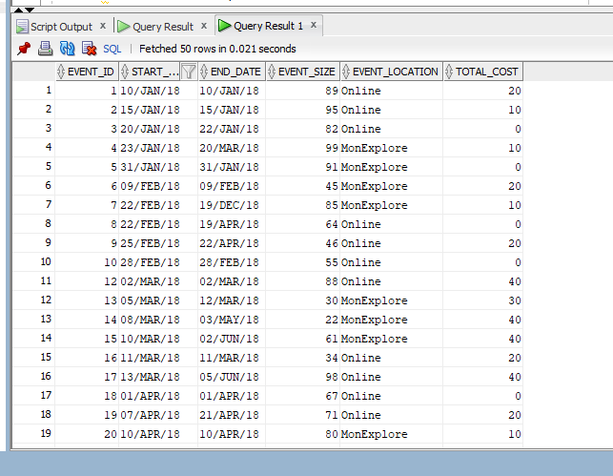
select * from attendancedim;
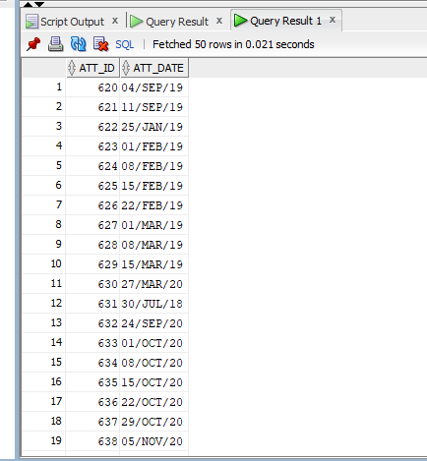
select * from subscriptiontimedim;
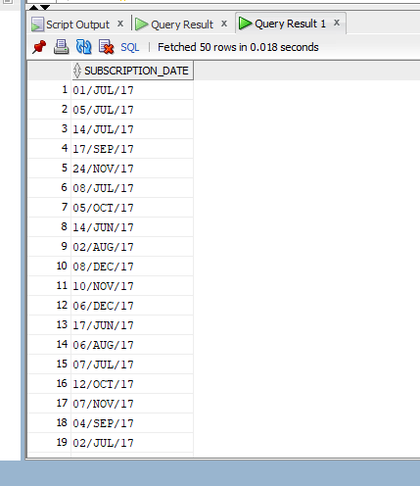
select * from addressdim;
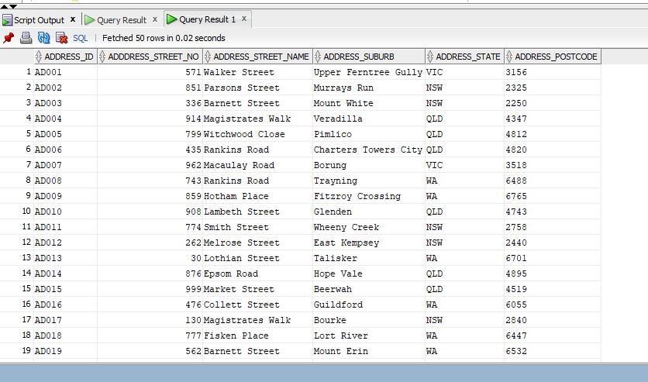
select * from persondim;
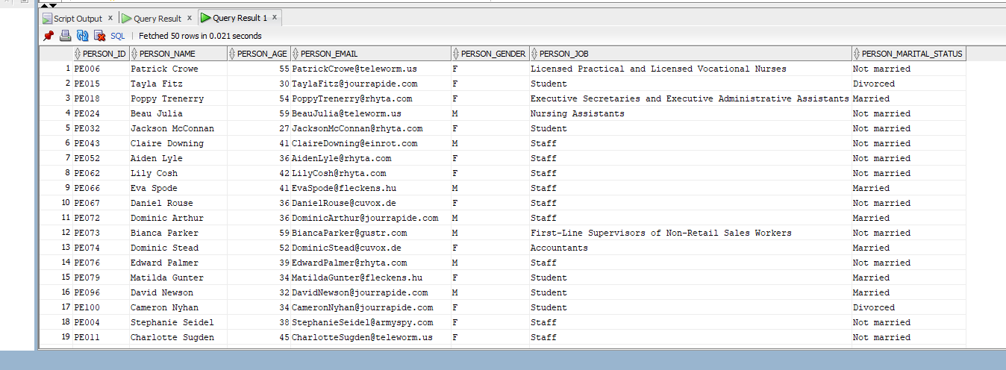
select * from registrationdim;
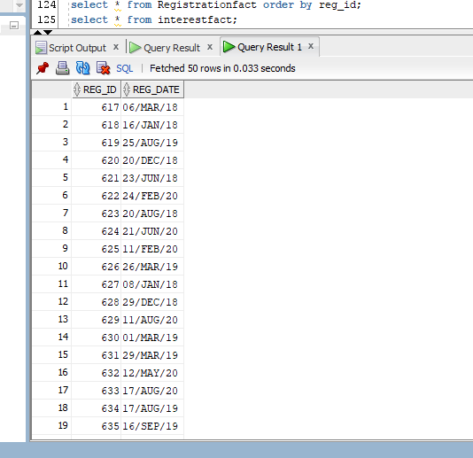
select * from mediadim;
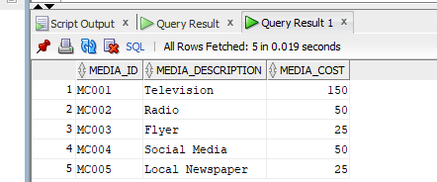
select * from topicdim;
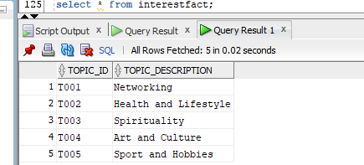
select count(*) from subscription;
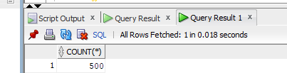
select count(*) from subscriptionfact;
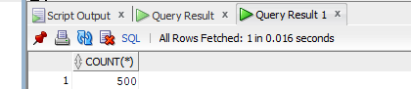
select * from subscriptionfact;
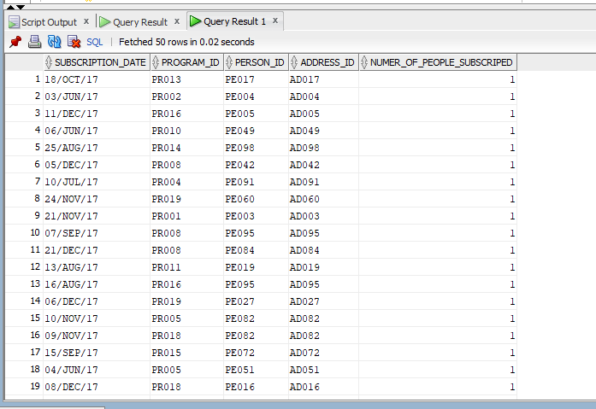
select count(*) from attendance;
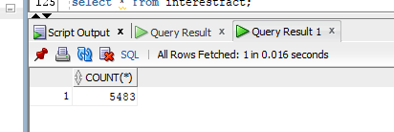
select count(*) from attendancefact;
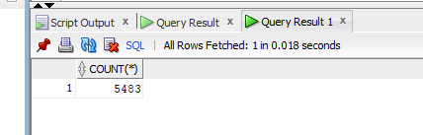
select * from attendancefact order by att_id;
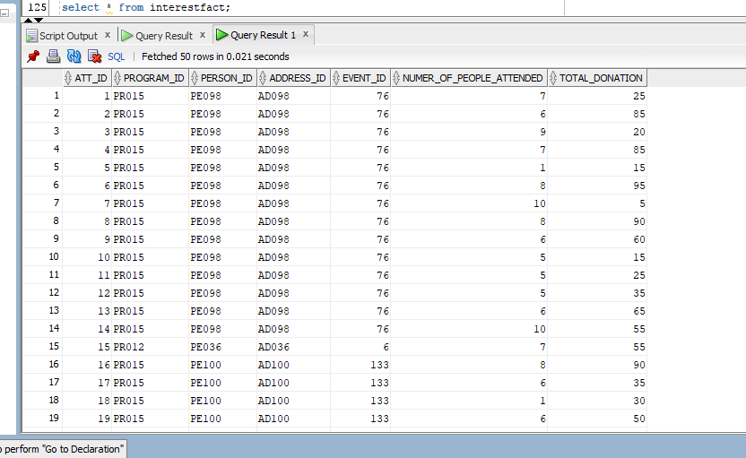
select count(*) from Registration;
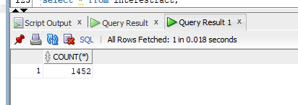
select count(*) from Registrationfact;
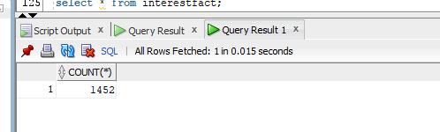
select * from Registrationfact order by reg_id;
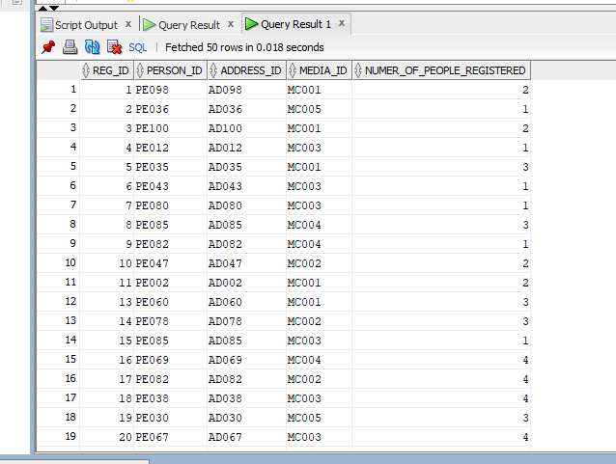
select * from interestfact; --no records in the cleaned person_interest table
